PHYSICS FORM 2
OPENER EXAM TERM 2 2023
NAME:_______________________________STREAM______DATE:__________

INSTRUCTIONS TO CANDIDATES:
(a) Write your Name and Adm .Number in the spaces provided above.
(b) Sign and write the date of examination in the spaces provided above.
(c) This paper consists of two Sections; A and B.
(d) Answer ALL the questions in Sections A and B in the spaces provided.
(e) All workings must be clearly shown.

FOR EXAMINER’S USE ONLY:
Section | Question | Maximum  Score | Candidate’s  Score
A | 1 – 11 | 25
 | 12 | 09
 | 13 | 11
B | 14 | 11
 | 15 | 10
 | 16 | 13
Total Score |  | 80

SECTION A (25 MARKS)

- Write down the vernier calliper’s reading shown in figure1 below: (1 mark)
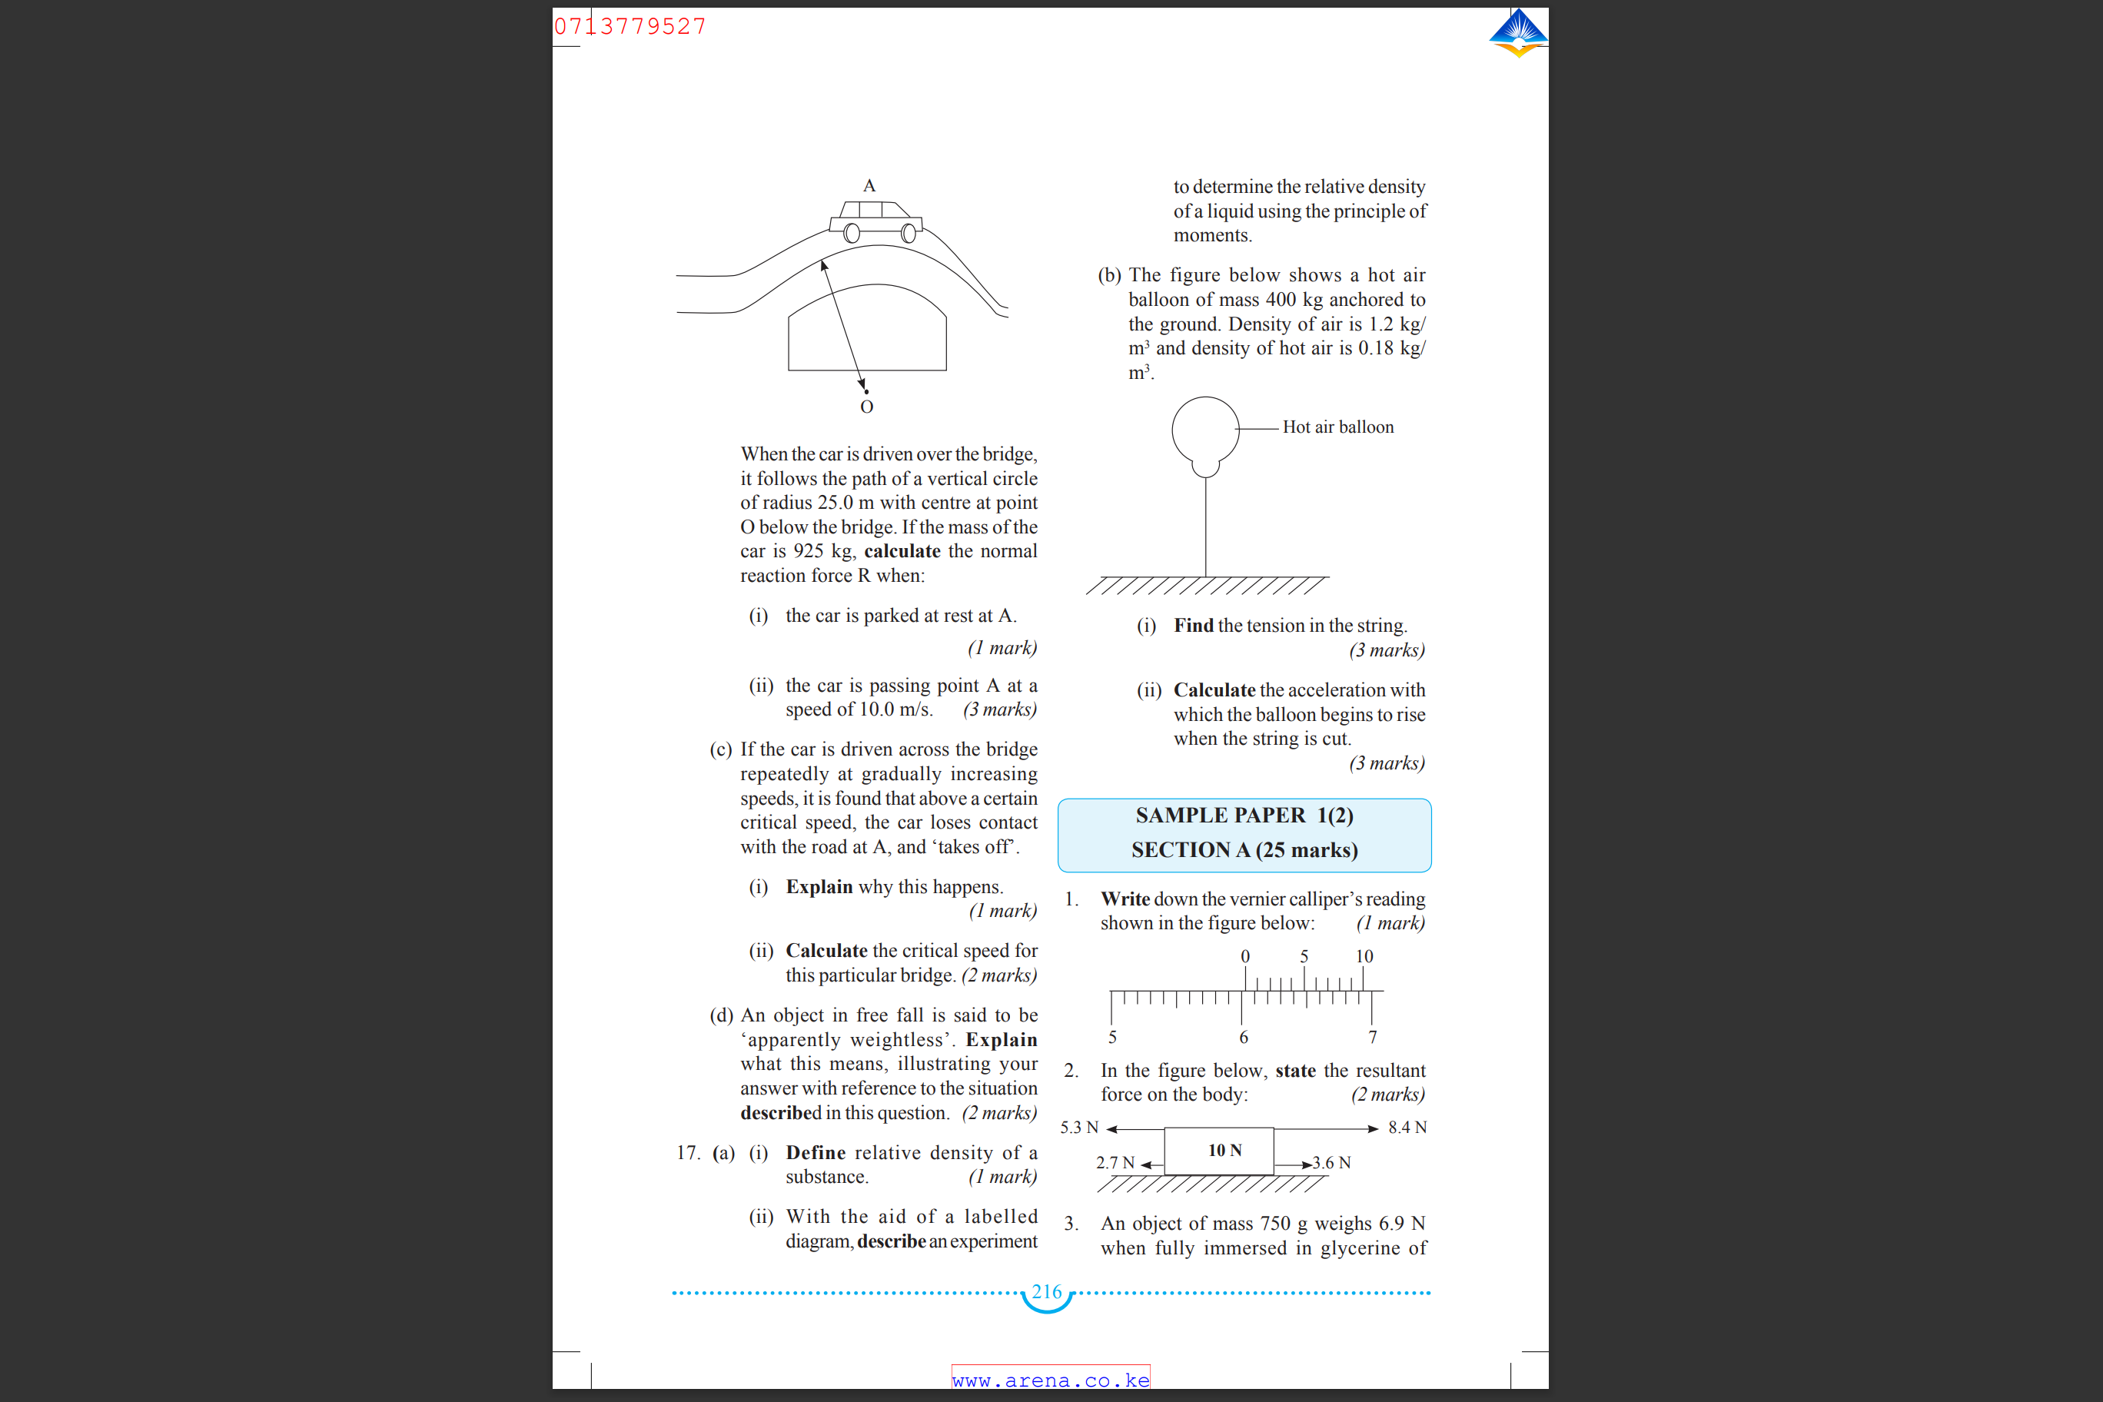
Figure 1
………………………………………………………………………………………………………………………………………………………………………………………………………………………………………………………………………………………………………

- Figure 2 below represents a simple gas thermometer set-up by a student.

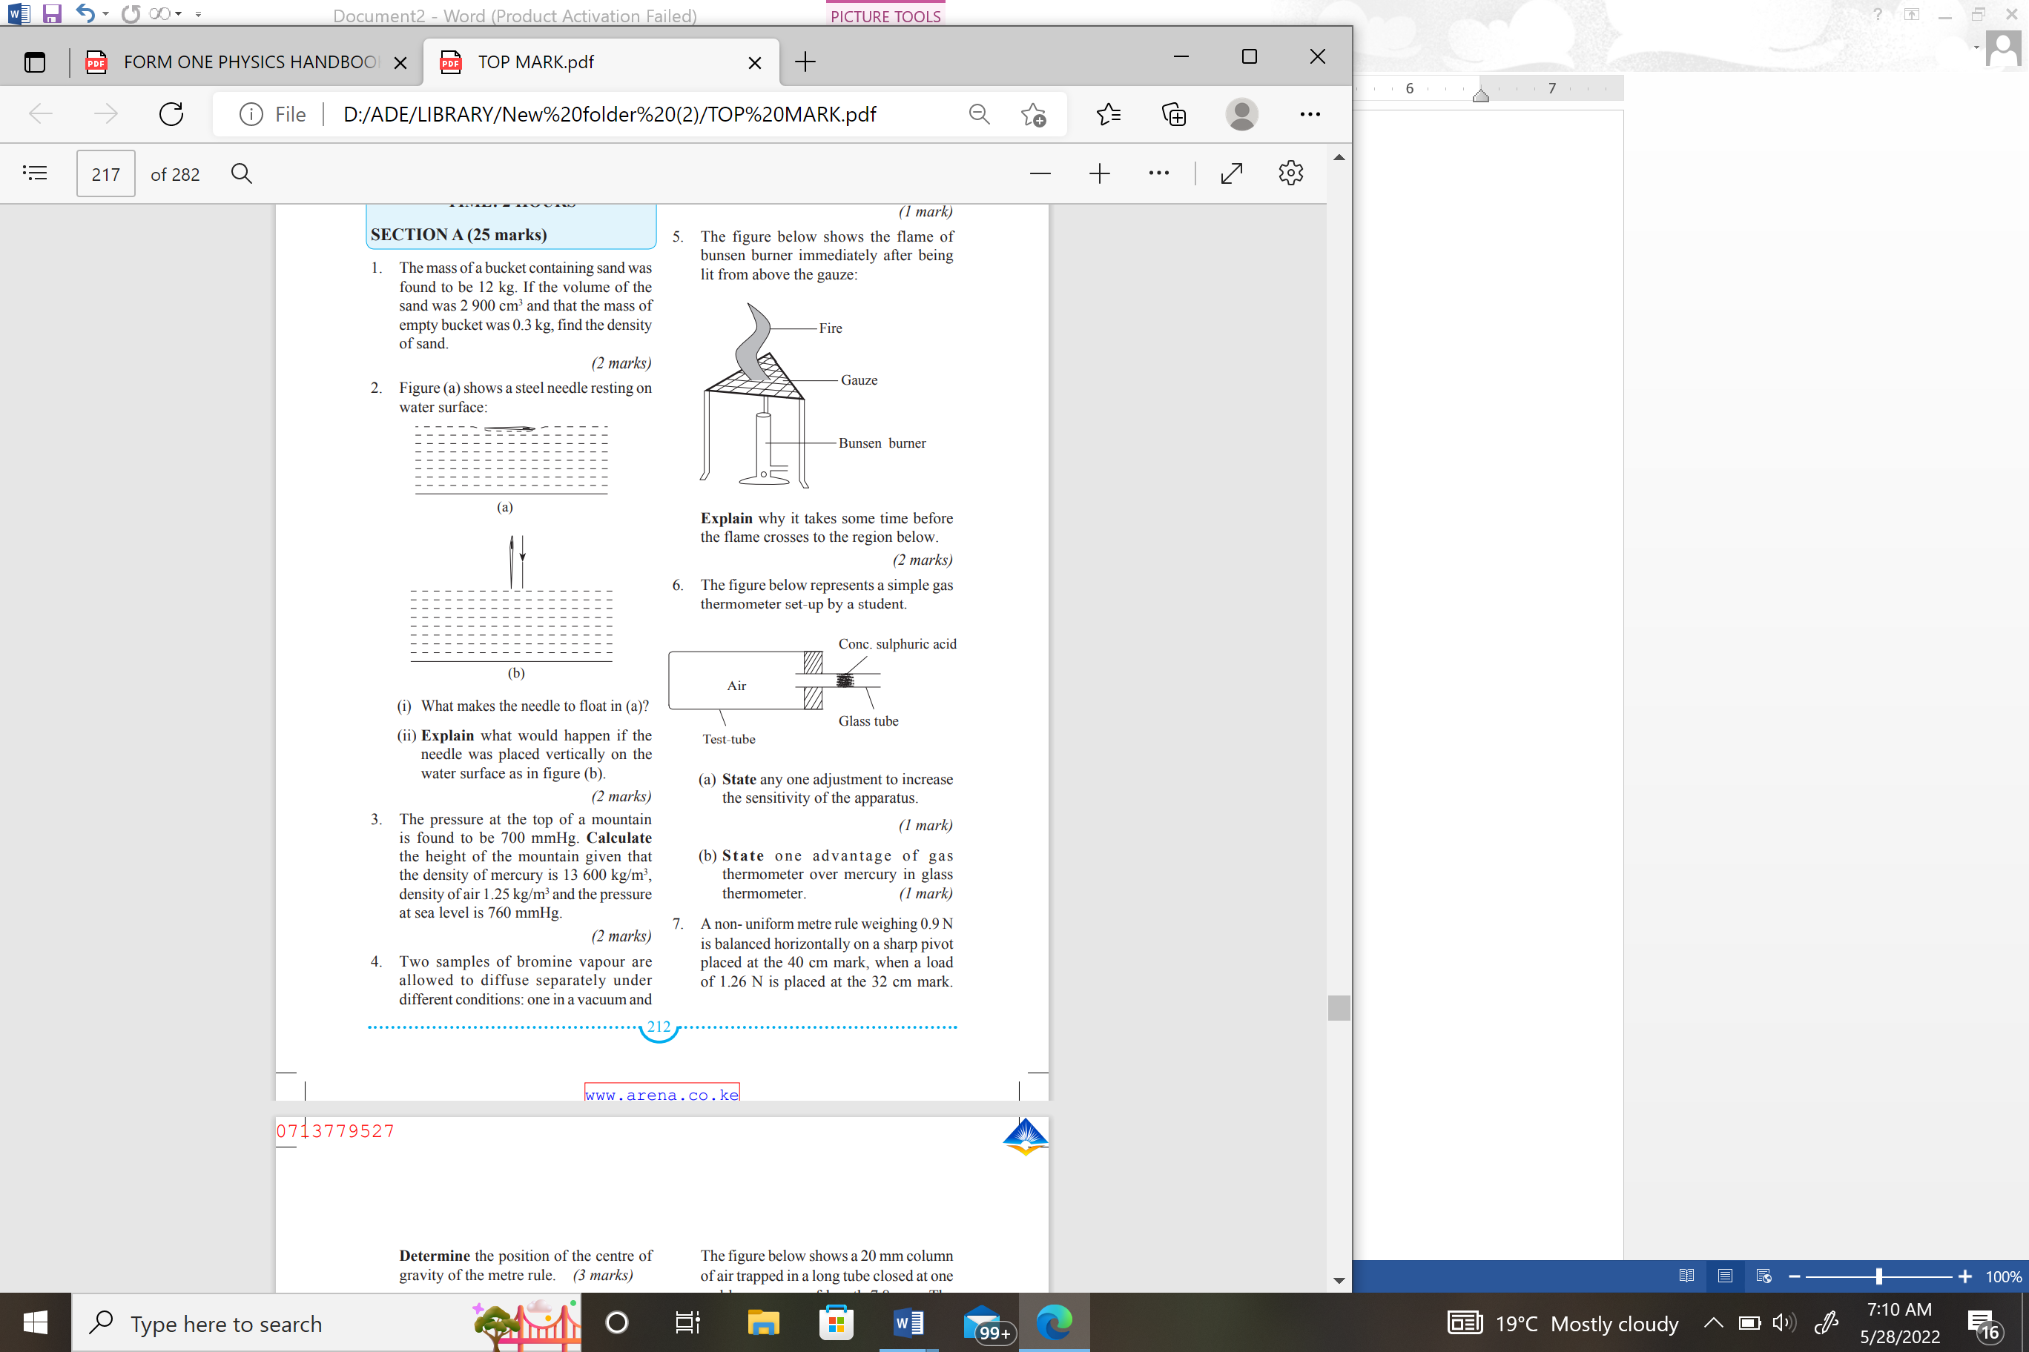
Figure 2

- State any one adjustment to increase the sensitivity of the apparatus. (1 mark)

………………………………………………………………………………………………………………………………………………………………………………………………………………………………………………………………………………………………………

- State one advantage of gas thermometer over mercury in glass thermometer. (1 mark)
………………………………………………………………………………………………………………………………………………………………………………………………………………………………………………………………………………………………………
- The pressure at the top of a mountain is found to be 700 mmHg. Calculate the height of the mountain given that the density of mercury is $13 600 kg/m^{3}$, density of air $1.25kg/m^{3}$and the pressure at sea level is 760 mmHg. (3 marks)

………………………………………………………………………………………………………………………………………………………………………………………………………………………………………………………………………………………………………………………………………………………………………………………………………………………………………………………………………………………………………………………………………………………………………………………………
- Figure 3 below shows a paint brush dipped in a clear paint and when removed from the paint
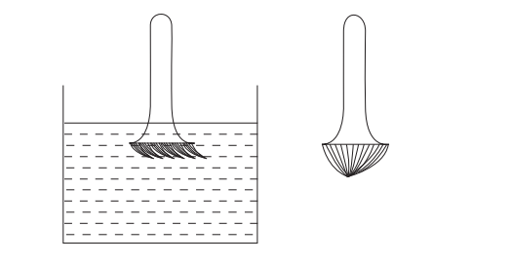
Figure 3
Explain the shape of the bristles. (2 marks)
……………………………………………………………………………………………………………………………………………………………………………………………………………………………………………………………………………………………………………………………………………………………………………………………………………………………………………………………………………………………………………………………………………………………………………………………… 5. State two factors that determine pressure in a liquid at a particular place. (2 marks)
………………………………………………………………………………………………………………………………………………………………………………………………………………………………………………………………………………………………………………………………………………………………………………………………………………………………………………………………………………………………………………………………………………………………………………………………

- Two metals X and Y welded together are heated so that they break the contact shown at P in the figure 4.
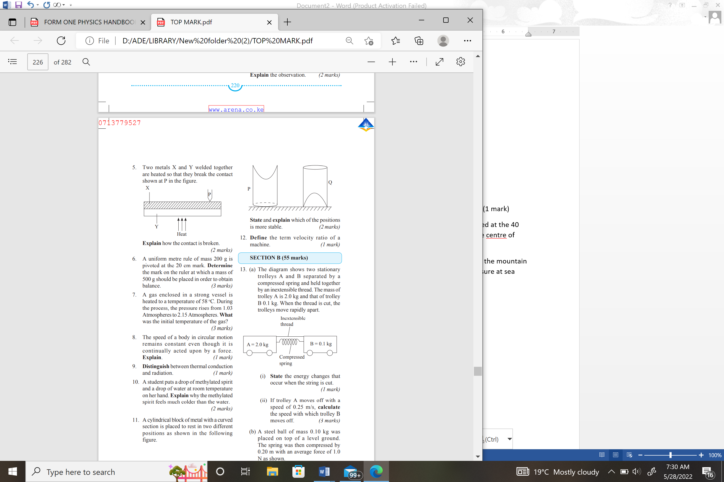
Figure 4
Explain how the contact is broken. (2 marks)
………………………………………………………………………………………………………………………………………………………………………………………………………………………………………………………………………………………………………………………………………………………………………………………………………………………………………………………………………………………………………………………………………………………………………………………………
7. Explain how a positively charged electroscope can be used to determine the charge on charged rod. (2 marks)
………………………………………………………………………………………………………………………………………………………………………………………………………………………………………………………………………………………………………………………………………………………………………………………………
- State two advantages of the lead-acid accumulator over the dry cell. (2 marks)

………………………………………………………………………………………………………………………………………………………………………………………………………………………………………………………………………………………………
- A soft iron rod and a steel bar are placed in turns in a solenoid connected as in figure 5 below.
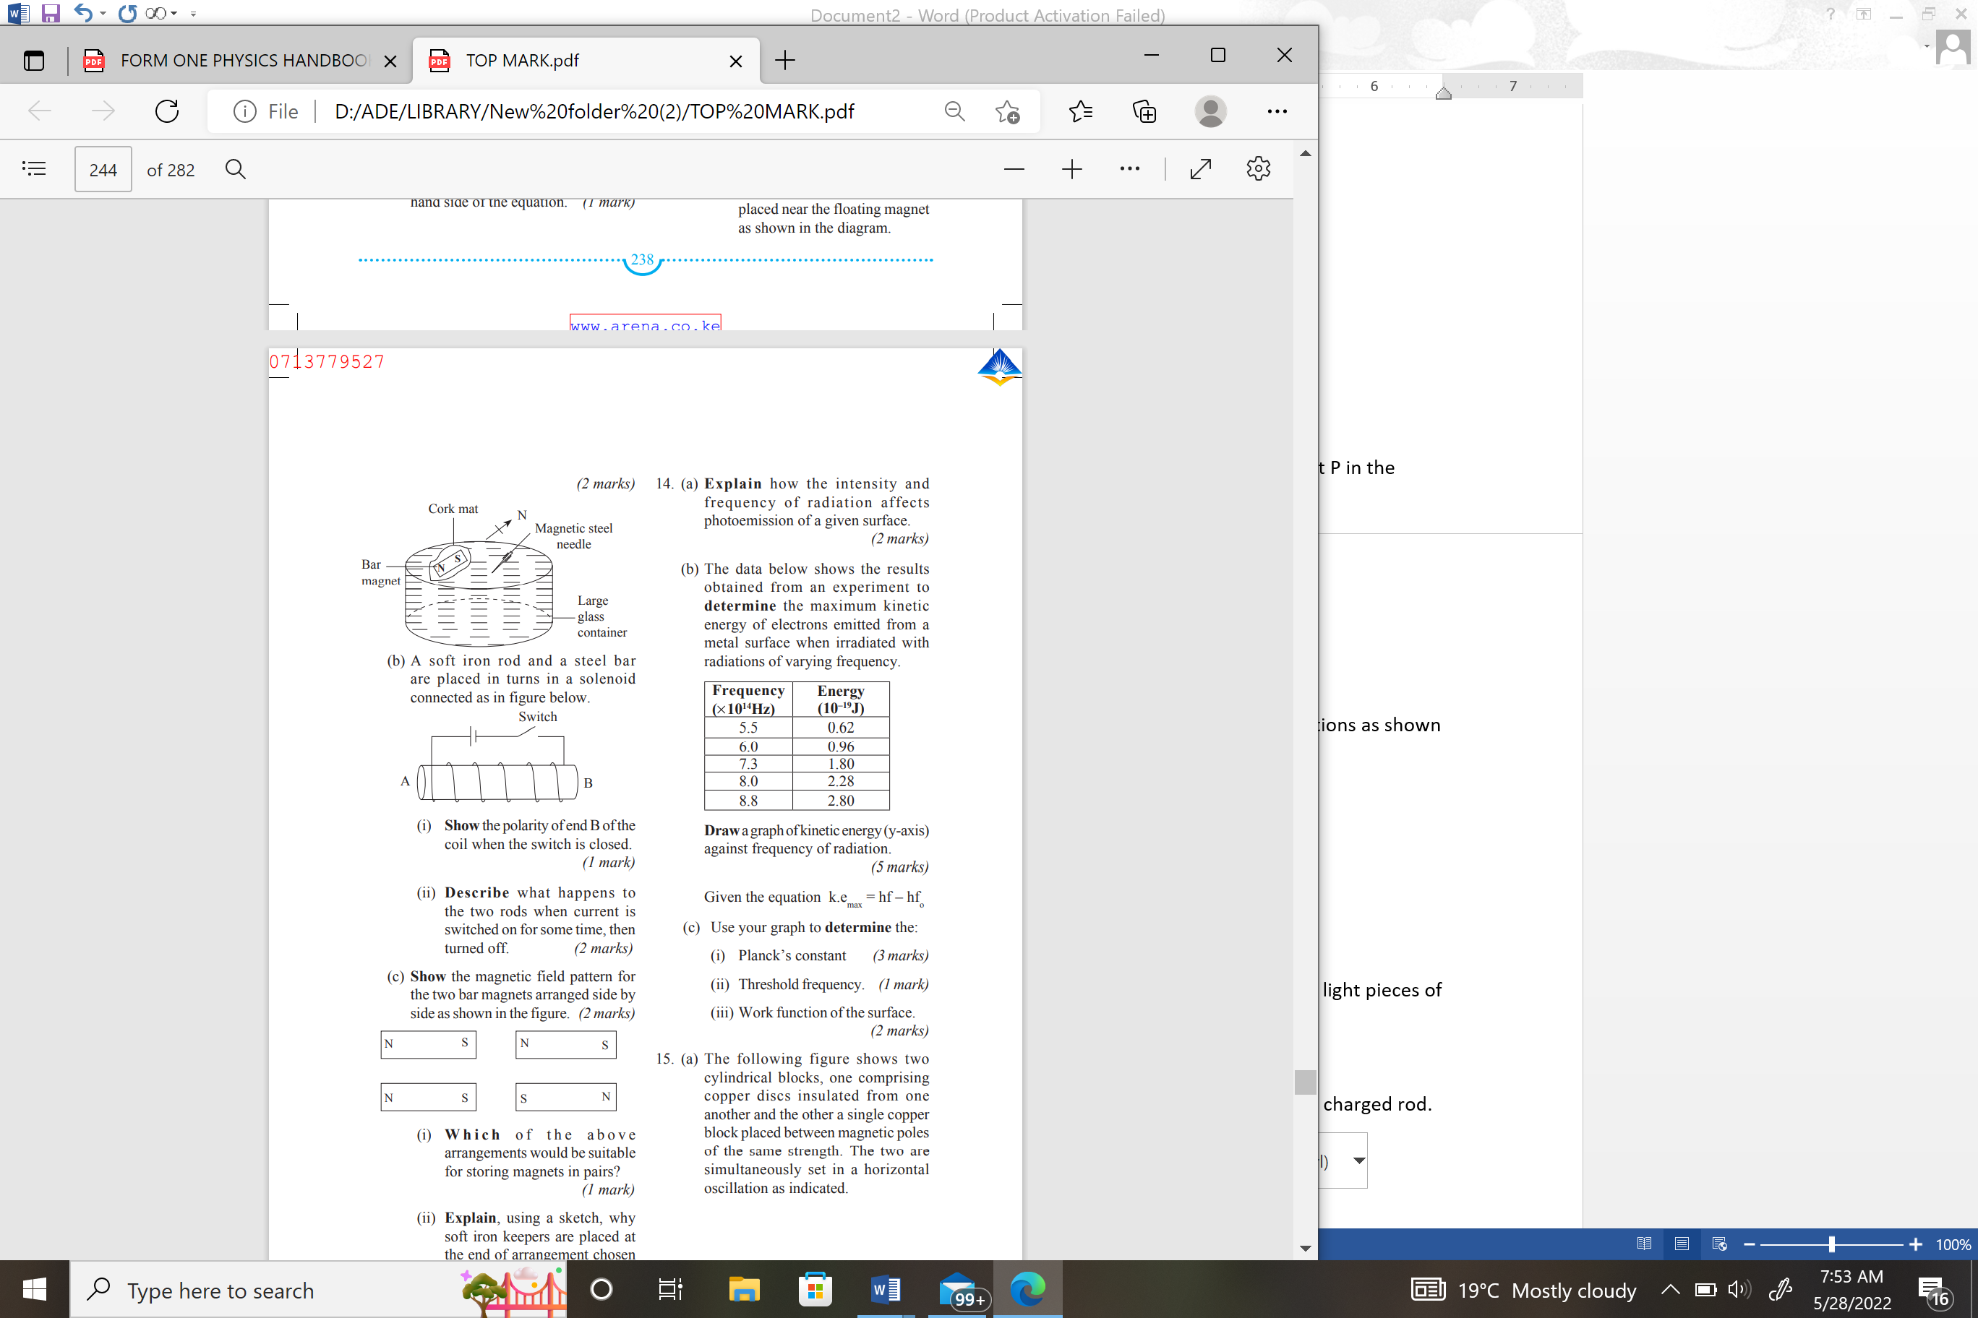
Figure 5

- Show the polarity of end B of the coil when the switch is closed. (1 mark)
………………………………………………………………………………………………………………………………………………………………………………………………
- Describe what happens to the two rods when current is switched on for some time, then turned off. (2 marks)

………………………………………………………………………………………………………………………………………………………………………………………………………………………………………………………………………………………………………………………………………………………………………………………………………………………………………………………………………………………………
- (a) State the effect on the image formed by a pinhole camera if:
- The size of the pinhole is increased. ( 1 mark)
…………………………………………………………………………………………………………………………………………………………………………
- The object is moved closer to the pinhole. ( 1 mark)
…………………………………………………………………………………………………………………………………………………………………………
- The screen is moved farther from the pinhole ( 1 mark)
…………………………………………………………………………………………………………………………………………………………………………
- Describe experiments to determine the density of a liquid (3 marks)
………………………………………………………………………………………………………………………………………………………………………………………………………………………………………………………………………………………………………………………………………………………………………………………………………………………………………………………………………………………………

SECTION B (55 MARKS)
Answer ALL the questions in this section in the spaces provided
- The diagram below shows two steel pins held at the poles of two magnets.
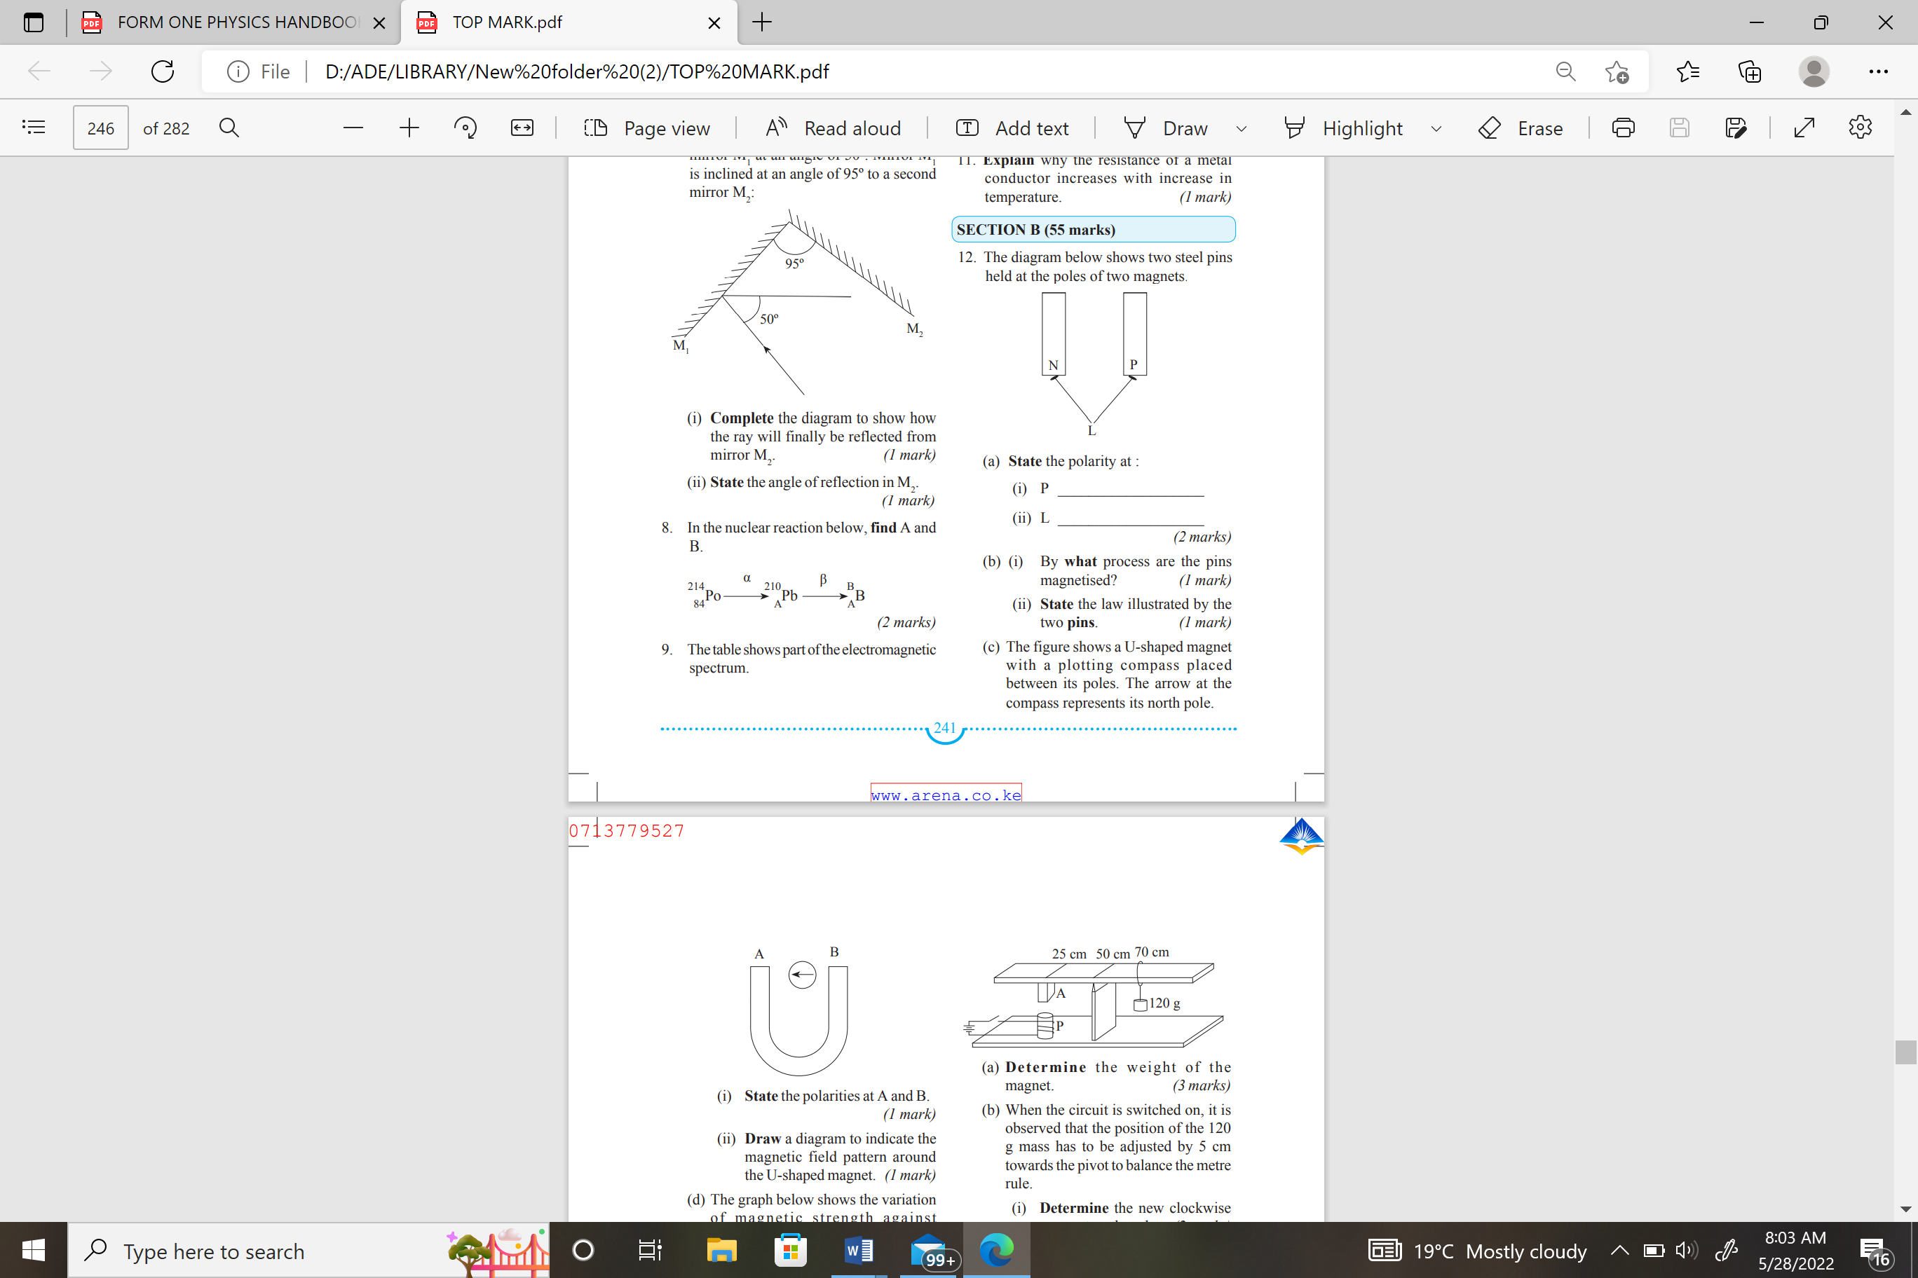
Figure 6
(a) State the polarity at:
P ___________________ (1 mark)

b) (i) By what process are the pins magnetized`? (1 mark)
……………………………………………………………………………………………………………………………………………………………………………………………… (ii) State the law illustrated by the two pins. (1 mark)
………………………………………………………………………………………………………………………………………………………………………………………………
(c) The figure 7 below shows a U-shaped magnet with a plotting compass placed between its poles. The arrow at the compass represents its north pole.

Figure 7
- State the polarities at A and B. (1 mark)

………………………………………………………………………………………………………………………………………………………………………………………………

- Draw on the diagram to indicate the magnetic field pattern around the U-shaped magnet. (1 mark)
(d) The graph below shows the variation of magnetic strength against magnetizing current.
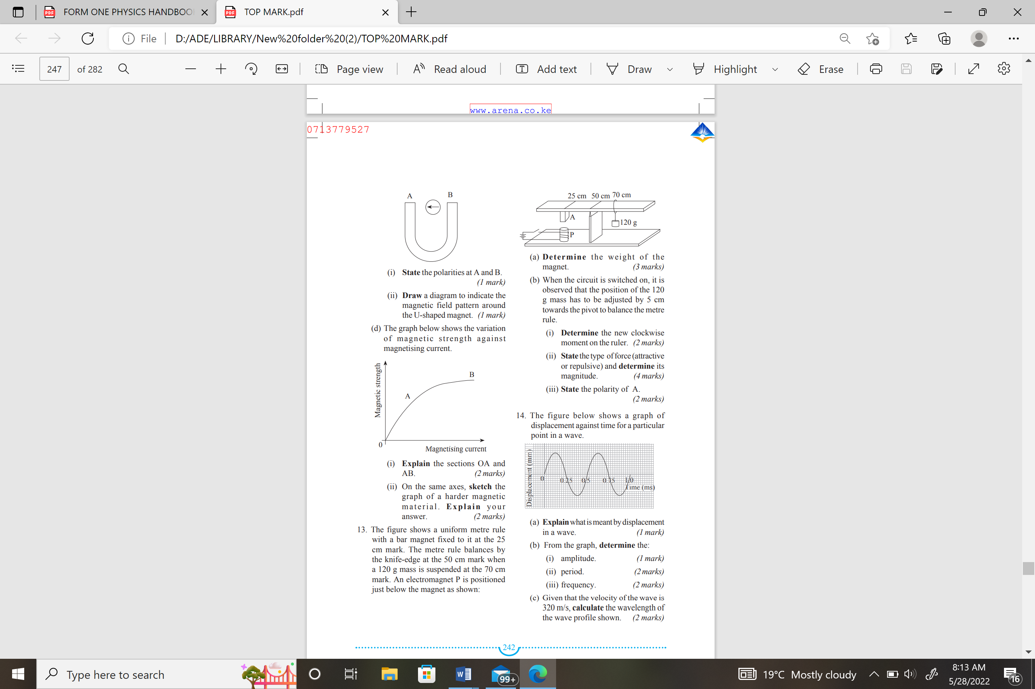
Figure 8

- Explain the sections OA and AB. (2 marks)

………………………………………………………………………………………………………………………………………………………………………………………………………………………………………………………………………………………………………………………………………………………………………………………………………………………………………………………………………………………………

- On the same axes, sketch the graph of a harder magnetic material. Explain your answer. (2 marks)
………………………………………………………………………………………………………………………………………………………………………………………………………………………………………………………………………………

13. (a) The figure 9 below shows a dry cell
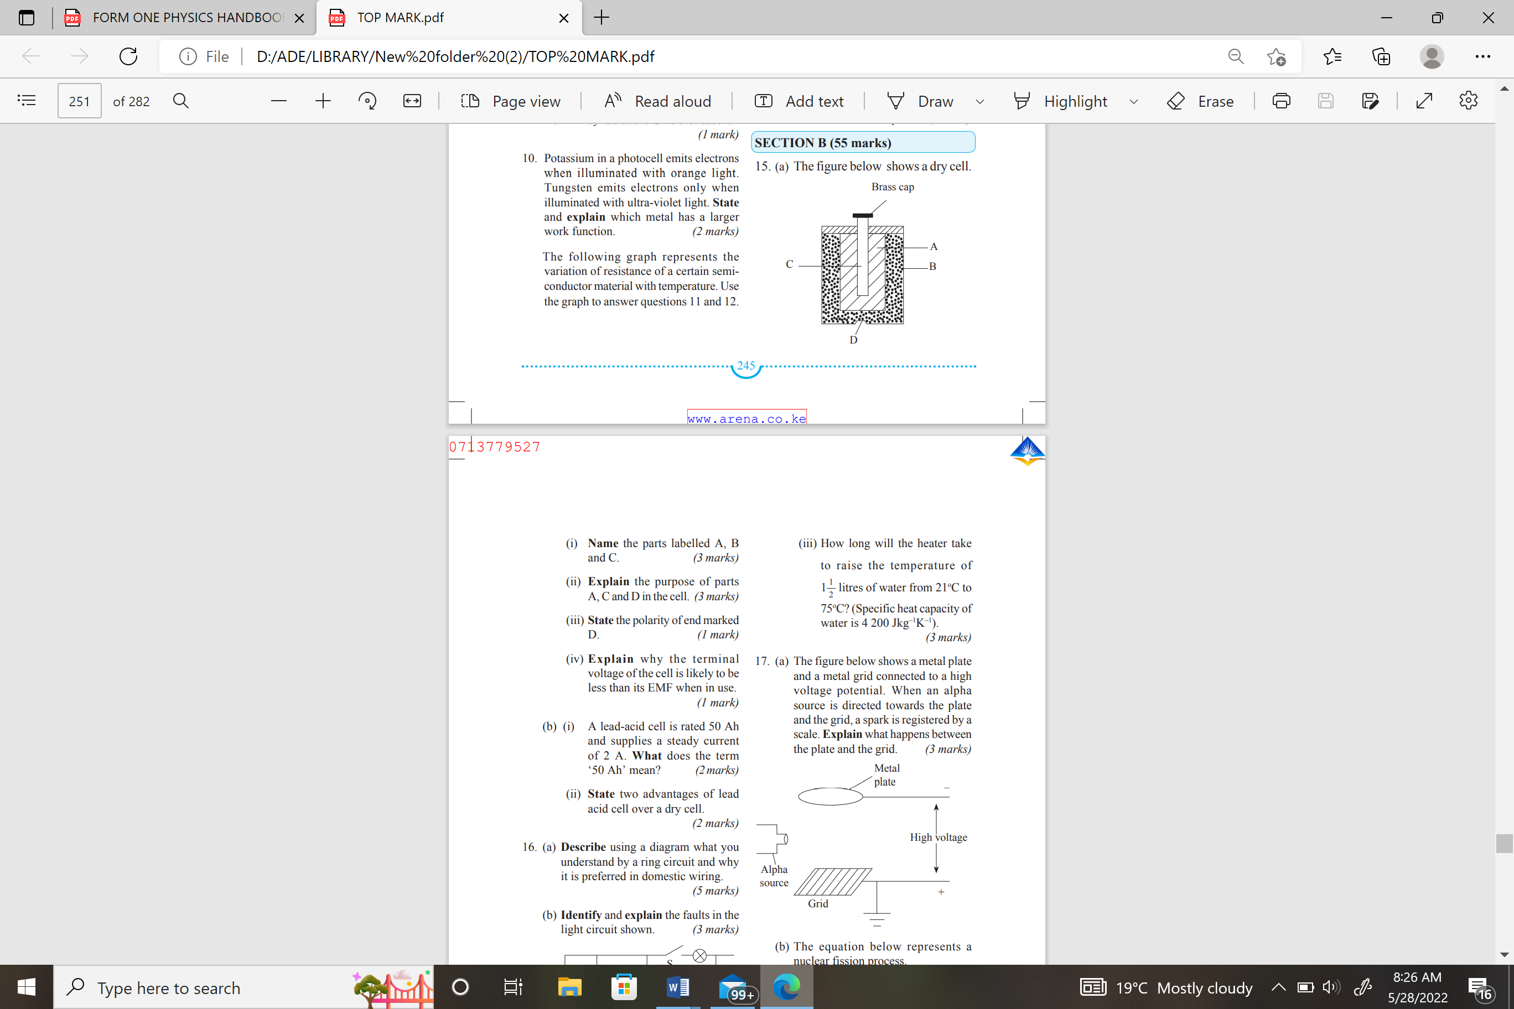
Figure 9
- Name the parts labelled A, B and C. (3 marks)

………………………………………………………………………………………………………………………………………………………………………………………………………………………………………………………………………………
- Explain the purpose of parts A, C and D in the cell. (3 marks)
………………………………………………………………………………………………………………………………………………………………………………………………………………………………………………………………………………
……………………………………………………………………………………………………………………………………………………………………………………
- State the polarity of end marked D. (1 mark)
………………………………………………………………………………………………………………………………………………………………………………………………………………………………………………………………………………

- Explain why the terminal voltage of the cell is likely to be less than its EMF when in use. (1 mark)
………………………………………………………………………………………………………………………………………………………………………………………………………………………………………………………………………………
- (i) A lead-acid cell is rated 50 Ah and supplies a steady current of 2 A. What does the term ‘50 Ah’ mean? (3marks)
………………………………………………………………………………………………………………………………………………………………………………………………………………………………………………………………………………
14. The figure 10 below shows a hydraulic brake system for a car. The area of the master piston A is $0.75{cm}^{2}$ while the slave pistons attached to the tyres P, Q, R and S are of area$3{cm}^{2}$ each. A force of 500 N is applied on the master cylinder.
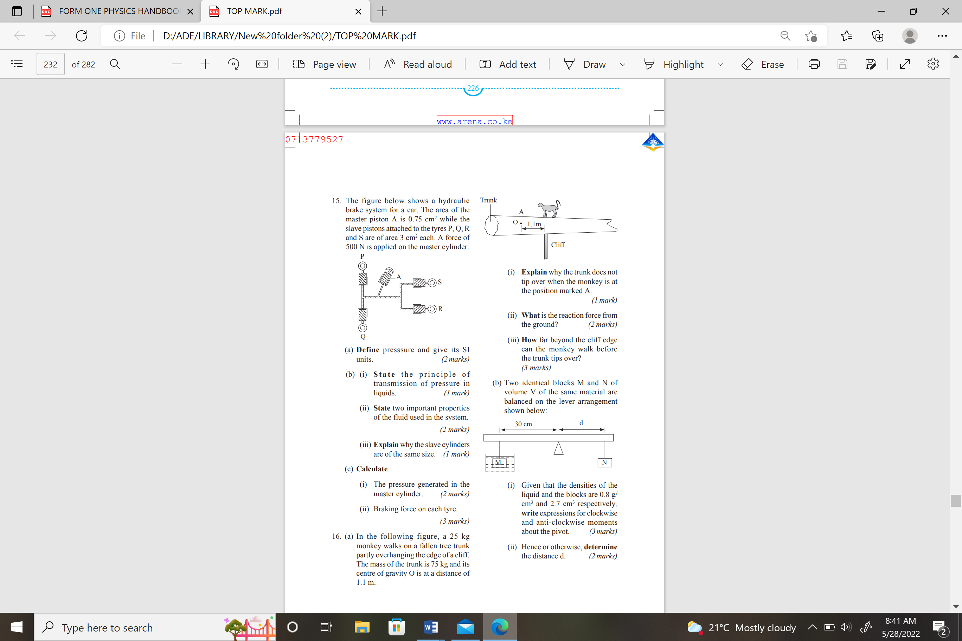
Figure 10
- Define pressure and give its SI units. (2 marks)
………………………………………………………………………………………………………………………………………………………………………………………………………………………………………………………………………………

- (i) State the principle of transmission of pressure in liquids. (1 mark)
……………………………………………………………………………………… ……………………………………………………………………………………………………………………………………………………………………………………
- State two important properties of the fluid used in the system. (2 marks)
………………………………………………………………………………………………………………………………………………………………………………………………………………………………………………………………………………

- Explain why the slave cylinders are of the same size. (1 mark)
………………………………………………………………………………………………………………………………………………………………………………………………………………………………………………………………………………
(c) Calculate:
(i) The pressure generated in the master cylinder. (2 marks)
………………………………………………………………………………………………………………………………………………………………………………………………………………………………………………………………………………

- Braking force on each tyre. (3 marks)
………………………………………………………………………………………………………………………………………………………………………………………………………………………………………………………………………………

15. The motion of smoke particles enclosed in a smoke cell can be studied using the set-up shown below
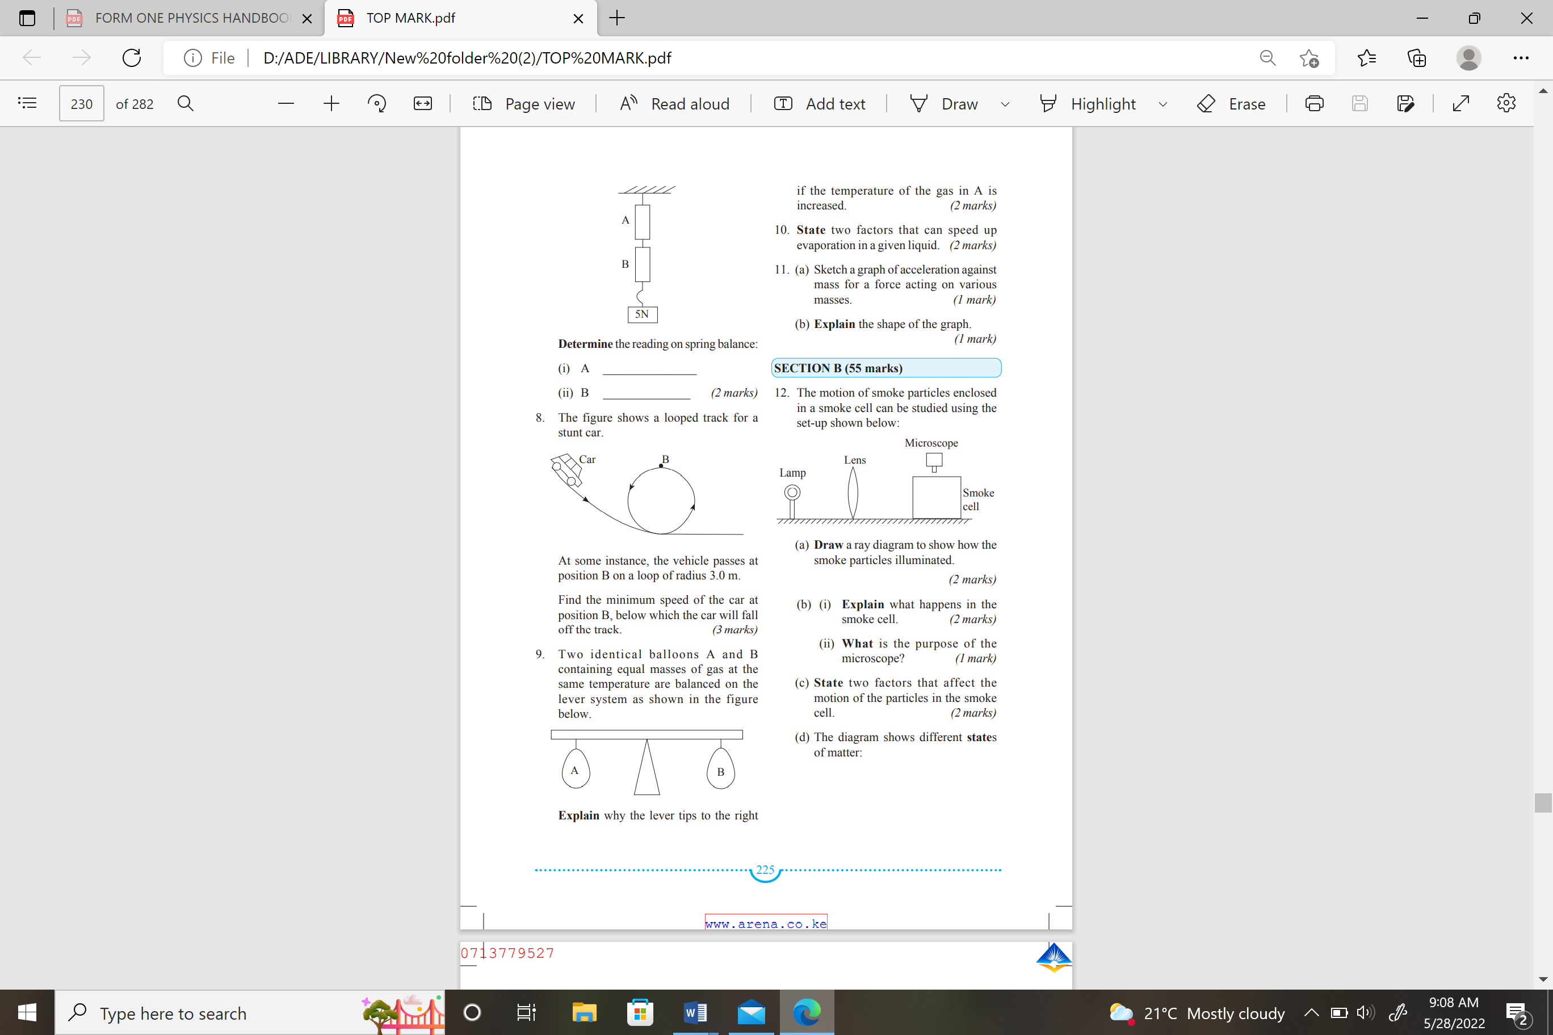
Figure 11
(a) What observation is made in the smoke cell? (2 marks)
………………………………………………………………………………………………………………………………………………………………………………………………………………………………………………………………………………

(b) (i) Explain what happens in the smoke cell. (2 marks)
………………………………………………………………………………………………………………………………………………………………………………………………………………………………………………………………………………

(ii) What is the purpose of the microscope? (1 mark)
………………………………………………………………………………………………………………………………………………………………………………………………………………………………………………………………………………

- State two factors that affect the motion of the particles in the smoke cell.
(2 marks)
………………………………………………………………………………………………………………………………………………………………………………………………………………………………………………………………………………
- The diagram shows different states of matter:
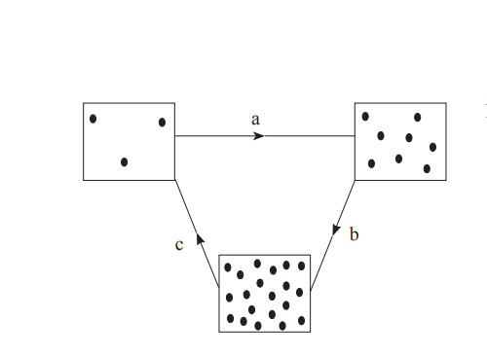
Figure 12
- Name the processes labelled a and c. (2 marks)
………………………………………………………………………………………………………………………………………………………………………………………………………………………………………………………………………………

- Explain why solids have a definite shape but liquids take the shape of the container in which they are put. (2 marks)
……………………………………………………………………………………………………………………………………………………………………………………………………………………………………………………………………………

16. The figure 13 below shows a liquid in a container

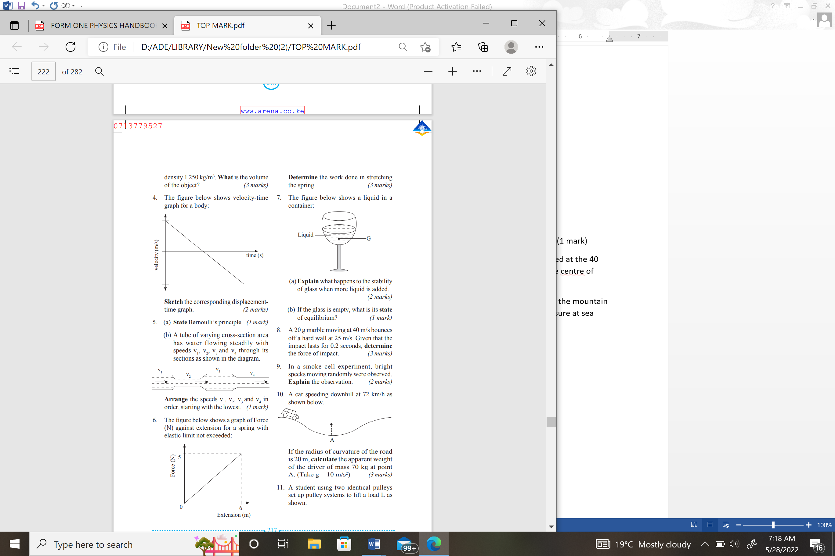
Figure 13
(a)Explain what happens to the stability of glass when more liquid is added. (2 marks)
………………………………………………………………………………………………………………………………………………………………………………………………………………………………………………………………………………
(b) If the glass is empty, what is its state of equilibrium? (1 mark)
………………………………………………………………………………………………………………………………………………………………………………………………………………………………………………………………………………

(c) A cylindrical block of metal with a curved section is placed to rest in two different positions as shown in the following figure 14.
Figure 14
State and explain which of the positions is more stable. (2 marks)
……………………………………………………………………………………………………………………………………………………………………………………………………………………………………………………………………………
(d) A non- uniform meter rule weighing 0.9 N is balanced horizontally on a sharp pivot placed at the 40 cm mark, when a load of 1.26 N is placed at the 32 cm mark. Determine the position of the center of gravity of the meter rule. (3 marks)
………………………………………………………………………………………………………………………………………………………………………………………………………………………………………………………………………………
(e) Suppose the student was given a flat irregularly-shaped object shown in figure 15, how would the center of gravity be determined? ( 3 marks)
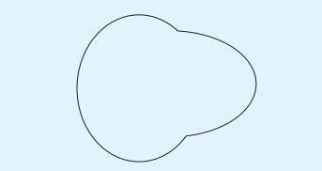
Figure 15
………………………………………………………………………………………………………………………………………………………………………………………………………………………………………………………………………………
………………………………………………………………………………………………………………………………………………………………………………………………………………………………………………………………………………

(f) What modifications are introduced to the buses to ensure stability?
………………………………………………………………………………………………………………………………………………………………………………………………………………………………………………………………………………
# END#

