NAME………………………………………………………….ADM NO…………..CLASS..…….……..

END OF TERM II
FORM 2 PHYSICS
TIME: 1 HOUR 45 MINS
Answer ALL questions this section in the spaces provided.
SECTION A : (30 MARKS)
1. Figure 1 shows a micrometer with a negative error of 0.02mm used to measure the diameter
of a ball bearing.
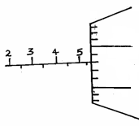
40
35

Record the diameter of the ball. (2mks)

2. An oil drop of volume 0.4mm³ was placed on a clean water surface. It spread to form a monoatomic circular patch of area 2000mm². Use this data to calculate the diameter of a molecule of oil. (3mks)

3. A fixed mass of pure water was cooled from 20°C to O°C. Sketch a graph of density of the water against temperature. (2mks)

4. Two 10g masses are fixed onto two similar aluminium plates, one polished and the other painted black, using wax as shown in the figure below.
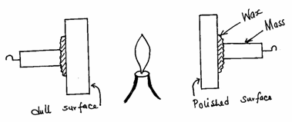

Give and explain the observation made. (2mks)

5. The figure below shows a charged leaf electroscope.

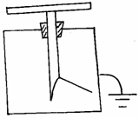

Given a dry glass rod and silk cloth, explain how you would determine the type of charge on the
electroscope. (2mks)

6. State two advantages of alkaline accumulator over the lead-acid cell. (2mks)

7. The figure below shows two magnets whose North poles are brought close to each other.
Indicate the magnetic field pattern between the two magnets. (2mks)

S
N
N
S

8. The diagram shows a system in equilibrium with the uniform rule supported at Q and resting horizontally.
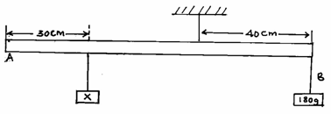

The rule is 1m long and weighs 1.8N. Calculate the weight of the block X. (3mks)

9. An object is placed infront of a concave mirror as shown in the figure below.
Complete the diagram to show how the image is formed. (3mks)

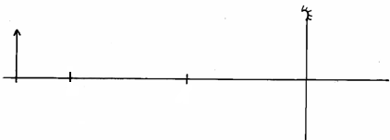
C
F

10. State and explain what will happen to the freely suspended magnet when the switch S is closed.

(2mks)

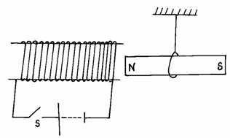

11. Three identical springs A, B and C are used to support a 15.5N weight as shown in the
figure below.
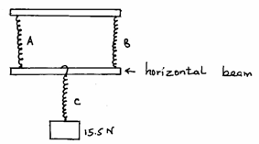

If the weight of the horizontal beam is 0.5N, determine the extension of each spring given that 4N cause an extension of 1cm when using one spring. (3mks)

12. State one of the major differences between mechanical waves and electromagnetic waves. (2mks)

13. A boat sent an ultrasound signal to the bottom of the sea and its echo received after 10
seconds. If the wavelength of the ultrasound in water is 0.05m and the frequency of the
transmitter is 50 KHz, calculate the depth of the sea. (3mks)

SECTION B: (40 MARKS)

14. (a) Complete the diagram below to show how an image is formed in a pinhole camera. (3mks)
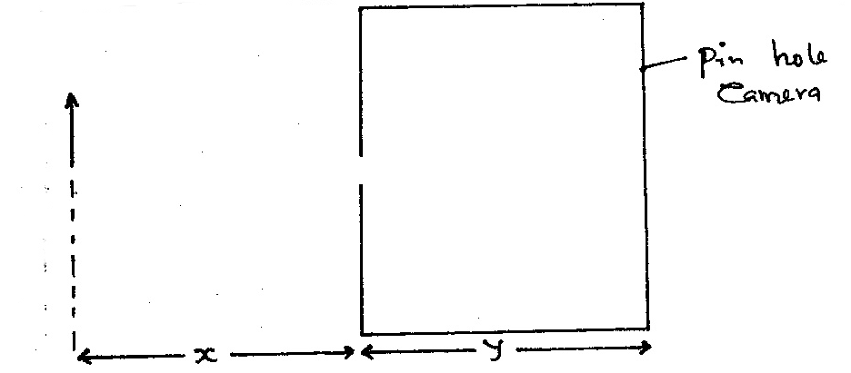

(b) State two characteristics of the image above. (2mks)

- State two changes that will be observed about this image if the pinhole is made wider. (2mks)

- If χ = 30cm, y = 12cm and the heights of the image is 4cm, calculate the height of the object.
(3mks)

15. The diagram below shows the wave profile of a transverse wave.

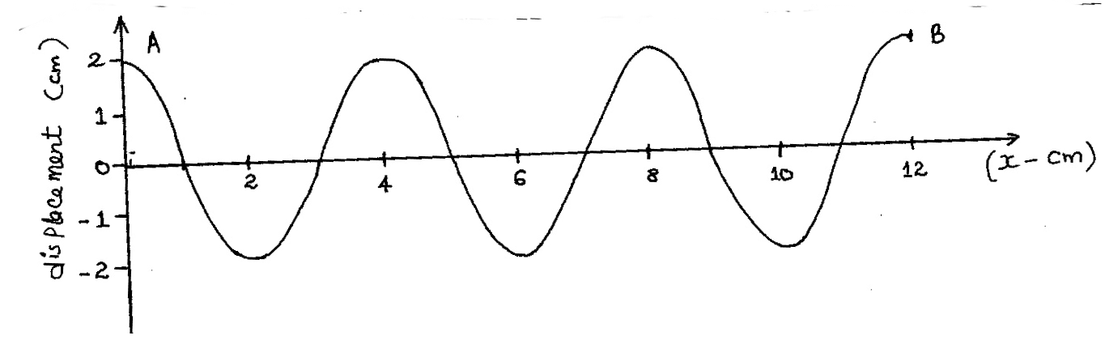

- Determine
(i) the amplitude of the wave. (1mk)

(ii) the wavelength of the wave in metres. (2mks)

(iii) the period of the wave if it takes 1.5 seconds to move from A to B. (3mks)

- Calculate:
(i) the frequency of the wave. (2mks)

(ii) the velocity of the wave. (2mks)

16. (a) What is diffusion? (2mk)

(b) A smoke cell contain a mixture of trapped air and smoke. The cell is brightly lit and viewed
through a microscope. State and explain what is observed. (2mks)

- A beaker is filled completely with water. A spoonful of common salt is added slowly.
The salt dissolves and the water does not overflow.
(i) State why the salt is added slowly. (1mk)

(ii) Why doesn’t the water overflow? (1mk)

- In the figure below, ammonia gas and acid gas diffuse and react to form a white deposit
on the walls of a long glass tube as shown.

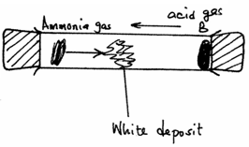

(i) What conclusion can be made from this result of this experiment? (1mk)

(ii) How does the density of a gas affect the rate of diffusion? (1mk)

- The experiment is performed at a lower temperature. State and explain what would
happen to the rate of diffusion of the gases. (2mks)

17. (a) Give four differences between mass and weight. (4mks)

(b) Sate Pascal’s Principal. (1mk)

(c) Name two applications of Pascal’s Principle. (2mks)

(d) Figure 3 shows a U-tube containing two liquids L₁ and L₂ of densities 1.6g/cm³ and 0.8g/cm³ respectively in equilibrium.
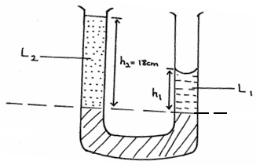

Given that h₂ = 18cm, determine the value of h₁. (3mks)

