FORM ONE HOLIDAY ASSIGNMENT 2021
1.A brass ring is heated,state and explain what happens to it's
a) Volume
b) Density
c) Mass
d) Diameter
2.A bimetallic strip was made by riveting of different linear expanivity.
a) Suggest any two such metals that can be used.
b) Draw and label diagrams to show what happens when this bimetallic strip is;
(i) at room temperature
(ii) heated beyond room temperature
(iii) Cooked below O c
3) Give Five disadvantage of expansion or contraction in solids.
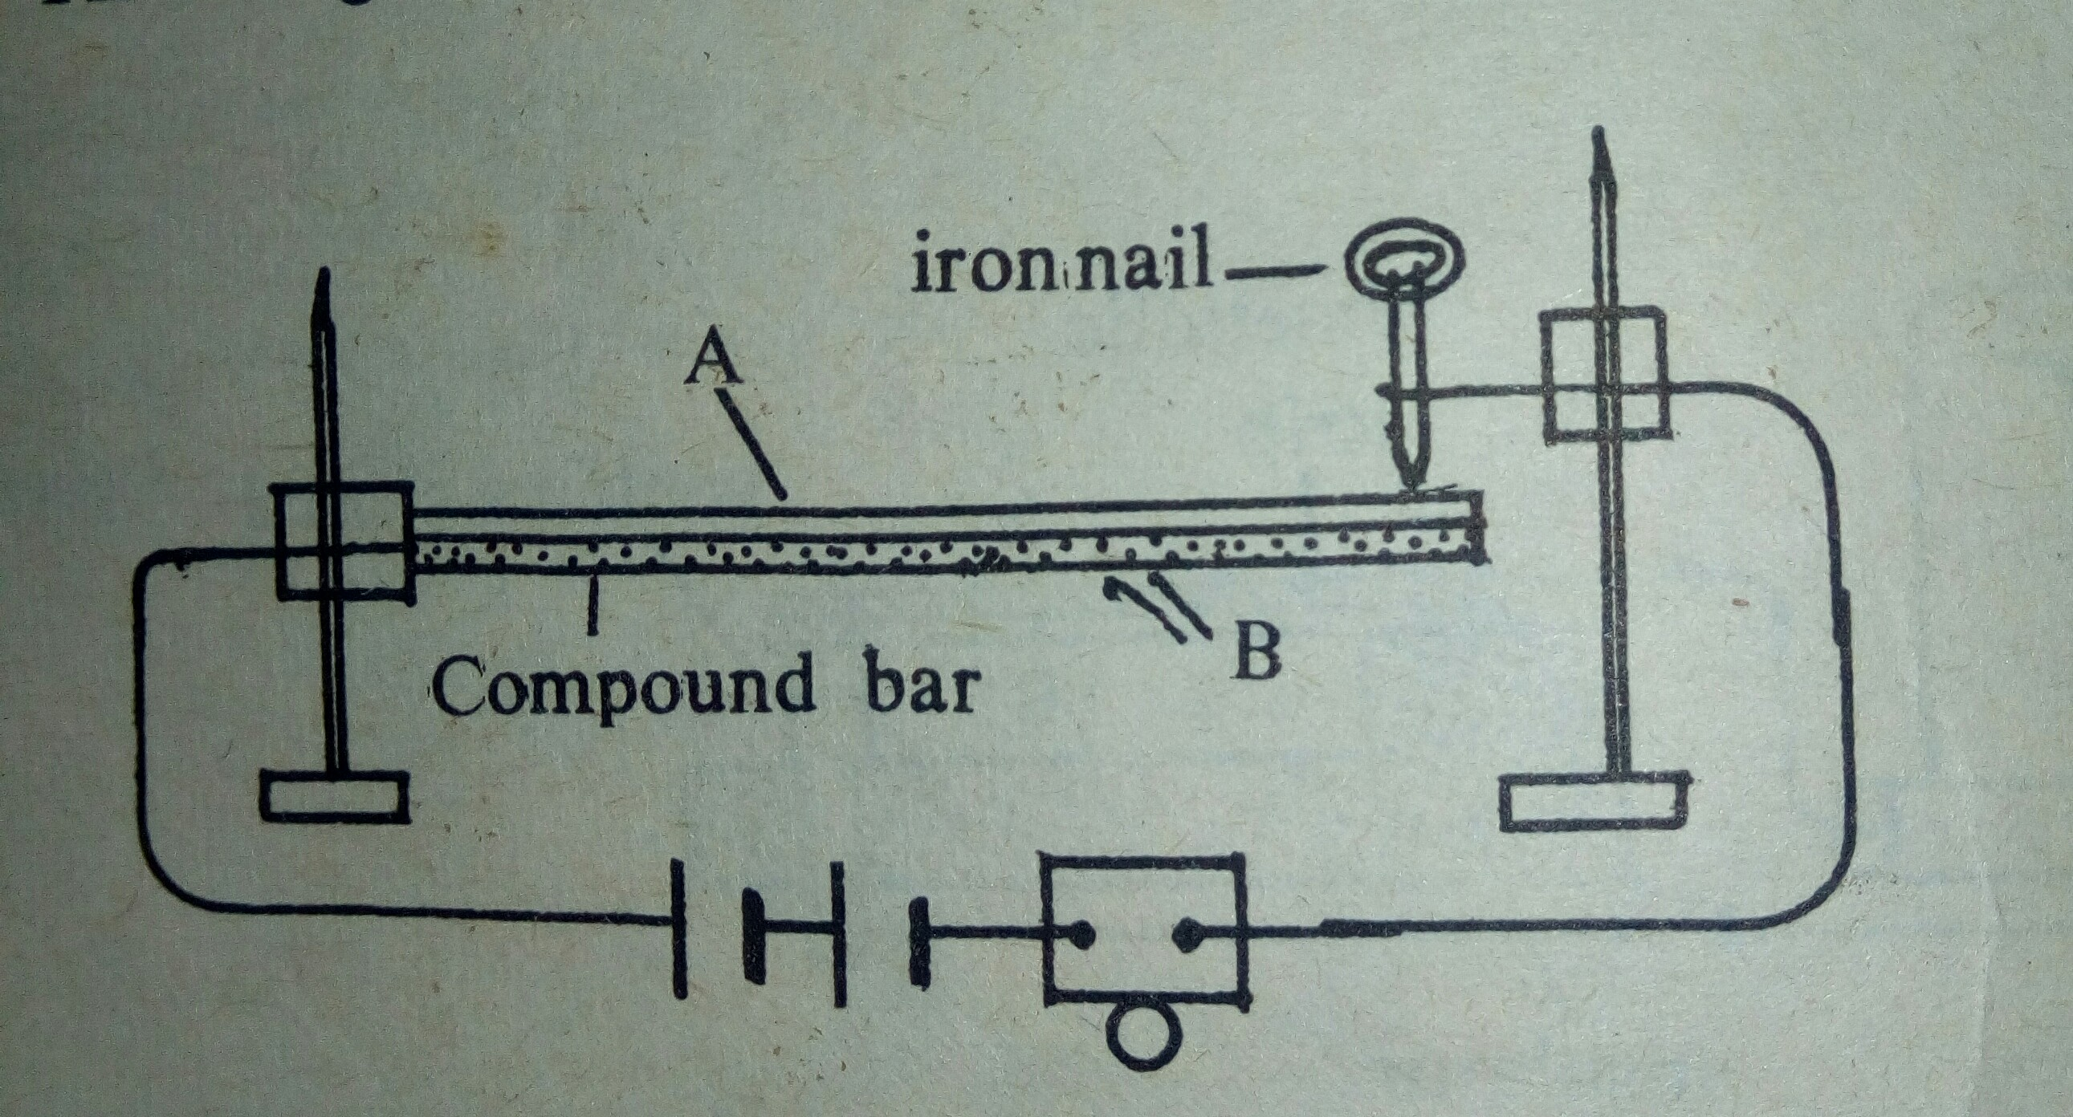
4)This diagram shows a model fire alarm

The compound bar is made of brass and invar
I) Label the parts A and B
(ii) When the bar is heated with a candle flame,the bell rings, Explain this
(iii) It is desired that the bell should ring only when the bar is strongly heated e.g with Bunsen burner.What changes would you make in this arrangement and why?
4) Draw sketches to show the allowance given for thermal expansion and or contradictiob in the following cases
(I)Long lengths of pipes
(ii) Long steel bridges
5)Give 3 examples where expansion of solids causes problems and 2 examples where it is an advantage
6) A substance X when heated or cooled at a certain temperature,Says ToC,expands.Name the substance X and state the value of T
(7). Explain each of the following
(a) The level of Mercury in a thermometer first falls and then rises when placed in warm water.
(b) A coca-cola bottle kept in deep fridge Cracks after sometime
(c) When boiling water poured into a thick glass tumbler and a thin glass tumbler,the tick glass one is more likely to break.
(d) Ovenware is made of Pyrex glass and not ordinary glass
8.Discuss the variation in the density of water when cooled from 10oC to 0oC.Sketch graph showing these changes.
9) Expansion -enemy and ally.justify statement by giving one example in case of expansion of solids, liquids and gears
10) Explain why a cart tyre is likely to burst when the car has been driven non-stop for a long distance at high speed
11) Describe briefly a simple experiment to show that
(a) all solids don't expand to the same extent on heating
(b)state whether the following substances are good or bad conductors of heat
Magnesium
Concrete
Glass
Fibre glass
Zinc
Water
Gold
Paraffin air
Wood chips
Steel wool
Pyrex glass
Plastics
Cooking oil
(c). Kerosene and alcohol don't contract to the same extent on heating
13.Describe an experiment to compare thermal conductivities of brass and steel.Give the diagram of the apparatus you would use
14) pots A,B and C are made of glass, Aluminium and clay respectively,They are of the same size and shape and are filled with the same quantity of water.Thepots are then placed in the sun.in which of the pots will the water be hottest after sometime?in which pot will the water remain coolest? Explain your answer.
15)State four uses of bad conductors of heat and two uses of good conductors of heat.
16)A 10- cent coin is kept on a sheet of paper placed on a tripod .Heat is applied to underneath of the paper by moving a burner flame to and fro,as soon as the paper begins to char heating is stopped.The coin is then removed and the paper examined.Describe what you would expect to observe and give an explanation of it?
17) Explain the following
(I) A wollen rug feels warmer to the bare feet than linoleum laid in the same room
(ii) Hot water tank are covered with a quilted fibreglass jacket
(iii) Newspaper can be used to keep cold things cold quite for sometime
(iv) The use of a folded cloth in lifting a hot plate
(V) On a cold morning a metal padlock of a wooden gate-door feels colder than the gate
Itself
(Vi) To keep ice -cream in hot days,it is sometimes wrapped in flannel and put into a refrigerator.

