232/2
PHYSICS
PAPER 2
(THEORY)
MARKING SCHEME F3

 | SECTION A  A lumious source of light emits light while a non-lumious source reflects light ✓ | 1mk
 | Electrons are repelled from the cap and flow to the leaf and plate.✓ Repulsion between the electrons on the plate and those on the leaf causes the leaf to rise.✓ | 2mks
 | f = $\frac{\text{Number} \text{of} \text{waves}}{\text{Time} \text{taken}}$✓ = $\frac{134}{\text{35} × {\text{10}}^{−3}} = \text{50}H_{3}$✓  Alt.  $f = \frac{1}{T} = \frac{1}{\left(\text{25} − 5\right) × {\text{10}}^{−3}}$ = 50H₃ ✓ | 2mks
 | Width of the aperture/ slit should be approximately or nearly equal to λ of the incident wave; | 2mks
 | Slope = $\frac{0\text{.}9 − 0\text{.}4}{3 − 7}$ ✓ = $−\frac{1}{f}$✓  = $− \frac{0\text{.}5}{5}$= 0.125  f = 8cm ✓ | 3mks
 | P = $\frac{V^{2}}{R}$✓ R = $\frac{V^{2}}{P} = \frac{{\text{240}}^{2}}{\text{2500}}$  = 23.04$Ω$ ✓ | 2mks
 | 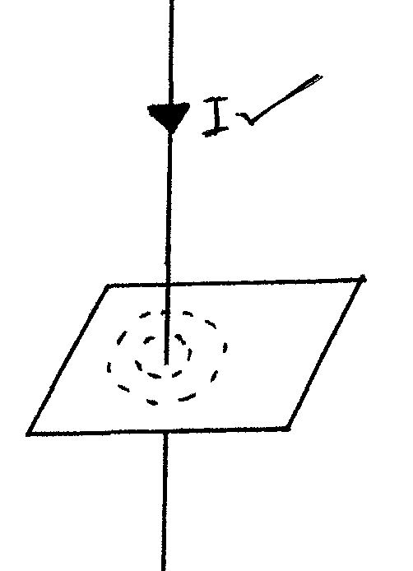 | 1mk
 | Repulsion only occurs between like poles of magnets while attract also occur between a magnet and a magnetic material | 1mk
 | 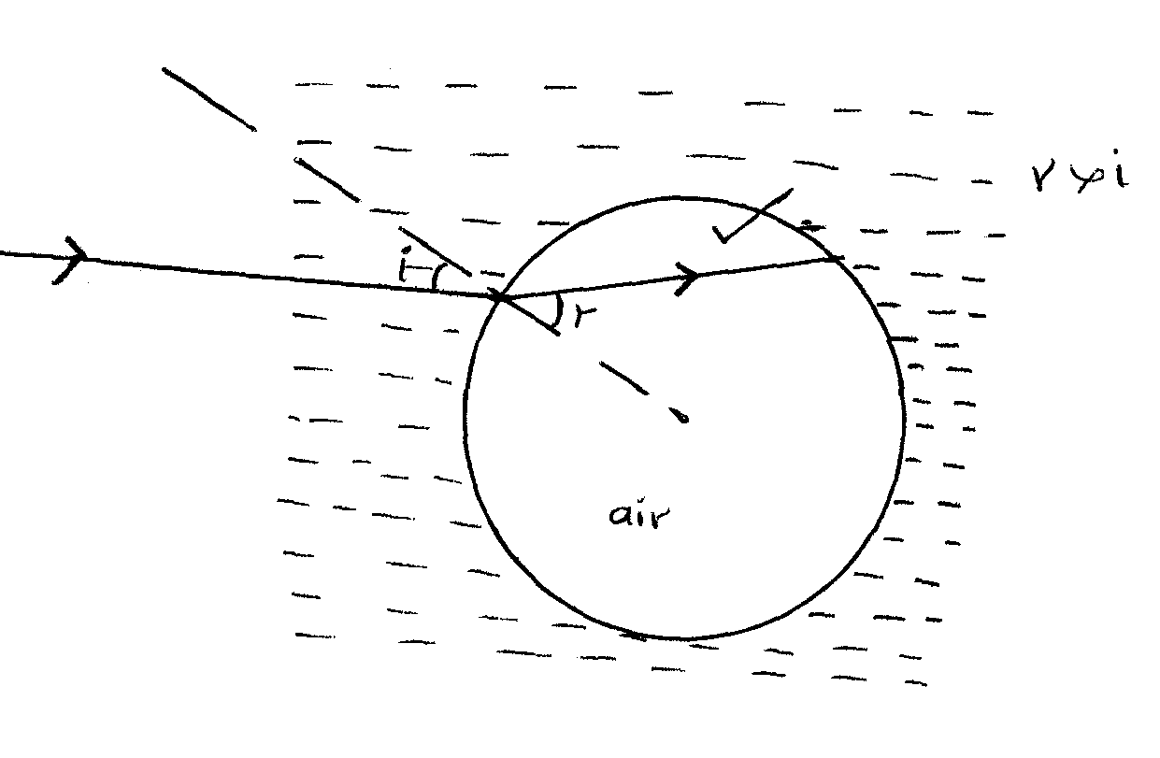 | 1mk
 | Hydrogen gas bubbles form around the positive plate. ✓ The hydrogen gas insulates the positive plate thus increasing internal resistance ✓ | 2mks
 | Electrons are attracted towards the rod leaving the atoms at the other end of the ball with net positive charges  Trees absorb sound | 2mks  1mks
 | In conductor the resistance increases with increase ✓ in temperature while in a semiconductor the resistance reduces with increase in temperature. | 1mk
 | E = Ir + IR ✓  = 2 x 0.5 + 2 x 10  = 11V ✓ | 2mks
 | SECTION B
 | (a) (i) The ratio of the sine of angle of incidence to the sine of angle of refraction is a constant for a pair of media  (ii) – Do not absorb light energy like mirrors  - Not affected by thickness as mirrors  - Do not wear off like the peeling of siyvering on mirror.  (b) (i) k ^{n}w = k^{n}a a^{n}w  = 1 x 1.33 = 0.9236  1.44  (ii) i = 70⁰  Sini = 0.9236  Sinr  Sin r = sin 70⁰ = 1.0174  0.9236  r is greater than 90⁰ hence the light reflection  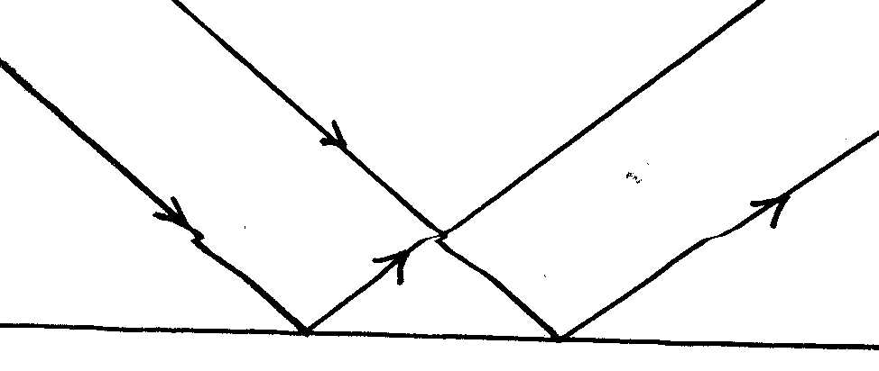s  (iii) The different colours travel at different velocities hence would have different angles of refraction and are dispersed  (iv) The eye would see a spectrum since the light rays are dispersed in the kerosene layer and are internally reflected at the kerosene – water surface the eye would see a spectrum at the surface | 1mk  2mks  3mks  3mks  1mks  2mks
 | (a) Current flowing through a conductor is directly proportional to the potential difference across it provided the temperature and other physical conditions are kept constant  (b) (i) The work done in driving charges through the coil is high due to its resistance. This energy is converted into heat in the coil  (ii) V = IR R = V = 12V  I 2.4  = 5.0$Ω$  (iii) H = VIt  H = 12 x 2.4 x 60  = 1728J  (iv) – Using a source with higher emf  - Reducing the length of the coil  = P = V²  R | 1mk  2mks  3mks  3mks  2mks
 | (a) capacitance c is the charge stored in a capacitor per unit voltage  (i) the deflection of the leaf decreases since the pd reduces with the distance of separation, the greater the deflection, the smaller the capacitance.  (ii) the deflection of the decreases since the pd increases with the area of overlaps or the greater the deflection the smaller the capacitance.  (iii) the deflection of the leaf decreases, the capacitance increases ,since the smaller the deflection the greater the capacitance.  C_{T}=C₁+$\frac{CC}{C+C}$✓1  =3$μF+\frac{4×4}{4+4}$✓1  =3$μ$F+2$μ$F✓1  =5$μ$f✓1  Charge on the 3$μ$F capacitor is the same as the overall charge Q =CV✓1  =5.0×10✓1  =50C✓1 | 1mk  2mks  2mks  2mks  3mks  3mks
 | $$(a) (i) T = \frac{T}{\text{20}} = \frac{\text{36}}{\text{20}} = 1\text{.}8s$$  $$(\text{ii}) f = \frac{1}{T} = \frac{1}{1\text{.}8} = 0\text{.}\text{5556}\text{Hz}$$  $$\begin{aligned}(c) \text{80}\text{cm} ⇒ S4λ \\ V = fλ \\ = \frac{1}{1\text{.}8} × 0\text{.}2 = 0\text{.}\text{111}m/s\end{aligned}$$ | 2mks  3mks  3mks
 | a)- A small force (effort) is used to overcome a large force (Load)  - Less energy is expended in doing work  - Less time is used in accomplishing the task  b) (i) - In one revolution, both wheel and axle complete one circumference  - V.R = Effort Distance/Load distance = 2R/2r  - V.R = R/r  (ii) V.R = 50/5 = 10  M.A = efficiency x V.R/100 = 90x10/100 = 9  Effort = Load/M.A = 200/9 = 22.22N  c) Gas Pressure = At.Pressure – Pressure due to H_{g} Volumn  P_{g} = 1.0x10⁵ – 0.4 x 13600x10  = 94560N/m²  d) By lowering the temperature of the liquid | 2mks  3mks  3mks  3mks  1mk

