NAME ____________________________________ ADM NO. _______________
DATE _______________
232/2
PHYSICS
PAPER 2
(THEORY)
FORM FOUR
END TERM 1 2021 EXAMS
TIME: 2 HRS

INSTRUCTIONS
- This paper consists of two sections, Section A and B. Answer ALL the questions in both sections in the spaces provided in this paper.
- ALL working must be clearly shown.
- KNEC mathematical tables and non-programmable silent electronic calculators may be used.
Note: Take acceleration due to gravity g = 10m/s²

FOR EXAMINER’S USE:
SECTION | QUESTION | MAXIMUM SCORE | STUDENTS SCORE
A | 1-12 | 25
B | 13 | 12
B | 14 | 11
B | 15 | 13
B | 16 | 08
B | 17 | 11
B | TOTAL | 80

SECTION A (25 MARKS)
Answer ALL the questions in this section in the spaces provided.
- State any one condition under which a pinhole camera may form an image on its screen which
has the same size as the object. (1 mark)
______________________________________________________________________________________________________________________________________________________________________
- The source of sound and two listeners are positioned close to a tall building as shown in the
figure below.
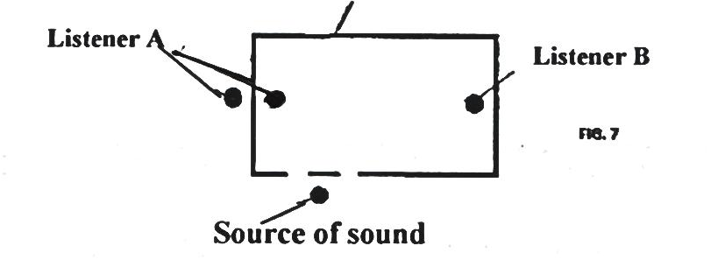
Source of Sound
Listener B
Listener A
- State the property of sound by which Listener A is able to hear the sound produced. (1 mark)
___________________________________________________________________________________
- Listener B is moving directly towards Listener A and has a problem hearing the sound produced. Explain. (2 marks)
_________________________________________________________________________________________________________________________________________________________________________________________________________________________________________________________
- Give two differences between a transformer and induction coil. (2 marks)
_________________________________________________________________________________________________________________________________________________________________________________________________________________________________________________________
- The figure below shows some region of part of the electromagnetic spectrum.
Red Violet
A | B | C |  | D | E | F

- Name the region that is detected by a blackened bulb thermometer. (1 mark)
___________________________________________________________________________________
- State one use of the E-M wave in the region labelledB. (1 mark)
______________________________________________________________________________________________________________________________________________________________________
- The figure below shows ultraviolet light striking a clean Zinc plate on a positively charged leaf electroscope.
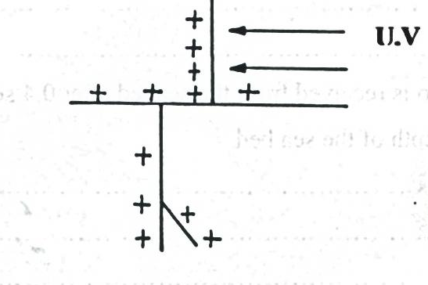
U.V
Explain the following observations:
- The leaf does not fall. (1 mark)
_________________________________________________________________________________________________________________________________________________________________________________________________________________________________________________________

- When the same experiment is carried with a negatively charged electroscope, the leaf falls. (1 mark)
_________________________________________________________________________________________________________________________________________________________________________________________________________________________________________________________
- A girl observes her face in a concave mirror of a focal length 90cm. If the mirror is 70cm away,
state two characteristics of the image observed. (2 marks)
_________________________________________________________________________________________________________________________________________________________________________________________________________________________________________________________
- The ammeter in the circuit in figure 3 has negligible internal resistance. The cell has an internal resistance of 0.5Ω and an electromotive force of 3.0V.
3.0V, 0.5Ω
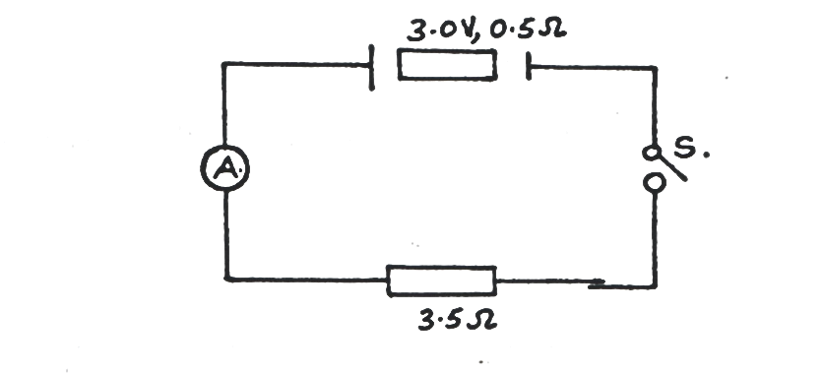Figure 3
S

3.5Ω
Determine the value of current the ammeter registers when switch S is closed. (2 marks)

- An electric heater is rated 3 kW. Find the electrical energy in kWh(kilo watt- hours) consumed
by the heater when used on a 240V supply for 180 minutes. (2 marks)

- An echo sounder produces a pulse and an echo is received from the seabed after 0.4 seconds.
If the speed of sound in water is 1500m/s. Calculate the depth of the sea bed. (2 marks)

- The set up in figure 4 below can be used in a laboratory for lifting and releasing a steel ball.
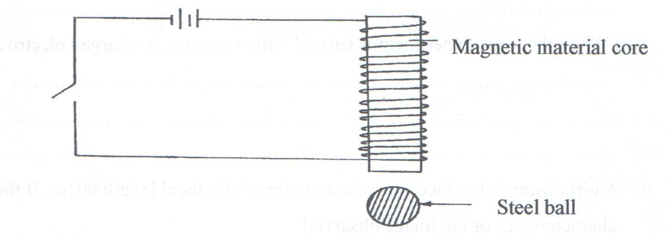
i) State the material which is suitable for use in the core. (1mark)
___________________________________________________________________________________

- If a slightly larger ball is to be lifted, it is necessary to make an electromagnet stronger.
Name two ways of increasing the strength of the magnet. (2 marks)
_________________________________________________________________________________________________________________________________________________________________________________________________________________________________________________________
- The figure 5 below shows the path of a ray of light passing through a rectangular block of Perspex placed in air.
Air
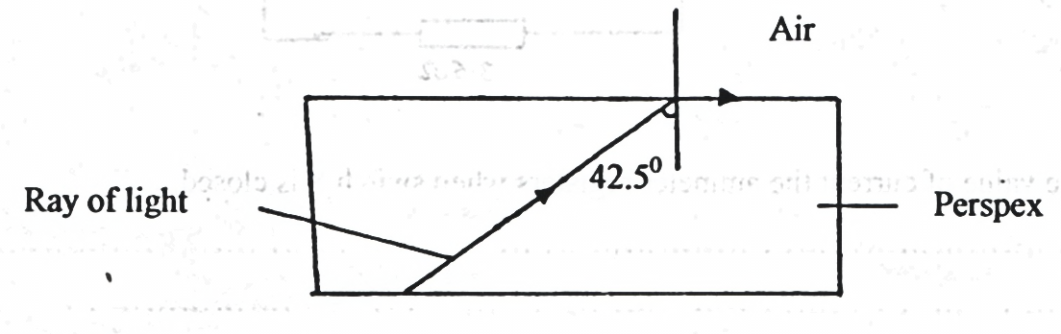
Ray of light
Perspex
Calculate the refractive index of Perspex. (2 marks)

- The sketch shown below is a displacement-time graph of a wave traveling at 320ms⁻¹
Find the wavelength of the wave. (2 marks)

SECTION B (55 MARKS)
Answer ALL the questions
- a) The mains electricity is transmitted through high tension voltage (H.T).
State one danger of this transmission. (1 mark)
______________________________________________________________________________________________________________________________________________________________________
b) The figure shows a section of a domestic wiring.
Bulbs

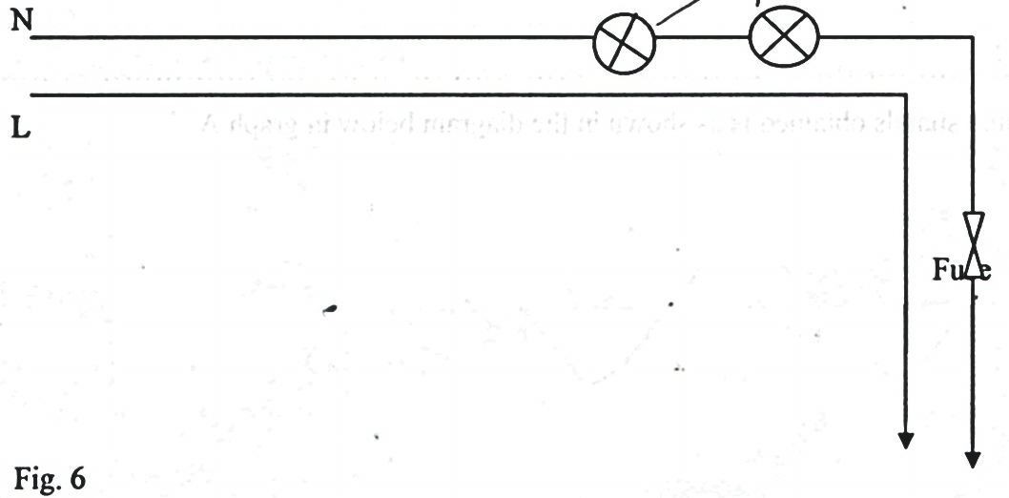
Fuse

L
N

i) Identify two serious mistakes in the circuit. (2 marks)
_________________________________________________________________________________________________________________________________________________________________________________________________________________________________________________________
ii) Explain why the circuits in domestic wiring should be connected in parallel with the main supply. (2 marks)
_________________________________________________________________________________________________________________________________________________________________________________________________________________________________________________________
c) Study the figure shown below
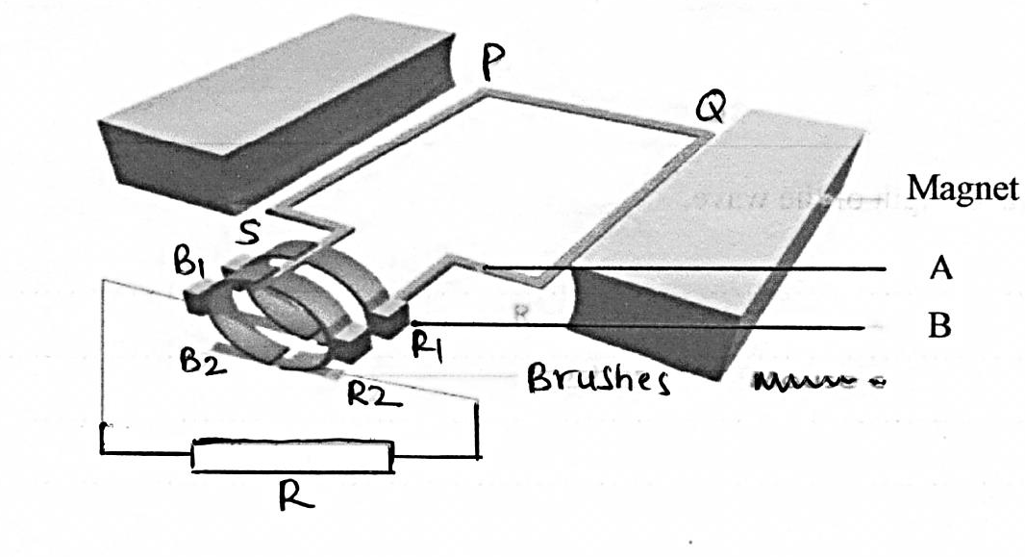
R₁
R₂
B₂

B₁
S
Q
P
Brushes
R

B
A
Magnet
i) State the name of the machine shown in figure above. (1 mark)
___________________________________________________________________________________
ii) What are the names of the parts labelled A and B? (2 marks)
A ___________________________________________________________________________
B ___________________________________________________________________________
- What would be the effect of doubling the number of turns of the coil if the speed of rotation remained unchanged? (1 mark)
______________________________________________________________________________________________________________________________________________________________________
d) The voltage-time signals obtained is as shown in the diagram below in graph A

i) Find the frequency of the alternating E.m.f shown by graph A. (2 marks)

ii) What alterations have been made to the machine in c) above to produce the emf represented
by graph B? (1 mark)

- The figure below shows the features of an X- ray tube
Target
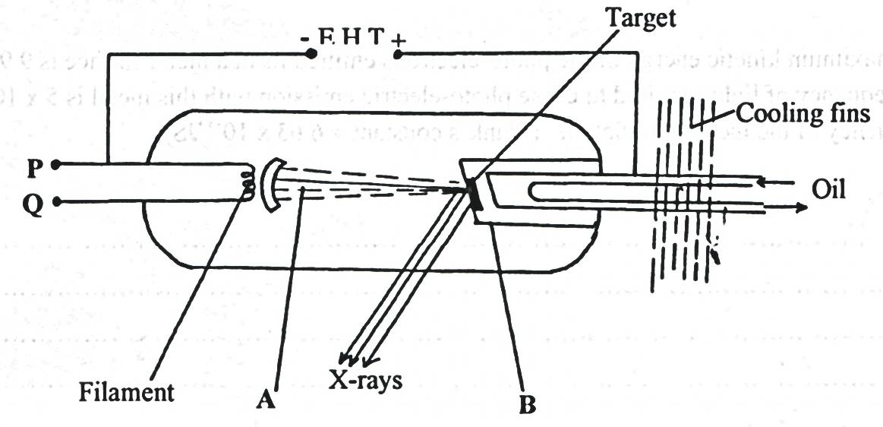
− +

E.H.T

X-rays
Q
P
Cooling fins
Oil
Filament
A
B
a) Name the parts labelled A and B. (1 mark)
A ___________________________________________________________________________
B ___________________________________________________________________________
b) Explain how a change in the potential across PQ changes the intensity of the X-rays produced
in the tube. (2 marks)
___________________________________________________________________________________
___________________________________________________________________________________
___________________________________________________________________________________
___________________________________________________________________________________
c) What property of lead makes it suitable for use as shielding material? (1 mark)
___________________________________________________________________________________
___________________________________________________________________________________
- In an X-ray tube operating at 100kV,the tube current is 20mA. Determine the number of
electrons hitting the target every second. (2 marks)
(Charge of an electron = 1.6 $×$ 10⁻¹⁹C)

- The figure below shows a cell. Use it to answer questions that follow:
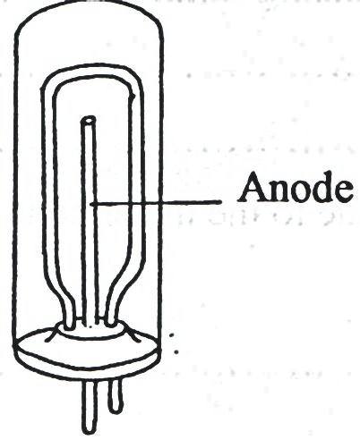
Anode
- Name the type of cell. (1 mark)
___________________________________________________________________________________
ii) Label the cathode. (1 mark)
iii) The maximum kinetic energy of the photo-electrons emitted from a metal surface is
9.95 x 10⁻²⁰J. If the threshold frequency of light required to cause photo-electric emission
with this metal is 5 x 10¹⁴ Hz. Calculate the frequency of the incident radiation.
(Plank’s constant = 6.63 x 10⁻³⁴ JS) (3 marks)

- a) i) Explain why carbon -14 (${}_{6}^{14}{ C}$) is radioactive while carbon $\left({}_{6}^{12}{ C}\right)$ is not. (1 mark)
_________________________________________________________________________________________________________________________________________________________________________________________________________________________________________________________
ii) A radioactive isotope showed a count rate of 82 counts per second initially. After a time of 210 seconds, the count rate dropped by 19 counts per second. The average background count remained constant at 10 counts per second. What is the half-life of the material? (2 marks)

b) The figure below shows features of a diffusion cloud chamber used for detecting radiations from a radioactive source.
Perpex lid
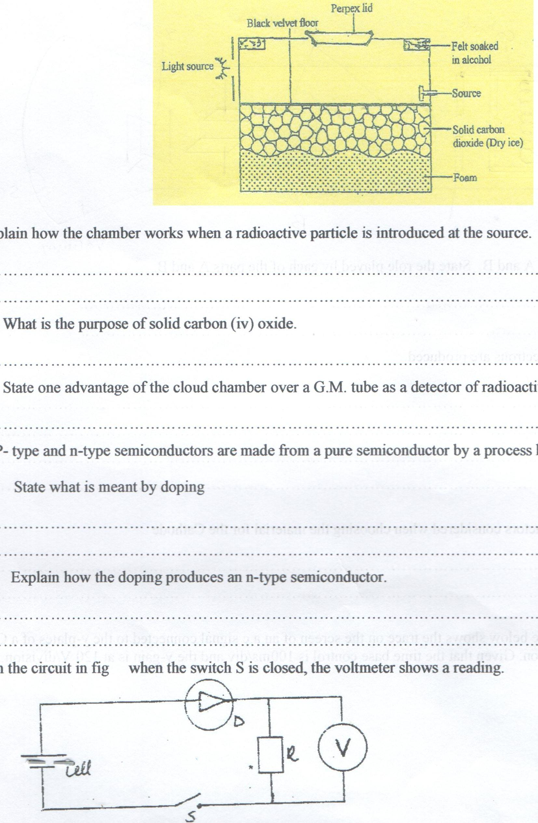
Black velvet floor
Light source

Felt soaked in alcohol
Solid carbon dioxide (dry ice)
Source
Foam
Explain how the chamber works when a radioactive particle is introduced at the source. (2 marks)
____________________________________________________________________________________________________________________________________________________________________________________________________________________________________________________________________________________________________________________________________
c) i) What is the purpose of solid carbon (IV) oxide. (1 mark)
__________________________________________________________________________________________________________________________________________________________________
ii) State one advantage of the cloud chamber over a G.M tube as a detector of radioactive radiations. (1 mark)
__________________________________________________________________________________________________________________________________________________________________
d) P-type and n-type semiconductors are made from a pure semiconductor by a process known as “doping”.
i) State what is meant by doping. (1 mark)
__________________________________________________________________________________________________________________________________________________________________
ii) Explain how the doping produces an n-type semi-conductor. (2 marks)
___________________________________________________________________________________________________________________________________________________________________________________________________________________________________________________
e) In the circuit in the figure below, when the switch S is closed, the voltmeter shows a reading.
S
R

D

V

Cell

When the cell terminals are reversed and the switch is closed, the voltmeter reading is zero. Explain these observations. (2 marks)
___________________________________________________________________________________________________________________________________________________________________________________________________________________________________________________

- a) The figure below shows the features of a cathode ray oscilloscope;-
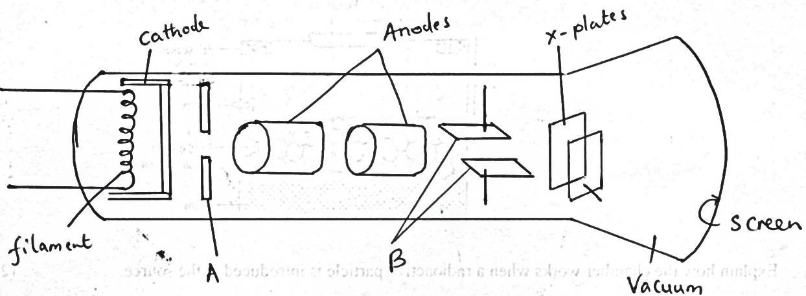
Filament
X-plates
Screen
Vacuum
Vacuum
B
A
Cathode
Anodes
- Name the parts A and B. State the role played by each of the parts A and B. (2 marks)
A ___________________________________________________________________________
___________________________________________________________________________
B ___________________________________________________________________________
___________________________________________________________________________
ii) Explain how electrons are produced. (2 marks)
_________________________________________________________________________________________________________________________________________________________________________________________________________________________________________________________
iii) State the factors considered when choosing the material for the cathode. (1 mark)
_________________________________________________________________________________________________________________________________________________________________________________________________________________________________________________________
b) The figure below shows the trace on the screen of an a.c signal connected to the y-plates
of a C.R.O with time base on. Given that the time base control is 100ms/div and the y-gain
is at 120V/division.
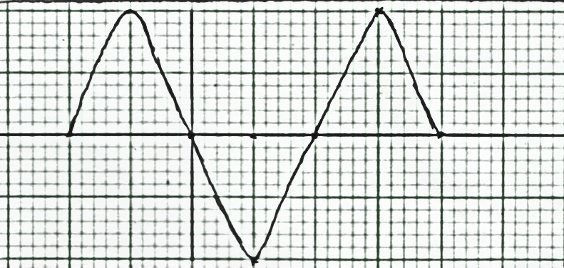
Determine:
i) The frequency of the a.c signal. (2 marks)

ii) The peak voltage of the input signal. (2 marks)

- a) The figure below shows straight wavefronts incident on convex reflector.
Complete the diagram to show the reflected wavefronts. (1 mark)
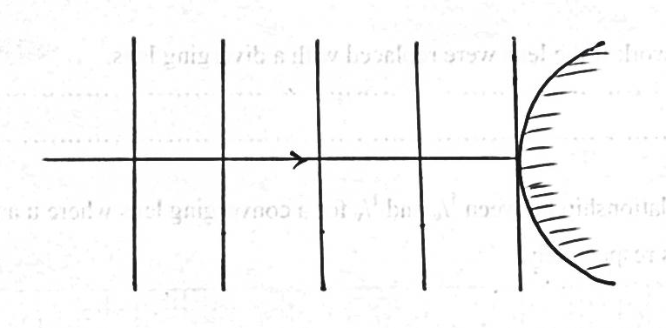
b) Narrow slits cannot be used to demonstrate interference of sound waves. Explain. (1 mark)
______________________________________________________________________________________________________________________________________________________________________
c) The figure below shows sound waves emitted by a drum struck.
Wave fronts
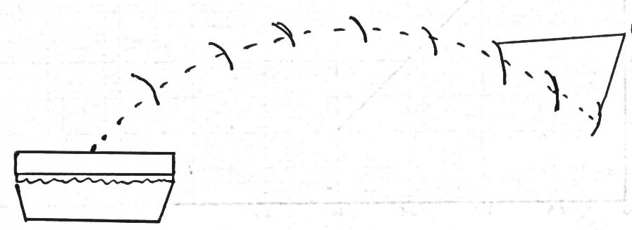
Explain why the wave fronts are directed to the ground. (2 marks)
_________________________________________________________________________________________________________________________________________________________________________________________________________________________________________________________

d) Figure below shows an experimental set up consisting of a mounted lens, I, A screens,
a metre rule and a candle
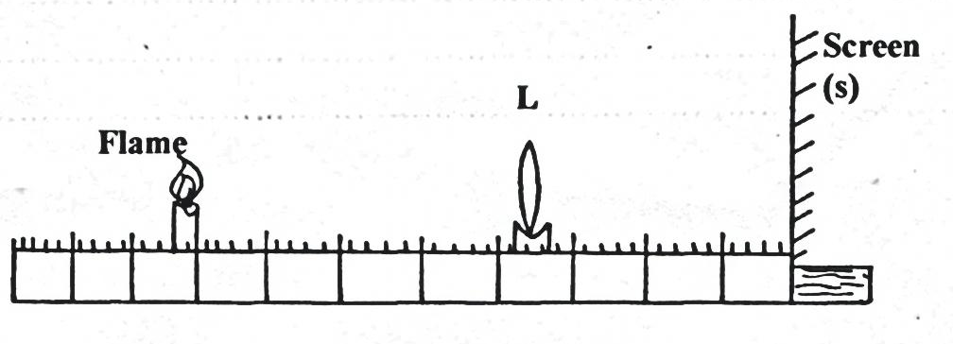
Flame
Screen (S)
L
i) Describe how the set up may be used to determine the focal length f, of the lens. (3 marks)
____________________________________________________________________________________________________________________________________________________________________________________________________________________________________________________________________________________________________________________________________________
ii) State why the set up would not work if the lens were replaced with a diverging lens. (1 mark)
______________________________________________________________________________________________________________________________________________________________________
e) The graph figure below shows the relationship between $\frac{1}{u}$ and $\frac{1}{v}$ for a converging lens where u and v are the object and image distances respectively.
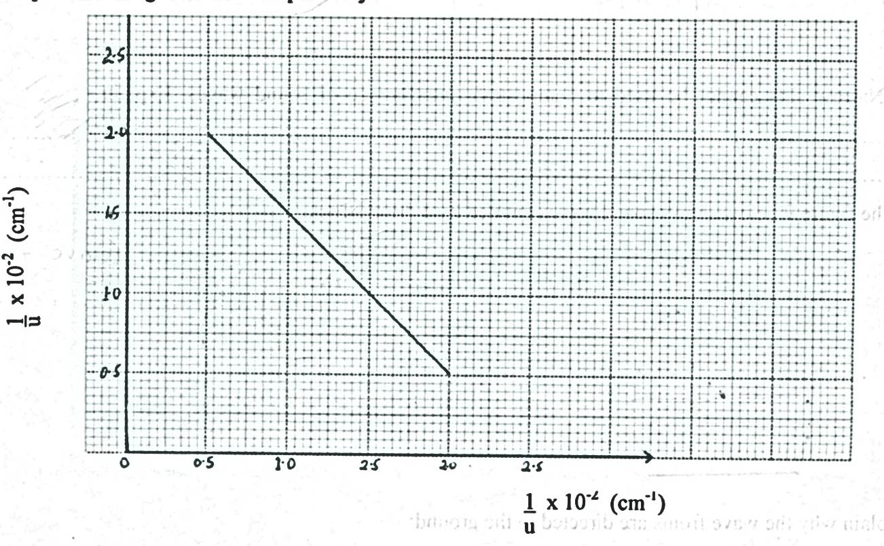
$$\frac{1}{u}×{10}^{-2}({cm}^{-1})$$
From the graph, determine the focal length, f of the lens. (3 marks)

