LANJET CLUSTER EXAMINATION
232/2
PHYSICS PAPER 2
DECEMBER 2020
MARKING SCHEME

SECTION A
- Parabolic reflectors do not form a caustic curve;
  - The filaments can be arranged so as to have parallel beams to help see far and a set of others to enable see near / directed downwards ;
Any one (1 mrk)
- This causes buckling of the plates as this is short circuiting;
3. A will have positive charge while B negative; when charged rod is brought near A positive charges are attracted towards it while the negative charges are repelled to B
On separation while strip is near A, B goes with negative charge and A remains with the positive;

4. E = IR + Ir Formula of substitution give 1 mark
3.0 = I x 3.5 + I x 0.5;
∴ I = 0.75A ;

- Vs = Ns
Vp Np

Vs = 1 ;
- 10

∴ Vs = 25V;
Now V_{Lm} = 4/5 x 25 ;
= 20 V;

Force ;
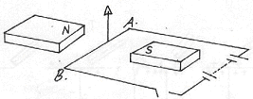

NB force (arrow) must touch the wire / conductor

7. W – V² t;
R

= 240² x 4 x 60 ;
480
= 28,800J;

8. 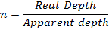
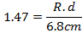

9.

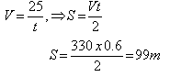

10. Introduction of controlled amounts of impurities into the lattice of a pure semi-conductor in order to
Enhance its electrical conductivity;

11. Radio waves; Infrared; x –rays and Gamma rays

Decreasing wavelength

12. Magnetism is easily induced in them; the dipoles of the
Keepers form a closed loop with those in the magnets
Hence protecting the magnets from being demagnetized;

13.
Time base doubled
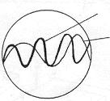
Original wave form

SECTION B

14.(a) (1 mark)
Where no current is flowing through/ where there is voltage drop a cross the source is equal to e.m.f
b)

2.0

Potential
Difference (Pd)
V
1.0

0.5 1.0 Current I A

(i) E= V + Ir
(ii) Gradient (R) 1.475 – 1.05 = 0.425 = 0.53125 Ώ
0.8- 0 0.8 (2 marks)
(b) From the graph current flowing when pd is 0.70 is 60.MA
Pd across R = 6.0 – 0.7 = 5.3v
R = 5.3 V 36mA
= 147Ω (3 marks)
(c) Parallel circuit 1/30 + 1/20 = 5/60 or 60/50
R = 12 Ω
Total resistance = 10 + 12 = 22Ω (2 marks)
(ii) l = ^{V}/_{R} = ^{2.1}/₂₂ = 0.095A (1 mark)
(iii) Reading of the voltmeter
V = lR = 10 x 2.1
22 = 0.95 (2 marks)

15.(a)
Lamp lights
When s is closed soft iron get magnetized it repels magnet that pushes contact and closes it.
Current flows lighting the bulb.

(b) (i)
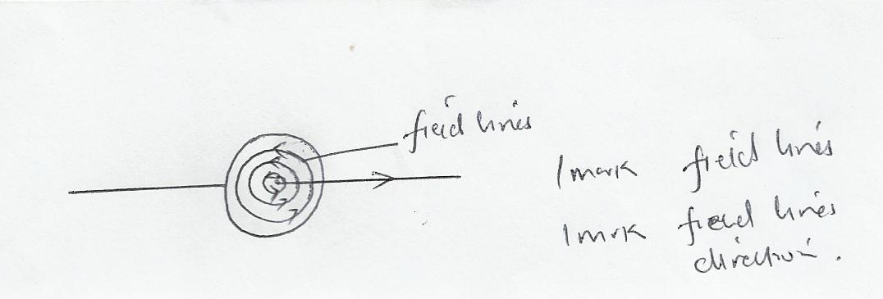

(ii)
Right hand grip rule
Maxwell – cork screw rule

;

iii)

- Electric bells
- Magnectic locks
- Loudspeakers
- Relays
- Motors and generators

16. a) i) A – Grid1
B – Electron gun1
ii) C – Vertical deflection of beam of electrons1
D – Horizontal deflection of beam of electrons1
iii) By thermionic emission or heating the filament1
iv) To prevent ionization of electrons as they move to the anode1
b) i) E = ev1
E = 1.6 x 10-19 x 800001
= 1.28 x 10⁻¹⁴ J1
ii) ½ mv² = 1.28 x 10⁻¹⁴1
v² = $\frac{2 ×1.28 × {10}^{-14}}{9.11 ×10-31}$
v = $\frac{\sqrt{2 ×1.28 ×10-14}}{9.11 ×10-31}$1
v = 2.23 x 10⁸ ms1

17. (a) GRAPH

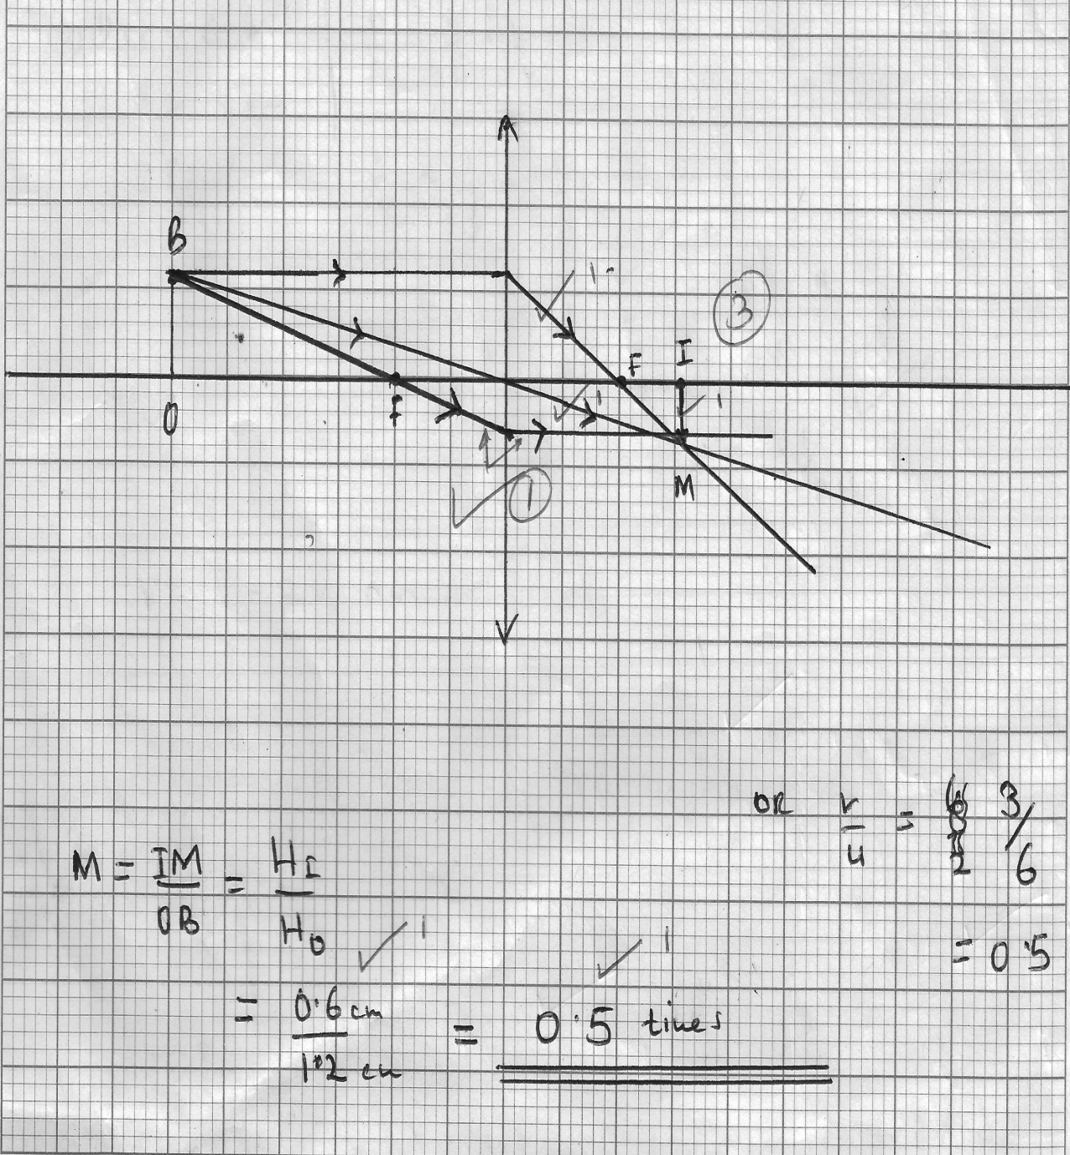
(b) (i)
$$u=6cm$$
$$f=8cm$$
$$v= ?$$

$$\frac{1}{f}= \frac{1}{u}- \frac{1}{v}$$

$$\frac{1}{v}= \frac{1}{f}- \frac{1}{u}$$

$$=\frac{1}{8}- \frac{1}{6}= \frac{3-4}{24}$$

$$\frac{-1}{24}$$

$$v= -24cm$$

(ii)
Hand lens / magnifying glass

(iii)
- Image formed is
- Virtual
- Erect/upright
- Magnified

18. (a)

The direction of the induced current is always as to oppose the change producing it.

(b)
X carbon brush
Y split ring

(c)
Speed of rotation
Number of turn of the coil
Strength of the magnet

(d)
IS = 13.5
V_{S} = 480
V_{p} = 240
Ƹ = 80%
P=IV
= 13.5 x 48 = 64.8 watts

$$80=648$$

$$100=x$$

$$⇒\frac{648 ×100}{80}=810 watts$$

$$IV=810$$

$$I ×240=810$$

$$I=\frac{810}{240}=3.375A$$

