231/2
Physics paper 2
FORM 4
MID TERM II 2020
TIME: 2HRS

Marking Scheme

Section A.
1.
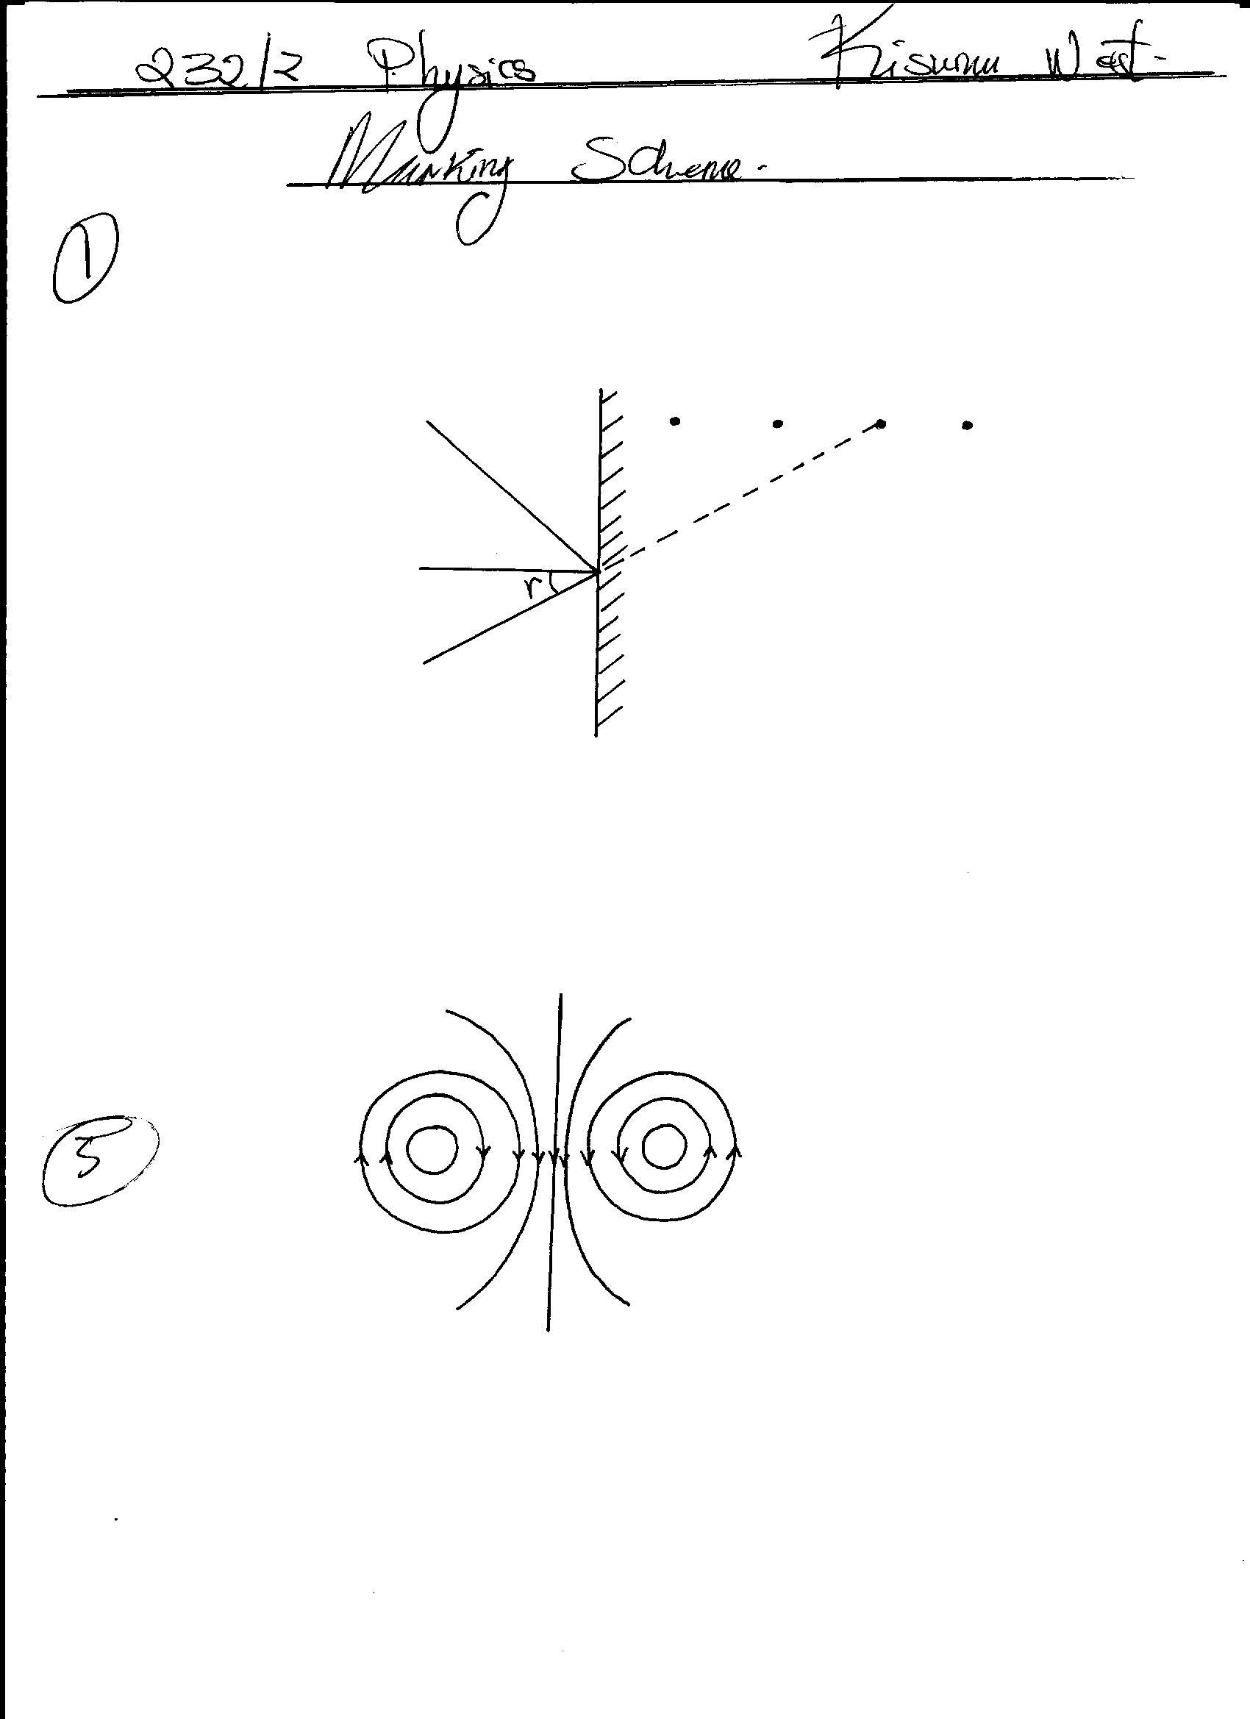

2mrks
- Object

Q√
O
√

Speed of sound =$\frac{2 ×distance}{time}$

depth = 1450x 0.20/2 =145 m
B.√
Loses its magnetism faster thereby becoming weaker hence attracting fewer iron filings√ (2mrks

 | Leaf initially falls due to negative charges neutralizing the positive charges. Excess negative charges on the cap are repelled towards the leaf and the stem of the electroscope, causing the leaf to rise.
(a)  (b) | Current 1 $\frac{power}{p.d}=\frac{100000}{500 V}=20$  Power loss = 1² R = 20² X 5 = 2000w  Power available for factory = 100,000 – 2,000 = 98,000W or 98KW  Resistance of cables/supply of high currents.
Resistors in parallel

RT =$\frac{5 X 5}{5 X 5}=\frac{25}{10}=2.5 4∩ =10A=∩$

$$Resistors in series$$

$$RT=3.5+2.5+4∩ =10∩$$

(b) | By the human skin to synthesize/manufacture vitamin D  - In bacteriology to kill harmful organisms  - In manufacture of washing powder and paints that fluoresce  - To detect forged documents such as cheques and fake currency notes in banks  - In burglar alarms  - In automatic door openers (any 1 mark)  Photographic plates/ films  Photocells  Light dependant resistors (LDR)
Photographic plates/ films
Photocells
Light dependant resistors (LDR)

(i)  (ii) | X – south poole Y – noth pole : using Flemings  left-hand rule  - Increasing current  - Strengthening magnetic field  - Turns of the coil (any 1 mark)
Q = it
But 1 = 3A and Q = 30Ah
30 = 3 X t
t= 10hours
 | Section B
12  13  (b) | a= 236-4 = 232  b = 72 – 2 = 70  (a) (i) √ Both rays  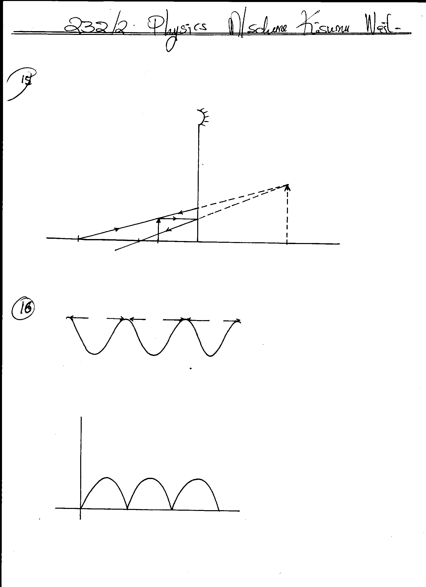  √ Virtual image  Image  F  O  C  (ii) Magnification = image height = 2.8√ = 2.545√  Object height 1.1  NB: Image and object heights must be measured accurately.  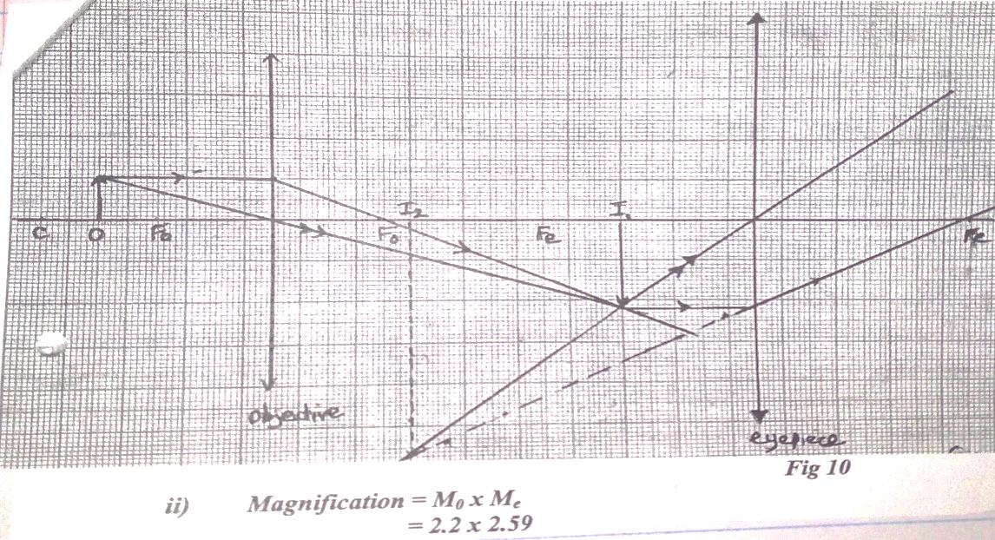  Marking of graph  Construction rays to for image I (2 marks)  Construction to form image 2 (2 marks)
14 a  (b) i  (ii)  (iii)  (c) | 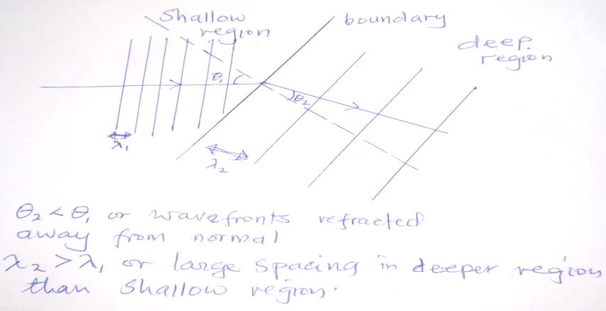  Q_{2 <} Q₁ or wavefronts refracted or larger spacing in deep  Away from normal shallow region  $$4\frac{3}{4} ƛ =237.5 CM$$  1 ƛ = $\frac{237.5cm}{4\frac{3}{4}} 50.0 cm$  Speed = $\frac{distance}{time}= \frac{224.0 cm}{2.8}=V=80.0cm/s$  V = f ƛ  80 = f x 50; f = 1.6Hz  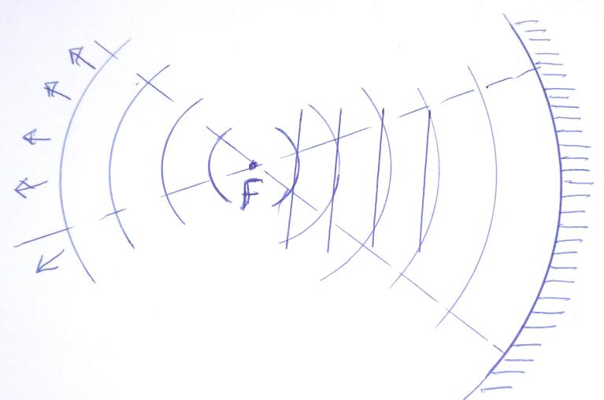  - Wave length spacing maintained  - Reflected wave fronts takes the shape of the reflector and more towards focal point F
- a  (b)  (c)  (d)  (e)  (f)  (g)  (ii) | Q: target/anode  R; concave focusing cathode  Q – target/anode; tungsten or molybdenum  It has a very high melting point  (hence not likely to melt due to very high temperatures of the target)  R- Concave focusing cathode. To concentrate (focus) the electron beam onto the target/anode  Current flows through the filament in the cathode and electrons are produced through thermionic emission.  When the electrons at very high speed are suddenly stopped by the target their kinetic energy is transformed into X-rays and heat.  To remove air molecules so that the electrons do not lose some of their kinetic energy through collision  High density/ its ability to absorb most of the X-rays  Harder/more penetrating/higher quality X-rays are produced  Intensity/quality of X-rays produced increases
16(a  c(i)  (d) i)  (ii)  (iii) | The setting free of electrons from a surface of a metal when illuminated/irradiated with radiation of suitable frequency.  Increase in intensity increases the number of emitted photoelectrons (photoelectrons increases)  increase in frequency of incident radiation increases the kinetic energy of photoelectrons emitted  threshold frequency fo = 4.6 X 10¹⁴ H_{z} (graph line extended to cut the frequency axis)  NB: must be from the graph  $$\frac{h}{e}=\frac{ΔVs}{Δf}$$  $$\frac{ΔVs}{Δf}=\frac{1.3-0.65}{\left(7.8-6.2\right) ×{10}^{14}}$$  $$\frac{0.65}{1.6 ×{10}^{14}}$$  $$=4.0625 ×{10}^{-15}$$  $$h=e ×gradient$$  $$=1.6 ×{10}^{-19} ×4.0625 {10}^{15}$$  $$=6.5 ×{10}^{-34} J_{5}$$  $$work functon W_{0}= {hf}_{o}$$  $$W_{o}=6.5 ×{10}^{-34} ×4.6 ×{10}^{14}$$  $$=2.99 ×{10}^{-19}JA=πr^{2}$$
17(a)  b)(i)  (ii)  20 | 19. (a)  √  (b) During the first half –cycle D₁ is forward biased while D₂ is reverse biased. Hence , current  takes the path A , D₁ RT .√  During the next half –cycle, D₂ is forward biased while D₁ is reverse biased and the path of  the current is BD₂RT.√  (c) - Protects a circuit from damage √  - As a switch √ Any 2  - In charging a battery using solar panels.  20i) The galvanometer deflects on one side and then back to zero  ii) A greater deflection will be obtained in the opposite direction as current takes less time to die off than to build up.  Bi) The changing current in the primary coil induces a current in the secondary coil due to charging magnetic field of the primary current.  ii) VS = NS = VS = 240 x 200 = 48V  VP NP 1000  iii) E = Power output x 100  Power input  = 48 x 0.7 x 100  240 x 0.2  = 70%

