NAME……………………………………………….……..…DATE…………………….…………

INDEX NO. ………………………….………………………..SIGNATURE………………………

232/2
PHYSICS
PAPER 2
THEORY
DECEMBER, 2020
TIME: 2HOURS

LANJET JOINT EVALUATION EXAM
KENYA CERTIFICATE OF SECONDARY EDUCATION 2020

232/ 2
PHYSICS
PAPER 2
DECEMBER 2020
TIME: 2HOURS

INSTRUCTIONS TO CANDIDATES:

This paper consists of TWO sections. Sections A and B
Answer ALL the questions in section A and B
All working MUST be clearly shown.
Mathematical tables and Electronic calculators may be used.

Take acceleration due to gravity, g = 10ms⁻²

FOR EXAMINER’S USE ONLY
SECTION | QUESTIONS | MAX SCORE | CANDIDATES SCORE
A | 1-13 | 25
B | 14 | 12
B | 15 | 10
B | 16 | 12
B | 17 | 12
B | 18 | 09
TOTAL SCORE |  | 80

This paper consists of 10 printed pages.
Candidates should check the question paper to ensure that all pages are printed as indicated
and no questions are missing

SECTION A ( 25 MARKS)
Answer all questions in this section
1. State one reason why in the construction of car head lamps parabolic reflectors are preferred to spherical reflectors. (1mk)

2. It is common practice that once an accumulator is recharged the terminals are connected using a wire to assess its state of charge. How is this dangerous to the life of the accumulator? (1mk)

3. Two identical spheres A and B each standing on an insulating base are in contact. A negatively charged rod is brought near sphere A as shown in figure 1
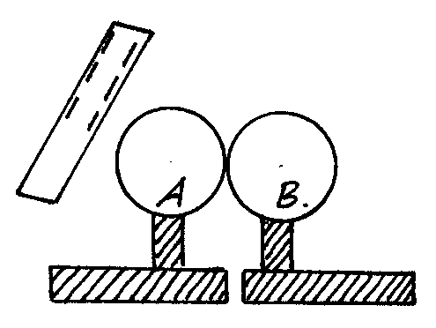
Fig. 1
In what way will A differ from B if separated while the rod is near? Explain. (2mks)

4. The ammeter in the circuit in figure 2 has negligible internal resistance. The cell has an internal resistance of 0.5Ω and an electromotive force of 3.0v.
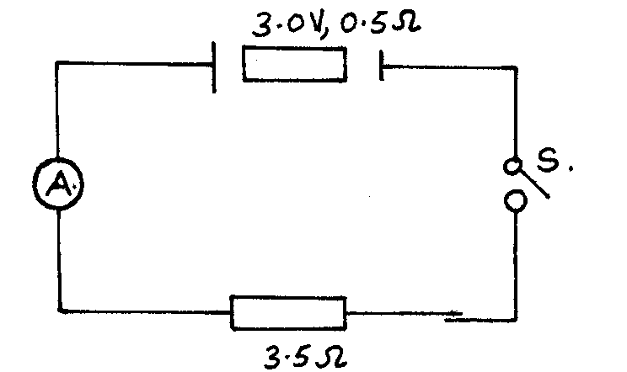

Fig. 2
Determine the value of current the ammeter registers when switch S is closed. (2mks)

5. Figure 3 represents a step down transformer of ratio 10:1. The turns are wound uniformly on the core and the primary coil is connected to a 250va.c supply. The lengths KL and MN are as indicated.
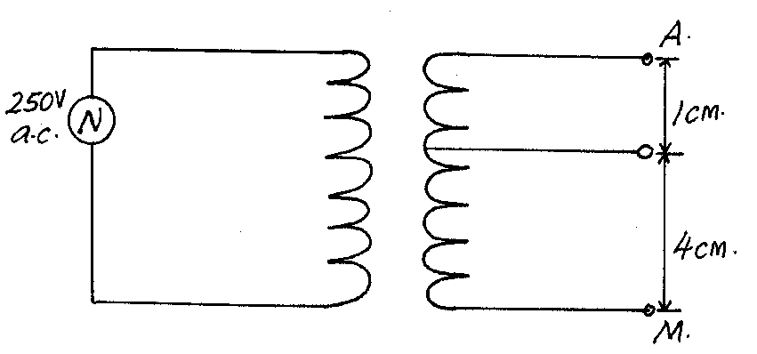
L
K
Fig. 3
Determine the p.d across LM. (4mks)

6. The diagram in figure 4 below shows a wire placed between the poles of two bar magnets.
A
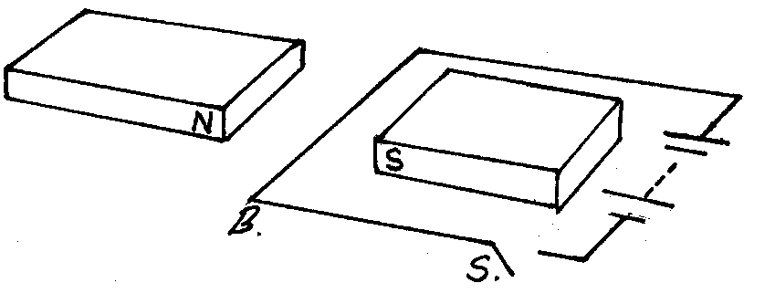
Fig. 4
Indicate with an arrow the force that acts on the section AB of the wire. (1mk)

7. An electric heater 480Ω is connected to a 240v main supply. Determine the energy dissipated in 4 minutes. (3mks)

8. A pin at the bottom of a beaker containing glycerine appears to be 6.8cm below the surface of glycerine. Determine the height of the column of glycerine in the beaker. (take the refractive index of glycerine as 1.47) (3mks)

9. A girl shouts and ears an echo after 0.6 seconds later from a cliff. If velocity of sound is 330m/s, calculate the distance between her and the cliff. (3mks)

10. What do you understand by ‘doping’ as applied with semiconductors? (1mk)

11. Arrange the following in order of decreasing wavelength Gamma radiation, Radio waves, Infrared and x-rays. (1mk)

12. Explain why soft iron keepers are suitable for storing magnets (2mks)

13. Figure 7shows a trace obtained on a cathode ray oscilloscope screen when an a.c is applied to the Y-plates and time base switched on.
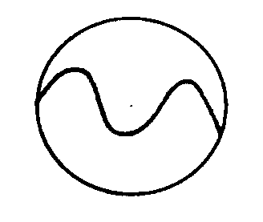
Fig. 7
On the same figure draw a waveform showing what would be observed if the time base is doubled. (1mk)

SECTION B ( 55 MARKS)
Answer ALL the questions in this section in the spaces provided
14.(a) What is meant by an open circuit? (1mk)

b) The graph in figure 5 shows the terminal voltage, V, of a certain battery varies with the current, I, being drawn from the battery.

2.0

Potential
Difference (Pd)
V
.

0.5 1.0 Current I A

(i) Write an expression relating the e.m.f. E, terminal voltage, V, current, I and the internal resistance, r, of the battery for the circuit drawn in (i) above. (1mk)

(ii) From the graph determine the; I internal resistance, r, of the battery. (2mks)

(b) When the device, X is connected in the circuit below, the voltage across it is 0.70 V.
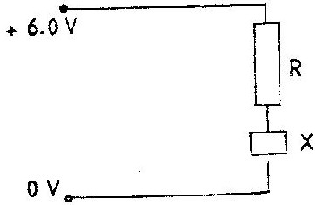

Calculate the value of the resistance R. (3mks)

(c) The cell in figure 10 has an e.m.f of 2.1 V and negligible internal resistance.
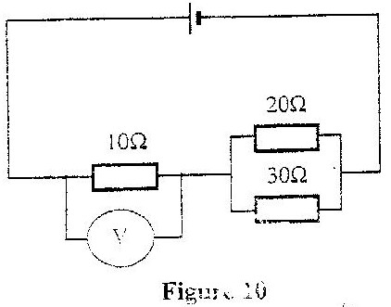

Determine the
(i) Total resistance in the circuit (2 marks)

(ii) Current in the circuit (1 mark)

(iii) Reading of the voltmeter (2 marks)

15. a) The figure 9 below shows magnetic relay circuit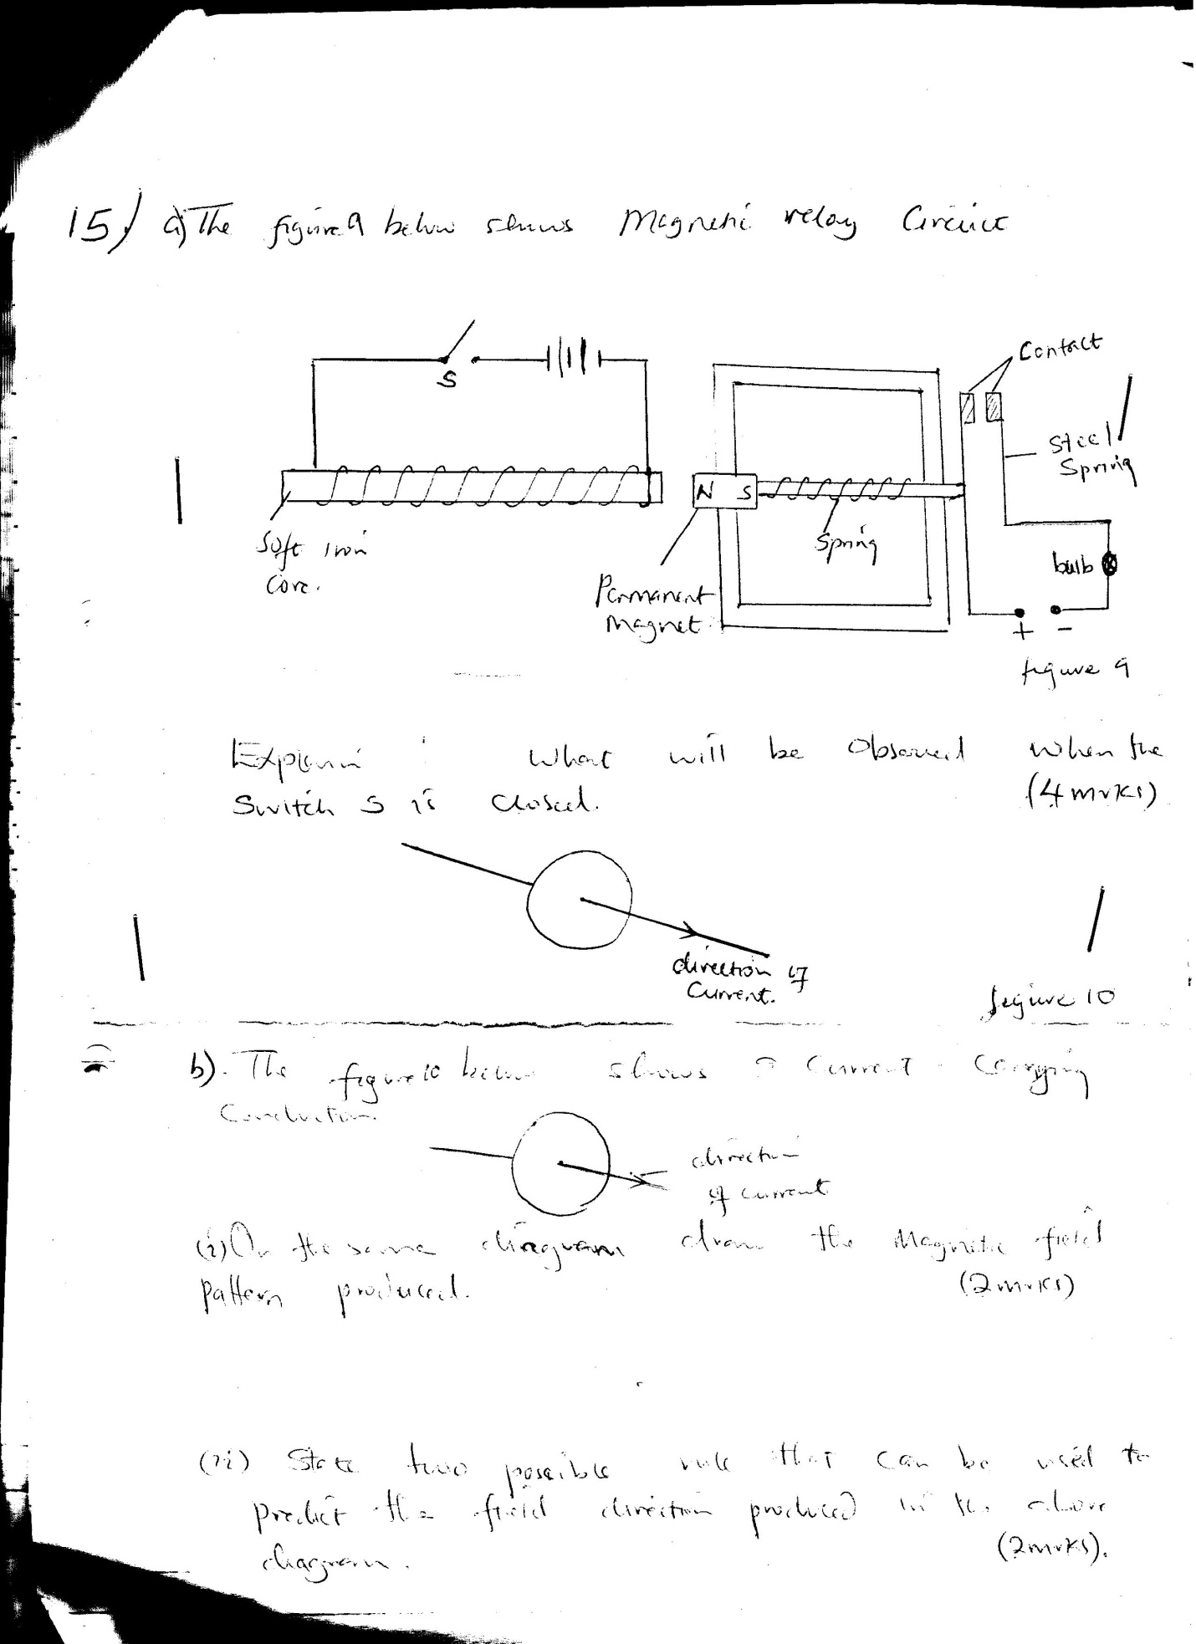

Explain what will be observed when the switch is closed (4mks)

(b) The figure 10 below shows a current carrying conductor
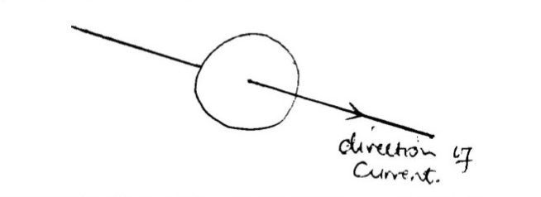
On the same diagram draw, the magnetic field pattern produced. (2mks)

(c) State two possible rules that can be used to predict the field direction produced in the above diagram. (2mks)

(d) List two applications of magnetic effect of electric current. (2mks)

16. a) The figure below represents a cathode ray oscilloscope (C.R.O)
b) Name the parts labelled A and B. (2mks)

A

B

c) What are the functions of parts labelled C and D? (2mks)

C

D

d) Explain how electrons are produced . (1mk)

e) Give a reason why the tube is evacuated. (1mk)

f) The potential between the anode and the cathode of an X-ray tube is 80kv. Calculate;
- The energy of an electron accelerated in the tube. (Electronic charge e = 1.6 x 10⁻¹⁹ C) (3mks)

- The velocity of electrons in the tube. (Mass of an electron = 9.11 x 10⁻³¹kg ) (3mks)

17 (a) The figure 12 below shows two rays starting from the top of an object OB incident on a converging lens of focal length 2cm.

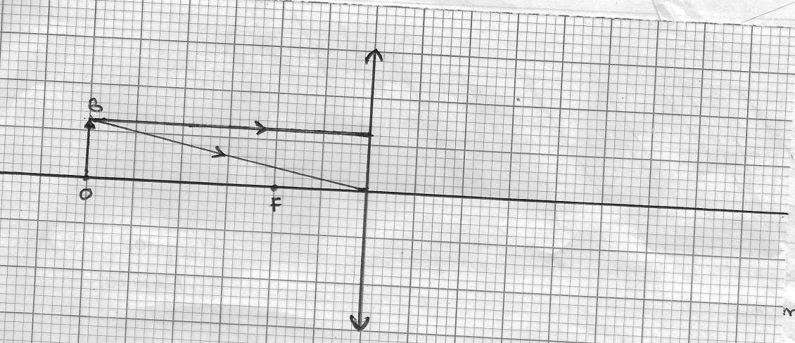

Complete the diagram to show the image formed (3mks)

(b) Add one or more incident ray from B and draw the corresponding refracted ray (1mk)

(c) Calculate the magnification produced by the lens (2mks)

(d) The figure 13 below shows an object placed at right angles to the principal axis of a thin converging lens.

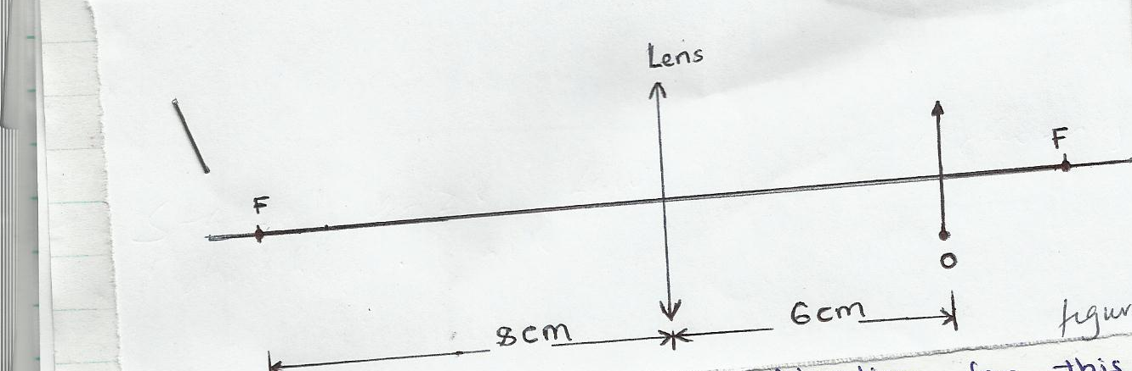

- Calculate the position of image formed (3mks)

- Give an application for this arrangement of a lens. (1mk)

- Describe the nature of the image formed (2mks)

18 (a) State Lenz’s law of electromagnetic induction (1mk)

(b) The figure 14 below shows a diagram of a simple electric generator
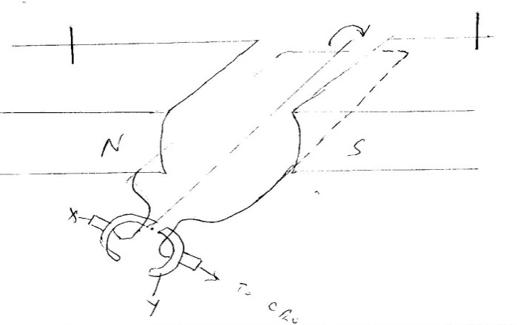

State three factors that would affect the value of the voltage output (3mks).

(c) A transformer supplies a current of 13.5A at a voltage of 48v to a device from an AC main supply 240V. Given that the transformer is 80% efficient, calculate;
- Power supplied to the transformer (3mks)

- Current in the primary coil (2mks)

