CANDIDATES’ NAME ………………………………………… INDEX NO……………..
CANDIDATES’ SIGNATURE………………………………….. DATE…………………..

TRIAL ONE EVALUATION TEST
Kenya Certificate of Secondary Education

PHYSICS PAPER 232/2
YEAR 2019

INSTRUCTIONS TO THE CANDIDATES
This paper consists of two sections A and B.
Answer all questions from both sections in the spaces provided.
All working must be clearly shown. Electronic calculator may be used.
FOR EXAMINER’S USE ONLY
SECTION | QUESTION | MAX SCORE | CANDIDATE’S SCORE
A | 1 – 12 | 25
B | 13 | 12
B | 14 | 14
B | 15 | 11
B | 16 | 9
B | 17 | 9
 | TOTAL | 80

SECTION A (25 MARKS)

1. Figure 1 shows a ray of light incident on a plane mirror.
Figure 1
70⁰

The plane mirror is then rotated clockwise through an angle of 20⁰ keeping the incident ray fixed. Determine the new angle of reflection. (2 Marks)

2. Explain why soft iron keepers are suitable for storing magnets (1marks)

3. Figure 5 shows part of the electromagnetic spectrum.
Z W P

Ultra Visible
violet Light
(a) Identify radiation W. (1 mark)

(b) State one the use of radiation W above. (1 mark)

4. (a) Distiquish between transverse waves and longitudinal waves. (1 Mark)

(b) Figure 3 below shows how the displacement varies for a certain wave.
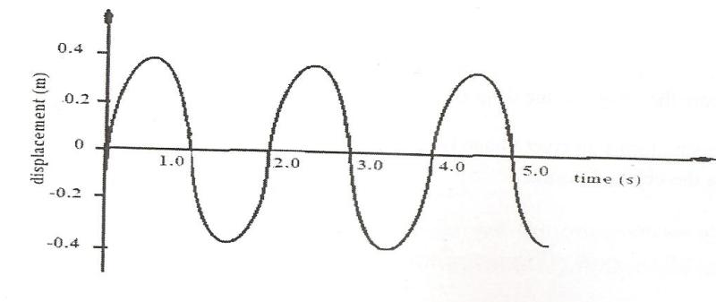

Determine the frequency of the wave. (2 marks)

5. A mine worker stands between two vertical cliffs 400m from the nearest cliff. The cliff are x metres apart. Every time he strike the rock once , he hears two echoes, the first one after 2.5 seconds, while the second follows 2 seconds later. Calculate
(a) The speed of sound in air. (2marks)

(b) The value of x (3marks)

6. The coil of an electric motor is usually wound on a soft iron armature. State the purpose of soft iron armature. (1 mark)

7. State one advantage of using an optical fibre in communication. (1mark)

8. State two factors that affect the strength of an electromagnet. (2marks)

9. The figure below (drawn to scale ) shows the image I formed by a convex mirror. F is the virtual principal focus of the mirror.
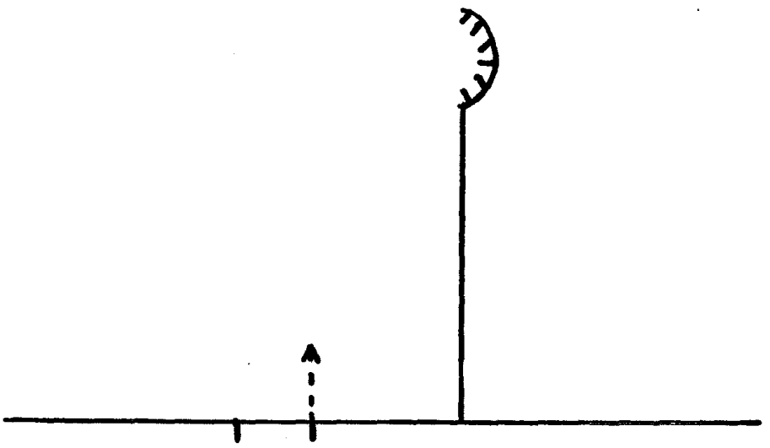

F I

Using a ray diagram locate the position of the object. (3marks )

10. Fig10 below shows a conductor carrying current placed in the magnetic field of two
magnets. Complete the diagram by showing the field pattern and the direction of force F that acts on
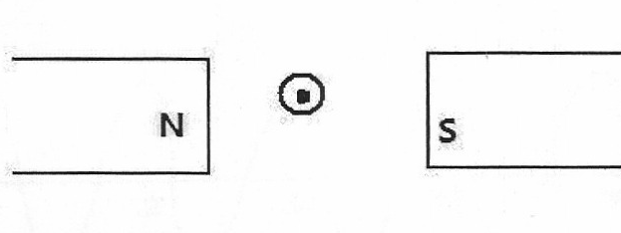
the conductor (2marks)
Figure 10

11. State two quantities that are used to determine whether accumulator require recharging or not. (2marks)

12. Explain how polarization reduces current in a simple cell. (1mark)

SECTION B (55 MARKS)
13(a) The figure below shows how a student set up a circuit using 3 identical bulbs X, Y and Z each rated “12V, 2.0A”
A
12V

X
Y
Z

(i) When operating normally, calculate the resistance of one of the bulbs. (2 Marks)

(ii) Calculate the effective resistance of the three bulbs. (2 Marks)

(iii) What will be reading of the ammeter? (2 Marks)

(iv) Draw a circuit diagram showing the three bulbs connected in such a way that they would all work at the same brightness especially if they are not identical. (2 Marks)

(b) When the switch S is kept open in the circuit shown below the voltmeter reads 1.5V. When the switch is closed, the readings drops to 1.3V and the current through the resistor is 0.5A.
V
R
S

(i) What is the e.m.f of the cell? (1 Mark)

(ii) What the terminal voltage of the cell? (1 Mark)

(iii) Calculate the value of R. (2 Marks)

14 (a) Figure 6 shows a human eye with a defect
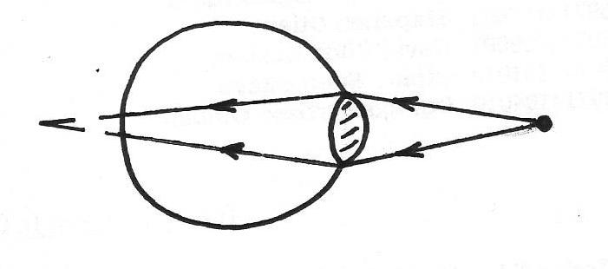

Object

(i) Identify the defect (1mark)

(ii) Explain how the defect could be corrected (2marks)

(iii) Draw a suitable diagram to show the correction of the defect (2marks)

(b) Outline two differences between the lens in camera and the human eye (2marks)

(c)The following graph shows the variation of image distance, V, with magnification, M, for a converging lens.
Image distance,V(cm)
10
Magnification, M
4
2
3
1
40
30
20

Using the graph and the equation $\frac{V}{f}=M+1$ to determine:
(i) The object position when the image position is 45cm (3 marks)

(ii) The focal length of the lens (2 marks)

(iii)The power of the lens. (2 marks)

15.(a) State three factors that determine the capacitance of a parallel place capacitor (3marks)

(b) A 5μF capacitor is charged to a potential difference of 200V and isolated. It is then connected to a 10μ capacitor. Find
(i) The resultant potential difference across the combination (3marks)

(ii) Energy stored before connection (2marks)

(iii) Total energy in the capacitors after connection (2marks)

(iv) Give one application of capacitors. (1 marks)

16.(a) In the experiment to observe interference of light waves a double slit is placed close to the source
see figure below
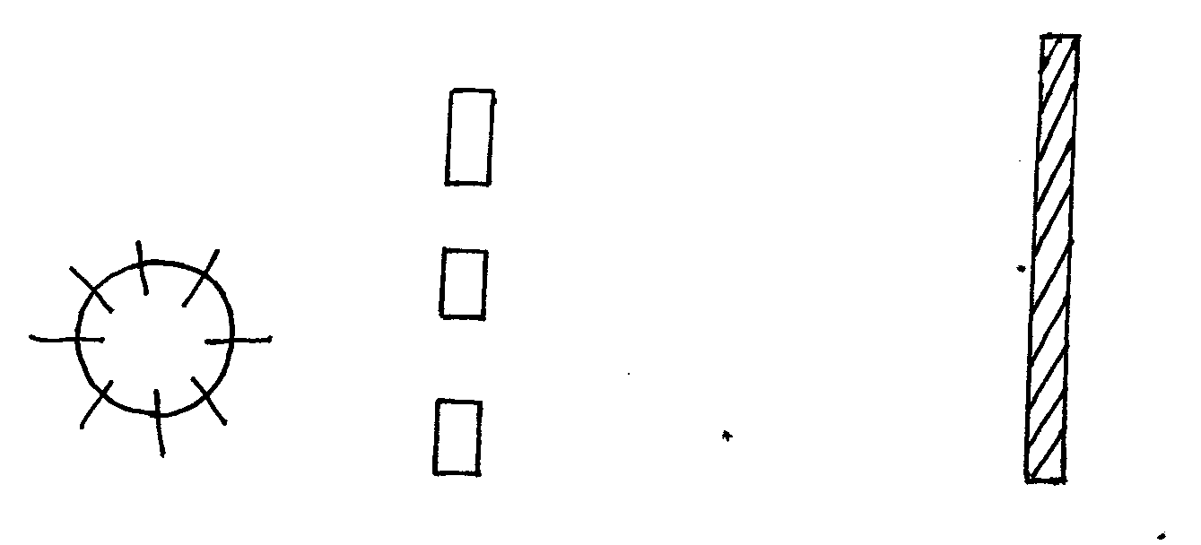

S₂
S₁

Screen
Double slot
Monochromatic source

(i) State the function of the double slit. (1mark)

(ii) State and explain what is observed on the screen. (3marks)

(b) State what is observed on the screen when:

(I) The slit separation S₁S₂ is reduced. (1mark)

(II)White light source is used in place of monochromatic source. (1mark)

(b) The figure below shows a set up by a student.
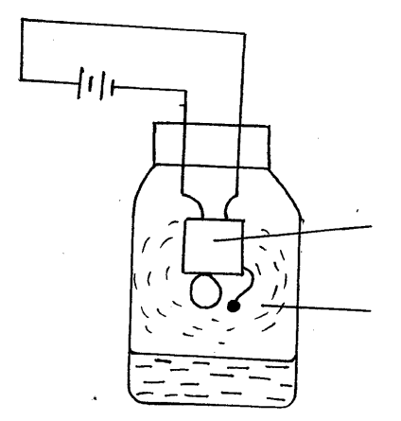

Electric buzzer

Steam from boiling water

State and explain what happens to the sound from the buzzer as the bottle and its contents are cooled to 0ºC (3marks)

17.(a) The diagram below shows a narrow beam of white light onto a glass prism.
X
Y

(i) What is the name of the phenomenon represented in the diagram? (1 Mark)

(ii) Name the colour at X and Y (2 Marks)

(b) The figure below shows the path of ray of yellow light through a glass prism. The speed of yellow light in the prism is 1.8 x 10⁸ m/s
(
60⁰
r
Ɵ

(i) Determine the refractive index of the prism material (Speed of light in vacuum, C = 3.0 x 10⁸ m/s) (3 Marks)

(ii) Show on the same diagram, the critical angle C and hence determine its value. (3 Marks)

