TRIAL ONE EVALUATION TEST 2019
232/3
PHYSICS
PAPER 3
(PRACTICAL)
MARCH/APRIL – 2019
MARKING SCHEME
1. (b)
S (cm) | 42 | 44 | 46 | 48 | 50 | 52
U₁ (cm) | 16.0 | 15.0 | 15.0 | 14.0 | 14.0 | 13.0 | (3mks)
U₂ (cm) | 25.0 | 28.0 | 31.0 | 33.0 | 36.0 | 38.0 | (3mks)
d = (U₂ – U₁) (cm) | 9.0 | 13.0 | 16.0 | 19.0 | 22.0 | 25.0 | (1mk)
d² (cm²) | 81 | 169 | 256 | 361 | 484 | 625 | (1mk)
S² (cm²) | 1764 | 1936 | 2116 | 2304 | 2500 | 2704 | (1mk)
S² – d²(cm²) | 1683 | 1767 | 1860 | 1943 | 2016 | 2079 | (1mk)  (10mks)

(c)
(ii) Slope = (1945 – 1770)cm² = 175cm = 43.75cm
(48 – 44)cm 4 (3mks)

(iii) S² – d² = 4fs
y = nx
4f = slope

f = slope = 43.75 = 10.9cm
4 4 (2mks)
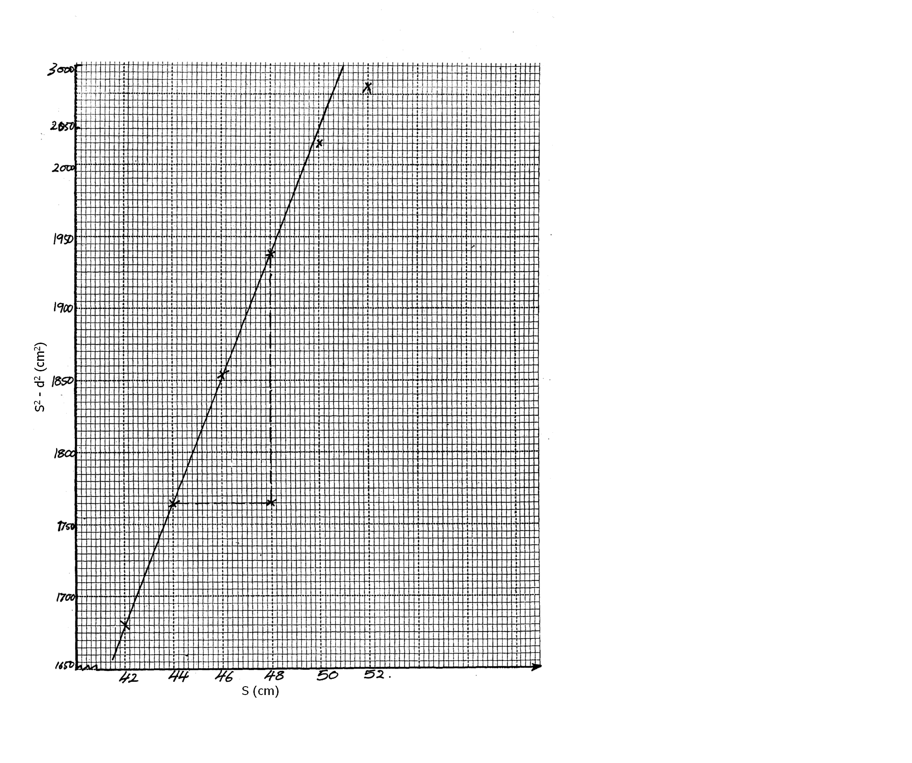

2. a) G = 50.0 + 1cm ✓ ½MK (49.0 – 51.0) ----MUST BE IN 1dp

x (cm) | x₁ (cm) | x₂ (cm) | x₃ (cm) | L₀ (cm) | L₁ (cm)
5.0 | 10.0 | 8.0 | 8.5 | 2.0 | 1.5
10.0 | 21.0 | 18.0 | 19.0 | 3.0 | 2.0
15.0 | 31.0 | 27.0 | 28.0 | 4.0 | 3.0
17.0 | 35.5 | 31.0 | 32.0 | 4.5 | 3.5
20.0 | 42.0 | 36.0 | 37.5 | 6.0 | 4.5
 | ✓ ½ each | ✓ ½ each | ✓ ½ each | ✓ ½ max of 1mk | ✓ ½ max of 1mk Total 9½mks

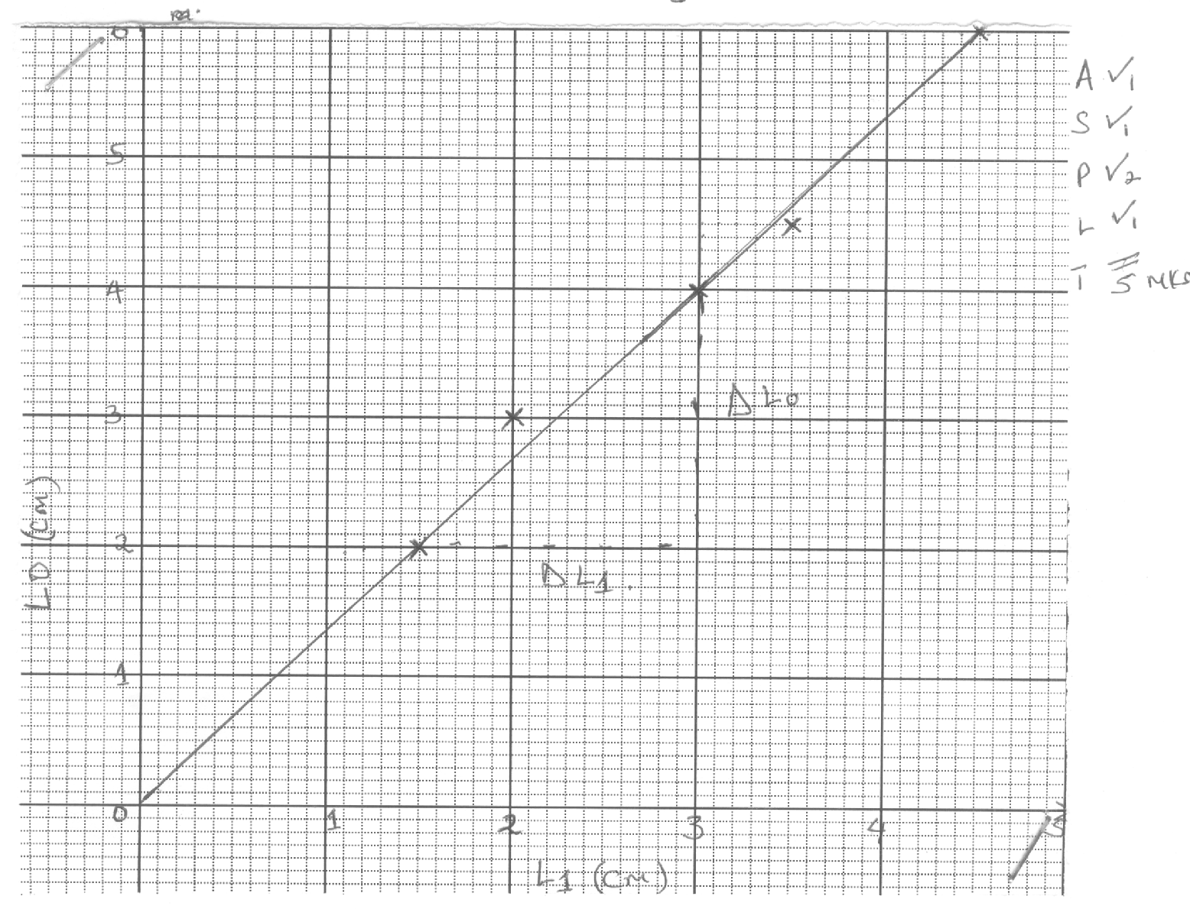

h) $S= \frac{{ΔL}_{o}}{{ΔL}_{1}}$on the graph ✓ = $\frac{4\text{.}0 − 2\text{.}0}{\text{30} − 1\text{.}5}$✓ = $\frac{2\text{.}0}{1\text{.}5}$ = 1.3333✓
i) K = 25 L₀ = 25S✓ = 25 x 1.3333 = 33.333✓
L₁

