NAME……………………………………………………….. INDEX NO…………………….........................

232/3 CANDIDATE’S SIGN………….….….….…....
PHYSICS
PAPER 3 DATE……….………………………………….
(PRACTICAL)
TIME: 2½ HOURS


TEACHER.CO.KE SERIES 1

INSTRUCTIONS TO CANDIDATES:
1. Write your name and index number in spaces provided above.
2. Sign and write the date of examination in spaces provided above.
3. Answer all the questions in spaces provided in the question paper.
4. You are supposed to spend the first 15 minutes of 2½ hours allowed for this paper
reading the whole paper carefully before commencing the work.
5. Marks are given for clear record of the observations actually made, their suitability,
accuracy and the use made of them.
6. Candidates are advised to record their observations as soon as they are made.
7. Non-programmable silent electronic calculators and KNEC Mathematical table may be used.

FOR EXAMINER’S USE ONLY
Question 1 | a | c & d | e | Part B | j | k | i & m | Total | 20
Maximum Score | 2 | 2 | 1 |  | 5 | 5 | 3
Candidate’s Score

Question 2 | a | b(i) – (vi) | Part B | (i) | (ii) | Total | 20
Maximum Score | 3 | 15 |  | 1 | 3
Candidate’s Score

GRAND TOTAL

Physics Paper 3
Turnover
1. You are provided with the following apparatus:
- Two optical pins mounted on corks.
- Candle.
- Metre rule.
- Screen.
- White sheet of paper.
- Lens and lens holder.
- Plane mirror.
- Clamp stand.
- Boss and a clamp.
- Piece of cellotape.
- Vernier calipers.

- Set up your apparatus as in figure 2 such that the tip of the cork is vertically above the center of lens.

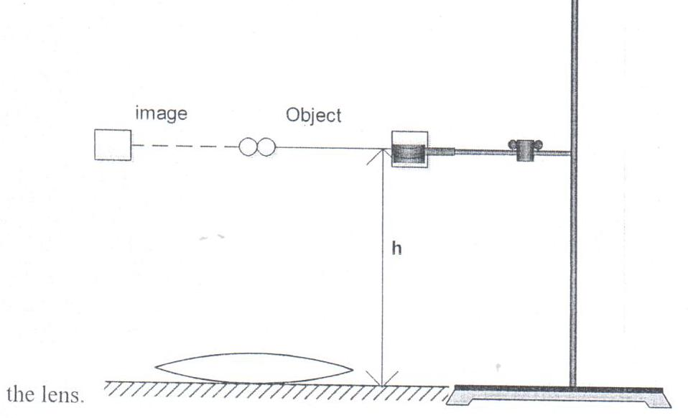

Figure 2

- Raise the cork until it coincides with is image without any parallax.

(c) Measure the height h. h = ____________ cm (2mks)

(d) Measure the thickness of the lens t. t = ____________ cm (1mk)

(e) Calculate the focal length from = ______________ cm (1mk)

PART B
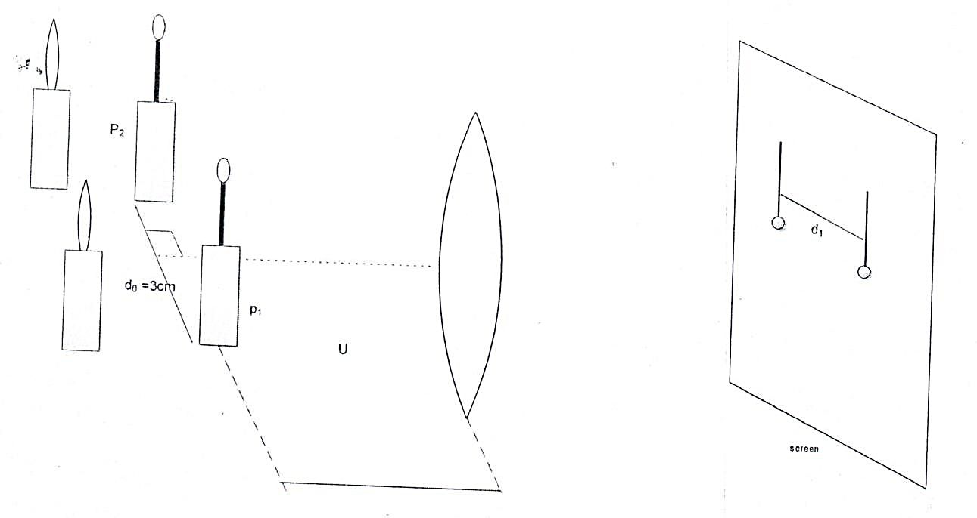

(a) Place pin P₁ and Pin P₂ 3cm apart and at right angle to the principal axis of the
convex lens.

(b) Place the candle behind P₁ to illuminate it.

- Fix the white sheet of paper on the screen using a cello tape.

(d) Place the screen in front of the lens and move it until a shape image of pin appear
on the screen.

(e) Draw a line against image of P₁.

- Without moving the screen, move the candle behind P₂ so that a shape image of
P₂ appears on the screen.

- Draw a line against the image of P₂ and measure the distance d1, between the
two images.
- Calculate the magnification from M = .

- Complete the table using other values of the objects distances (U) in the table.

 | Object distance  U(cm) | d₁(cm) | Magnification (M)
1. | 23.5
2. | 26.5
3. | 30.0
4. | 35.0
5. | 40.0
6. | 45.0
7. | 50.0 |  |  |  | (5mks)
(j) Plot a graph of U (cm) against. (5mks)

Physics Paper 3 3

(k) Determine the gradient of the graph. (3mks)

Physics Paper 3
(l) Given that determine the focal length of the lens. (2mks)

(m) Calculate the average value of focal length. (1mk)

2. You are provided with the following apparatus.
- 2 new dry cells size D
- A cell holder.
- One 100cm resistance wire mounted on millimeter scale.
- 1 switch.
- 1 Voltmetre 0 – 3V.
- 1 Ammeter 0 – 1A.
- 8 connecting wires (4 with at least 1 crocodile clip).
- Resistor wire mounted on cardboard.

- Connect the circuit as shown below in figure 3.0.
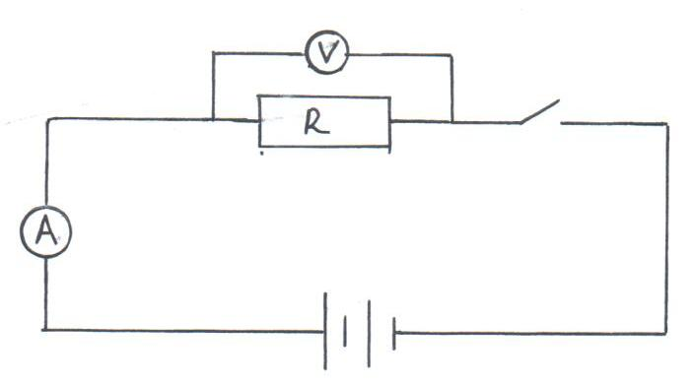

Figure 3.0

Record the reading of
(i) Ammeter, I = __________________ A (1mk)

(ii) Voltmeter, V = ________________ V (1mk)

(iii) Given that, find K = ___________________ (1mk)

- Disconnect figure 3.0 above and arrange the apparatus as shown below.

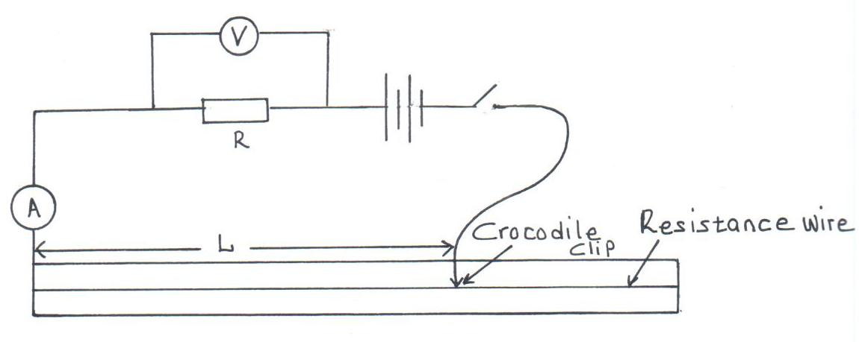

(i) Adjust the position of crocodile clip on the resistance wire to a point such that
L = 10cm.

- Record in the table 2, the value of p.d across R and corresponding current
through R.

(iii) Repeat procedure in (2) above for L = 20, 30, 40, 50, 60, 70cm.

L(cm) | 10 | 20 | 30 | 40 | 50
V(V)
I(A) |  |  |  |  |  | (5mks)

(iv) On the grid provided plot the graph of V (Y-axis) against I (X-axis). (5mks)

(v) Find the slope of the graph. (2mks)

(vi) What quantity is represented by the slope of the graph? (1mk)

PART B
You are provided with the following:
- A 70cm long thread.
- Stopwatch.
- Metre rule.
- Clamp, boss and retort stand.
- Small pieces of wood.

Proceed as follows:
(i) Using the provided thread, tie the marble to be used as a pendulum clamp the thread
so that the length of the pendulum to the centre of the marble is 50cm as in figure 3.
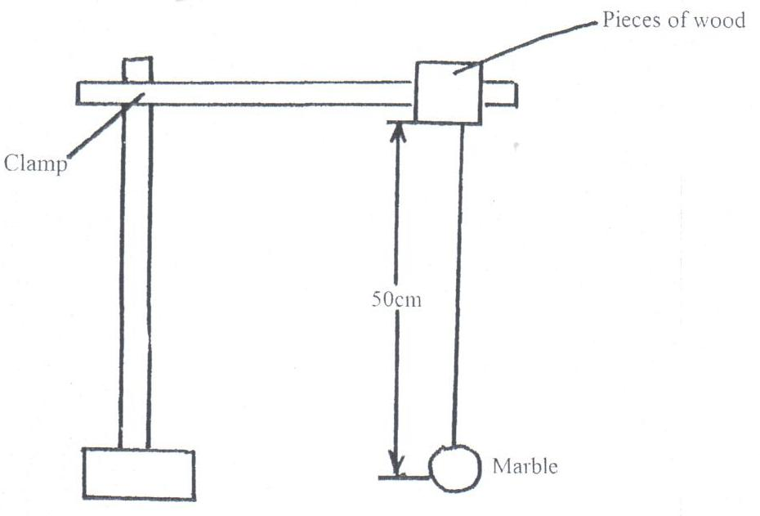

Displace the marble slightly so as to oscillate along the vertical plane.
Time and record the time, t, for 20 oscillations.

t = ___________ S (1mk)

(ii) If the oscillation of the marble is given by the formula.
Use the values in part (i) above to determine the value of g. (3mks)

