NAME: …………………………………………. INDEX NO: ……………………………….

SCHOOL: ………………..…………………… DATE : ……………………………………..

CANDIDATE’S SIGNATURE:……………………

TEACHER.CO.KE SERIES 11

232 / 3
PHYSICS
PAPER 3
(PRACTICAL)
TIME: 2 ½ HOURS

INSTRUCTIONS TO CANDIDATES

- Write your Name and Index Number in the spaces provided above.
- Sign and write the date of Examination in the spaces provided above.
- Answer all questions in the spaces provided.
- You are supposed to spend the first 15 minutes of the 2½ hours allowed for this paper reading the whole paper carefully before commencing your work.
- Marks will be given for clear records of observations actually made, their suitability, accuracy and the use made of them.
- Candidates are advised to record their observations as soon as they are made.
- All working must be clearly shown where necessary.
- Mathematical tables and silent electronic calculators may be used.

FOR EXAMINER’S USE ONLY
Question 1 | b | c | d | e | f | g | h | TOTAL
Max. Score | 3 | 2 | 6 | 5 | 1 | 1 | 2 | 20
Candidate’s Score

Question 2 | e | f | g | h | i | j | k | l | m | TOTAL
Max. Score | 8 | 5 | 1 | 1 | 1 | 1 | 1 | 2 | 1 | 20
Candidate’s Score
GRAND TOTAL

- Question one
This question has two parts A and B. Answer both parts.

PART A
You are provided with the following:-
- A retort stand, clamp and boss.
- A spiral spring.
- A stop watch.
- Three 100g masses.

Proceed as follows:
    - Suspend a 100g mass at the end of the spring as shown in figure 1.
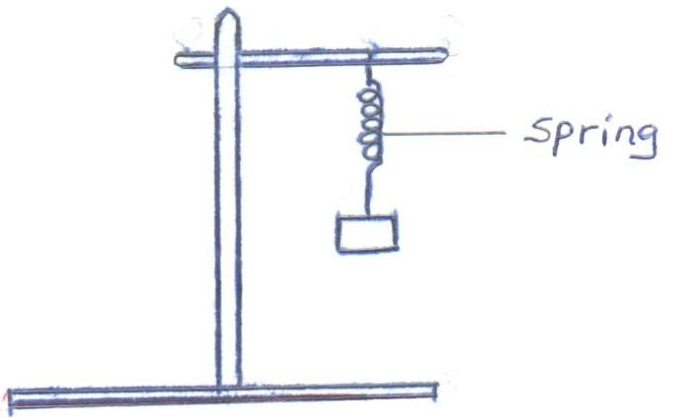

Fig. 1

Now give the mass a small vertical displacement and release so that it performs vertical oscillations. Time ten oscillations and determine the period T. Enter your results in table 1.

    - Repeat the experiment for the other values of mass and complete the table.
Table 1
Mass m (g) | 100 | 200 | 300
Time for 10 oscillations (s)
Periodic time T(s)
(3mks)
    - Given that T = π m , where k is the spring constant, find the average value k for the spring. K (2mks)

PART B
You are provided with the following:-
- A 250ml glass beaker
- A Bunsen burner
- A Thermometer
- A Stop watch
- A Tripod stand and a Wire gauze
- A measuring cylinder 100ml
- Water
Set the apparatus as shown in figure 2 below.
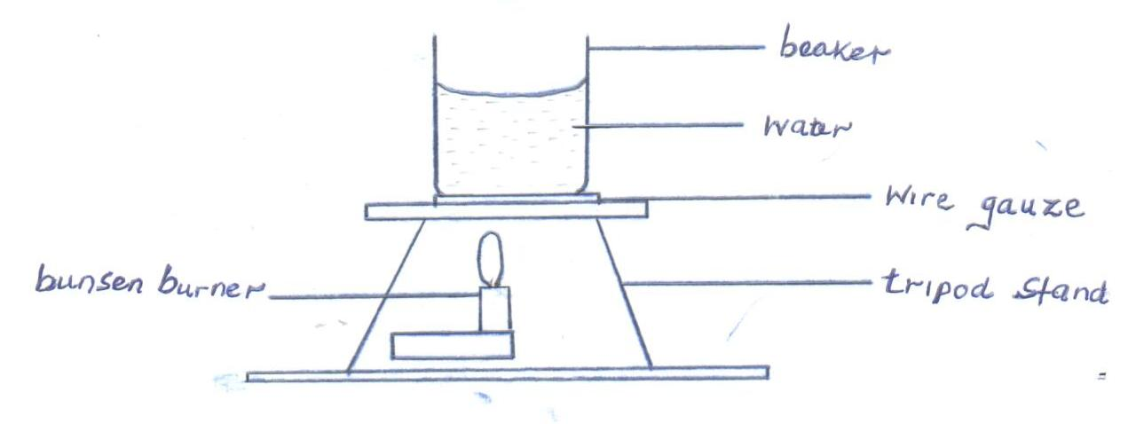
Fig. 2
    - Measure 100cm³ of water and pour it into the beaker. Take the initial temperature of the water.
T₀ = …………………………………………….⁰C (1mk)
Now heat the water to a temperature of 80⁰C. switch off the gas tap and place a thermometer into the beaker and start the stop watch when the temperature is 65⁰C. Take the temperature T⁰C of water ever two minutes. Record your results in the table 2 below.

Table 2
Time, t(min) | 2 | 4 | 6 | 8 | 10 | 12 | 14
Temperature (T) ⁰C
(T - T₀)
Log (T - T₀)
(5mks)

    - Plot a graph of Log (T - T₀) against Time (t). (5mks)

    - Find the value of P of log (T - T₀) when t = 0. (1mk)

    - Determine N, where N is the antilog of P. (1mk)

    - Calculate the temperature of the surrounding T_{R} using the expression N = 65–T_{R}
(2mks)
- Question 2
Part A
You are provided with the following:-
- A lens and a lens holder.
- A candle.
- A white screen.

Proceed as follows:
        - Set the apparatus as shown below.
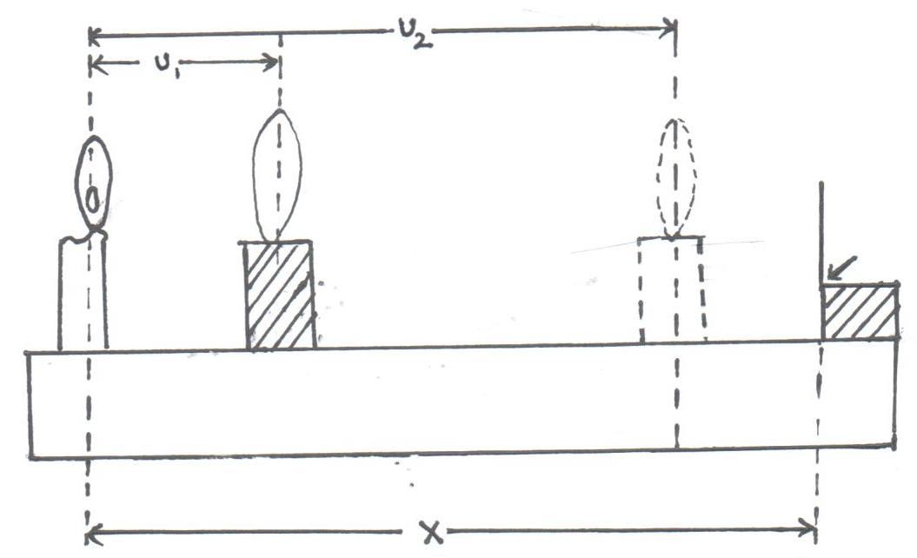

Lens
Candle Lens holder White screen

Metre O P Q
Rule

        - Place the white screen at a distance X = 100cm from the candle. Let the lens be at position P, adjacent to the lit candle.

        - Move the lens towards the screen until an enlarged image of the candle is formed on the screen. Measure and record the distance u₁.

        - Move the lens to a second position Q where the image of the candle is sharp but diminished on the screen.
Measure and record the distance u₂.
Hence determine the value of d = u₂ - u₁.

        - Repeat the procedure in (c) and (d) for either values of x = 95, 90, 85, 80cm. Complete table 2 shown below.
Table 2
x (cm) | 100 | 95 | 90 | 85 | 80
u₁(cm)
U₂(cm)
d = u₂ - u₁(cm)
y = ^{d2}/_{x}(cm) (2d.p)
(8mks)
        - On the grid provided, plot a graph of y against x. (5mks)

        - Determine the value of x = x₀, when y = 0. (1mk)
x₀ = …………………………………………… cm

        - Given that k = x_{o}, determine the value of k. (1mk)
4
PART B
You are provided with the following:-
- A voltmeter
- A resistance wire labelled R mounted on a metre rule.
- A metre rule.
- A resistance wire labelled T mounted on a small piece of carton.
- Two dry cells and a cell holder.
- Six connecting wires, each with a crocodile clip at one end.
- A switch.
Proceed as follows;
        - Measure and record the e.m.f. E₀ of the cells connected in series, E₀ = ____ v.
(1mk)
        - Connect the circuit as shown below. Point O on resistance wire P is at 50cm mark of the metre rule. A and B are points on resistance wire P such that AO = OB = X = 30cm.
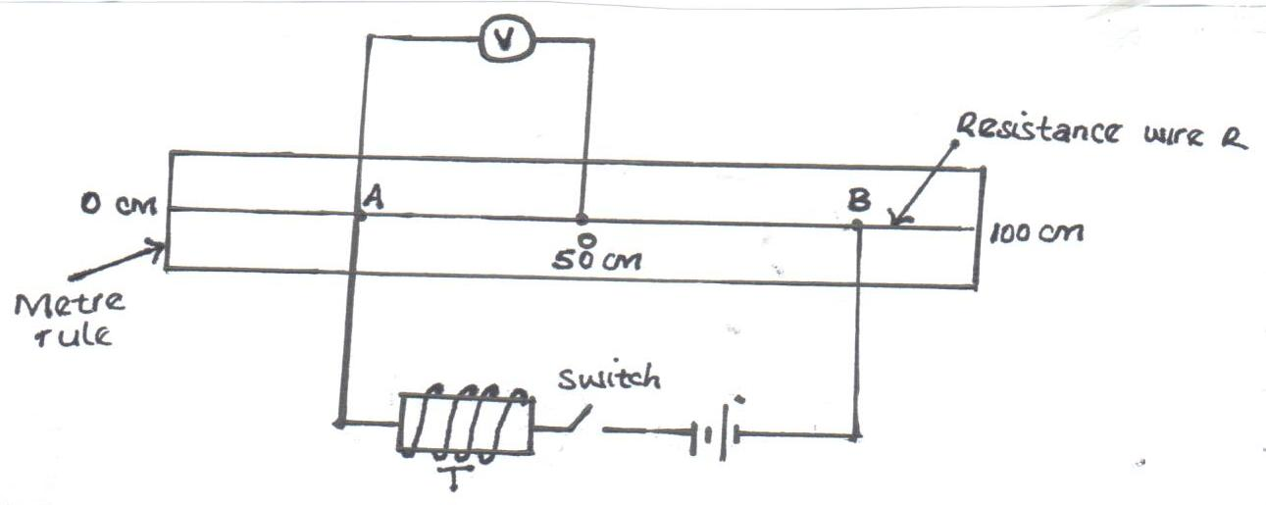
        - Close the switch. Read and record the potential difference V across AO
V = …………………………………………. Volts. (1mk)

        - The relationship between V and x is given by:
I = 35 + 1
V x y
Determine the value of y. (2mks)

        - Use the e.m.f. E₀ to determine the constant k, given that:
k = 8 (1mk)
35E₀

