NAME: …………………………………………. INDEX NO: ……………………………….

SIGNATURE: ………………………………… DATE : …………………………………..

CANDIDATE’S SIGNATURE: …………………

TEACHER.CO.KE SERIES 12
232 / 3
PHYSICS
PAPER 3
(PRACTICAL)
TIME: 2 ½ HOURS

INSTRUCTIONS TO CANDIDATES

- Write your Name, Index Number and School in the spaces provided above.
- Sign and write the date of Examination in the spaces provided above.
- Answer all questions in the spaces provided.
- You are supposed to spend the first 15 minutes of the 2½ hours allowed for this paper reading the whole paper carefully before commencing your work.
- Marks are given for a clear record of observations actually made, their suitability, accuracy and the use made of them.
- Non-programmable silent electronic calculators and KNEC Mathematical tables may be used in calculations.

FOR EXAMINER’S USE ONLY
QUESTION 1

Part A |  |  |  |  |  |  |  | Part B |  |  |  | Sub-total
Question | (i) | (ii) | (iii) | (iv) | (v) | (vi | (vii) | Question | e | f | g | Sub-total
Max score | ½ | ½ | ½ | ½ | ½ | ½ | 3 | Max score | 6 | 5 | 3 | 20
Candidate’s score |  |  |  |  |  |  |  | Candidate’s score

QUESTION 2

Question | c | d(i) | d(ii) | e(i) | e(ii) | f | g | Sub-total |  | TOTAL SCORE
Max score | 7 | 5 | 3 | 1 | 1 | 2 | 1 | 20 |  | 40
Candidate’s score

- PART A
You are provided with the following:-
- A boiling tube.
- Some dry sand.
- A liquid in a measuring cylinder labelled L.
- Half metre rule.
- A vernier calipers (to be shared)
- A weighing machine (one per form)
- Tissue paper.
- A measuring cylinder.

Proceed as follows:
    - Measure the length of the boiling tube.
h = _____________________ cm (½mk)
    - Put a little amount of sand in the boiling tube and place it in the measuring cylinder which is almost filled with liquid L. Add sand, little by little until the tube floats upright as shown in fig. 1
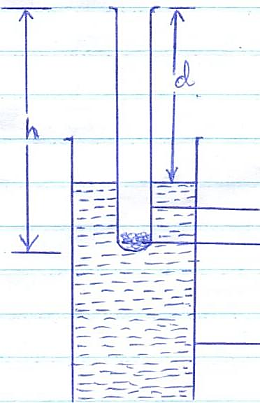

Fig.1

Boiling tube
Sand

Measuring cylinder

Measure the length, d, of the boiling tube which is above the liquid.
d= _____________________ cm (½mk)
    - Determine the length, t, of the boiling tube which is immersed in the liquid.
t = _____________________ cm (½mk)
    - Remove the boiling tube from the measuring cylinder, wipe it dry (on the outside) and measure its mass, m, including the sand inside.
m = _____________________ g (½mk)

    - Measure the external diameter, D, of the boiling tube.
D = _____________________ cm (½mk)

    - Determine the external radius, R
R = _____________________ cm (½mk)

    - Using the formula m = 12pπR², determine p for the liquid.
p_____________________ cm (3mks)

PART B
You are provided with the following:-
- A white screen with cross wires labelled O.
- A lens and a lens holder.
- A white screen labelled S.
- A metre rule.
- A candle.
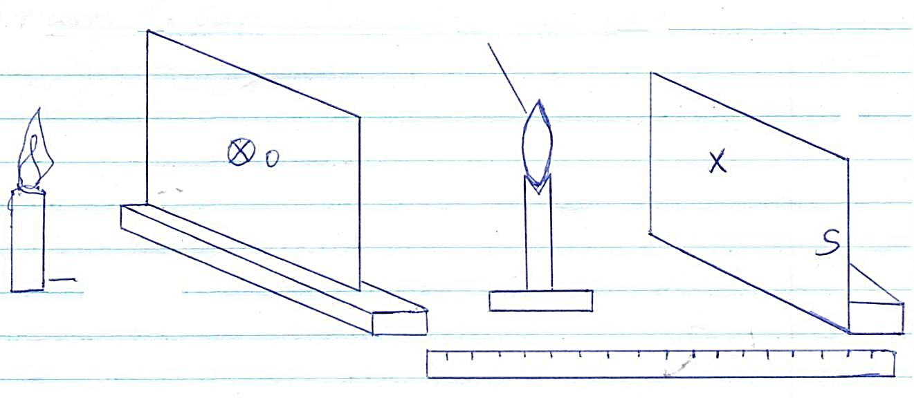
        - Set up the apparatus as shown in fig. 2.
Lens

Candle

        - Position the lens so that the object distance u = 20cm.
        - Adjust the screen S so that a sharp image of the cross wire is formed on the screen S. Measure the image distance v. Record the value u and the corresponding value of v in table 1.
        - Repeat (b) and (c) above for other values of u in table 1.

        - Complete table 1.
u (cm) | 20 | 25 | 30 | 35 | 40 | 45
v (cm)
u + v (cm)
uv (cm²)

        - On the grid provided, plot a graph of uv against (u+v) (5mks)

        - Determine the slope of the graph and state its significance. (3mks)

- You are provided with the following apparatus:-
- A voltmeter
- An ammeter
- A switch
- 6 connecting wires (one with a crocodile clip)
- 2 new dry cells.
- A cell holder.
- A nichrome wire mounted on a millimetre scale.

Procedure
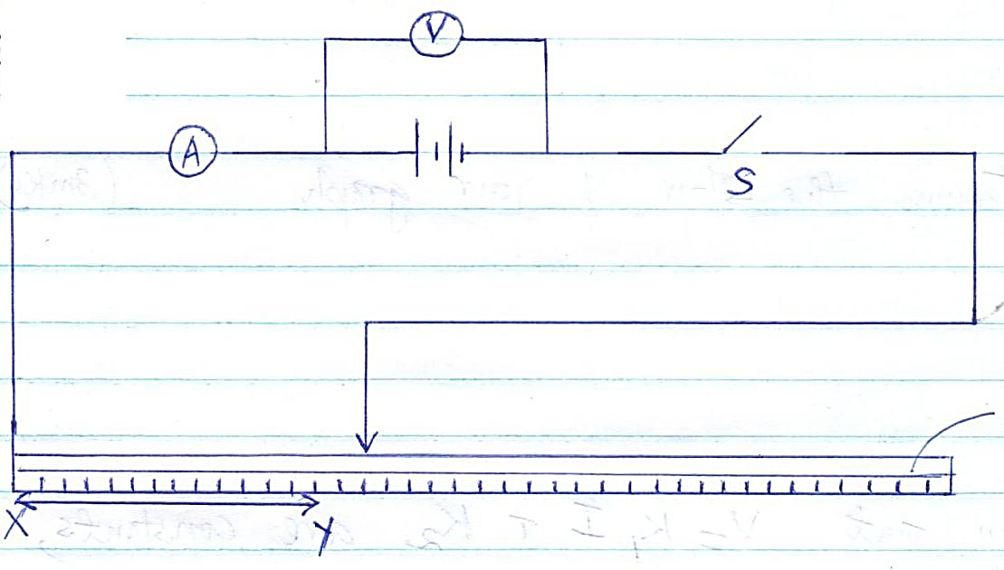
        - Connect the apparatus as shown in fig. 3

Nichrome
wire

        - With the crocodile clip at y, 80cm from x, close the switch and record the voltmeter reading and the corresponding ammeter reading in table 2.

        - Repeat the procedure in part (b) for other lengths of xy as shown in table 2. complete the table.
Length (xy) cm | 80 | 70 | 60 | 50 | 40 | 30 | 20
Voltmeter reading (V)
Ammeter reading (A)

        - (i) On the grid provided, plot a graph of p.d(V) against current I (A). (5mks)

(ii) Determine the slope of your graph. (3mks)

        - Given that V = K₁I + K₂ where K₁ and K₂ are constants, determine:
- The value of K₁. (1mk)

- The value of K₂. (1mk)

        - What quantity do constants K₁ and K₂ represent? (2mks)

        - State the reason why the switch should be open when no readings are being taken. (1mk)

