Name:………………………………………...……………………………Index No………………………

232/3 Candidate’s Signature:……………….…………
PHYSICS PRACTICAL
PAPER 3 Date:…………………………….………
TIME:2 ½ HOURS


TEACHER.CO.KE SERIES 15

Kenya Certificate of Secondary Education (K.C.S.E.)

232/3
Physics
Paper 3
2 ½ hours

INSTRUCTIONS TO CANDIDATES

- Write your name and index number in the spaces provided above.
- Sign and write the date of examination in the spaces provided above.
- Answer ALL the questions in the spaces provided in the question paper.
- You are supposed to spend the first 15 minutes of the 2½ hours allowed for this paper reading the whole paper carefully before commencing your work.
- Marks are given for a clear record of the observations actually made, their suitability, accuracy and the use made of them.
- Candidates are advised to record their observations as soon as they are made.
- Non-programmable silent electronic calculators may be used.
- This paper consists of 8 printed pages.
- Candidates should check the question paper to ascertain that all the pages are printed as indicated and that no questions are missing.
- Candidates should answer the questions in English.

For Examiner’s Use Only
Question 1
 | c | d(i) | (ii) | (iii) | (iv) | f | g
Maximum Score | 7 | 4 | 2 | 2 | 2 | 1 | 2 | 20  Total
Candidate’s Score

Question 2
 | b | e | f | g | h | i | k | k | m | Total
Maximum Score | 1 | 6 | 4 | 2 | 2 | 2 | 1 | 3 | 2 | 20
Candidate’s Score |  |  |  |  |  |  |  |  |  | GRAND  TOTAL

This paper consists of 8 printed pages. Candidates should check to ascertain that all pages are printed as indicated and that no questions are missing.

QUESTION 1
You are provided with the following
- Triangular card marked PQR
- Plastic or glass beaker
- Straight piece of wire
- Two strips of cellotape
- Optical pin
- Set square
- Millimeter scale
- Stop watch
You are required also to have a complete mathematical set
Proceed as follows
(a) Draw the perpendicular line to the base QR and measure and record, the height PM of the triangle
PM=h……………………………….. (1mk)

y
R
M
Q
h
P
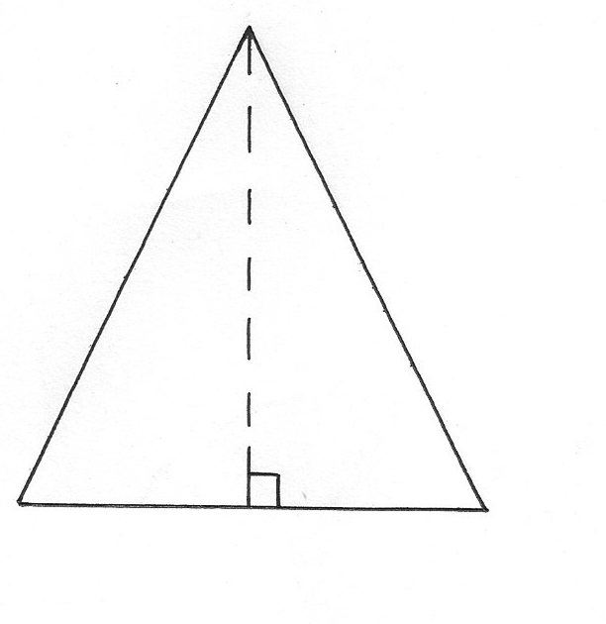

(b) Using the optical pin provided make holes along the perpendicular line drawn such that
the distance y=10mm, 20mm,30mm,35mm,40mm,50mm, and 55mm from P.

(c) By using a small piece of cellotape attach both ends of the thin length of wire to
the circumference of the beaker with the wire passing through the hole y=10mm and the
card hangs freely. Displace the card so that it oscillates about the wire as an axis.
See figure below
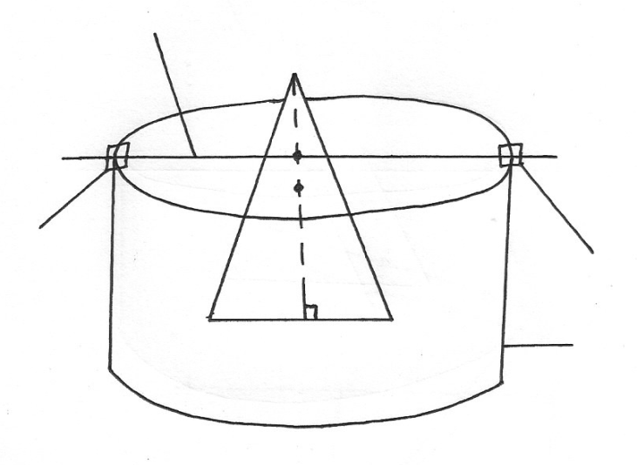
Cellotape
Beaker
Cellotape
Thin wire
Q
M
R
P

(d) Determine the time for 5 complete oscillations and then find the periodic time T.
Record the value in the table 1
(e) Increase y to 20mm and repeat the experiment so as to determine the new value of T. Repeat
the procedure in (d) for other values of y and complete the table
Table 1

Y(mm) | 10 | 20 | 30 | 25 | 40 | 50 | 55
Time for 5 oscillations
Periodic time, T (seconds)
On the grid provided ;
(f) Plot a graph of T(y-axis) against y (5mks)

(g) From the graph, determine T, the periodic time for which y= 1/3h. (2mks)

(h) Hence, calculate the constant K from the formula,

where t is the time for 5 complete oscillations when y= 1/3h (3mks)

QUESTION 2
You are provided with the following;
- 3 new dry cells (size D)
- A bulb
- A voltmeter (0-3V or 0-5V)
- An ammeter (0-1A)
- A mounted nichrome wire on a millimeter scale
- A switch
- 7 connecting wire at least 2 with crocodile clips at the ends
- A micrometer screw gauge (to be shared)
Proceed as follows;
(a)(i) Set up the circuit as shown in figure below;

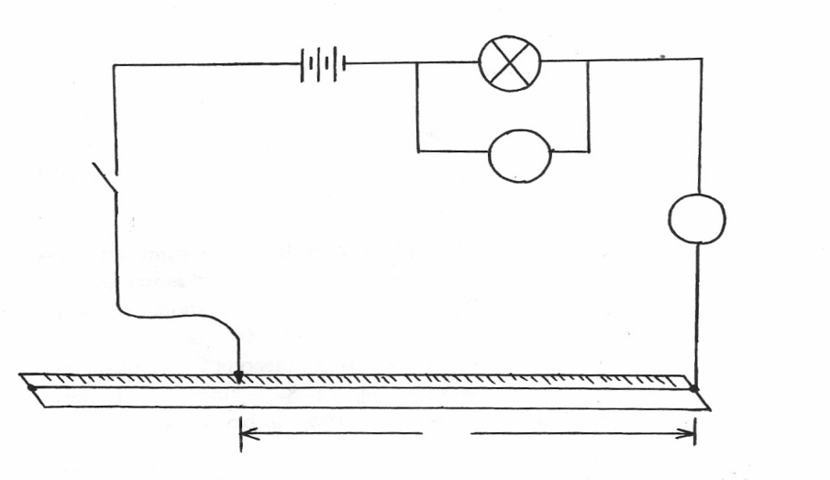
Cells
Bulb
Switch
Nichrome wire
mounted
100cm
0cm
A
B
L
L=100cm
A

(ii) With the crocodile clip A take (L=100cm) take the voltmeter and the ammeter readings.
Record V and I. repeat the readings for L=80,60,40,20, and 0cm respectively. Complete
the table below; Key
Length L(cm) | 100 | 80 | 60 | 40 | 20 | 0
Voltage V(v)
Current,I(A)
(6mks)
(iii) What changes do you observe on the bulb as L decreases from A? (1mk)
……………………………………………………………………………………………………
(iv) Plot a graph of current I (y-axis)against voltage ,V (5mks

(v) Determine the slope of your graph at V=2 volts (3mks)

(b)(i) Given the apparatus in a (i) above, draw a diagram of the circuit you would use to
determine the current through the resistance wire AB and the potential differences across it (1mk)

(ii) Set up the circuit you have drawn. Record the ammeter reading I and the voltmeter reading
V, when L=100cm (1mk)
V=………………………………………….
I=……………………………………………
(iii) Using a micrometer screw gauge, measure the diameter d of the wire (1mk)
d=………………………………….mm=…………………………..m
(iv) Calculate the quantity P given that
and state its SI units, where L=1m (2mks)

