Name…………………………………… …………………………..………… Index No:………………………….

232/3 Candidate’s Signature …………..……………
PHYSICS Date: …………………………
PRACTICAL
PAPER 3
2 ½ hours


TEACHER.CO.KE SERIES 21

INSTRUCTIONS TO CANDIDATES:

    - Write your name and index number in the spaces provided above.
    - Sign and write the date of the examination in the spaces provided above.
    - You are supposed to spend the first 15 minutes of the 2 ½ hours allowed for this paper reading the whole paper carefully before commencing your work.
    - Marks are given for a clear record of the observation actually made, their suitability, accuracy and the use made of them.

FOR EXAMINERS’ USE ONLY
Question 1
Question 2
Total

This paper consists of 8 printed pages. Candidates should check to ascertain that all pages are printed as indicated and that no questions are missing.
Part A
- Question 1
You are provided with the following apparatus
- One resistor labeled R
- A wire labeled W mounted on millimeter scale
- A wire lebelled S mounted on a millimeter scale
- One dry cell and a cell holder
- One jockey
- One centre zero galvanometer
- Eight connecting wires, four with crocodile clips at both ends
- A micrometer screw gauge
- A switch

Proceed as follows
- Determine the average diameter D, of the wire labeled W, using the micrometer screw gauge provided.

D₁=________________________mm, ( ½ mk)
D₂=__________________________mm ( ½ mk)

D = D₁ + D₂
2
=_____________________________m ( ½ mk)

- Set up the apparatus as shown in the circuit diagram in figure 1, below.
Use the crocodile clips to fix length L, of wire labeled S at 50 cm from the end connected to the galvanometer G.

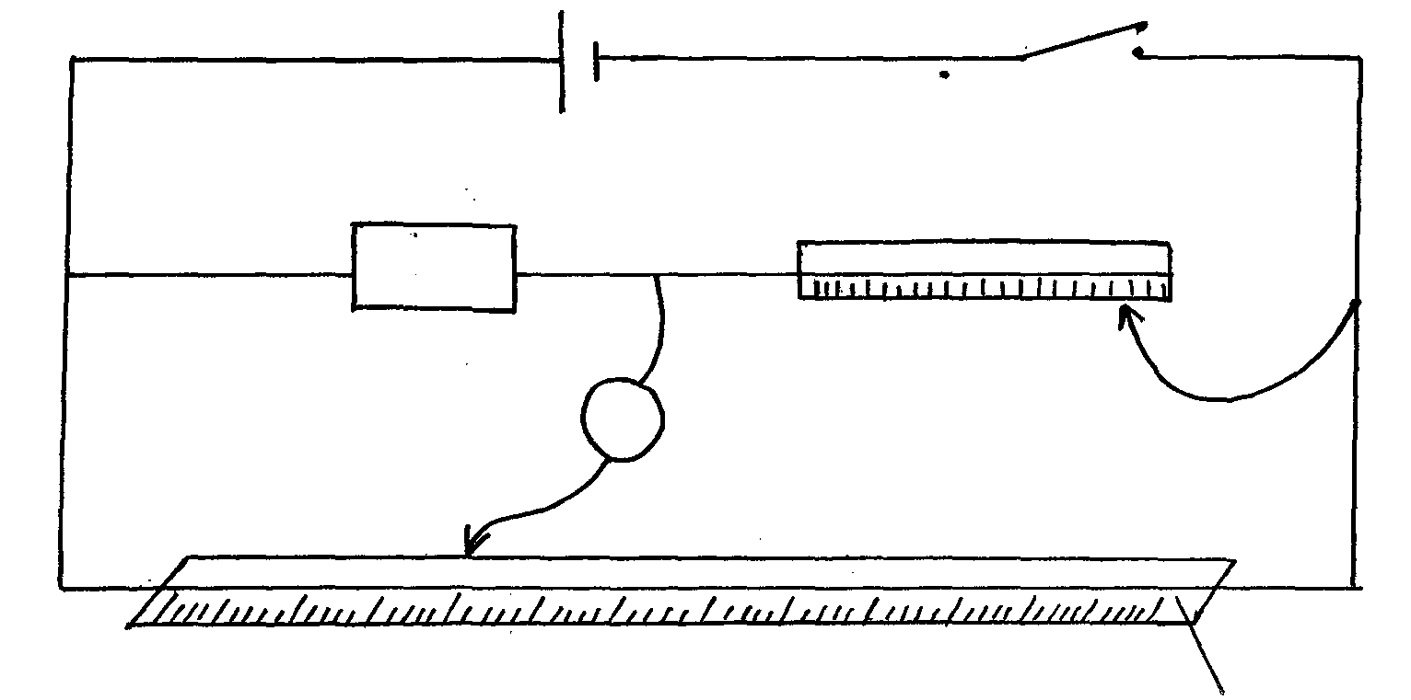

R

S
W

- Close the switch, and use the jockey to touch one end of the wire W, and then the other end. The deflections on the galvanometer should be in opposite directions, if not check the circuit. Adjust the positions of the jockey along the wire W until there is no deflection in the galvanometer. Record the value of x and y.

X = _____________________________________cm ( ½ mk)

Y=____________________________________ cm ( ½ mk)

- Repeat for other values of L in the table

L (cm) | 45 | 40 | 35 | 30 | 25 | 20
X (cm)
Y (cm

(3mks)

(e)(i) Plot a graph of ¹/x (y- axis) against, L (4mks)

(ii) Determine the slope , m of the graph. (2mks)

(iii) Given that K = 100D, determine the value of K (2mks)
m

PART B
You are provided with the following apparatus

- A rectangular glass block
- Four optical pins
- A piece of soft board
- A plain sheet of paper
- 4 thumb tacks

Proceed as follows
Place the plain sheet of paper on the soft board and fix it using the thumb tacks provided. Place the glass block at the centre of the sheet, draw its outline. Remove the glass block.

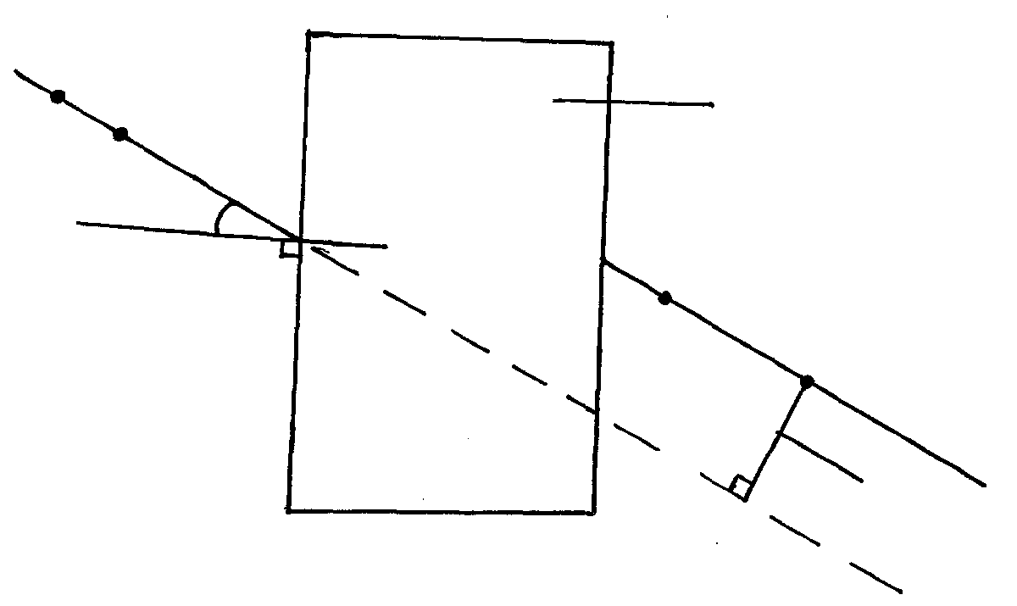
Glass block

40º
P₁
P₂
P₃
P₄

d

(ii) Draw normal at point 2cm from the end of one of the longer side of the block outline.
Draw a line at an angle of θ = 40º from the normal. Stick two pins p₁ and p₂ vertically on this line.
By viewing through the glass from the opposite side stick two other pins p₃and p₄ vertically such that they are in line with the images of the first two pins. Draw a line through the marks made by p₃ and p₄ to touch the outline. Extend the line p₁p₂ through the outline (dotted line).
Measure and record the perpendicular distance d₁,between the extended line and the line p₃p₄.

d₁ = ___________________ cm (1mk)

Repeat the procedure in above θ = 60º

Hence find d = d₁ + d₂
2
= _________________________cm (1mk)

NB: the sheet of paper with the drawing MUST be handed in together with the question paper.

Question 2 A

You are provided with the following apparatus

- Two metre rule ( not half metre rules)
- Two stands and two clamps
- Two bosses
- Three pieces of threads
- One optical pin
- A piece of cellotape ( and or plasticine)
- A spring
- One mass of 200g
- A stop watch.

Proceed as follows
- Set up apparatus as shown in the figure 1 below. Attach the pin ( to act as the pointer) at one end of the metre rule using a cellotape.

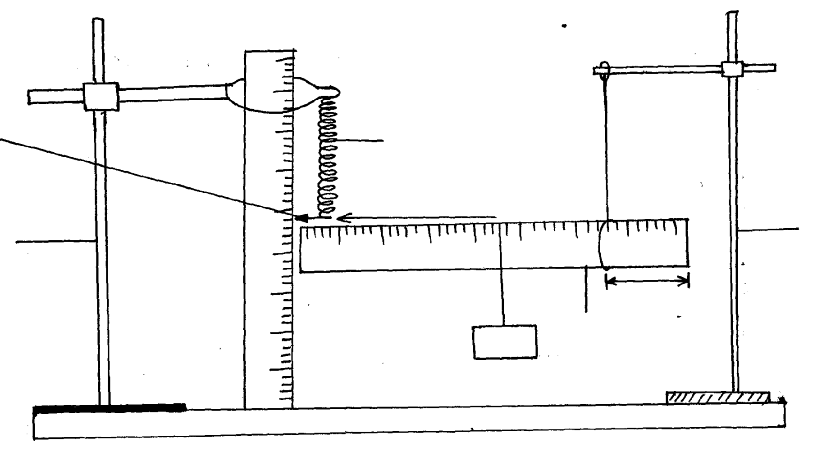

Optical pin (pointer)

Lo cm
L =10cm
Stand
200g
Metre rule
15cm
Stand

- Suspend one end of the metre rule with a thread at 5 cm mark from the end
- Suspend the other end with spring also 5cm from the end so that metere rule is horizontal.
- Hold the other rule vertically on the bench so that it is near the end with apointer as shown in the diagram above.
- Read the pointer position, Lo_____________________________cm (1mk)
- Hang on the horizontal metre rule the 200g mass at a length l = 10cm from the spring record the extension, e, of the spring in the table below.
- Displace the mass slightly downward and release it to oscillate vertically. Take time for 20 oscillation and record in he table below.
- Repeat for other position of L, of the mass.

NB: before taking the reading, ensure the oscillation is steady.
Length L (cm) | 10 | 20 | 30 | 40 | 50
Extension M (cm)
Time for 20 oscillation ( sec)
Periodic time T (sec)
T² (sec)²

(5mks)
- Plot a graph of extension, e (m) ( y – axis) against T² (s)² (5mks)
- Calculate the gradient of the graph (2mks)

- Given that + C, determine the value of R ( 3mks)

Part B

(b) You are provided with a lens P a lens holder a white screen and a 30cm rule

Procedure:

- Set the apparatus as shown in figure 4 below. Focus a sharp image of a distant object on the screen. The object should be at least 10cm away.
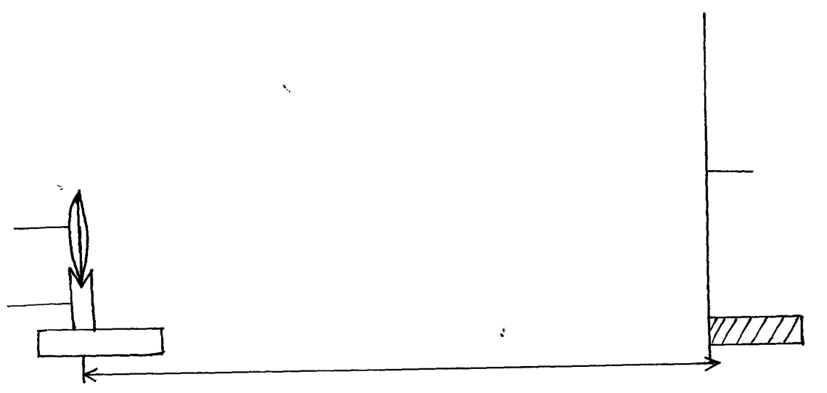

Screen
p

x
Lens holder
Lens

- Measure he distance x in cm between the lens and the screen at which a sharp image is obtained repeat this two times, using different objects and record your readings in table 3 below.

Table 3
Object | Distance X, (cm)
1
2
(2mks)

- Calculate the average value of x (2mks)

- What is the physical significance of the result obtained in (iii) above ? (1mk)

