Name:………………………………………………………………………………… Adm. No. …………………….
Class: …………………………
Signature:…………………….
232/3
PHYSICS Date: …………………………..
PRACTICAL
TIME: 2 ½ HRS

TEACHER.CO.KE SERIES 22

Kenya Certificate to Secondary Education
PHYSICS PAPER 3
PRACTICAL

Instructions
- Write your name, admission number, class, signature and date of examination in the spaces provided at the top of the page.
- Answer all the questions in the spaces provided in this paper.
- You are supposed to spend the first 15 minutes of the 2 ½ hours allowed for this paper reading the whole paper carefully before your start.
- Marks will be given for clear record of observations actually made, for their suitability and accuracy, and the use made of them.
- Candidates are advised to record their observations as soon as they are made.
- Electronic calculators and mathematical tables may be used.

FOR EXAMINER’S USE ONLY

Question 1
 | c | d | e | f | g | h  TOTAL
Maximum Score | 6 | 5 | 2 | 2 | 2 | 3
Candidate’s Score

Question 2
 | e | f | g | h(i) | h(ii) | i  TOTAL
Maximum score | 5 | 5 | 3 | 3 | 2 | 2
Candidate’s score |  |  |  |  |  | GRAND TOTAL

This paper consists of 8 printed pages. Candidates are advised to check and to make sure all pages are printed.
1. You are provided with the following;

- a galvanometer
- a dry cell and a cell holder
- a switch
- a wire labelled Y mounted on a piece of wood.
- eight connecting wires each with a crocodile clip at one end.
- a resistance wire labelled AB mounted on a millimeter scale.
- Six 10 ohm carbon resistors
- a jockey or crocodile clip
- micrometer screw gauge (to be shared)

Proceed as follows:

(a) Set up the circuit as shown in figure 1. Z is one of the 10 ohms carbon resistors.
Y
Z

G

B
A
P a

Figure 1
(b) Close the switch. Tap the jockey at various points on the wire AB and locate point P at which the galvanometer shows zero deflection, measure and record in table 1 the length a, where a = PB.

(c) Repeat the procedure in (b) using two 10Ω resistors in parallel, three resistors in parallel four resistors in parallel, five resistors in parallel and six resistors in parallel. Record your readings in table 1. Complete the table. X is the effective resistance for the parallel combination i.e. $X= \frac{10}{n}$ where n is the number of resistors in parallel. (6 marks)

Number of 10Ω  Carbon resistor | One | Two | Three | Four | Five | Six
X (Ω)
a (cm)
$\frac{1}{X}$ $(Ω$⁻¹)
$$\frac{1}{a} \left({cm}^{-1}\right)$$
(d) Plot a graph of $\frac{1}{a}$ (y-axis) against $\frac{1}{X}$ (5 marks)


(e) Determine the slope m of the graph. (2 marks)

(f) Given that $\frac{1}{a} = \frac{R}{K} . \frac{1}{X}+ \frac{1}{K}$ where K = 100cm. Use the graph to determine R. (2 marks)

(g) Measure the diameter d and the length L of wire Y and hence determine its cross-sectional area A. (2 marks)
L = ………………………………..cm = ……………………………….m
d = ………………………………….. m
A = ………………………………….
= …………………………………………. m²
(h) Determine the resistivity of the wire Y given that its
Resistance, $R= \frac{L}{A}$where is the resistivity of wire X.
L - the length of the wire Y
R – resistance of wire Y
A – cross sectional area of wire Y (3 marks)

2. You are provided with the following:
  - A spiral spring
  - A complete stand
  - A metre rule
  - A 100g mass
  - A knife edge (raised on a wooden block)
  - A half metre rule.

Proceed as follows:
(a) Determine the c.o.g of the metre rule using the knife edge
c.o.g. = ………………………….cm (1 mark)

(b) Set up the apparatus as shown. Using a string, hang the 100g mass on the c.o.g of the metre rule.

clamp

spring

h

metal rule
100 cm
c.o.g

100g

d 5cm

- Adjust the position of the pivot so that it is approximately 5cm from the free end of the metre rule.

- Adjust the clamp so that the metre rule is horizontal and the spring is vertical at 2cm mark.

- Measure and record the length h of the coiled part of the spring and distance d from the pivot to the point where the springs is attached to the metre rule.

- Repeat (c) and (d) for different positions of the pivot along the metre rule as shown in the table.

Position of pivot from free end | 5 | 15 | 25 | 35 | 45
Length h (cm)
d(cm)
(5 marks)

- Plot a graph of h (y-axis) against . (5 marks)
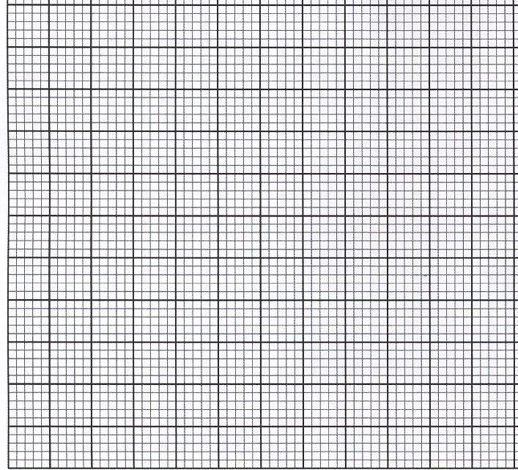

- Determine the gradient m and y – intercept c of the line.

m = (2 marks)

c = (1 mark)

(h) Determine:

(i) the weight W of the metre rule using the 100g mass.
d1 d2
c.o.g.

1.0N
W

d₁ = ………………………………………………………….. (½ mark)
d₂ = ………………………………………………………….. (½ mark)

Use your measurements to determine the weight, W of the metre rule. (1 mark)

(ii) the spring constant K using the 100g mass. (2 marks)

h_{o} h

100g

h_{o} = ……………………………………………………… (½ mark)
h = ………………………………………………………. (½ mark)

Hence determine the spring constant K in S.I units (1 mark)

(i) The relationship between d and h is given by the equation.
h = where A and B are constants.
The value of A = where
W = weight of the metre rule
K = spring constant of the spring
Z = is a constant
B = $\frac{W+1}{K}$ + L₀ where L_{o} is a constant.

Use your answer of W and K to determine;

(i) Z (1 mark)

(ii) Lo (1 mark)

