NAME:………………………………………………INDEX………………..…..DATE…………..
SCHOOL:……………………………………………………SIGNATURE…………….…………

TEACHER.CO.KE SERIES 31

232/ 3
PHYSICS
PAPER 3
(PRACTICAL)

INSTRUCTIONS TO CANDIDATES

- Write your name, index number, date and sign in the spaces provided above.
- You are advised to spend the first 15 minutes of the hours given reading the entire question paper
- Answer all the questions in the spaces provided
- Marks are given for clear record of observations actually made for their suitability and accuracy for the use of them.
- Candidates are advised to record their observations as soon as they are made.
- K.N.E.C Mathematical tables and Non programmable silent electronic calculators may be used.
For Examiner’s Use Only

Question | Maximum Score | Candidates’ Score
Q1
Q2
Total

QUESTION 1
You are provided with the following apparatus:
- clamp
- boss
- stand
- optical pin
- copper wire (15 cm long)
- protractor
- two pieces of plasticine
- cork
- Set up the apparatus as shown in the diagram below
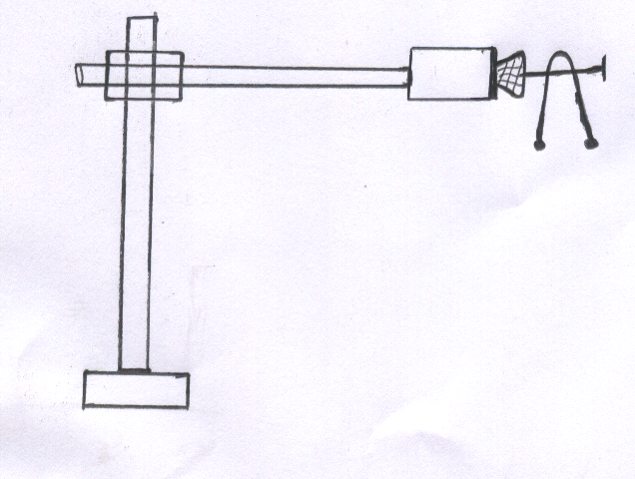
Angle
- Bend the wire in the middle so as to make an angle of 50⁰. Attach the two small pieces of plasticine at both ends of the bent wire as shown in the diagram.
- Place the bent wire on the optical pin and give a small horizontal displacement. Take the time for 10 complete oscillations and record in the table below.
- Repeat the procedure above for other values of and complete the table below. (9mks)
Angle | Time’t’for10oscillations (s) | Period T (s) | Frequency f (Hz) | f² (Hz)² | Cos
50
60
70
80
90
100
- On the graph paper provided, pot a graph of f² (y-axis) against cos (5mks)

Determine the gradient ‘S’ of the graph (3 mks)

- The equation for the oscillation of the wire is given by the formula:
Given that L = 0.15m, use the gradient of the graph to determine the value of Z. (3mks)

QUESTION 2
You are provided with the following:
- One dry cell and a cell holder
- One voltmeter
- One ammeter
- A wire mounted on a mm scale labelled R
- Seven (7) connecting wires with at least 4 with crocodile clips
- A micrometer screw gauge (to be shared)
- Set up the apparatus as shown in the figure below
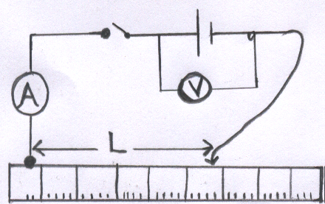

- Starting with L equal to 20cm close the switch and record the readings of voltage ‘V’ and ammeter (A), then open the switch.
- Repeat the procedure in (b) above for the values of L equal to 30cm, 40cm, 50cm, 60cm, and 70cm and record your results in the table below. (6mks)
Length L (cm) | 20 | 30 | 40 | 50 | 60 | 70
Voltage V (v)
Current I (A)

- Plot a graph of against L (5mks)

- Find the slope ‘S’ of your graph (3 mks)

- Calculate the value of R. Given that R=100 S (2 mks)

- Measure the diameter D of the wire (2 mks)

- Calculate the resistivity P of the wire given by (2 mks)

