NAME: ………………………………………………………… INDEX NO. ………………….…………
SCHOOL: ………………………………………………………. CANDIDATE’S SIGN. …………............
DATE……………………………………..………………………

TEACHER.CO.KE SERIES 32
232/3
PHYSICS
PAPER 3 (PRACTICAL)
TIME: 2¹/₄ HOURS

INSTRUCTIONS TO CANDIDATES:
- Write your name and index number in the spaces provided above.
- Sign and write the date of the examination in the spaces provided above.
- You are supposed to spend the first 15 minutes of the 2 ½ hours allowed for this paper reading the whole paper carefully.
- Marks are given for a clear record of the observation actually made, their suitability, accuracy and the use made of them.
- KNEC mathematical tables and silent non-programmable electronic calculators may be used.
For Examiners’ Use Only
Question 1 | c | f | g(i) | g(ii) | g(iii) | h
Max Score | 2 | 7 | 5 | 2 | 2 | 2
Candidate’s score

TOTAL
 | Part I |  |  |  | Part II
Question 2 | b | d | e | f | b | c
Max Score | 1 | 8 | 5 | 2 | 3 | 1
Candidate’s score

TOTAL

GRAND TOTAL

This paper consists of 4 printed pages. Candidates should check to ascertain that all pages are printed as indicated and that no questions are missing.

1. You are provided with the following;
- A piece of candle
- Plane mirror
- Metre rule
- A thin lens mounted on a lens holder
- A cardboard with cross-wire at its centre
- A piece of plasticine
- A white screen
Proceed as follows;
- Set up the apparatus as shown in figure 1.

Ensure that the candle frame is at the same height as the cross wires. The plane mirror should also be attached to the lens as shown using a piece of cellotape. Plasticine can be used to fix the metre rule to the table.
- Place the cardboard with cross-wire at the centre at the O mark of the metre rule.
- Move the object along the metre rule until a sharp image of the cross wire is formed alongside the object cross-wire.
Measure the length d using the metre rule.
d:……………………………………………………………………m (2mks)
- Now arrange the candle flame, the lens, the object and the screen as shown below.

- Adjust the distance between the lens and the object O to each of the distances given in the table. For every value of u, adjust the position of the screen until a sharp image of the cross wires appear on the screen. Measure the value of v and record in the table.

- Repeat the procedure (e) above for each of the other values of u and complete the table below.
Table 1
u(cm) | 35 | 40 | 45 | 50 | 55 | 60 | 70
v(cm)
uv(cm³)
u+v(cm)
(7mks)
g)i) Plot the graph of uv against u+v. (5mks)

ii) From your graph, calculate the slope, S (2mks)

iii) Use the graph to determine the focal length. (2mks)

h) How is the focal length obtained in (i) above related to d obtained in (c). Explain your answer. (2mks)

2. PART I
You are provided with the following;
- A spiral spring
- One stand, one boss and one clamp
- A metre rule
- A stop watch
- A set of masses
Proceed as follows;
- Arrange the set up as shown below.

- Note the reading of the pointer of the spring when no mass is suspended from its hook.
L_{o}=…………………………………………….cm (1mk)
- Attach a 50g mass on the spiral spring and measure the length L of the spring with the mass 50g on the spring, slightly displace the spring downwards and note the time for 20 oscillations. Record your results in the table 2 below.
- Repeat procedure (c) above for 100g, 120g, 150g, 200g and 250g. Complete the table below.
Table 2
Mass M(g) | 50 | 100 | 120 | 150 | 200 | 250
L(cm)
e=L-L_{o}(cm)
Time, t for 20 oscillations (s)
Log t
Log e
(8mks)
e) Plot the graph of log t against log e. (5mks)

f) Given that;
Log t intercept = ½ log 16π²
A
Determine the value of A (2mks)

PART II
You are provided with the following apparatus;
- One new dry cell
- One cell holder
- Switch, K
- An ammeter
- A voltmeter
- A variable resistor, rheostat or potentiometer
- Seven connecting wires, at least 4 of which with crocodile clips
- A bulb holder
- A torch bulb 2.5V (for 2 dry cells)
- Set up the apparatus as shown below.
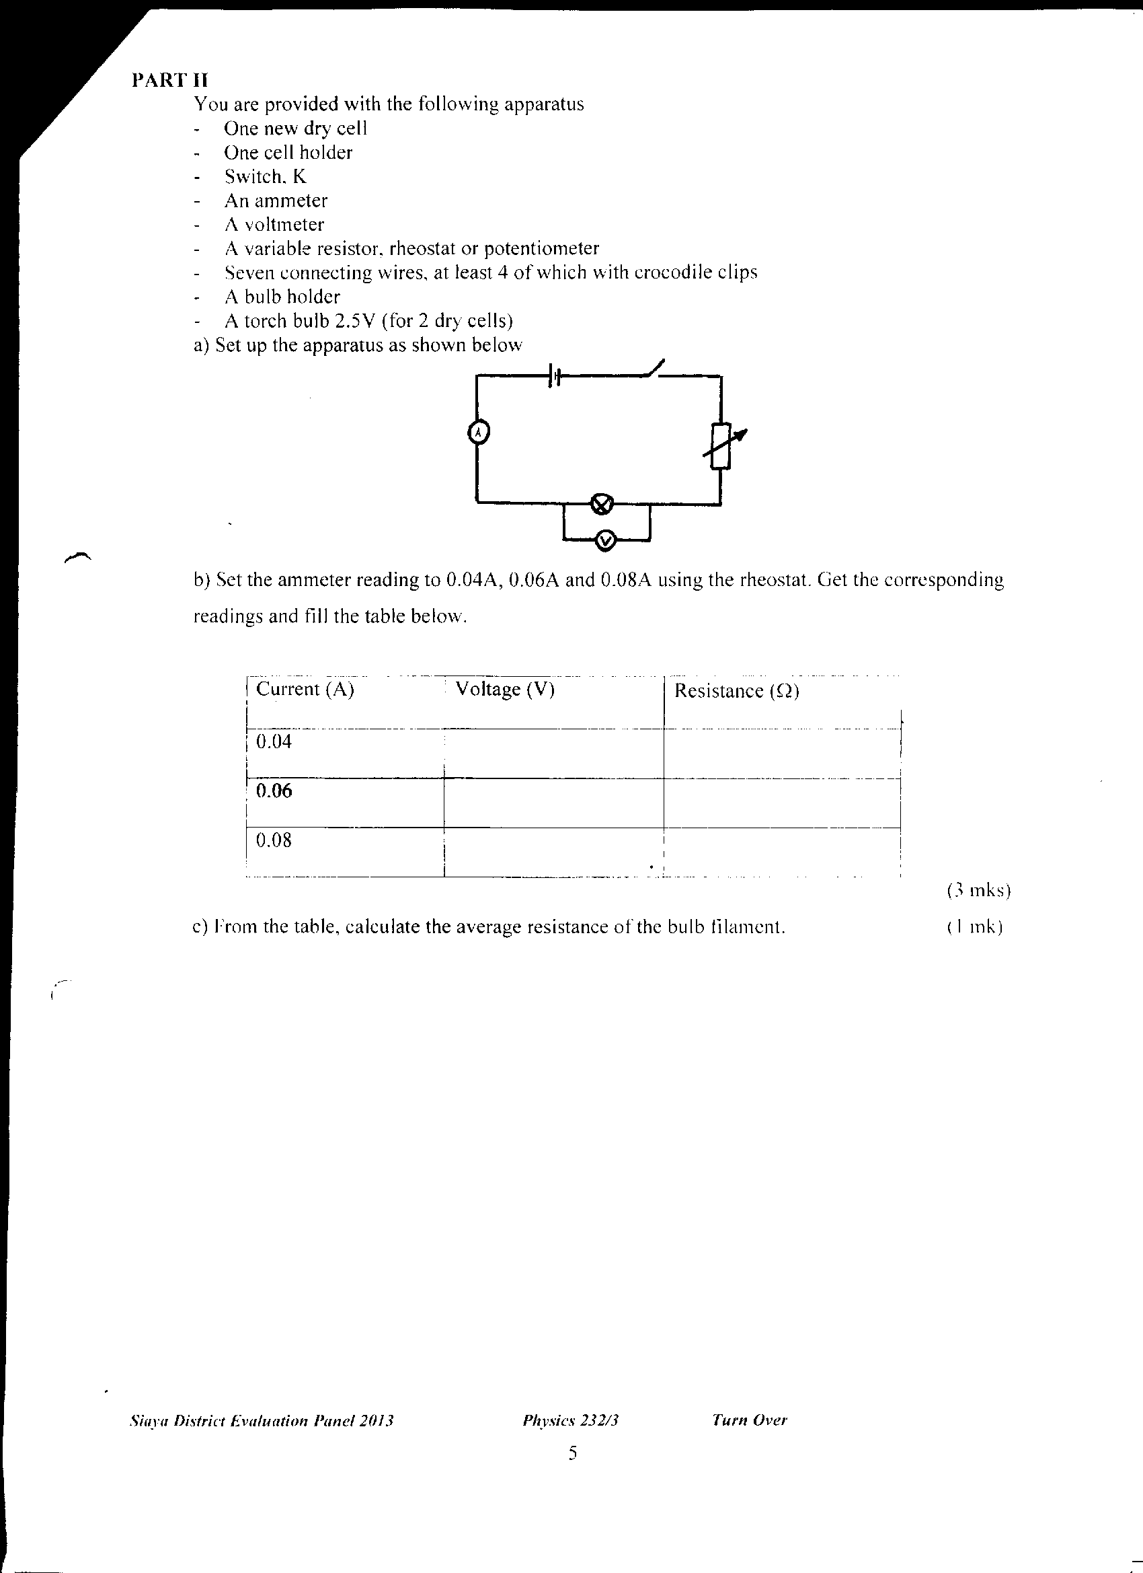

- Set the ammeter reading to 0.04A, 0.06A and 0.08A using the rheostat. Get the corresponding readings and fill the table below.
Table 3
Current (A) | Voltage (V) | Resistance (Ω)
0.04
0.06
0.08
(3mks)
c) From the table, calculate the average resistance of the bulb filament. (1mk)

