NAME: …………………………………………. INDEX NO: ……………………………….

SIGNATURE: ………………………………… DATE : …………………………………..

SIGNATURE: ……………………………

TEACHER.CO.KE SERIES 37

232 / 3
PHYSICS
PAPER 3
(PRACTICAL)
TIME: 2 ½ HOURS

INSTRUCTIONS TO CANDIDATES

- Write your Name and Index Number in the spaces provided above.
- Sign and write the date of Examination in the spaces provided above.
- Answer all questions in the spaces provided.
- You are supposed to spend the first 15 minutes of the 2½ hours allowed for this paper reading the whole paper carefully before commencing your work.
- Marks will be given for clear records of observations actually made, their suitability, accuracy and the use made of them.
- Candidates are advised to record their observations as soon as they are made.
- All working must be clearly shown where necessary.
- Mathematical tables and silent electronic calculators may be used in calculations.

FOR EXAMINER’S USE ONLY

Question | Maximum score | Candidate’s score
1 | 20
2 | 20
TOTAL | 40

- You are provided with the following:-
- Two dry cells.
- Nichrome wire 100cm on a mm scale.
- An ammeter.
- Cell holder.
- Voltmeter.
- Connecting wires with crocodile clips.
- Switch.

Proceed as follows:

    - Connect the circuit as shown in the diagram.
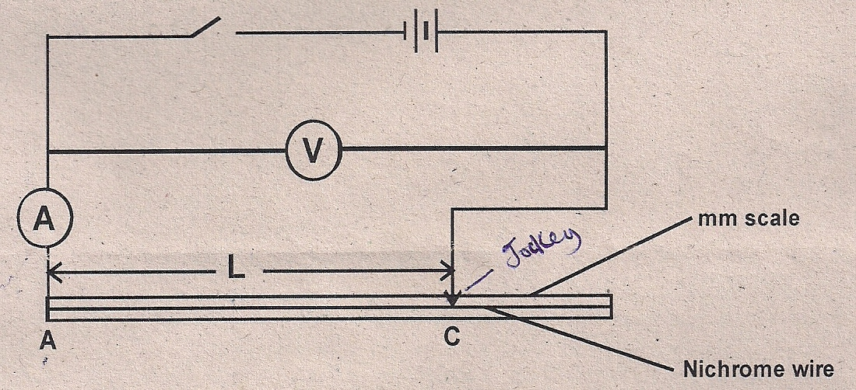
    - Connect the ends A and C where AC is the length L of the Nichrome wire across the terminals as shown. Close the switch and measure both current I and potential difference (p.d) across the wire AC when L = 100cm.
Current I = (1mk)

p.d. V = (1mk)

    - Measure the E.m.f. of the cells, E.
E = (1mk)

    - Reduce the length L (AC) to the lengths shown in the table below. In each case record the current, I, and the corresponding p.d. (7mks)
Length L (cm) | 100 | 70 | 60 | 50 | 40 | 20
I (A)
P.d (V)
E – V (v)

    - Plot a graph of E – V against (A) on x-axis in the grid provided. (5mks)

    - Determine the slope of the graph. (3mks)

    - Given that E = V + Ir, determine the internal resistance, r, of each cell. (2mks)

- You are provided with the following apparatus:-
- A metre rule.
- One stop watch. one stand, clamp and boss.
- One spring.
- Two pieces of wood.
- A beam balance or electronic balance (to be shared)
- One mass labeled M.

Proceed as follows:
        - Hang the spring vertically by clamping one end as shown in figure 1. (The small pieces of wood to clamp the spring).
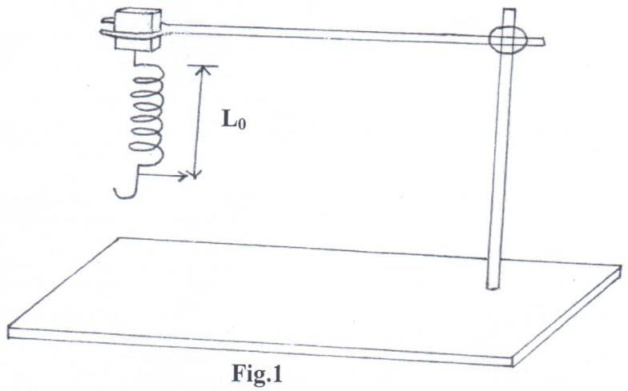
        - Measure the length, Lo, of the unloaded spring, and record below.
Lo ___________________________mm (½ mk)

        - Hang the mass M given from the lower end of the spring. Measure the length, L₁ of the loaded spring.
L₁ = _________________________ mm (½ mk)

        - Find the value of L₁ – Lo in centimeters
L = L₁ – Lo _____________________ cm (1mk)

        - Using the balance given, find the mass of the object M.
Mass of M = __________________ g (1mk)

        - Hang the mass M from the lower end of the spring. Displace it by a small vertical distance and release so that the spring makes vertical oscillations.

Measure and record, time for the number of oscillations given in the table below.
Oscillations, N | 5 | 7 | 10 | 13 | 15 | 18 | 20
Time in seconds, t (s)
(N + 10t) (s)
10
(N + 10t)² (s²)
19
Complete the table above. (7mks)
        - On the grid provided, plot a graph of N + 10t ² (y-axis) against N. (5mks)
10
        - (i) Determine the slope S, of the graph at N = 16. (3mks)

(ii) Find the constant k, given that:
K = MS (2mks)
13L

