Name: ………………………………………………………………… Adm. No: ……………………......................

Date: ……………….…………..…................................................. Candidate’s Signature:…………………………….

TEACHER.CO.KE SERIES 38

232/3
PHYSICS
Paper 3 (Practical)
Time: 2 ½ Hours

Kenya Certificate of Secondary Education (K.C.S.E)
Physics
Paper 3

INSTRUCTIONS TO THE CANDIDATES:
- Write your name and index number in the spaces provided above.
- Sign and write the date of the examination in the spaces provided above.
- You are supposed to spend the first 15 minutes of the 2 ½ hours allowed for this paper reading the whole paper carefully.
- Marks are given for a clear record of the observation actually made, their suitability, accuracy and the use made of them
.

FOR EXAMINER’S USE ONLY

Question | Maximum Score | Candidate’s Score
1 | 20
2 | 20
TOTAL | 40

This paper consists of 7 printed pages. Candidates should check to ascertain that all pages are printed as indicated and that no questions are missing.

QUESTION
Apparatus
Concave mirror on a lens holder
Screen
Metre rule
Candle
Proceed as follows;

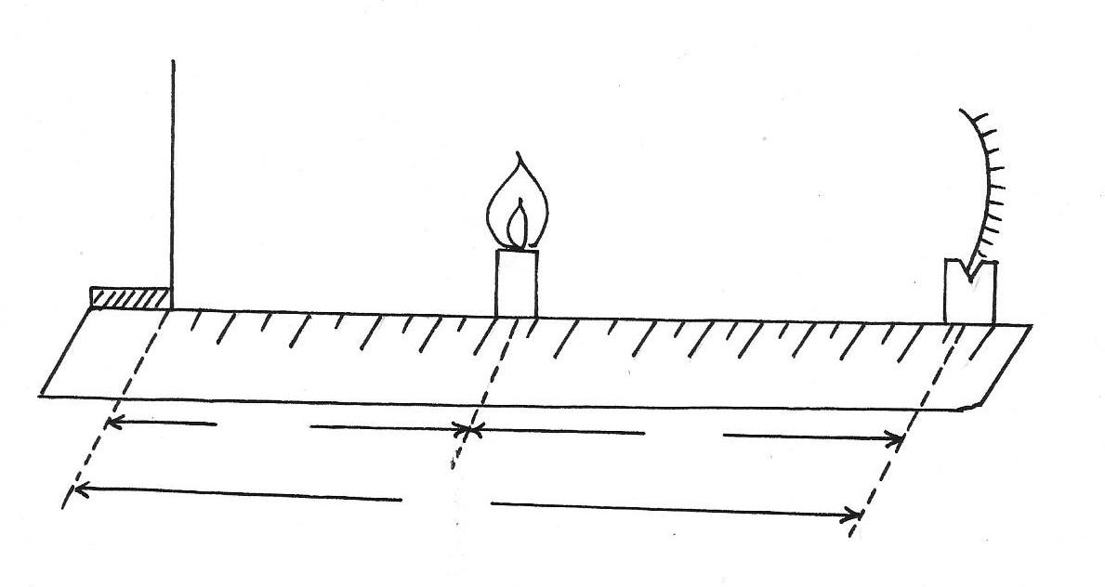
Metre rule
screen
Candle
Concave mirror
x
u
V
Figure 1

(i) Set the apparatus as shown in fig 1
(ii) Place the candle at a distance x= 5.0cm from the screen
(iii) Move the mirror to and from to focus a clear, sharp image of the candle on the screen
(iv) Measure and record the distance u between the mirror and candle and the distance v between the screen and the mirror.
(v) Repeat the experiment for other values of x and complete the table below (table 1)
X(cm) | 5.0 | 10.0 | 15.0 | 20.0 | 25.0 | 30.0
U(cm)
V(cm)
(u+v) cm
Uv(cm2)
(vi) Plot a graph of (u+v) (y axis) against uv (5mks)
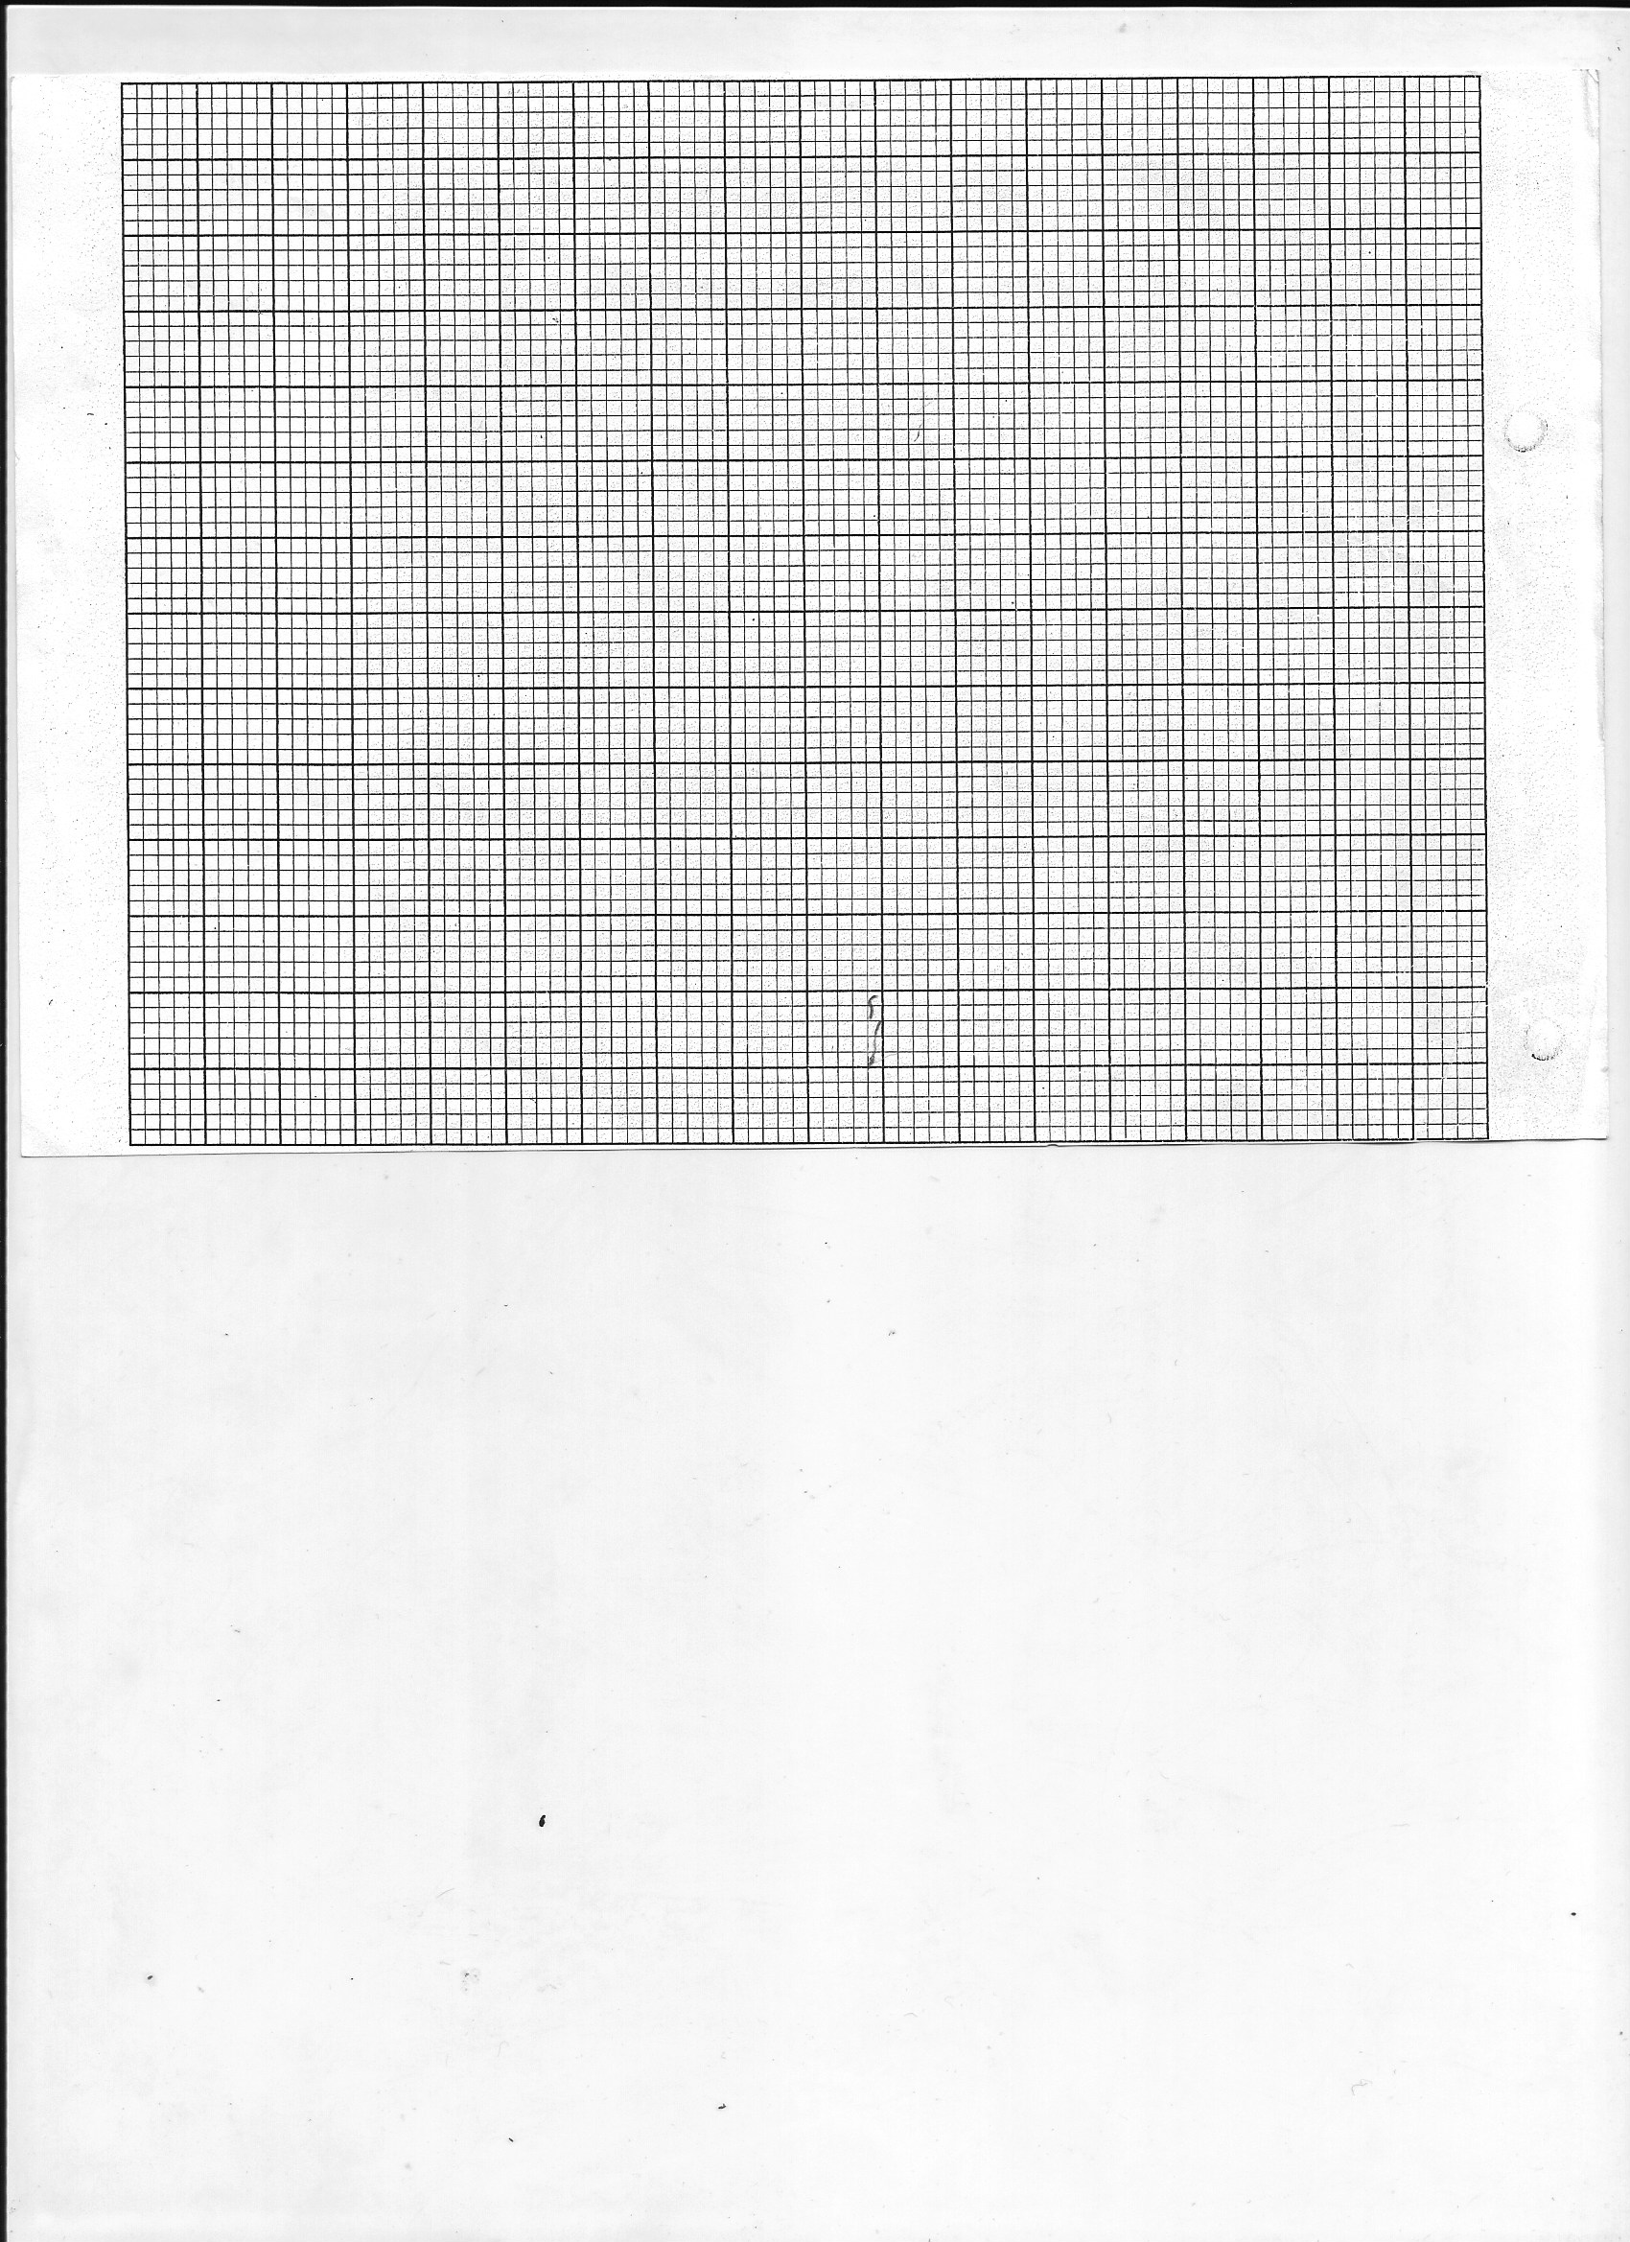

(v) Determine the slope S of the graph (5mks)
......................................................................................................................................................
......................................................................................................................................................
(b) Using the value of S obtained in VII above, determines the value of f, the focal length of the mirror. (2mks)
......................................................................................................................................................
......................................................................................................................................................
(c) Given that R = 4f determine the value of R (2mks)
S²
......................................................................................................................................................
......................................................................................................................................................
......................................................................................................................................................
QUESTION 2
You are provided with the following
- An ammeter (0-1A)
- A voltmeter
- A wire mounted on a mm scale
- A switch
- A long wire with a crocodile clip at one end (crocodile clip to be used or a jockey)
- 2 new size D dry cells and a cell holder
- A micrometer screw gauge(may be shared)
- Six connecting wires, two with crocodile clips at the end
Proceed as follows
(i) measure the diameter d of the mounted wire at 3 different points
Average diameter= mm (1mk)
(ii) Set up the apparatus as shown in the circuit diagram in fig 2

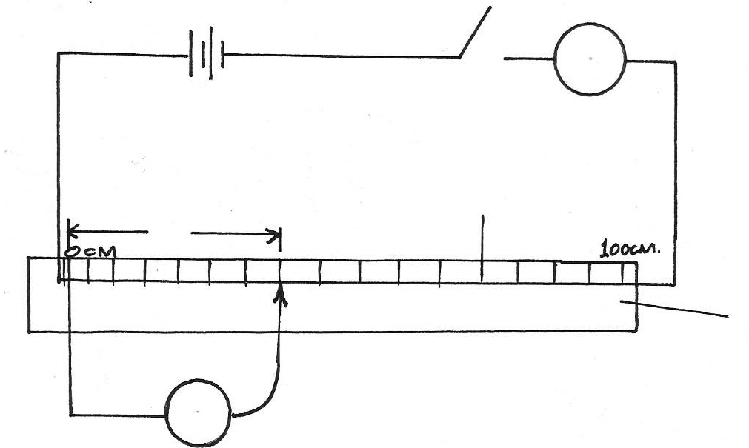
Mm scale
Mounted wire
A
Figure 2
L

V

(iii) Close the switch and tap the mounted wire with crocodile chip as shown in the circuit. Ensure that both meters show possible deflection. Open the switch
(iv) Tap the wire at L= 20cm, close the switch, and record in the table provided the ammeter and the voltmeter reading.
(v) Repeat procedure in IV for the other values of L, shown in the table below and complete the table. (8mks)

L (cm) | L(m) | V(volts) | I | R= V (Ω)  I
20
30
40
50
60
70
80

(vi) Plot the graph of R(y-axis) against Lcm (grid provided)

(a) Determine the slope of the graph (3mks)
......................................................................................................................................................
......................................................................................................................................................
......................................................................................................................................................
R =ℓL
A
(b) Given that the where A is the cross sectional area of the wire and ρ is a constant for the material of wire. Determine the value of the constant ρ

