Name…………………………………………………………………………… Index No……………..
School………………………………………………………………………….. Date………………….
Candidate’s signature…………………………………..

TEACHER.CO.KE SERIES 40

232/3
PHYSICS
PRACTICAL
PAPER 3

INSTRUCTIONS TO THE CANDIDATES:
. Write your name and Index Number in the spaces provided above.
2. Sign and write the date of examination in the spaces provided above
3. Answer all the questions in the spaces provided in the question paper.
4. You are supposed to spend the first 15 minutes of the 2 ½ hours allowed for this paper reading the whole paper carefully before commencing your work.
5. Marks are given for a clear record of the observations actually made, their suitability, accuracy and the use made of them.
6. Candidates are advised to record their observations as soon as they are made.
7. Non-programmable silent electronic calculators and KNEC mathematical tables may be used.

FOR EXAMINERS’ USE ONLY
Q1
QUESTION | a | b | c | TOTAL
MAXIMUM SCORE | 1 | 2 | 17
CANDIDATES SCORE

Q.2
QUESTION | b | c | d | e | f | g | TOTAL
MAXIMUM SCORE | 8 | - | 5 | 3 | 3 | 1
CANDIDATES SCORE

This paper consists of 12 Printed pages.
Candidates should check to ascertain that all pages are printed as indicated and that no questions are missing.

1. You are provided with the following
- A metre rule
- A piece of thread
- A clamp, boss and stand
- A mass labeled W
- 2 masses of 20g
- A mass of 50g
- 2 masses of 10g
Procedure
a) Using thread suspend the metre rule from the stand and note down the centre of gravity.

G=………………………………………… cm
b) i) Hang the mass W from the 65 cm mark. Suspend the 50g mass from the other side
and adjust its position till the system is in equilibrium as shown in the figure below
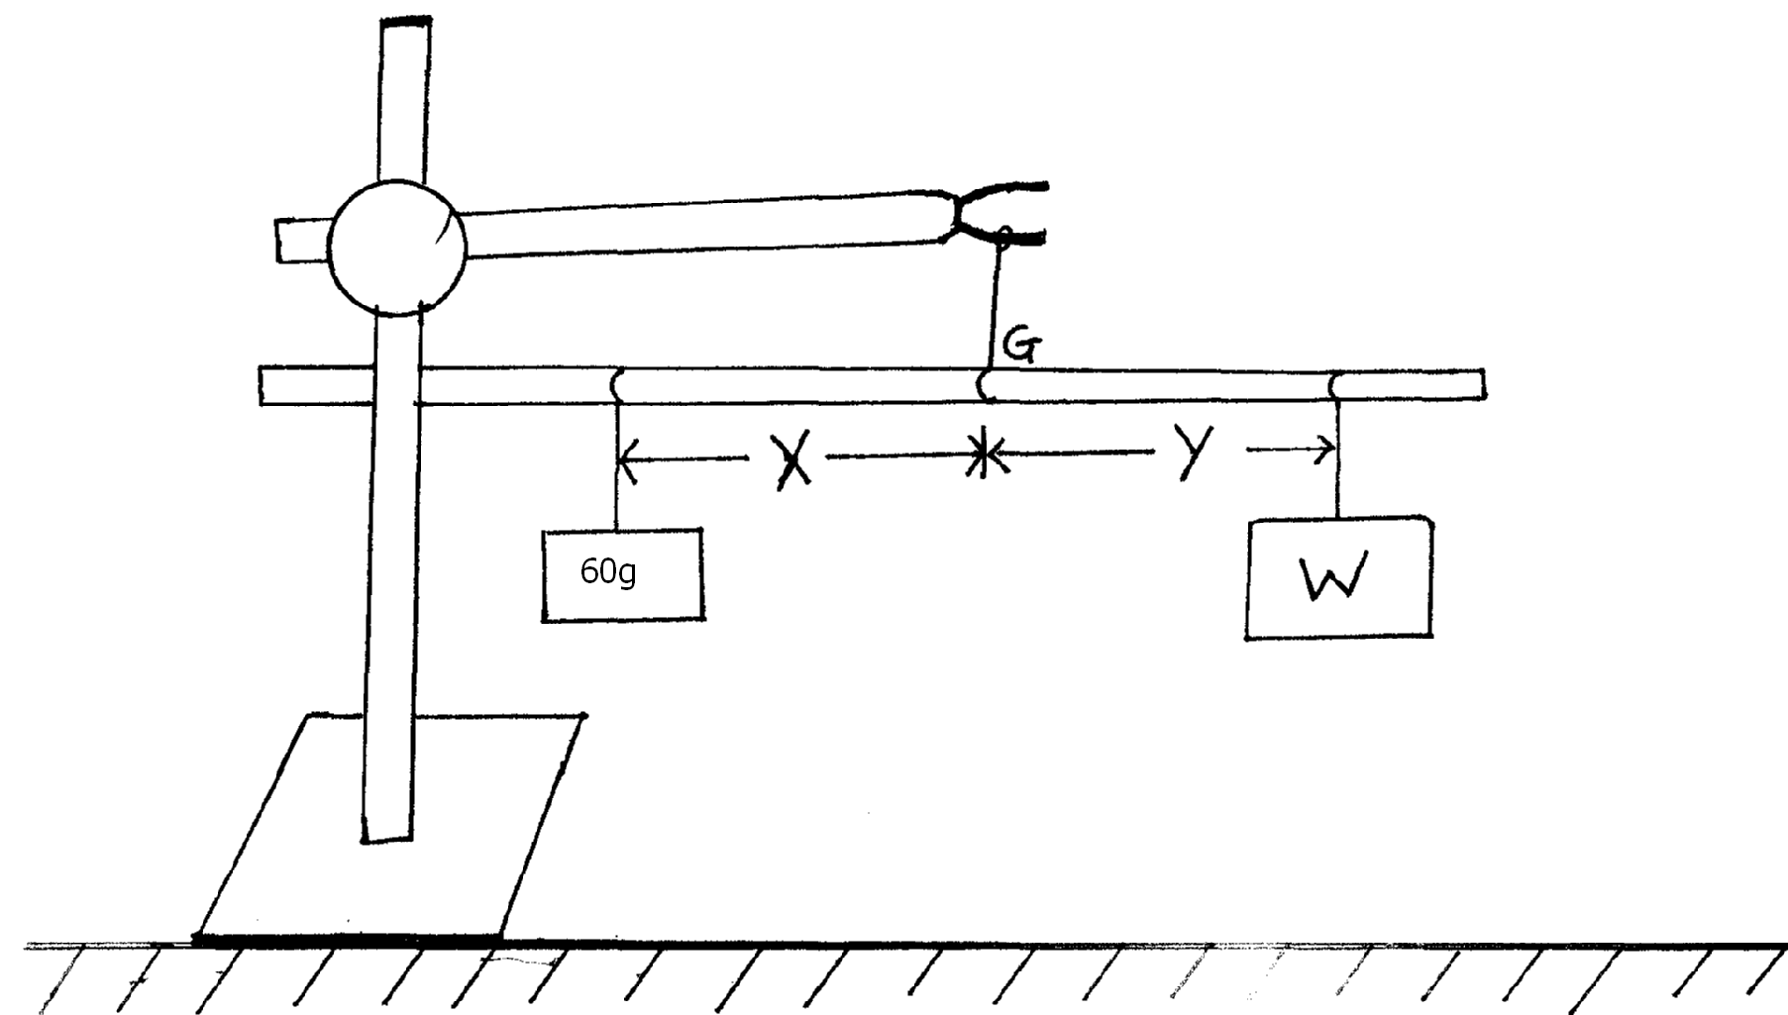

ii) Measure distance X and Y
X=…………………….. Metres (1 mark)
Y=…………………….. Metres (1 mark)
c) i) Maintaining the points of suspension of the metre rule at G and the mass labeled W
at 65cm mark. Repeat the experiment for the masses of 70, 80,, 90, 100 and 120g.. enter the results in the table below.
Mass(g) | WeightF(N) | DistanceX(M)
50
70
80
90
100
120
ii) Plot a graph of F against (5 mark)

iii) Determine the slope, S, of the graph. (3 marks)

iv) Given that F= where W is a constant, find its value. (3 marks)

2. You are provided with the following apparatus
- An Ammeter(0-1.0A)
- A voltmeter(0-2.5V)
- A resistance wire PQ mounted on a mm scale
- Two new dry cells.
- A switch
- A cell holder
- Six connecting wires
Procedure
- Set up the apparatus as shown below.
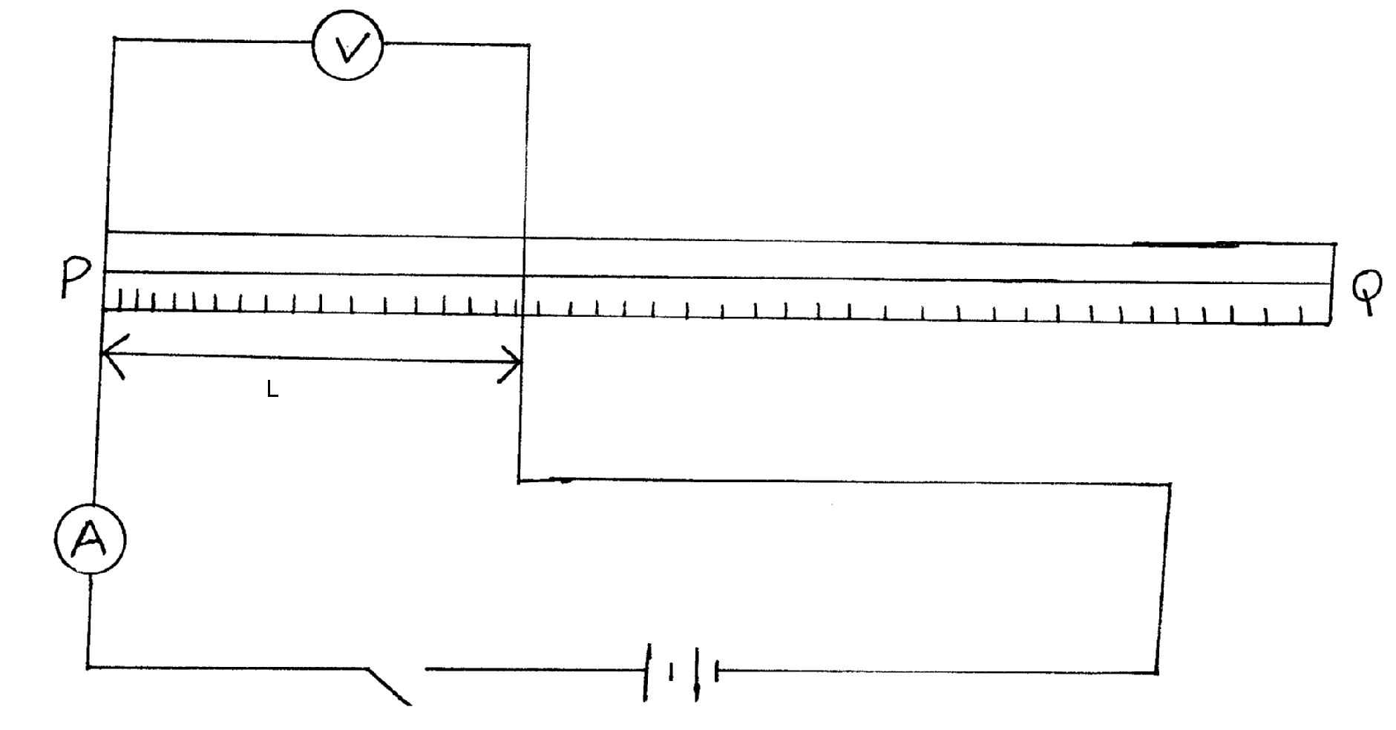

b) Starting with L=0.2 m, close the switch. Record the value of I, the current through the
wire and V, the p.d across it. Enter your results in the table drawn below

L(M) | 0.2 | 0.4 | 0.5 | 0.6 | 0.7 | 0.8
I(A)

p.d(V)

R=
c) Repeat part (b) above for the value of L, shown in the table.
Record the corresponding values of I and V. Calculate the values of R and and enter the values in the table.
d) On the grid provided, plot graph of R(y-axis) against (x-axis) (5 marks)

e) Determine the slope, S, of your graph. (3 marks)

f) If the graph obeys the equation:
Determine :
- The value of E. (1 mark)

- The value of r. (2 marks)

g) Draw a simple circuit you can use to determine the E.M.F of a single cell. (1 mark)

END

