NAME: ………………………………………………………. INDEX NO:..…...……………………….
SCHOOL: …………………………………………………… Candidate’s signature: ………………..
Date: ……………………………………

TEACHER.CO.KE SERIES 43

232 / 3
PHYSICS
PAPER 3
2 ½ HOURS

INSTRUCTIONS TO CANDIDATES
- Write your name and index number in the spaces provided above.
- Answer ALL the questions in the spaces provided in the question paper.
- You are not allowed to start working with the apparatus for the first ¼ hours of the 2 ½ hours allowed for this paper. This time is to enable you read the question paper and make sure you have all the apparatus you may need.
- Marks are given for a clear record of the observations actually made, for their suitability and accuracy and the use made of them.
- Candidates are advised to record their observations as soon as they are made.
- Mathematical tables and electronic calculators may be used in calculations.

FOR EXAMINERS USE ONLY
Question 1 | A | B(i) | B(ii) | C(i) | C(ii)
Maximum Score | 8 | 5 | 2 | 3 | 2
Candidate’s Score

Question 2 | D(iv) | D(v) | E (iii) | E(v) | F | G
Maximum Score | 2 | 2 | 5 | 8 | 1 | 2
Candidate’s Score

This paper consists of 7 printed pages.
Candidates should check the question paper to ensure that all pages are printed as indicated and no questions are missing.

- You are provided with;
- A bob mass attached on a string having a mark on it.
- Stop watch.
- Metre rule.
- Wooden plank with nail fixed at its Centre.
- Two complete retort stand.
- Cotton thread with a mark.

Procedure
- Arrange the apparatus as shown.
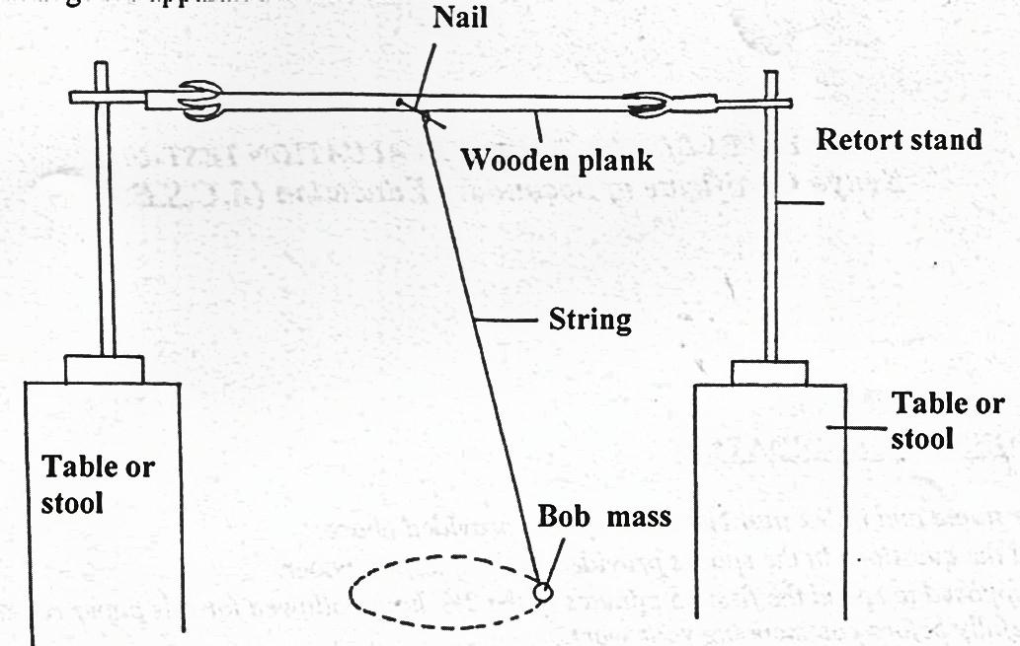
Tie the string so as that the nail. Set the bob into a conical pendulum oscillation with a small angle displacement to the vertical. Obtain time for 10 oscillations and period t second and square for period. The reduce the string by a length d and repeat exercise of determining time 10 oscillations period and period, filling and completing table 1.

Table 1
d,m | 0 | 0.2 | 0.3 | 0.5 | 0.6 | 0.7 | 0.8 | 0.9
Time for 10 oscillations,(s)
Period, T,(s)
Period²T²,(S²)

- i) Draw graph of T²(S²)against reduced distance d(m). (5 marks)

- Determine slope, G, of your graph. (2 marks)

- Given that.
T²n +39478d =39.478L where d is reduced distanced distance and L and n are constant, determine
- L (3 marks)

- n (2 marks)

PART 1
You are provided with the following set of apparatus.
- A metre rule.
- A white screen.
- A candle.
- Lens and lens holder.

Procedure
- Set up apparatus as shown.
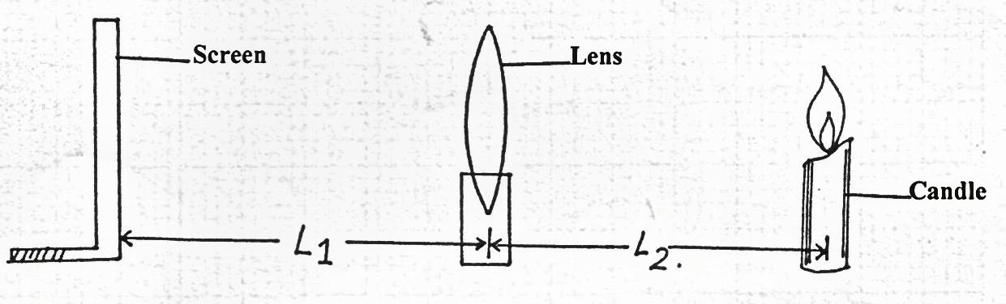
- Staring with L₁=30cm, adjust the position of the candle in order to obtain a sharp image on the screen. Record the value of L₂.
- Repeat the procedure for L₁=60 cm.

- Fill and complete for values of L₁/L₂ below. (2 marks)
L₁ cm | L₂(cm)
30
60

- Given the equation where
Determine the value of focal length f, (2 marks)

PART 11
You are given the following apparatus.
- An ammeter (0-1.OA).
- A wire labeled P mounted on a millimeter scale.
- One size D new dry cell.
- Four connecting wires(two with clips at the end)
- Switch.
- Micrometer screw gauge.

Procedure
E. i) set up the apparatus as shown in the figure.
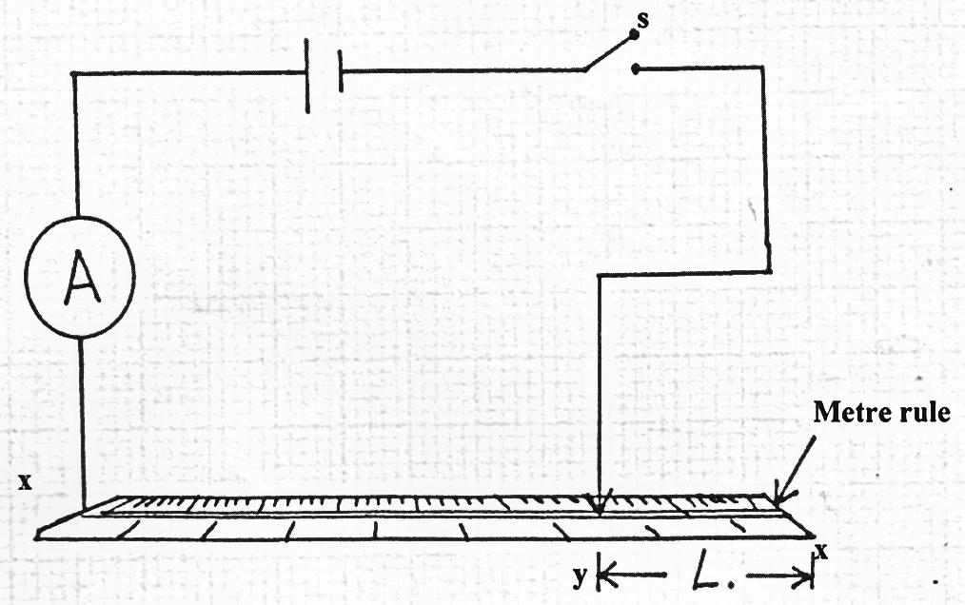
ii) Adjust the length L of the wire 20cm by placing the crocodile clip at Y. Record the ammeter reading.
iii) Repeat the procedure above for values of length L given in the table below and record the corresponding ammeter readings.
Length L(cm) | 20 | 30 | 40 | 50 | 60 | 70
Length (100-L)cm
Current I(A)
(A⁻¹)

- Complete the table above. (5 marks)
- a) Plot the graph of length (100 – L) (vertical axis)against (5 marks)

b) Determine the slope of the graph. (3 marks)

c) Measure the diameter of the mounted wire using the micrometer screw gauge.
Record the diameter d, in centimeters.
d = ……………………………… cm (1 mark)
d) Given that relation 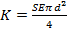
Where S the slope of the graph and E = 1.5v, determine the value of K. (2 marks)

