Name_________________________________________________________ Index No. _____________ Candidate’s signature ______ Date _______

TEACHER.CO.KE SERIES 5
PHYSICS
PAPER 3
PRACTICAL
INSTRUCTIONS TO CANDIDATES
(a) Write your name and index number in the spaces provided above.
(b) Sign and write the date of examination in the space provided above.
(c) Answer all the questions in the spaces provided in the question paper.
(d) You are supposed to spend the first 15 minute of the 2 ½ hours allowed for this paper reading the whole paper carefully before commencing your work.
Question 1 | a | c | e | g | h | i | j | Total
Maximum score | 1 | 1 | 2 | 6 | 5 | 3 | 2 | 20
Candidates score
FOR EXAMINERS USE ONLY
 | A |  |  |  | B
Question 2 | b | c | d (i) | d (ii) | b | c | d | e | f | Total
Maximum score | 1 | 3 | 1 | 1 | 2 | 3 | 5 | 3 | 1 | 20
Candidate score

Question 1
You are provided with the following apparatus
- Metre rule with marked ends A and B
- Knife edge
- Masses one 10g, two 20g and one 50g
- Thread = 30cm long

Procedure
(a) Record the value Ro as indicated on the metre rule
R_{o} = __________________________________ (1mk)

(b) Balance the metre rule provided on the knife edge with graduated side upwards
(c) Note the balance point and record its distance from end B.

L_{o} = _________________________________ cm (1mk)
(d) Using the thread provided hang a mass M of 10g at 10cm mark from end A and move the knife edge until the arrangement balances as shown below.

L₁ L_{o}
A 10cm B
●
P

M L₂
10g Knife edge

(e) Read and record the distances L1 and L2

L₁ = _______________________________cm (1mk)

L₂ = ______________________________cm (1mk)

(f) Repeat the above procedure for value M = 20g, 30g, 40g, 50g, 60g, 70g. (All masses must be hang at 10cm mark from end A)
(g) Fill the table below (6mks)
Mass M(g) | 10 | 20 | 30 | 40 | 50 | 60 | 70
L₁ (cm)
L₂ (cm)
L₂ – L_{o} (cm)
L₂ – L_{o}
L₁

(h) Plot a graph of M(y – axis) against L₂ – L_{o}
L₁ (5mks)

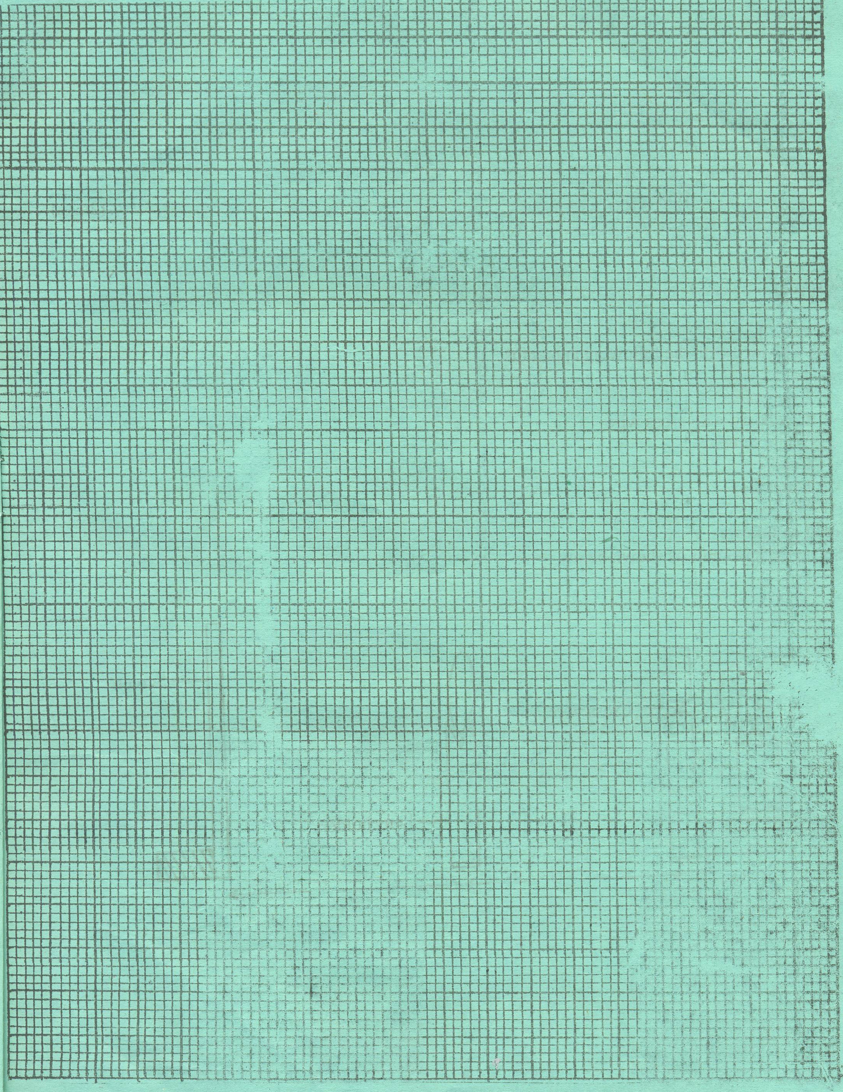

(i) Calculate the slope K of the graph (3mks)

(j) Determine n, if n = K
1000 (2mks)

Question 2 A
You are provided with the following apparatus
- Lens
- Lens holder
- Cardboard with cross wire
- White screen S
- Candle
- Match box

Proceed as follows
(a) Set up the apparatus as shown below

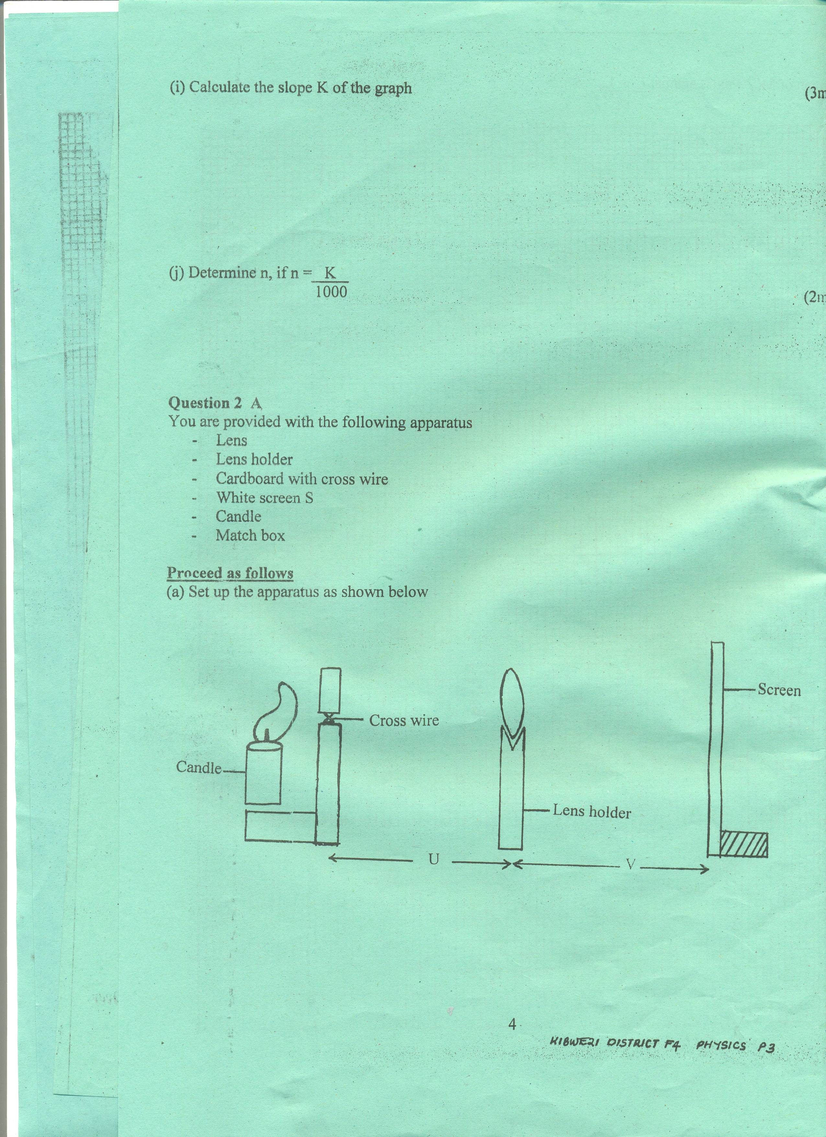

(b) Let the distance U be 15cm. by adjusting the distance of the screen from the lens, determine the distance V that will give the sharpest image of the cross wire on the screen.
Record the value for V

V = ______________________________ cm (1mk)

(c) Repeat the experiment for U = 20cm, 25cm and enter them in the table. Complete the table. (3mks)
U(cm) | V(cm) | ^{I}/_{U}(cm⁻¹) | ¹/_{V}(cm⁻¹) | ^{I}/_{U} + ^{I}/_{V} = ^{I}/_{f}(cm⁻¹)
15
20
25

(d) Determine
(i) Mean value of ^{I}/_{f} (1mk)

(ii) Mean value of f (1mk)

Question 2 B
You are provided with the following apparatus
- Two cells and cell holders
- One voltmeter
- Six connecting wires
- Nichrome wire XY mounted on 100cm scale
- Four crocodile clips
- One Ammeter

Proceed as follows

(a) Connect the apparatus provided as shown below

V

A

●
X P Y

(b) Adjust the length XP of the wire to 80cm using the crocodile clip at P. leave this disconnected when the reading is being taken

Read the voltmeter, V = ____________________V (1mk)

Read the ammeter, A = ____________________A (1mk)

(c) Repeat the procedure for other varied lengths XP and complete the table. (3mks)
Length XP(cm) | 80 | 70 | 60 | 50 | 40 | 30
P.d (V)
Current (A)

(d) Use the grid provided to plot a graph p.d against the current. (5mks)

(e) Calculate the slope and state its significance. (3mks)

(f) Determine the y – intercept of the graph. (1mk)

