Name: …………………………………………………………………… Index No: ……………………….
Candidate’s Signature:…………………… Date: ……………….…………..…

232/3
PHYSICS
(PRACTICAL)
PAPER 3
Time: 2 Hours

Kenya Certificate of Secondary Education

INSTRUCTIONS TO THE CANDIDATES:
- Write your name and index number in the spaces provided above.
- Sign and write the date of the examination in the spaces provided above.
- You are supposed to spend the first 15 minutes of the 2 ½ hours allowed for this paper reading the whole paper carefully.
- Marks are given for a clear record of the observation actually made, their suitability, accuracy and the use made of them.
- Candidates are advised to record their observations as soon as they are made
- All working must be clearly shown
- Mathematical tables, and electrical calculators may be used

FOR EXAMINER’S USE ONLY
Question | Maximum Score | Candidate’s Score
1 | 20
2 | 20
TOTAL | 40

This paper consists of 6 printed pages. Candidates should check to ascertain that all pages are printed as indicated and that no questions are missing.

- Question 1
You are provided with the following
A meter rule
A retort stand, clamp and boss
A 500 ml beaker ¾ full of water
A 50g mass
Liquid L in a beaker
10 cm cello tape
Tissue paper

Proceed as follows:
a) Balance the meter rule horizontally by suspending it from the stand and clamp with one of the thread.
Record the balance point G.
G = ………………………………………..cm mark (1mrk)

Note
For the rest of the experiment the position of the thread through G does not change, use cello tape to fix the position of thread.
b) Using a 100g mass and a 50g mass, set up the apparatus as shown below. The thread suspending the masses should be looped such that their positions of support can be adjusted.
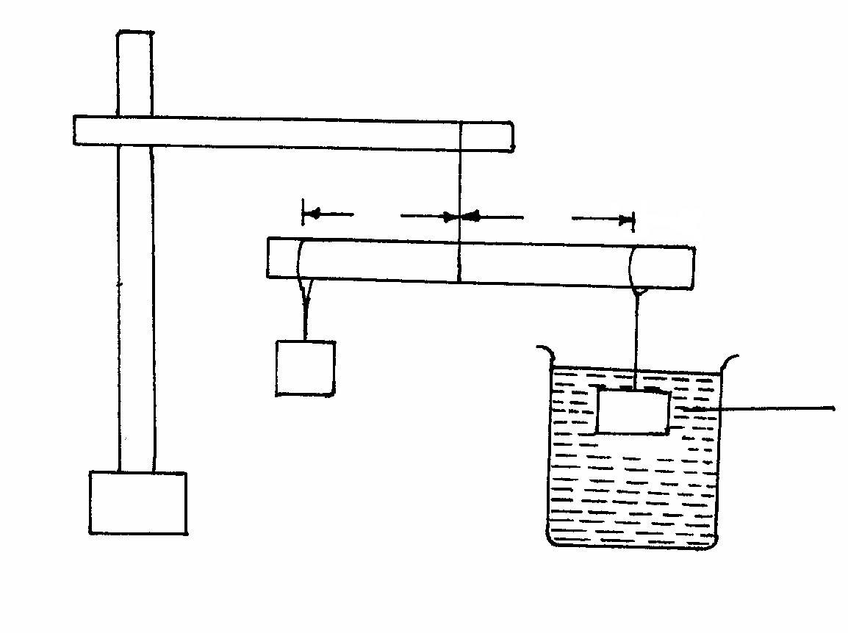
D
100g
50g
X
G
Water

Move the position of the 100g mass to and fro until the beam balance horizontally.
Note:
Distance X and D are measured from G.
Read and record the values of X and D
X=……………………………………..,,,,cm 1mrk)
D=…………………………………………cm (1mrk)

Work out the weight W₁ of the 100g mass
W₁ = ………………………………… (1mrk)

Apply principle of moments to determine the upthrust U _{w} in water. (1mrk)
U _{w}_______________________________

Remove the 100g mass from the water and dry it using the tissue paper, then suspended it
- Now balance the metre rule when the 100g mass is fully submerged in liquid L
Record distance X.
X =________________________________cm (1mrk)
Apply principle of moment to work out the upthrust U_{L} in the liquid (1mrk)

- Determine the relative density r.d of the Liquid L given that
r.d = U_{L}
U_{W} (2mrks)

Maintaining the 100g mass in liquid L,replace the 50g mass with the other 100g mass and adjust distance D to D =100mm. Adjust distance X until equilibrium is attained and record distance X.
Adjust D to the values indicated in the table below and record corresponding distance X that maintain equilibrium when the 100g mass is fully submerged. Complete the table
D(mm) | 100 | 150 | 200 | 250 | 300 | 350 | 400
X mm
(4mrks)

Plot a graph of X (vertical axis) against D on the grid provided (5mkrs)
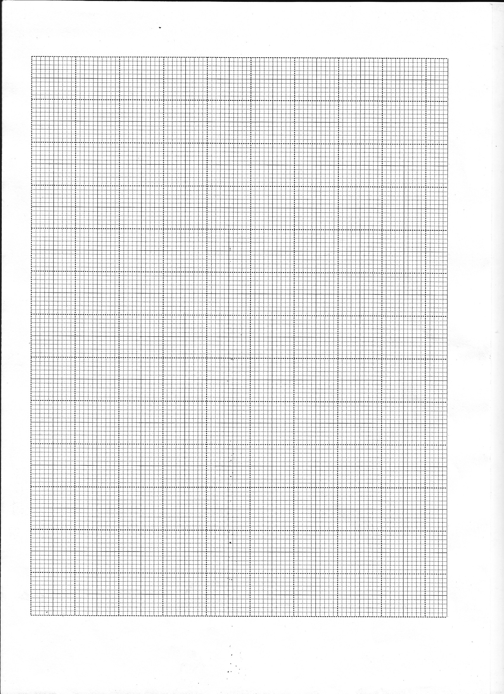
Determine the gradient S of the graph (2mrks)

Question 2
You are provided with the following
A milliammeter
A voltmeter
A wire mounted an a mm scale
A switch
Along wire with a crocodile clip at one end (crocodile clip to be used or a jockey)
A new size D dry cell and a cell holder
A micrometer screw gauge (may be shared)
5 connecting wires ,two with crocodile clips at the end.
Proceed as follows
- Measure the diameter of d the mounted wire at the different points
Average diameter =………………………………………………mm (1mrk)

- Set up the apparatus as shown in the circuit diagram in the figure below
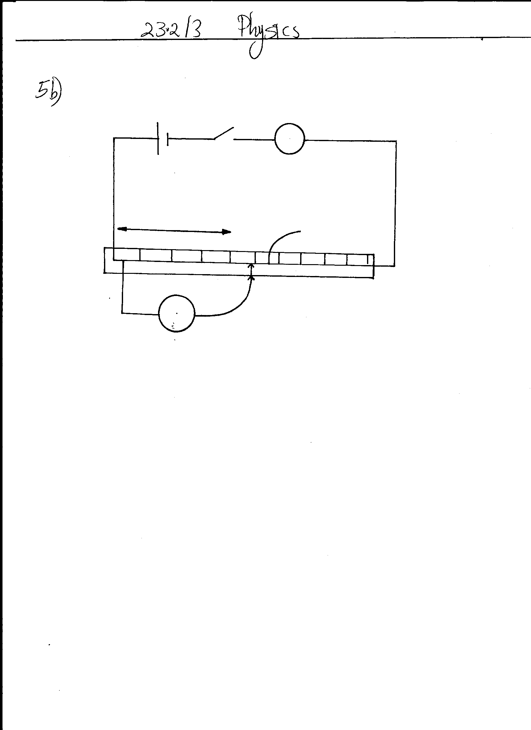
mA
V
L
0cm
Wire mounted
100cm

c) Close the switch and tap the mounted wire with crocodile clip as shown in the circuit. Ensure that both meters shows positive deflection. Open the switch.
d) Tap the wire at L=20cm, close the switch, read and record in the table provided the millimeter and voltmeter reading.

e) Repeat the procedure in(c) for other values of L, shown in the table below and complete the table. (8mrks)
L (cm) | L(m) | V(volts) | I |  | R =V  I
L (cm) | L(m) | V(volts) | mA | Amp | R =V  I
20
30
40
50
60
70
80
- Plot the graph of R (y-axis) against L(m) (5mrks)

- Determine the slope of the graph (3mrks)

ii) Given that the R= ρ L where A is the cross sectional area of the wire and ρ is a constant
A
for the material of the wire, determine the value of the constant ρ (3mrks)

