Name_________________________________________________________ Index No. ______________
Candidates signature ______
Date __________________


TEACHER.CO.KE SERIES 6

PHYSICS
PAPER 3
2 ½ HOURS

INSTRUCTIONS TO CANDIDATES
- Answer ALL the questions in the spaces provided in the spaces provided in the question paper.
- You are supposed to spend the first 15 min of the time given to go through the whole paper carefully before commencing your work
- Marks are given for a clear record of the observations actually made, their suitability and accuracy and the use made of them
- Record the observations as soon as they are made, mathematics tables, scientific calculators may be used

FOR EXAMINER’S USE ONLY
Question | Total marks | Candidate’s score
1 | 17
2 | 23

This paper consists of 5 printed pages
Turn Over
Question 1
You are provided with the following:
- Complete stand
- Meter rule
- Half meter rule
- Spring with a pointer
- 100g mass
- 30cm of masking tape
- 2 strings 10cm each

Proceed as follows.
(a) Set up the apparatus as shown below

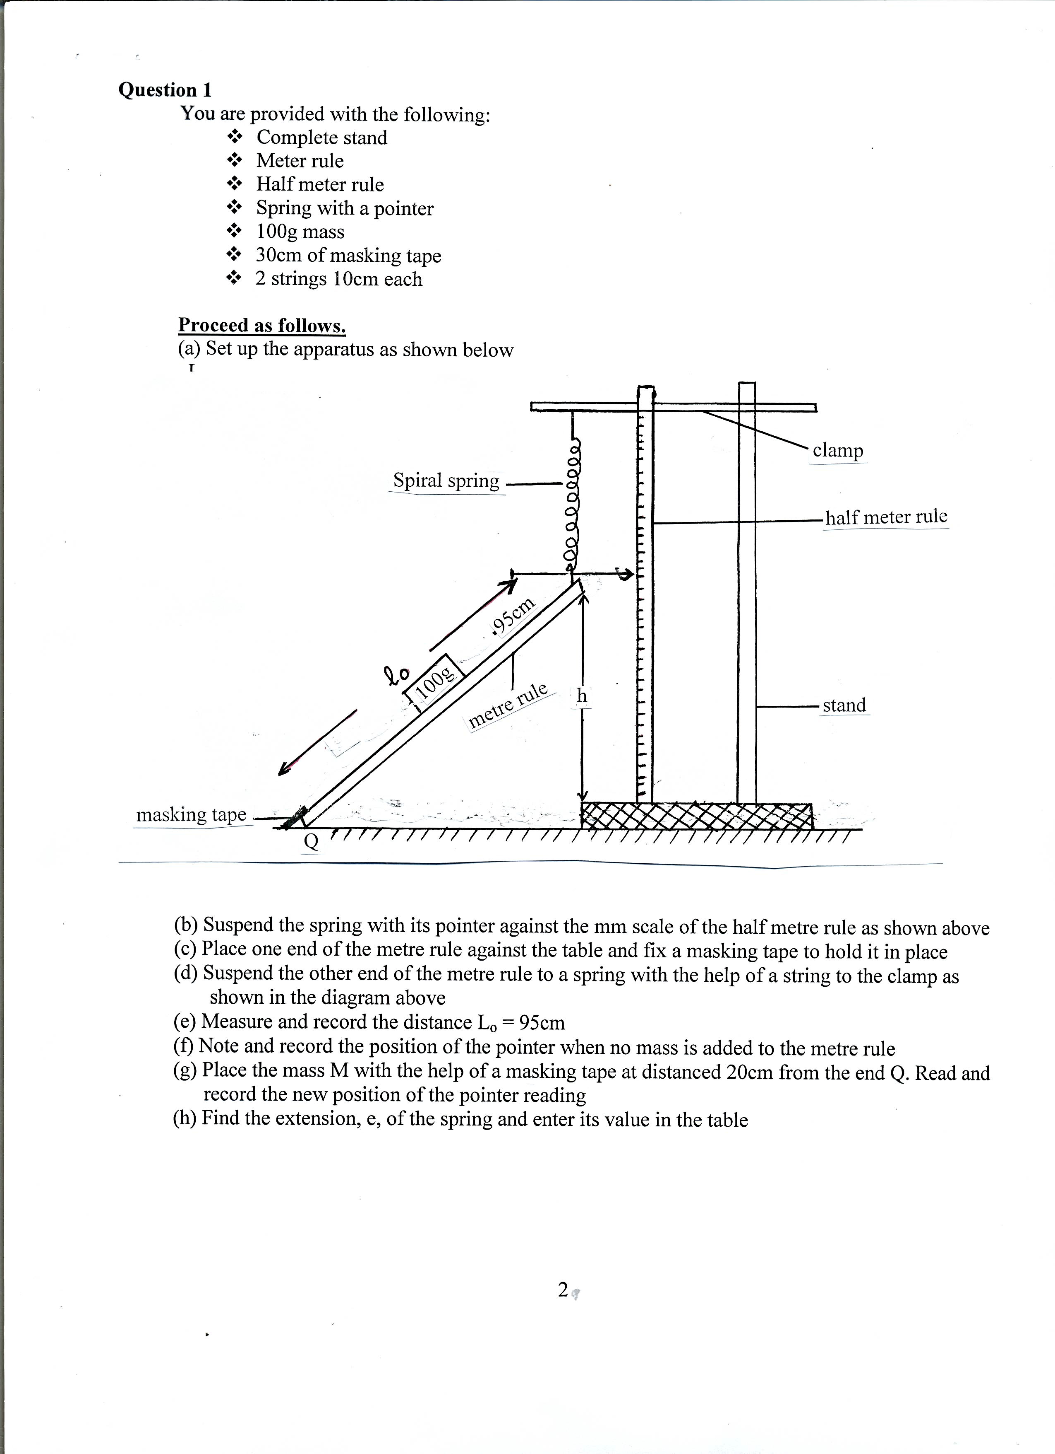

(b) Suspend the spring with its pointer against the mm scale of the half metre rule as shown above
(c) Place one end of the metre rule against the table and fix a masking tape to hold it in place
(d) Suspend the other end of the metre rule to a spring with the help of a string to the clamp as
shown in the diagram above
(e) Measure and record the distance L_{o} = 95cm
(f) Note and record the position of the pointer when no mass is added to the metre rule
(g) Place the mass M with the help of a masking tape at distanced 20cm from the end Q. Read and
record the new position of the pointer reading
(h) Find the extension, e, of the spring and enter its value in the table

(i) Repeat for other values of d and record the corresponding values of extension, and fill in the table
Distance, d (cm) | 0 | 20 | 30 | 40 | 50 | 60 | 70
Pointer reading
Extension, e, (cm)
(7mks)
(j) Plot a graph of extension, e, (y-axis) against distance, d, (5mks)
(k) Determine the slope, S, of the graph (3mks)

(l) Determine the value of constant, K, from the equation (3mks)
K = 0.98
S x L_{o}

Question 2
You are provided with the following.
- A dry cell 1.5V, new and in a cell holder
- A voltmeter (Range 0 – 2.5V or 0 – 3.0V)
- An ammeter (Range 0 – 1.0A)
- A constantan wire, W, (SWG 30) mounted on a millimeter scale on a wooden plank
- 7 connecting wires with at least one with a crocodile clip at one end
- A micrometer screw gauge
- A switch

Proceed as follows:
(a) (I) connect the circuit as shown in the diagram below.
NB: Ensure the circuit is complete before commencing the experiment. The switch K should control both circuits.

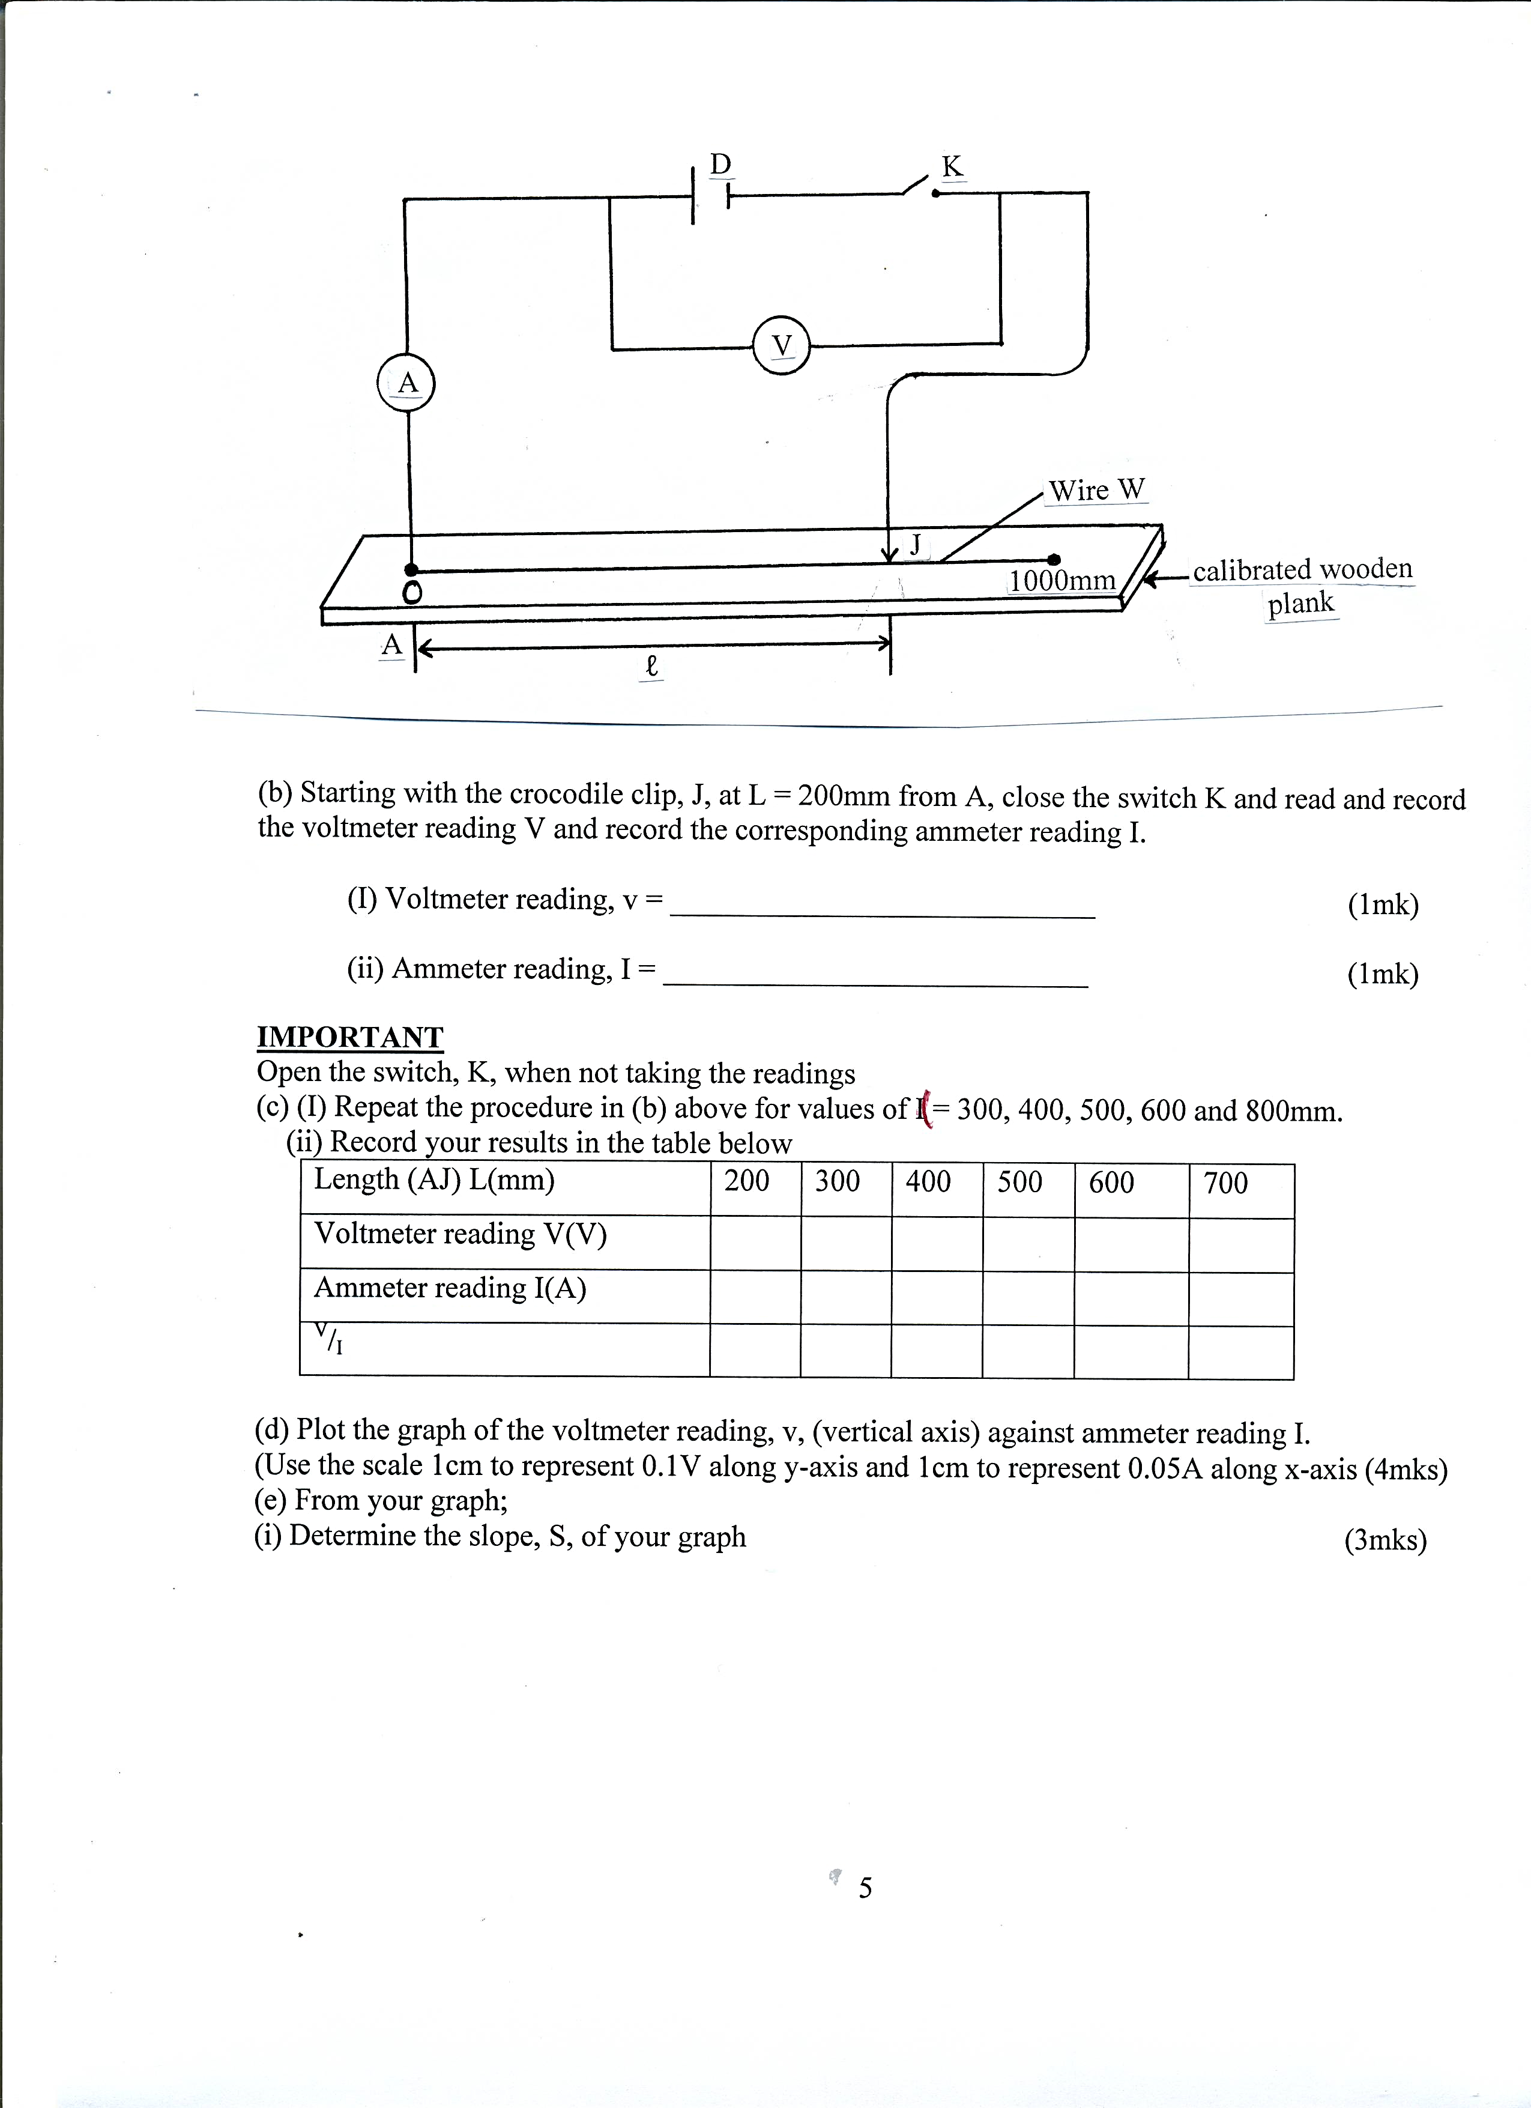

(b) Starting with the crocodile clip, J, at L = 200mm from A, close the switch K and read and record the voltmeter reading V and record the corresponding ammeter reading I.

(I) Voltmeter reading, v = ____________________________ (1mk)

(ii) Ammeter reading, I = ____________________________ (1mk)

IMPORTANT
Open the switch, K, when not taking the readings
(c) (I) Repeat the procedure in (b) above for values of ( = 300, 400, 500, 600 and 800mm.
(ii) Record your results in the table below
Length (AJ) L(mm) | 200 | 300 | 400 | 500 | 600 | 700
Voltmeter reading V(V)
Ammeter reading I(A)
^{V}/_{I}

(d) Plot the graph of the voltmeter reading, v, (vertical axis) against ammeter reading I.
(Use the scale 1cm to represent 0.1V along y-axis and 1cm to represent 0.05A along x-axis (4mks)
(e) From your graph;
(i) Determine the slope, S, of your graph (3mks)

(ii) Determine emf of the cell (1mk)

(iii) Measure the thickness, t, in meters of the wire, W,

t = __________________________________ (1mk)

(g) Now connect the voltmeter across the wire, W, to enable you obtain a potential drop across any part length, AJ, of the wire, AB
(I) Using the length, AJ, = L = 550mm, close the switch and then read the voltmeter and corresponding ammeter readings.

Voltmeter reading, V = _____________________________ (1mk)

Ammeter reading, I = ______________________________ (1mk)

(ii) Calculate the value of P from
P = 11Vt²
14IL
Where L, V, t and I are quantities obtained in their SI units. (2mks)

(iii) What does the quantity P represent (1mk)

(iv) Sketch the diagram for the set up you have used in (g) above (2mks)

