NAME……………………………………………………….. INDEX NO……………………........................

232/3 CANDIDATE’S SIGN………….….….….…...
PHYSICS
PAPER 3 DATE……….…………………………………
(PRACTICAL)
TIME: 2½ HOURS


TEACHER.CO.KE SERIES 7

INSTRUCTIONS TO CANDIDATES:
1. Write your name and index number in spaces provided above.
2. Sign and write the date of examination in spaces provided above.
3. Answer all the questions in spaces provided in the question paper.
4. You are supposed to spend the first 15 minutes of 2½ hours allowed for this paper
reading the whole paper carefully before commencing the work.
5. Marks are given for clear record of the observations actually made, their suitability,
accuracy and the use made of them.
6. Candidates are advised to record their observations as soon as they are made.
7. Non-programmable silent electronic calculators and KNEC Mathematical table may be used.

FOR EXAMINER’S USE ONLY
Question 1 | b | c & d | d | f | g | h(i) | h(ii) | Total | 20
Maximum Score | 1 | 4 | 2 | 5 | 3 | 1 | 1
Candidate’s Score

Question 2 | a | b | c | d | Part II | b | c | Total | 20
Maximum Score | 5 | 5 | 2 | 5 |  | 1 | 2
Candidate’s Score

GRAND TOTAL

Physics Paper 3 Turnover
1. You are provided with the following:
- 2 new dry cells size D.
- A cell holder.
- A switch.
- An ammeter (0 - 2.5A) or 0 – 1A)
- A voltmeter (0 – 5V)
- 6 connecting wires, 3 with crocodile clips.
- Nichrome wire mounted on the metre rule labelled X.
- A micrometer screw gauge (to be shared).

Proceed as follows:
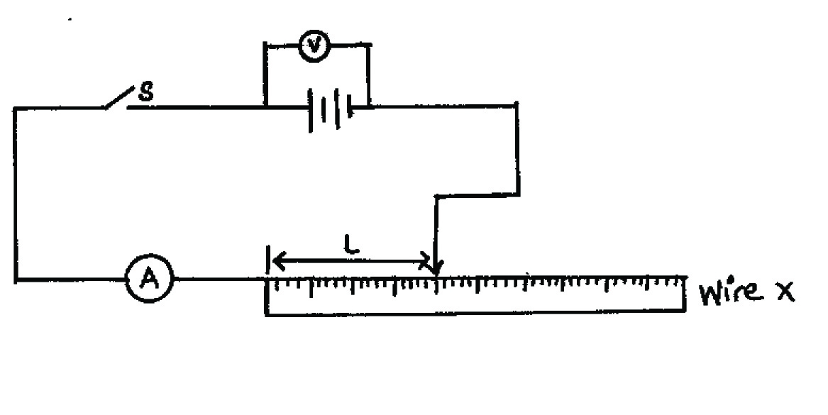
- Connect the circuit as shown in the figure below.

Determining the area (X-section) of the wire.

- Measure the voltage, E before closing the switch.

E = __________________________________________________________ (1mk)

(c) Adjust the length L of the wire 0.2m, close the switch S and read the value of current and record in the table below.

Length (m) | 0.2 | 0.3 | 0.4 | 0.5 | 0.6 | 0.7
Current I(A)
(Aˉ¹) |  |  |  |  |  |  | (2dp)  (6mks)

(d) Repeat the procedure in (c) above for the value of lengths given.

(e) Calculate the values of and record in the table above.

Physics Paper 3
(f) On the grid provided plot a graph of (y axis) against L. (5mks)

Physics Paper 3
(g) Determine the gradient of the graph. (3mks)

(h) (i) Measure the diameter of the wire in three points used. (1mk)

d₁ = ………………………… d₂ = ………………………d₃ = ……………….………..

Averaged d = ……………………………………………………………………….…..

(ii) Determine the cross section area, A of the wire. (1mk)
From the equation.
; determine

(i) the value of K. (2mks)

(ii) the value of Q. (1mk)

Physics Paper 3
2. PART I

You are provided with the following
- A rectangular glass block.
- Soft board.
- Plain sheets of paper.
- 4 optical pins.
- 4 thumb pins.

You are required to determine the refractive index of the glass block by tracing rays of light
through the block. Place the rectangular glass block on the plain paper (stuck on the soft board)
and trace it round. Remove the block; draw a normal at point O and an incident at 15 degrees
as shown below.

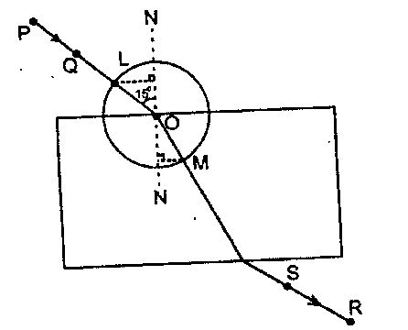

Stick two pins P and Q along the incident ray and replace the glass block while closing one eye,
look through the glass block from the opposite side and insert two other pins S and R exactly in
line with the images of P and Q.

Remove the glass block and join SR to the outline of the block. Hence obtain the refracted ray
inside the glass as shown in diagram above.

With O as the centre, draw a circle of radius 5cm to cut both the incident ray and the refracted
ray at L and M respectively. Using a set square, draw the perpendiculars LN and MN to the
normal.
(a) Measure LN and MN in millimeters and record your values in table below. (5mks)

Angle of incidence (i) | LN (mm) | MN (mm)
15 degrees
30 degrees
45 degrees
60 degrees
75 degrees

Repeat the above steps for angles of incidence of 30°, 45° and 75° degrees.
Complete the table below.
NB: (Insert the plain paper in the question paper).
Physics Paper 3 5
(b) Plot a graph of LN against MN on the grid provided. (5mks)

Physics Paper 3
(c) Calculate the slope of your graph. (2mks)

(d) (i) Also measure and record the values of the angle of refraction ® that corresponds
to the given values of the angles of incidence (i). (5mks)

i | r | Sin i | Sin r
15°
30°

45°
60°
75°

Calculate the ration Sin/Sin r and record in the table above.

(ii) Calculate the average value of Sin i/Sin r

Physics Paper 3
2. PART II

You are provided with the following
- A lens and lens holder.
- A candle.
- A screen.
- A metre rule.

Set up the apparatus as shown in figure below.

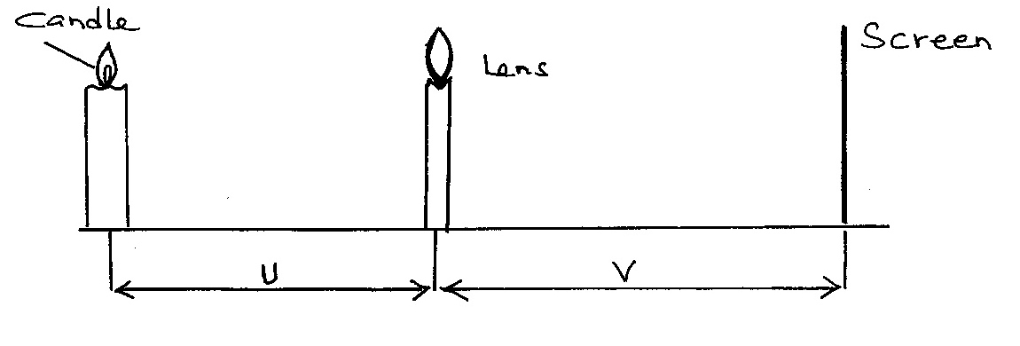

(a) Starting with U = 30cm, adjust the position of the screen to obtain a sharp image of
the candle. Record the value of V in table below.

(b) Repeat the procedure in (a) for U = 20cm. Complete the table (a). (1mk)

Table (a)

U (cm) | V (cm)
20

30

(c) Given that the focal length of the lens satisfies the equation determine the average value of the focal length, (2mks)

