NAME: ………………………………………………….. INDEX NO: …………………………………...
SCHOOL: ………………………………………………. CANDIDATE SIGN: ………………………….
DATE: ………………………………………...

TEACHER.CO.KE SERIES 8
232/3
PHYSICS
(PRACTICAL)
PAPER 3

TIME: 2 HOURS

INSTRUCTIONS TO CANDIDATES
1. Answer all the questions in the spaces provided
2. Mathematical tables and electronic calculators may be used.
3. All workings MUST be clearly shown necessary.

For examiners use only
QUESTIONS | MAX.SCORE | CANDIDATE SCORE
1 | 21
2 | 19
Total score | 40

This paper consists of 5 printed pages.
Candidates should check the question paper to
Ensure that all the pages are printed as indicated and no questions are missing.

1. You are provided with;
(a) A Marble with a piece of the thread attached.
(b) Two wooden blocks.
(c) Clamp, stand + boss
(d) Metre rule.
(e) ½ metre rule supported on a wooden block.
(f) 2 pieces of cellotape.
(g) Stop watch.

Procedure:
(I) Fix the thread between the wooden blocks and fasten in the clamp. Adjust the thread so that the length, L, shown in the figure below is 50cm.

(II) Fix the metre rule horizontally to the bench using the cello tape provided.
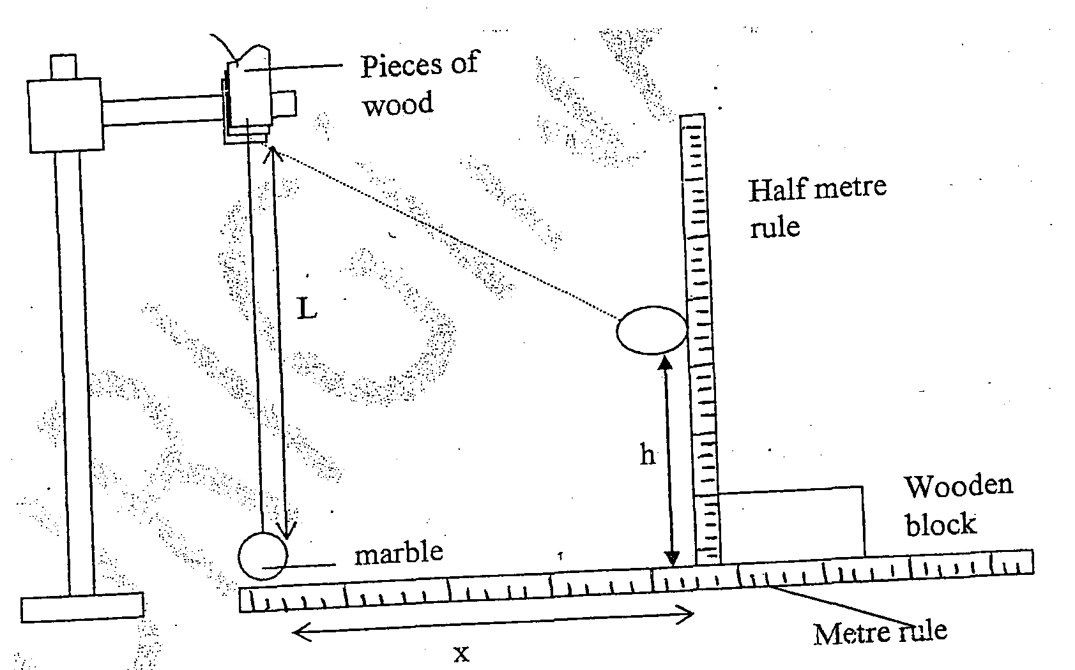

(III) Adjust the clamp so that the marble is next to the end of the metre rule as shown above.

(IV) Displace the marble by a horizontal distance X20cm and measure the corresponding vertical displacement h=____________ cm. (1mark)

(V) Repeat the experiment to find h for each of the following values of X and complete the table.
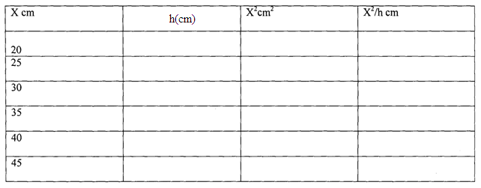
(6mks)

(VI) plot a graph X²/h against h.
(give the grid/draw grid)

(VII) Determine the slope of the graph. (2mks)

(VIII) From the graph find the value of X^{2/}h when h=0 (2mks)

(IX) With the metre rule and half-metre removed — Displace the marble through a horizontal distance of about 10cm and let it to swing freely, Time 20 oscillations.

Time for 20 oscillations ______________________ (lmk)
(X) Determine periodic time , T
Periodic time, T=_____________________________ (1 mk)

(XI) Calculate the value of P from the following equations. (4mks)
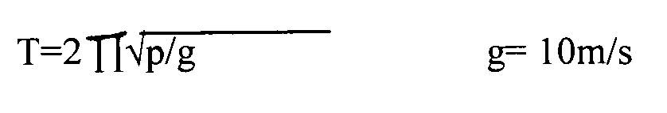

2. You are provided with the following apparatus
• A metre rule
• A log of plasticine
• Bi convex lens
• A candle
• A lens holder
• Across wire mounted on a cardboard
• A white screen

- Determine the focal length of the lens using a distance object.
F=……………………………………………………………………….. (lmk)

(b) Briefly explain the method you have used above. (2mks)

- Set up the apparatus as shown

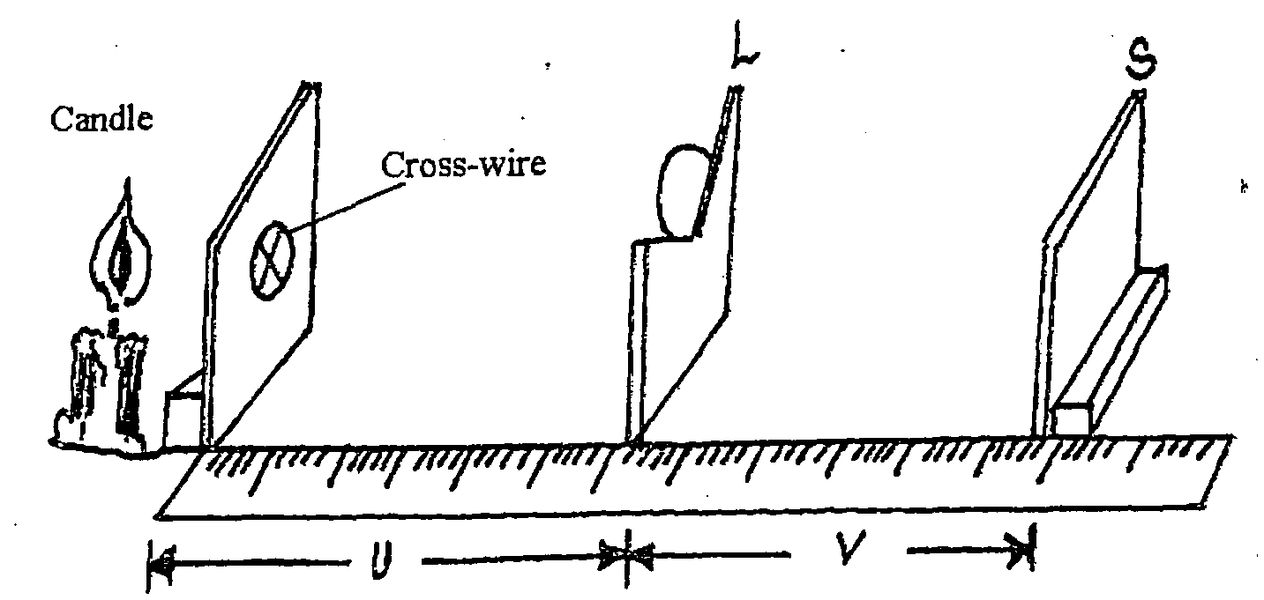

(d) Starting with u=30cm, vary the position of the screen S until a sharp image of the cross wire is observed on the screen. Measure and record the value o the image distance v.

(e) Repeat the experiment above for other values of u35cm, 40cm, 50cm, and 55cm

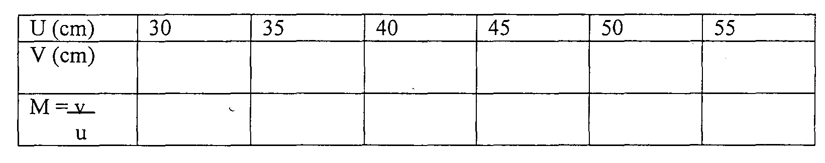

(f) Plot a graph of M against v (5marks)

(g) Determine the slope of the graph (2mks)

(h) The equation of the graph is given by 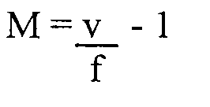

Use the graph to obtain the value of f (2mks)

