**CROP PRODUCTION II (PLANTING)**

This topic entails the following:

* Correct planting materials for various crops
* Selection and preparation of planting materials
* Determination of optimum time of planting
* Factors which determine planting depth
* Planting procedure for different crops
* Factors which determine seed rate, spacing and plant population.
* Calculation of plant population
* Economic value of land.

The following relevant questions and their answers in this topic will greatly help and motivate

the user to comprehend and understand the required concepts and practices:

1. State **two** reasons for seed treatment of tree species before planting

2. Give **three** factors that determine spacing of beans

3. State **four** reasons for using certified seeds for planting

4. Below are diagrams showing vegetative material used for propagation.

a) Name the propagation materials A, B, C, D

b) What is the term used for inducing **B** to start germinating?

c) State **four** advantages of vegetative propagation on crop production

5. Differentiate between hybrid and composite

6. a) A farmer planted 100 maize seeds and 90 seeds germinated.

Calculate the germination percentage

b) Given that maize is planted at a spacing of 75cm by 25cm, calculate the plant population in a

plot measuring 4m by 3m

7. Give **four** qualities of a mother plant which should be considered when selecting vegetative

material for propagation

8. Explain **five** practices that a farmer should carry out to ensure uniform germination of seeds

9. State **two** factors which determine the depth of planting

10. State **two** advantages of adding organic matter to sandy soil

11. Calculate the number of tea plants in two hectares (2ha) given that the spacing is 150cm x 75cm

and one seedling is planted per hole

12. Outline **four** reasons why training is important in some crops

13. Give **four** factors that influence the depth of planting

14. Two precautions taken when harvesting cotton

15. Outline **four** reasons why training is important in some crops

16. Give **four** factors that influence the depth of planting

17. Two precautions taken when harvesting cotton

18. State **four** factors that determine the spacing of annual crops

19. Outline **four** advantages of rolling in seedbed preparation

20. List **two** factors that effect rooting of cuttings in crop production

21. Outline **three** ways of preparing materials before sowing

22. Outline **three** ways of preparing materials before sowing

23. Distinguish between over sowing and under sowing

24. Study the illustration below of a tea vegetative material and answer the questions that follow

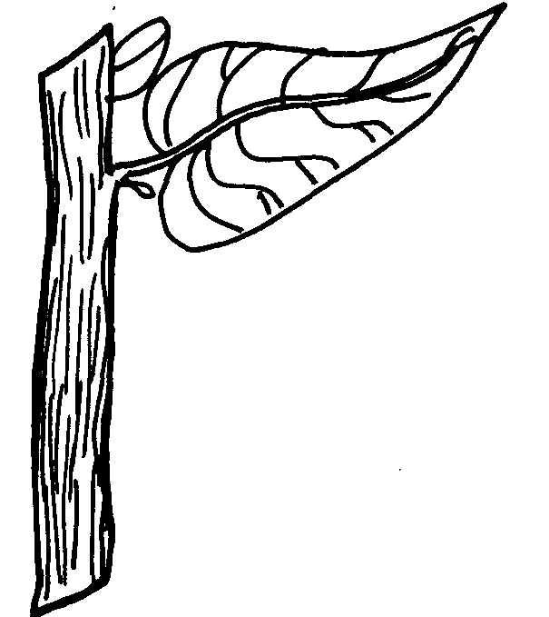

a) What name is given to the vegetative material drawn above for tea propagation

b) State **two** devisable characteristics of the selected plants used to develop the plant shown

c) Give **two** precautions observed during the preparation of the material above before planting

25. The diagram below illustrates the spacing which is used when planting beans. Study the diagram

and answer the questions that follow:

a) State the spacing illustrated above

b) Suppose the student is asked to use the illustrated spacing to plant in a plot 4m by 3m leaving

30cm distance from the edge; calculate;

i) The number of rows on the wider side of the plot

ii) Calculate the plant population

26. Using planting material whose diagram is shown below, list **four** factors that would influence the

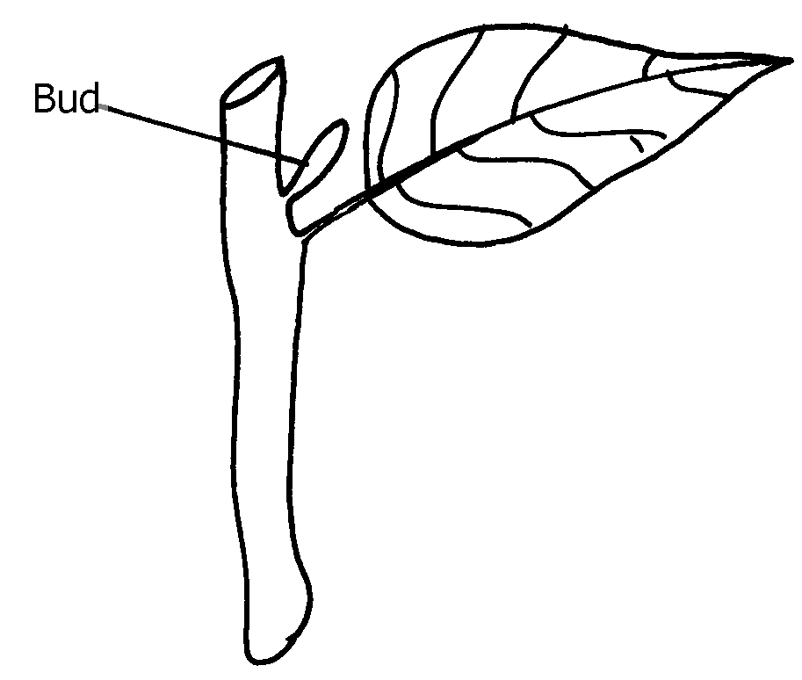 rooting of the structure

27. Describe the selection, preparation and raising of vegetative tea seedlings in the nursery

28. Explain the factors considered in timely planting of annual crops

29. Give four disadvantages of broadcasting as a method of planting.

30. Define the following terminologies as used in Agriculture

31. Give two advantages of producing crops by use of seeds over vegetative propaganda

32. State **four** ways of preparing planting materials before planting

**CROP PRODUCTION II (PLANTING)**

1. two reasons for seed treatment of tree species before planting

* Break dormancy

Control pests and diseases

2. three factors that determine spacing of beans

* Type of soil
* Moisture in soil
* Species/ size of bean plant
* Machinery to be used
* Purpose of beans

Stand in the field

3. four reasons for using certified seeds for planting

* High yielding
* Quality produce
* High germination percentage
* Grow faster

4. a) A Banana sucker

B Stem tubes

C Bulb

D Stem cutting

b) Chitting

c) four advantages of vegetative propagation on crop production

* Grow faster
* True copy of mother plant
* Have no dormancy period
* Easy to obtain 4x ½ = 2 mks

5. Differentiate between hybrid and composite

|  |  |
| --- | --- |
| Hybrid | composite |
| Seeds produced by  crossing inbreedlines  and controlled pollination√ | Seeds produced by growing different  varieties together under uncontrolled  pollination√ 2// |

6. a) Germinated seed x100√

Total seeds planted

=90 x100 (2)

100 = 90%√

b) Given that maize is planted at a spacing of 75cm by 25cm, calculate the plant population in a plot measuring 4m by 3m

plant ppl = land area√

Spacing

4mx3m

75x25cm

400cmx300cm

75cmx25cm = 64plants√ (2)

7. four qualities of a mother plant which should be considered when selecting vegetative

material for propagation.

* High quality.
* High yielding.
* Disease resistance / healthy/ disease tree.

Fast growth/ fast maturity.

8. - Select seeds of the same size, variety, age and free from pests and diseases.

- Plant seeds at the same time.

- Prepare the whole field to required uniform tilth.

- Plant at the right moisture content of the soil / irrigation uniformly.

- Treat seeds before planting i.e. break dormancy.

- Plant at the correct depth. (5 x 1 = 5 mks)

9. two factors which determine the depth of planting

- Soil type

* Size of seed
* Soil moisture content

- The type of germination

10. - Reduces leaching

* Improves water holding capacity
* Improves soil structure
* Suffer soil pH
* Moderate soil temperature
* Increases microbial activities
* Increases cation exchange capacity

- Improve fertility of the soil after decomposition

11. Area

Spacing

Tea population (10,000x2

1.5mx 0.75) 1

20,000m²

1.125m² 1

= 17,777 plants

Needed in carbohydrate metabolism

12. Four reasons why training is important in some crops

* Facilitate field practices of spraying and harvesting
* Improves crop quality by preventing solving
* Enable crop grow in the required direction
* Improve yield
* Control pest and diseases

13. Four factors that influence the depth of planting are:

* The size of the seed
* Soil moisture content
* Type of soil /soil texture
* Type of germination

14.

* Avoid mixing with foreign materials
* Harvesting during the dry weather
* During harvesting separate grade A and B

Don’t put in gunny/sisal bags

Needed in carbohydrate metabolism

15. Four reasons why training is important in some crops

* Facilitate field practices of spraying and harvesting
* Improves crop quality by preventing solving
* Enable crop grow in the required direction
* Improve yield
* Control pest and diseases

16. Four factors that influence the depth of planting are:

* The size of the seed
* Soil moisture content
* Type of soil /soil texture
* Type of germination

17

* Avoid mixing with foreign materials
* Harvesting during the dry weather
* During harvesting separate grade A and B

Don’t put in gunny/sisal bags

18. - Moisture content of soil

* Use of which the crop is to be put
* Number of seeds per hole
* Prevalence of certain diseases/ pests
* Machinery to be used in subsequent operations
* Fertility status of the soil

19. Four advantages of rolling in seedbed preparation are:

* Press the seeds against the soil moisture
* Controls soil erosion
* Ensure uniform germination
* Controls removal of small seeds by wind
* Breaks large soil cods

20. two factors that effect rooting of cuttings in crop production

* Temperature
* Relative humidity
* Light intensity
* Oxygen supply
* Chemical treatment
* Leaf area

21.

* Breaking seed dormancy
* Seed dressing

Seed inoculation

22.

* Breaking seed dormancy
* Seed dressing

Seed inoculation

23. Under sowing is the establishment of pasture under a cover crop usually maize while over sowing is the establishment of pasture legume in an existing grains pasture

24. a) Stem cutting

b)

* High yielding
* High quality
* Good rooting ability
* Adaptable to the ecological zone

c)

* Make top cut near the auxiliary bud as close as possible and sloping away from it
* Lower cut must be sloping at an angle and be 2.5 – 4cm below the leaf
* Single leaf internodes cuttings must be kept shaded and wet floating in water from the time of cutting to planting

25 a) (30 X 15) cm2 / 30cm X 15cm

b)

4M – 0.6 M + 1

0.3M

3.4 + 1

0.3= 12 raws

c) Plant population

3M – 0.6 +1

0.15

= 2.4 + 1

0.15

= 16 plants X 12 raws = 192 plants

26. – Temperature;

- Relative humidity;

- Light intensity;

- Oxygen supply;

- Leaf area;

- Chemical treatment;

27. Selection of mother plants (tea);

- Select healthy bushes/free of pests and diseases;

- Select high quality bushes;

- Select those which are high yielding;

- Select those with good rooting ability;

- select those which adapt to a wide range of ecological conditions; (4x1=4mks)

Preparation of planting materials

* Prune the selected tea bushes and leave unchecked for six months;
* Select and cut good branches for making cuttings
* Obtain the cuttings form the middle of the branches/discard the brown and the hard bottom part/ the green soft top part
* Make single leaf internodes cutting carefully 2.5-4cm long;
* Make slant cut with the use of scalpel/sharp knife taking away from the node;
* Make top cutting near the auxiliary bud as much as ossible;
* Keep the cuttings wet in the water to avoid dehydration until they are planted;
* Keep the cutting under the nursery;

Raising of tea seedlings in the nursery

* Plant cuttings on rooting medium in polythene sleeves/sleeves measure 25 x 7.5-10cm and sealed cut.
* Rooting medium consists of fertile sub-soil and phosphate fertilizer;
* Plant single leaf internodes per polythene sleeve,
* Place the sleeves in the vegetative propagation units,
* Erect wooden hoops over the sleeves cuttings, then place polythene sheet over it/erect shade over the nursery;
* Water sleeved seedlings every 3weeks/main high humidity;
* Uproot weeds when they appear;
* Hardening off done 4 months after raising (9x1=9mks)

28. Factors to consider in timely planting of annual crops

* Escape from serious weed competition;
* Utilization of early rainfall;
* Exploitation of Nitrogen flush in the soil that has accumulated during dry season;
* Escape from serious pest + disease attack e.g. stalk borer in maize;
* Fetch high market prices when harvested early;
* Reduce competition for labour during labour peak period;
* For harvesting season to coincide with dry period to reduce losses e.g. cotton

Early planting means early farming/calendar for the farmer to enable him /her to finish up other farm activities; (8x1=8mks)

29.

* It is wasteful because a higher seed rate is used.
* It is not possible to use machines.
* It is not possible to establish plant population.
* Lack of uniformity in seed establishment.

30. (i) Seed inoculation;

* It is the treatment of legume seeds with Nitro-culture/artificial bacteria to increase their Nitrogen fixation in the soil ,if grown in Nitrogen deficie soils.

(ii)Chitting;- Breaking of dormancy in Irish potatoes before planting

(iii) Tipping;- Removal of three leaves and a bud from each shoot above the required height of the

table in tea during plucking table formation / formation of a uniform and flat plucking table in tea.

31. two advantages of producing crops by use of seeds over vegetative propaganda

* Seed treatment is easier
* Seeds can be stored for a long time
* Faster and uniform germination
* Mechanization of farm operation is easy/possible

Application of fertilizer/manure is easy and can also be mechanized

32. four ways of preparing planting materials before planting

* Breaking seed dormancy
* Seed dressing
* Chitting
* Seed cleaning
* Seed inoculation

Root trimming as in banana or tree seedlings