MID TERM 1 EXAM 2021
AGRICULTURE FORM TWO QUESTIONS
- What is soil fertility? (1mk)
.....................................................................................................................................................................................................................................................................................................................................................................................................................................................................................................................
- How can soil lose fertility? (4mks)
...................................................................................................................................................................................................................................................................................................................................................................................................................................................................................................................................................................................................................................................................................................................................................................................................................................................................
- Name the Major Macro nutrients (2mks)
.....................................................................................................................................................................................................................................................................................................................................................................................................................................................................................................................
- State two roles and two deficiencies of the following plant nutrients;
- Nitrogen (4mks)
Roles Deficiency

- Phosphorous (4mks)
Roles Deficiency

- What is soil sampling? (1mk)
.........................................................................................................................................................................................................................................................................................................................................................................................................................................................................................
- List the methods of soil sampling. (2mks)
.....................................................................................................................................................................................................................................................................................................................................................................................................................................................................................................................
- Describe the procedure of soil sampling (6mks)
................................................................................................................................................................................................................................................................................................................................................................................................................................................................................................................................................................................................................................................................................................................................................................................................................................................................... State four deficiency symptoms of potassium (2mks)
............................................................................................................................................................................................................................................................................................................................................................................................................................................................................................................................................................................................................................................................................................
- List the common organic manures (2mks)
............................................................................................................................................................................................................................................................................................................................................................................................................................................................................................................................................................................................................................................................................................
- State four properties of Nitrogenous fertilizers (2mks)
............................................................................................................................................................................................................................................................................................................................................................................................................................................................................................................................................................................................................................................................................................
- List four methods of fertilizer application (2mks)
............................................................................................................................................................................................................................................................................................................................................................................................................................................................................................................................................................................................................................................................................................
- Name two types of large scale farming (1mk)
.....................................................................................................................................................................................................................................................................................................................................................................................................................................................................................................................
- State the soil properties influenced by texture (2mks)
............................................................................................................................................................................................................................................................................................................................................................................................................................................................................................................................................................................................................................................................................................
- Name the 5 categories of tools and equipment (2 ½ mks)
..................................................................................................................................................................................................................................................................................................................................................................................................................................................................................................................................................................................................................................................................................................................................................................................................................................................................

- List the major types of irrigation (2mks)
............................................................................................................................................................................................................................................................................................................................................................................................................................................................................................................................................................................................................................................................................................
- Give five characteristics of indigenous cattle (2 ½ mks)
............................................................................................................................................................................................................................................................................................................................................................................................................................................................................................................................................................................................................................................................................................
- Study the processes of chemical water treatment below and answer the questions that follow.
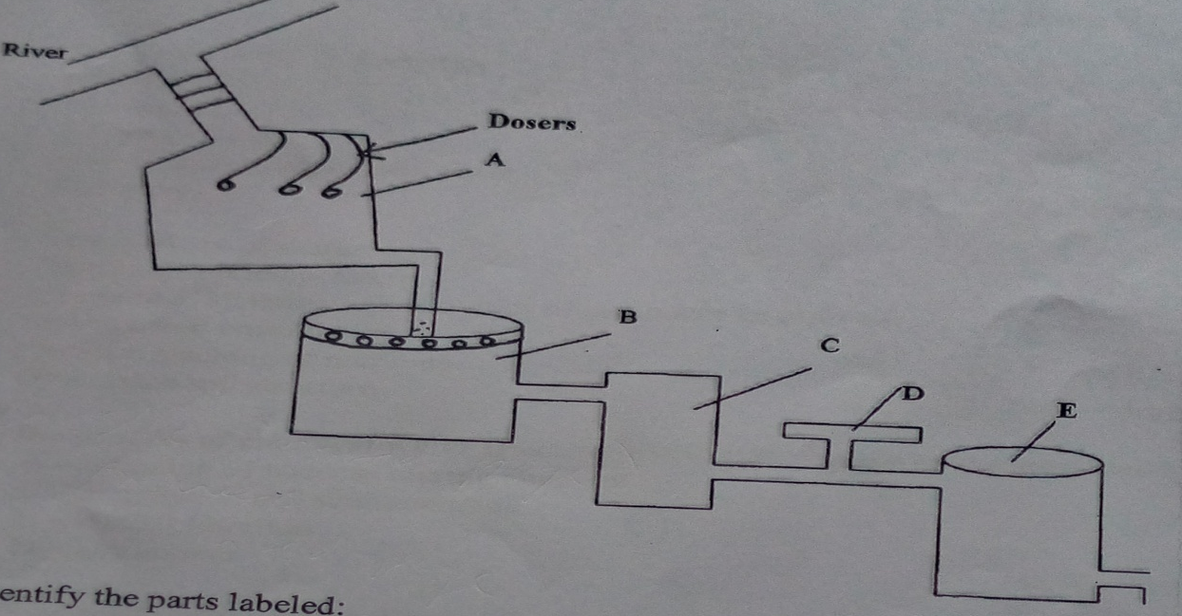
- Identify the parts labeled; (2mks)
A –
B –
C –
D –
- State two chemical substances added at part labeled B and give their functions (2mks)
...................................................................................................................................................................................................................................................................................................................................................................................................................................................................................................
- State two factors which influence the quantity of the chemical used in part labeled D. (2mks)
Chlorine added depends on:
...................................................................................................................................................................................................................................................................................................................................................................................................................................................................................................
- Give two uses of water in crop production (2mks)
...................................................................................................................................................................................................................................................................................................................................................................................................................................................................................................

