MARKING SCHEME

FORM FOUR BIOLOGY 2021
.

- Name the hormone which controls moulting in insects. 1mrk
  - ) Moulting hormone/ ecdysone

  - b) State the importance of moulting in insects. 1mrk

    - b) It allows growth to take place; since growth can not take place in the presences of the
- (a) State two functions of the kidney 2mrks
      - – Excretion;
        - Osmo-regulation;

  - (b) Name two substances that are not found in urine of a healthy person 2mrks
– Glucose
Amino acids
  - ( Name two diseases that affect the kidney 2mrks
– Nephritis;
kidney stones /Gall stones;
- Hepatitis A and B; (mark first 2 pts (2mks)

- The diagram below represents a growth pattern of arthropods.

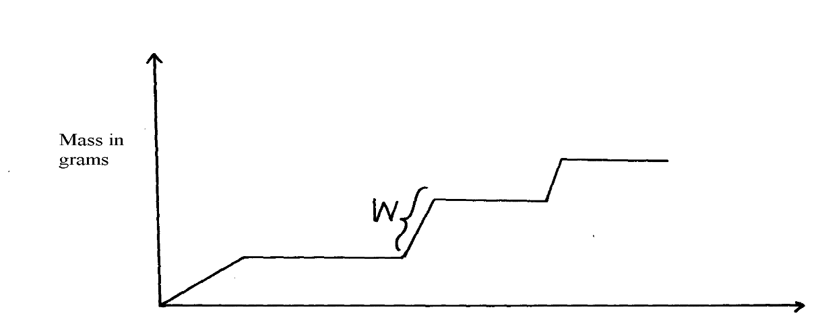
X

Time (days)

(a) Name the type of growth pattern represented on the graph. Intermittent growth curve; 1mrk
(b)Identify the process represented by X. Moulting 1MRK

- ;(c) Which hormone is responsible for process at X in 15 (b) above? 1mrk

  - (b) Moulting hormone;Ecdysone

- Distinguish between primary growth and secondary growth in a flowering plant 4MRKS
Primary growth results form the activity of primary/embryonic tissues/apical meristems and lead to increase in height, while secondary growth result from activities of secondary meristems; /cambium and leads to increase of girth/diameter /circumference;

  - What is the role of the following to a germinating seed:
(i) Oxygen Oxidizes food to release energy needed for germination; 1mrk

(ii)Cotyledons Stores food for the seed; - Stores enzymes 1mrk
- Give three applications of plant growth hormones in agriculture 3mrks
  - Ripening of fruits
  - Selective weed
  - Parthenocorpy
    - Reject Prunning of coffee and tea

- State two functions of calcium in the human body 2mrks

        - -Contraction of muscles
        - Formation of bones

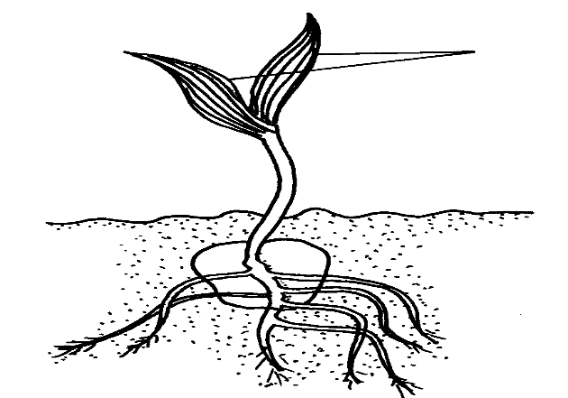
- The diagram below represents a stage during the process of germination.
X

Name the type of germination illustrated in the diagram. 1mrk
(a)(i) Hypogeal;

Give a reason for your answer in (a) (i) above. 1mrk

COTYLEDONS REMAIN UNDER THE GROUND

(b) Give two functions of the part labelled X 2mrks Photosynthesis; OWTTE
    - Gaseous exchange

- Explain how placenta is adapted to its functions 4MRKS

It has chondrionic villis to increase surface area for excahgne of materials
Has thin epithelium for rapid exchange of exchanged substances
Has counter current flow of foetal and maternal blood to enhance speed diffusion gradient.
Highly vascularised (dense network of capillaries) for faster transport of exchanged material

- State the role of the following during germination: 2MRKS
oxygen (a) For oxidation of stored food;
(b) enzyme (b) Breakdown and oxidation of food

- Part of one strand of a DNA molecule was found to have the following base sequence.
    - G – T – C – A – G – T
      - What is the sequence on m-RNA strand copied from this DNA portion?
    - C-A – G – U – C _ A ; 1mrk

- State two roles of DNA molecule. 2mrks
Stones genetic information (in a coded form);
enables transfer of genetic information unchanged to daughter cells through replication);
Translates genetic information into characteristic of an organism 9thorugh protein synthesis);

- State three ways by which plants compensate for lack of ability to move from one place to another. 3mrks
  - Ability to pollinate; response to stimuli (tactic) nastic or tropics); Ability to exploit localized nutrients an ability to photosynthesize; Ability to disperse seeds/fruits, propagation;

- A student mixed a sample of urine from a person with Benedict’s solution and heated, the colour changed to orange.
a)What was present in the urine sample? 1mrk
      - Glucose;

b)What did the student conclude on the health status of the person? 1mrk The person was a sufferer of diabetes mellitus;

c)Which organ in the person may not be functioning properly Pancrease; 1mrk

- Differentiate between continuous and discontinuous variations 2mrks
Continuous variation shows gradation in characteristic with intermediate; discontinuous shows distinct characteristics between organisms with no intermediate groupings;

- Members of the same species of organism tend to differ due to variation. State three causes of variation in organisms 3mrks

mutation;
  - -intermixing of genes already in the population through sexual reproduction recombination;
  - -crossing over during prophase of meosis I
  - -interdependent assortment of chromosomes, during metaphase of meosis I

- How is the placenta adapted to its functions? 4mrks

Large number/ numerous blood vessels to increase surface area for exchange of materials
Thin membrane for faster diffusion across it
Has villi to increase surface area for diffusion
Special cells to produce hormones
Membrane selectively allows materials across it

