EXAM
CHEM F4 MARKING SCHEME 2021
1. (a) (i) T₂ and T₃ / T₂ and T₄/T₃ any other order
(ii) T₅ $and T6$
(iii) T₃$and T4$
(b) T₄
(c) (i) T₅ or T₆
(ii) Reason: it is unsaturated
(iii) Polymerization
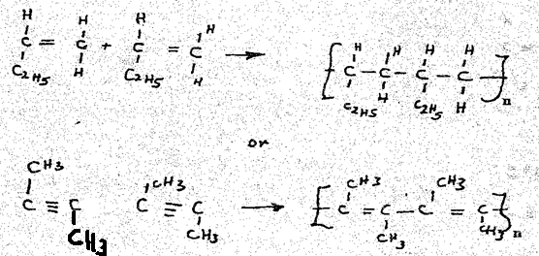
(iv) (I) Process: Esterification
(II) Compounds
- Butanoic acid (CH₃CH₂CH₂COOH)
- Ethanol (C₂H₅OH)

2. i) Alkali metals
ii) Noble gases
b) H - Metals
M - Non-metals
c) A - Air balloons
N - Prevention of oxidation of filament.
d) G has a bigger atomic radius than H .There
is an increase in nuclear charge
e) R forms an ion by gaining an electron.
The negative charge is bigger than the
positive.
f) I₂X₃
g) E .It has the biggest E0 value / Has high
tendency to gain electrons.
h) i) P - 2 .8.8.2
ii) Ion of E ==> 2.8
i) H or P
j) The second ionization energy of H is bigger than the 1st .2nd ionisation energy involves the removal of an electron from charged particle.
3. i) Cooling curve
ii) BC
- The kinetic energy of the molecules decrease as heat energy is lost to the surrounding leading to a drop / decrease in temperature.
b. (i) 1000cm³ = 0.1mol
25 cm³ = 0.0025mol.
ii) H₂X _{(aq)} + 2 NaOH _{(aq)} Na₂X_{(aq)} + H₂ O_{(l)}
Mole ratio 1 : 2
Moles of acid = 0.0025
2
= 0.00125mol.
Molarity = 1000 x 0.00125
18.7
= 0.0668M
4a) Add excess Zinc powder to Nitric (V) acid
Zn_{(s)} + 2HNO_{3(aq)} Zn(NO₃)_{2(aq}) + H₂O_{(l)}
Dissolve solid sodium carbonate in water
Na₂CO_{3(s)} + water Na₂CO_{3(aq)}
Mix the resulting mixture with zinc nitrate solution
Na₂CO_{3(aq)} + Zn(NO₃)_{2(aq)} ZnCO_{3(s)} + 2NaNO_{3(aq)}
Filter out zinc carbonate and dry it.
b)
 | Advantage | Disadvantage
R – COO – Na ⁺ | They are cheaper compared to soapless detergent | Forms scum with hard water
R – SO₃ – Na ⁺ | They don’t form scum with Mg²⁺ & Ca²⁺ | Made from petroleum products or vegetable oils which are expensive

(c) B = R – OSO₃ – Na⁺ - Because it does not form scum with hard water
(i) Pb ²⁺
(ii) (Cl ⁻)

() Ag ⁺ _{(aq)} + Cl – _{( aq)} Ag Cl _{(s)}
(NH₂)₂CO = RMM = 60
2NH_{3 (g) +} CO_{2 (g)} (NH₂)₂ CO _{(aq)} + H₂O _{(l)}
620kg 1 mole
36, 470.588 moles
Mass = 620 x 1000
= 620,000g
Moles = 620,000 = 36,470.588 moles √1
17
Moles of (NH₂)₂ CO = 36,470.588
2
= 18,235.29 moles
Mass = moles x RMM
= 18,235.29 x 60
= 1,094,117.65g accept alternative method
5.a)
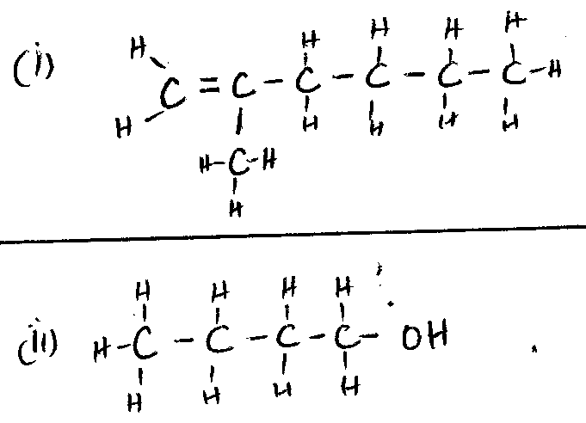
(b) (i) Dehydration
(ii) Cracking

