**MID TERM 1 EXAM TERM 1 2021**

**CHEMISTRY FORM 4**

**TIME: 1HR 10MINS**

**NAME………………………………………………ADM NO……………CLASS………….**

1. The list below shows the formulae of some organic compounds. Use letters T1 to T6 to answer the questions that follow.

T1 – CH3CH2CH2CH2CH3

T2 – CH3CH2CH2COOC2H5

T3 – CH3CH2CH2CH2OH

T4 – CH3CH2CH2COOH

T5 – CH3CH2CHCH2

T6 – CH3CCCH3

(a)Select compounds which:

(i)Are not hydrocarbons (2Mrks)

(ii)Would decolourise both bromine water and acidified potassium manganite (VII) (2Mrks)

(iii)Would produce hydrogen gas when reacted with potassium metal (1Mrk)

(b) Select a compound which would produce bubbles of a gas when reacted with sodium carbonate. (1Mrk)

(c) (i) Identify the compound that is likely to undergo polymerization. Give a reason for your answer. Using two molecules show how polymerization occurs.

I. Compound (1Mrk)

II. Reason (1Mrk)

III. Polymerization (1Mrk)

(iv) Name the process by which compound T2 is formed and identify the compounds that were used to form it.

I. Process (1Mrk)

II. Compounds (2Mrks)

(i)

(ii)

1. Study the periodic table below and answer the questions that follow. The letters do not represent the actual symbols of the elements.



a) Name the chemical family to which the following elements belong

i) C, G, O (1Mrk)

ii) B, F, N, S (1Mrk)

b) Classify elements H and M as either metals or non-metals. (2Mrks)

c) State one use of element. A and N (2Mrks)

d) Compare the atomic radius of G and H. (2Mrks)

e) Ionic radius of R is larger than its atomic radius. Explain. (2Mrks)

f) Write down the formula of the compound formed when element I reacts with element X. (1Mrk)

g) Identify the strongest oxidizing agent. Explain. (2Mrks)

h) Write down the electron arrangement of:- (2Mrks)

i) Element P

ii) Ion of E

i) Identify an element with a charge of +2. (1Mrk)

j) Compare the first and second ionisation energies of element H. (2Mrks)

1. a) A Student in form four placed a thermometer in molten naphthalene at 850C and recorded the temperature and time until the naphthalene solidified. From the values obtained, the figure below was drawn.

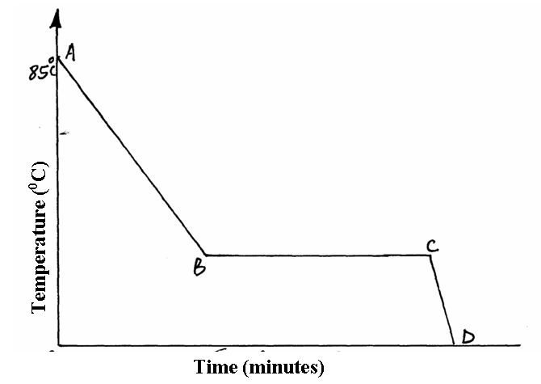

1. What name is given to such a figure (1mrk)
2. Which part of the figure represents the change of state of naphthalene? (1mrk)
3. In terms of kinetic theory. Explain what happens to molecules along AB. (2mkrks)

b) In a certain reaction, 18.7cm3 of a dibasic acid required 25cm3 of 0.1M NaOH for complete neutralization.

1. How many moles of Sodium hydroxide are contained in 25cm3? (1mrk)

1. Calculate the molarity of the dibasic acid. (2mrks)

**4a**)) Using reagents provided only, explain how you could prepare solid Zinc carbonate. (3mrks)

* Zinc powder
* Nitric (V) acid (dilute)
* Water
* Solid sodium carbonate

b) The structures below represent two cleansing agents

(A) R – COO – Na+

(B) R – OSO3 – Na+

(i) In the table below, give one advantage and one disadvantage of using each of them. (2mrks)

|  |  |  |
| --- | --- | --- |
|  | Advantage | Disadvantage |
| R – COO – Na+ |  |  |
| R – OSO3 – Na+ |  |  |

(ii) Which of the two cleaning agents is the better for washing? Explain. (2mrks)

c) The table below shows the observations made on tests carried out on a colorless liquid sample.

|  |  |  |
| --- | --- | --- |
| Exp | Test | Observation |
| (i) | Addition of excess NaOH (aq) | White precipitate soluble in excess |
| (ii) | Addition of dilute H2SO4 (aq) | White precipitate |
| (iii) | Addition of AgNO3 (aq) | White precipitate |

Identify (i) Cation in the sample (1mrk)

(ii) Anion in the sample (1mk)

(ii) Write the ionic equation for the reaction taking place in experiment (III). (1mrk)

d) Urea (NH2)2CO is prepared by the reaction between ammonia and carbon (IV) oxide gas.

2NH3 (g) + CO2 (g)  (NH2)2 CO (aq) + H2O (l)

In one process, 620kg of ammonia were reacted with excess carbon (IV) oxide gas.

Calculate the mass of the urea that was formed. (H = 1.0, C =12.0, N = 14,O = 16 and RMM of ammonia is 17 ) (2mrks)

5) (a) Draw the structural formula of the following compounds:- (2mrks)

(i) 2 – melthylhex –l-ene

(ii) Butan –l-ol

(b) Two methods of preparing alkenes are shown by the following general equations.

(i) Alkanol Al203, 400oC Alkene

(ii) Alkane Catalyst Alkene

Heat

What type of reactions is described by equations? (2mrks)

(i)

(ii)