MATHEMATICS FORM III 2021
MID TERM EXAM
NAME:…………………………………………………... ADM NO…………………………...
SCHOOL:…………………………………………….….. CANDIDATE’S SIGN ……………

DATE ……………………………………..
INSTRUCTIONS TO CANDIDATES
1. Write your name and Adm. number in the spaces provided above
2. The paper contains two sections: Section I and Section II
3. Answer All the questions in Section I and strictly any two questions from Section II.
4. All answers and working must be written on the question paper in the spaces provided
below each question.
5. Show all the steps in your calculations, giving your answers at each stage in the spaces
below each question
6. Marks may be given for correct working even if the answer is wrong
7. Non-programmable silent electronic calculators and KNEC mathematical tables may be
used, except unless stated otherwise.
SECTION 1 (30 Marks)

- Evaluate the value of x in (3mks)
81^{x+1} + 3^{4x} = 246

- Given that 3^{5x-2y} =243 and 3^{2y-y} =3; (3mks)
Find value of x and y

- Use tables of reciprocals, square, square roots and cubes to evaluate the following correct to be 4 significant figures. (4mks)
- (0.06458)^{1/2} + ($\frac{2}{0.4327}$)²

- A straight line passes through A(-2,1) and B(2,-K). this line is perpendicular to the line 3y+2x=5. Determine the value of k. (3mks)

- Two dogs which are regarded to be similar have length of their tails in the ration 4:3
- If the bigger dog has a tail 64cm long; find the length of the tail of the smaller dog
(1mk)

- If the smaller dog requires 810g of meat per day, determine the mass of meat per day required by the bigger dog (2mks)

- Solve for y Sin (3y - 30°) Cos (7y +50°) (2mks)

- Simplify the expression below by factorizing numerators and denominators (3mks)

- 4y² – x²
2x² – xy – 6y²

- Form three inequalities represented by region R in the figure below (3mks)

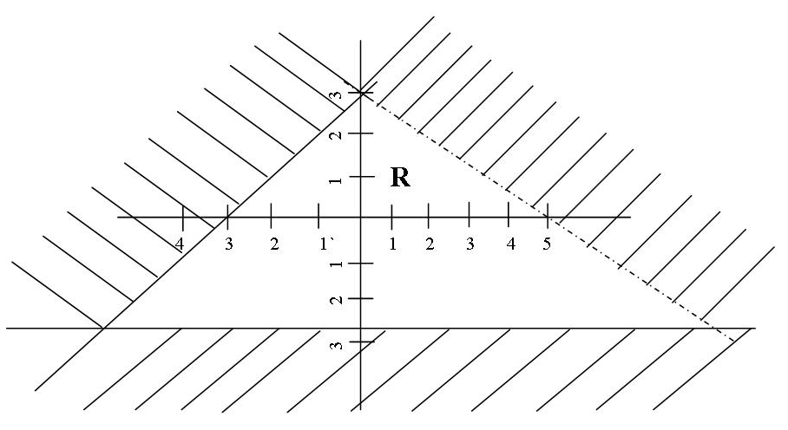

- The position vectors of points P and Q are P=2i + 3j – k and Q=3i – 2j +2k respectively. Find magnitude of PQ correct to 4 significant figures (3mks)

- a) Work out the exact value of R=$\frac{1}{0.003146-0.003130}$ (1mk)

b) An approximate value of R may be obtained by first correcting each of the decimal in
the denominator to 5 decimal places. Work out
- The approximate value (2mks)

- The error introduced by the approximation (1mk)

- The interior angles of a lexagon are 2x°, $\frac{1}{2}x°$, x+40,110, 130° and 160°. Find the value of the smallest angle. (2mks)

SECTION II (20 mks)

- The figure below shows two intersecting circles of radius 8cm and 6cm respectively. The common chord AB=9cm and P and Q are centres as shown in the figure below
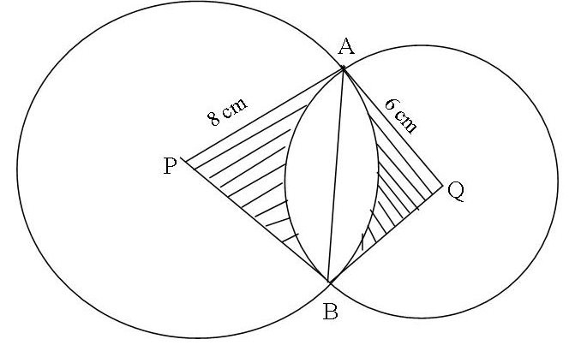
- Calculate the size of
- <APB (2mks)

- <AQB (2mks)
- Find the area of the common unsharded region (4mks)

- Find the area of the sharded region (2mks)

- A pole stands directly across the street from the building. The angle of depression of the top of the building from the top of the pole is 24.5° and angle of elevation of the pole from the foot of the building is 48.6°. given that the distance between the pole and the building is 50cm. calculate to 2 d.p
- The height of the pole (4mks)

- The difference in height between the pole and the building (2mks)

- The height of the building (2mks)

- The angle of elevation of the top of the building from the foot of the pole. (2mks)

- A passenger noticed that she had forgotten her bag in a bus 12 minutes after the bus had left. To catch up with the bus she immediately took a taxi which travelled at a speed of 95km/h. the bus maintained a speed of 75km/h. determine
- The distance covered by the bus in 12minutes (2mks)

- Time taken by the taxi to catch up with the bus (4mks)

- The distance covered by the taxi to catch up with the bus. (4mks)

- The velocity time graph below represents the motion of a car for 10 seconds
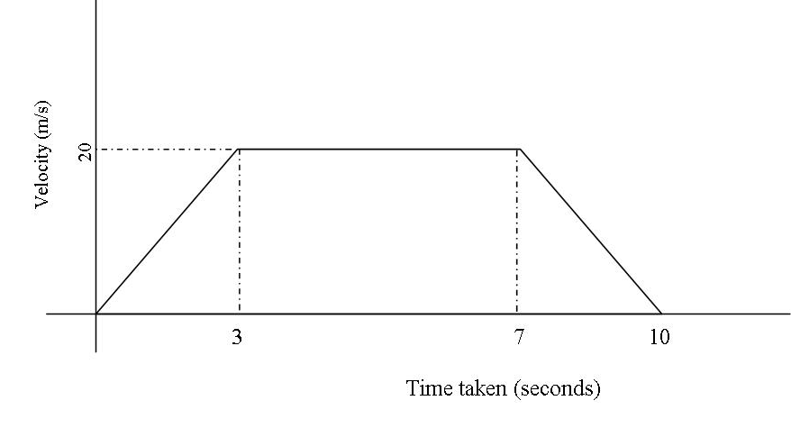
Find;
- Rate of acceleration (1mk)

- The rate of retardation (1mk)

- Total distance travelled (2mks)

- The total distance travelled during the first 4 seconds (2mks)

- The average speed maintained during the entire journey (2mks)

- The distance travelled at the constant speed. (2mks)

- a) Draw the graph of y=6+X+X² taking integral values of x in -4≤ x≤5. Using the same axes draw the graph of y=2 – 2x (2mks)
b) From your graph find the values of x which satisfy the simultaneous equations (6mks)
y=6+x-x²
y=2 – 2x
c) Write down and simplify a quadratic equation which is satisfied by the values x where
the two graphs intersect. (2mks)

