MARKING SCHEME F2
ANESTAR
No | Calculation | Marks
1 | Numerator  -8÷2+12x9-4x6  BODMAS  -8x2= - 4  -4+12x9 – 4 x6  12+9=108  4x6=24  -4+108-24=80  Denominator(BODMAS)  56÷7x2  56÷7=8  8x2=16  80/16=5 | M₁  M₁  A₁
2 | Prime 1 – 10 =2357  Square No = - 1 – 10=941  2357 – 941=1416 | M₁  M₁  A₁
3 | - 100500  2 5250  2 2625  5 525  5 105  5 21  3 7  7 1  2² x 3¹x5³x7¹  - 2¹x3²x7²=882  P=882 | M₁  M₁  A₁
4 | 1764 2744  2 882 2 1372  2 441 2 686  3 147 2 343  3 49 7 49  7 7 7 7  7 1 7 1  $\sqrt{2^{2}x3^{2}x7^{2}}$ $\sqrt[3]{2^{3}x7^{3}}$  =2x3x7x7 =2x7  2 x 3 x 7  2 x 7 =3 | M₁  M₁  A₁
5 | 5s+3b=1750x1  3s+1b=850x3  5s+3b=1750  9s+3b=2550 -  -4s = - 800  -4s= -800  -4 -4  Shirts=200  3(200) + b=850  b=850 – 600  skirts=250 | M₁  M₁  A₁
6 | Exterior angle + interior angle=180°  156 + Exterior angle=180°  Exterior angle = 180° - 156°  =24°  N=360/24  =15sides | M₁  M₁  A₁
7 | Sum of interior angles of an  Octagon=(2n – 4)90  =(2 x 8 – 4)90  =1080  2x+$\frac{1}{2}x$+x+40+110+135+160+2x+10+185=1080  5$\frac{1}{2}x$ + 640=1080  5$\frac{1}{2}x$=1080 – 640  5$\frac{1}{2}x=440$  5$\frac{1}{2}$ 5$\frac{1}{2}$ x=80 | M₁  M₁  A₁
8 | $$\frac{3}{0.216}+ \frac{10}{2.76}$$  $\frac{3}{2.76{x10}^{-1}}$ + $\frac{10}{2.76{x10}^{0}}$  3(0.3623x10¹) + 10(0.3623)  =10.869 + 3.623 = 14.492 | M₁  M₁  A₁
9 | 1948 – 750=1198 – 990 = 208  208 +560 = 768 x8  =sh.6144 | M₁  M₁  A₁
10 | Find the GCD  2 48 60  2 24 30  3 12 15  4 5  2x2x3=12cm  x=12cm  area=12cm x 12cm =144cm² | M₁  M₁  A₁
11 | x+y – 2= -1  x – 2y + z=-7  -2+y – z= -1  -2 – 2y + z= -7  Y – z=1  -2y+z=-5 +  -y = -4  -y= -4  Y=4  4 – z= -1  Yz=x3  Z=3 | M₁  M₁  A₁
12 | SECTION (II)  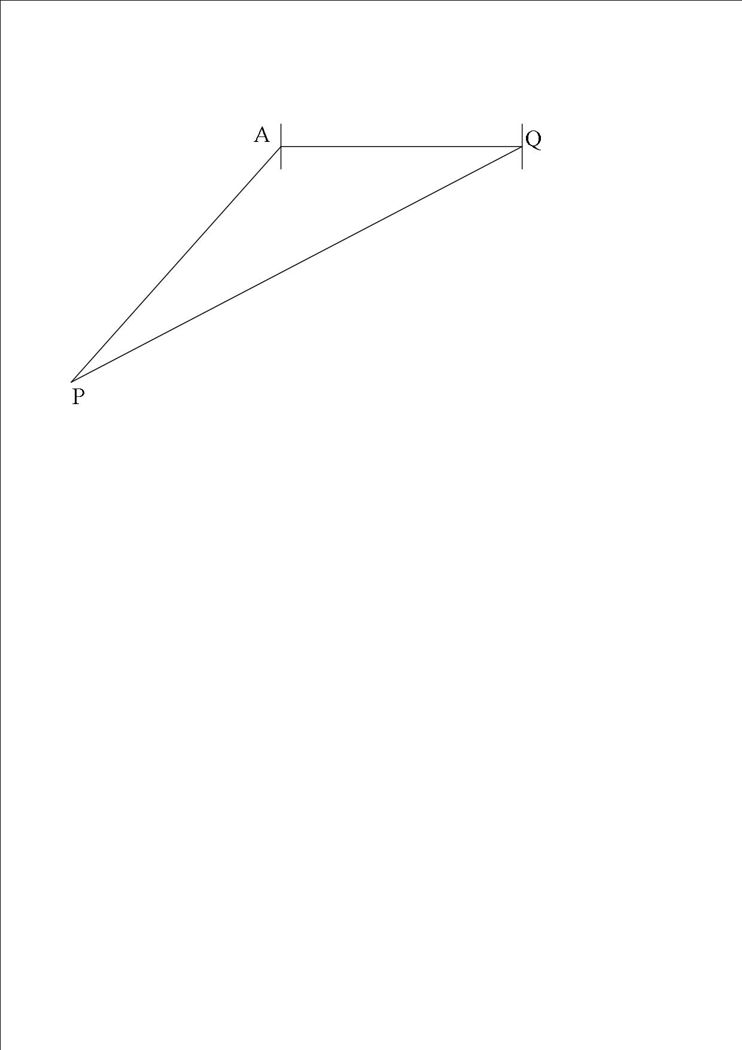  Distance P=900 x $\frac{40}{60}$ = 600km  Q=750 x $\frac{40}{60}$ = 500km  b)10.7 (+/-0.1) x 100 1070 (+/-10km)  - I) 574°W  II) 074° | B₄  B₂  M₁  M₁  M₁  M₁
13 | - =$\frac{1}{2}bh$  $\frac{1}{2}$x6x4  =12cm²  - DC²=10² - 6²  $\sqrt{{DC}^{2}}$ = $\sqrt{{10}^{2}x6^{2}}$  $DC$=8  $$\frac{1}{2}\left(4+8\right)6$$  $$\frac{1}{2}x12x6$$  =36cm²  - $\frac{1}{2}x6xb=25$  $6b=50$  6 6  B=8$\frac{1}{3}$cm | M₁  M₁  M₁  M₁  M₁  M₁  M₁  M₁  M₁  M₁
14 | - i) $\frac{30}{100} x 86400$  =25920  ii) $\frac{112 000}{16 000} : \frac{128 000}{16 000}$  = 7 : 8  iii) $\frac{40}{100} x 86, 400$  = 34, 560  - Nzau = $\frac{7}{15} x 25920+12960=25056$  Masee= $\frac{8}{15} x 25920+12960=26784$ | M₁  A₁  M₁  M₁  A₁  M₁  A₁  M₁  M₁  A₁
15 | - (8.457 x10²)²  71.52 x 10⁴ = 715200  - $\sqrt{45.667x{10}^{2}}$  =6.7580 x 10¹  =67.58  - i) 25000 + 15000 + 34000 = 74000  ii) $\frac{150000-74000}{2}$  =38000 | M₁  A₁  M₁  M₁  A₁  M₁  A₁  M₁  M₁  A₁
16 | - 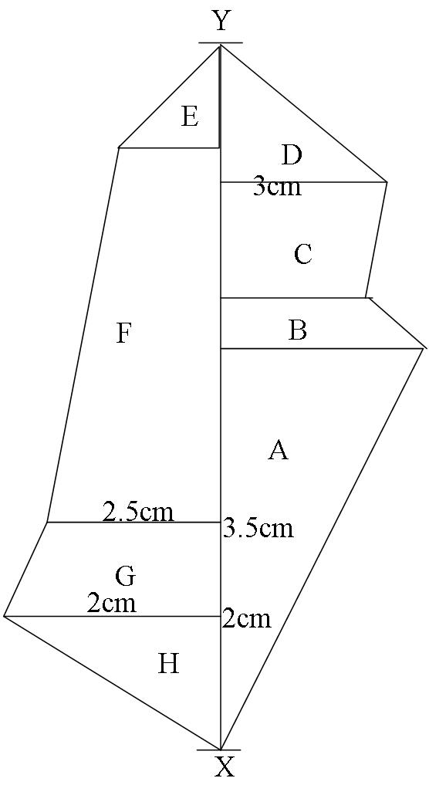  Area A = $\frac{1}{2} x 220 x 160=17600m$²  B=$\frac{(100+160)}{2}X20=2600m$²  C=$\frac{(100+120)}{2}X60=13200m$²  D=$\frac{1}{2} x 100 x 120=6000m$²  E=$\frac{1}{2} x 60 x 60=1800m$²  F=$\frac{(60+100)}{2}X200=32000m$²  G=$\frac{(100+120)}{2}X60=6600m$²  H=$\frac{1}{2} x 120 x 80=4800m$²  Total area=84600m²  $\frac{84600}{10000}$ = 8.46  8.46 x80000 = sh. 67800 | B₅  B₅

