MARKING SCHEME
FORM III OPENER EXAM 2021
No | Calculations | Marks
1 | 81^{x+1} + 3^{4x} = 246  3^{4(x+1)} + 3^{4x} = 246  3^{4x} x 3⁴ + 3^{4x} = 246  Let 3^{4x} = y  81y +y= 246  82y=246  82 82  y=3  3^{4x}=3¹  $\frac{4x}{4}$ = $\frac{1}{4}$  x=$\frac{1}{4}$ | M₁  M₁  A₁
2 | 3^{5x – 2y} = 3⁵  3^{2x-y}=3¹  5x – 2y =5x2  2x – y = 1 x5  10x – 4y = 10  10x – 5y = 5 -  y = 5  2x – 5= 1  $\frac{2x}{2}= \frac{6}{2}$ x=3 | M₁  M₁  A₁
3 | $\sqrt{6.458x{10}^{-2}}$ = 6.5613 x 10⁻¹ = 0.65413  2 ($\frac{1}{4.327 x {10}^{-1}}$) = 2 ( 0.2319 x 10¹) = 4.638  (4.638)² = 21.511  0.65413 + 21.511 = 22.16513 | M₁  M₁  M₁  A₁
4 | 3y + 2x = 5  $$\frac{3y}{3}= \frac{5}{3}- \frac{2x}{3}$$  y=-$\frac{2}{3}x+ \frac{5}{3}$  m₁= -$\frac{2}{3}$  m₂=$\frac{3}{2}$  $$\frac{-k-1}{2+2}= \frac{3}{2}$$  -2k – 2= 12  -2k=12 + 2  K= -7 | M₁  M₁  A₁
5 | If 4 = 64  3 = ?  = $\frac{3 x 64}{4}$ = 48cm  V.sf=($\frac{4}{3}$)³ = $\frac{64}{27}$  If 27 = 810  64 = ?  $\frac{64 x 810}{27}$ = 1920g | M₁  M₁  A₁
6 | 3y – 30 + 7y + 50 = 90  $$\frac{10y}{10}= \frac{70}{10}$$  Y=7 | M₁  A₁
7 | Numerator  (2y + x) (2y – x)  Denominator  (2x² – 4xy) + ( 3xy – 6y²)  2x(x – 2y) + 3y( x – 2y)  (2x +3y) (x+2y)  $\frac{\left(2y+x\right)(2y-x)}{\left(2y+3y\right)-1(2y-x)}$ = $\frac{2y+x}{-2x-3y}$ | M₁  M₁  A₁
8 | L₁ = $\frac{x}{5}+ \frac{y}{3}=1$  3x +5y =15  3x + 5y <15  L₂ = $\frac{x}{-3}+ \frac{y}{3}=1$  x – y = -3  x – y ≥ -3  L₃ y= -3  y≥ -3 | M₁  M₁  A₁
9 | 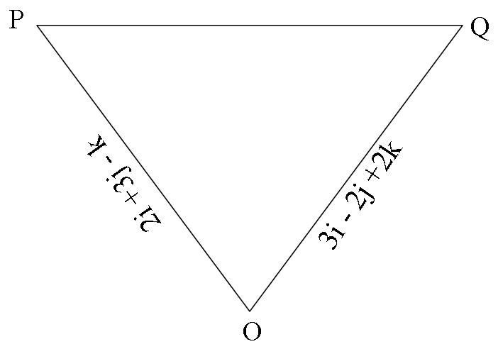  PQ=-2i – 3j + k + 3i – 2j + 2k  = I – 5j + 3k  $\sqrt{{(1)}^{2}+{(-5)}^{2}+{(3)}^{2}}$  $\sqrt{34}$ = 5.831 | M₁  M₁  A₁
10 | - R =$\frac{1}{0.003144-0.003130}$  = 62500  - $\frac{1}{0.00315-0.00313}$  = 50000  - 62500 – 50000  =12500 | M₁  M₁  A₁
11 | 2x + $\frac{1}{2}x+x+110+130+160=\left(2x6-4\right)90$  3.5x + 440=720  $$\frac{3.5x}{3.5}= \frac{280}{3.5}$$  X=80  $$\frac{1}{2}x80=40$$ | M₁  0  A₁
 | SECTION II
12 | - <APB = Sin ɵ = $\frac{4.5}{8}$  ɵ = Sin ⁻¹ 0.5625  =34.2 x2= 68.4°  <AQB = Sin ɵ = $\frac{4.5}{6}$  ɵ = Sin ⁻¹ 0.75  =48.2 X2 = 96.4°  - $\frac{68.4}{360} x \frac{22}{7}x 8x8- \frac{1}{2}x8x8 Sin 68.4$  =8.47  $$\frac{96.4}{360} x \frac{22}{7}x 6x6- \frac{1}{2}x6x6 Sin 96.4$$  $$=12.41$$  = 8.47 +12.41 = 20.88  - $\frac{1}{2}x8x8 Sin 68.4$ + $\frac{1}{2}x6x6 Sin 96.4$  $$=42.16$$  =42.16 – 2088  =21.26 | M₁  A₁  M₁  A₁  M₁  A₁  M₁  A₁  M₁  A₁
14 | - 75 x$\frac{12}{60}=15km$  - $\frac{15}{20}=45 minutes$  - 95 x $\frac{3}{4}=71.25km$ | M₁ A₁  M₁ A₁ M₁ A₁  M₁ A₁ M₁ A₁
15 | - $\frac{20}{3}=6\frac{2}{3}$m/s  - -$\frac{20}{3}= 6\frac{2}{3}$m/s  - $\frac{1}{2} \left(4+10\right)20=140m$  - $\frac{1}{2} \left(4+1\right)20$ = 50m  - Speed= $\frac{140}{10}=14\frac{m}{s}$  - Distance = 20 x 4 = 80m | B₁  B₁  M₁ A₁  M₁ A₁  M₁ A₁  M₁ A₁

