TEACHER.CO.KE
PHYSICS FORM FOUR EXAMS 2021
- A body moves 30 m due east in 4 seconds, then 40 m due north in 8 seconds. Determine:
- The total distance moved by the body. (6mks)
- The displacement of the body.
- The average speed of the body.
- The average velocity of the body.
Solution
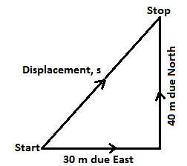
- $Total distance = total length covered$
$$30 m + 40 m =70 m$$

- $Total displacement is \left(\sqrt{{30}^{2}+{40}^{2}}\right) m$
$$\sqrt{2500 }m=50 m on bearing {36.87}^{o}$$
- $Average speed=\frac{total distance covered}{total time taken}$
$$=\frac{70}{12}=5.833 ms^{-1}$$
- $verage velocity=\frac{total displacement}{total time taken}$
$$=\frac{50}{12}=4.167 {ms}^{-1}on bearing {36.87}^{o}$$
- The speed of a of body rolling on an inclined plane is 10 ms⁻¹ when time is 0 s at time t = 10 s the speed of the body is found to be 25 ms⁻¹. If the body is moving in the same direction throughout, calculate the average acceleration of the body
(3mks)
Solution
$$a=\frac{v-u}{t}$$
$$a= \frac{\left(25-10\right){ms}^{-1}}{\left(10-0\right) s}$$
$$a=\frac{15{ ms}^{-1}}{10 s}=1.5{ ms}^{-2}$$

3, A car starting from rest accelerates uniformly for 5 minutes to reach 30 ms⁻¹. It continues at this speed for the next 20 minutes and then decelerates uniformly to come to stop in 10 minutes. On the axes provided, sketch the graph of velocity against time for the motion of the car and hence, find the total distance covered by the car.
(4mks)

Solution
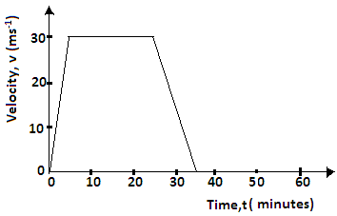
$$Total distance=total area under the graph$$
$$Total distance=\frac{1}{2}\left(35+20\right)60×30$$
$$Total distance=49500 m$$

4.What is the momentum of a racing car of mass 500kg driven at 270km/h? (3mks)
Solution
$$v=270 kmh^{-1}=75 ms^{-1}; m=500 kg$$
$$momentum=mass\left(kg\right)×velocity\left(ms^{-1}\right)$$
$$momentum=500 kg × 75 m$$
$$=37500 kgms^{-1}$$

5.A certain machine uses an effort of 400N to raise a load of 600N. If the efficiency of the machine is 75%, determine its velocity ration. (3mks)
Solution
$$M.A=\frac{load}{effort}$$
$$M.A=\frac{600}{400}=1.5$$
$$η=\frac{M.A}{V.R}×100\%⇒75=\frac{1.5}{V.R}×100\%$$
$$V.R=\frac{1.5}{75}×100\%=2$$

6.A block and tackle system is used to lift a mass of 400 kg. If this machine has a velocity ratio of 5 and an efficiency of 75 %
- Sketch a possible arrangement of the pulleys showing how the rope is wound (5mks)
- Solution

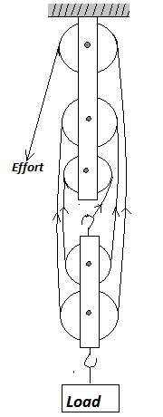
- Calculate the effort applied.
- Solution
$$η=\frac{M.A}{V.R}×100\% ⇒ 75=\frac{M.A}{5}×100\%$$
$$M.A=\frac{75×5}{100}=3.75$$
$$M.A=\frac{Load}{Effort}; 3.75=\frac{400×10}{Effort}$$
$$⇒Effort=\frac{4000}{3.75}=1066.7 N$$

7. A ray of light passes through air into a certain transparent material. If the angles of incidence and refraction are 60⁰ and 35⁰ respectively, calculate the refractive index of the material (3mks)
Solution
$$Refractive index=\frac{\sin{i}}{\sin{r}}$$
$$Refractive index=\frac{sin 60}{\sin{35}}=1.510$$

8.The volume of a gas enclosed with a movable piston is 300 cm³ when the temperature is 2o º C. Determine the temperature at which the volume of the gas increases to 355 cm³. (Assume pressure does not change) (3mks)
Solution
$$V_{1}={300 cm}^{3}, V_{2}={355 cm}^{3}, T_{1}=20{}_{.}^{o}C=\left(20+273\right)K=293 K, T_{2}=?$$
$$\frac{V_{1}}{T_{1}}=\frac{V_{2}}{T_{2}}$$
$$\frac{{300 cm}^{3}}{293 K}=\frac{{355 cm}^{3}}{T_{2}}$$
$$T_{2}=\frac{{355 cm}^{3}×293 K}{{300 cm}^{3}}=346.72 K$$
$$In celsius scale, T_{2}=346.72-293=53.72 {}_{.}^{o}C$$

9.The figure below shows 3 resistors in series connected to power source. A current of 1.5A flow through the circuit. (5mks)
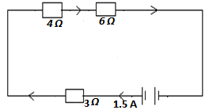
Calculate:
- The total resistance
- The voltage across the source
- The voltage drop across each resistor
Solution
$${a) R}_{T}=R_{1}+R_{2}+R_{3}$$
$${ R}_{T}=4+6+3=13 Ω$$
$$b) V=IR$$
$$V=1.5 ×13=19.5 V$$
$$c) V_{4Ω}=1.5 ×4=6 V$$
$$V_{6Ω}=1.5 ×6=9 V$$
$$V_{3Ω}=1.5 ×3=4.5 V$$

10.When a current of 2A flows in a resistor for 10 minutes, 15KJ of electrical energy is dissipated. Determine the voltage across the resistor. (2mks)
Solution
$$E=VIt$$
$$15×1000=V ×2 ×10×60$$
$$V=\frac{15000}{1200}=12.5 V$$
11.How many 100W electric irons could be safely connected to a 240V moving circuit fitted with a 13A fuse? (2mks)
Solution
$$P=VI$$
$$(No. of irons) x 1000 = VI$$
$$No. of irons =\frac{13 x 240}{1000}$$
$$= 3.12= 3 irons$$

12.Calculate the amount of heat required to convert 4kg of ice at -10⁰c to liquid at 5⁰c (specific heat capacity of water is 4200Jkg⁻¹k⁻¹ ,specific heat capacity of ice =2100Jkg⁻¹k⁻¹, specific latent heat of fusion of ice =340,000Jkg⁻¹k⁻¹) (3mks)
Solution
$$Q=m_{ice}c_{ice}{∆θ}_{ice}+m_{ice}l_{f ice}+ m_{water}c_{water}{∆θ}_{water}$$
$$Q=4×2100×\left(10-0\right)+4×340000+4×4200×\left(5-0\right)$$
$$Q=84000+1360000+84000$$
$$Q=1528000 J or 1.528 MJ$$

13. A kettle rated at 4.0kW containing 2.0kg of water is left switched on. How long will it take the water to boil dry in the kettle if the initial temperature of water is 20⁰c (specific heat capacity of water is 4200Jkg⁻¹k⁻¹ specific latent heat of vaporization of water is 2.26x10⁶Jkg⁻¹. (4mks)
Solution
$$Q=Pt= m_{water}c_{water}{∆θ}_{water}+ml_{V water}$$
$$4000×t=2×4200×\left(100-20\right)+2×{2.26×10}^{6}$$
$$t=\frac{672000+4520000}{4000}=1298s$$
14.An object is placed 12 cm from a converging lens of focal length 18 cm. Find the position of the image. Solution (2mks)
Since it is a converging lens f = +18 cm (real-is-positive and virtual-is-negative rule)
The object is real therefore u = +12 cm, substituting in the lens formula, then
1 / f = 1 / u + 1 / v or 1 / v = 1 / f – 1 / u = 1 / 18 – 1 / 12 = - 1 / 36
Hence v = - 36 then the image is virtual, erect and same size as the object.

15.The focal length of a converging lens is found to be 10 cm. How far should the lens be placed from an illuminated object to obtain an image which is magnified five times on the screen? Solution
f = + 10 cm m = v / u = 5 hence v = 5 u (2mks)

