FORM 4 BUSINESS STUDIES
MID TERM 1 EXAM 2021
TIME:2 HOURS
NAME………………………………………………………………………….CLASS……….ADM NO………….
- Define the following terms as used in Business Studies. (4 mks)
- Economics………………………………………………………………………………
………………………………………………………………………………………….
- Entrepreneurship………………………………………………………………………..
…………………………………………………………………………………………..
- Opportunity cost………………………………………………………………………...
…………………………………………………………………………………………..
- Scale of preference……………………………………………………………………...
…………………………………………………………………………………………..

- Highlight four reasons why food is an important basic need. (4 mks)

- ………………………………………………………………………………………….
- …………………………………………………………………………………………..
- …………………………………………………………………………………………..
- …………………………………………………………………………………………..

- Outline four importance of a warehouse to a consumer. (4 mks)

- ………………………………………………………………………………………….
- …………………………………………………………………………………………..
- …………………………………………………………………………………………..
- …………………………………………………………………………………………..

- Outline four requirements for one to start a limited liability company as one of the forms of business units. (4 mks)

- ………………………………………………………………………………………….
- …………………………………………………………………………………………..
- …………………………………………………………………………………………..
- …………………………………………………………………………………………..
- Highlight four factors a firm must take into account when deciding on the product(s) to produce.

- ………………………………………………………………………………………….
- …………………………………………………………………………………………..
- …………………………………………………………………………………………..
- …………………………………………………………………………………………..

- Highlight four ways in which entrepreneurs can observe ethics in the management of their business. (4 mks)

- ………………………………………………………………………………………….
- …………………………………………………………………………………………..
- …………………………………………………………………………………………..
- …………………………………………………………………………………………..

- The following information was extracted from the books of Dawida business enterprise for the year ended 30th June 2000.

Capital as at 30th June, 2000 640,000
Capital as at 1st July 1999 420,000
Drawing for the year 180,000
Net profit for the year 140,000

Determine the additional capital during the year. (4 mks)

- Below is a demand and supply curve.
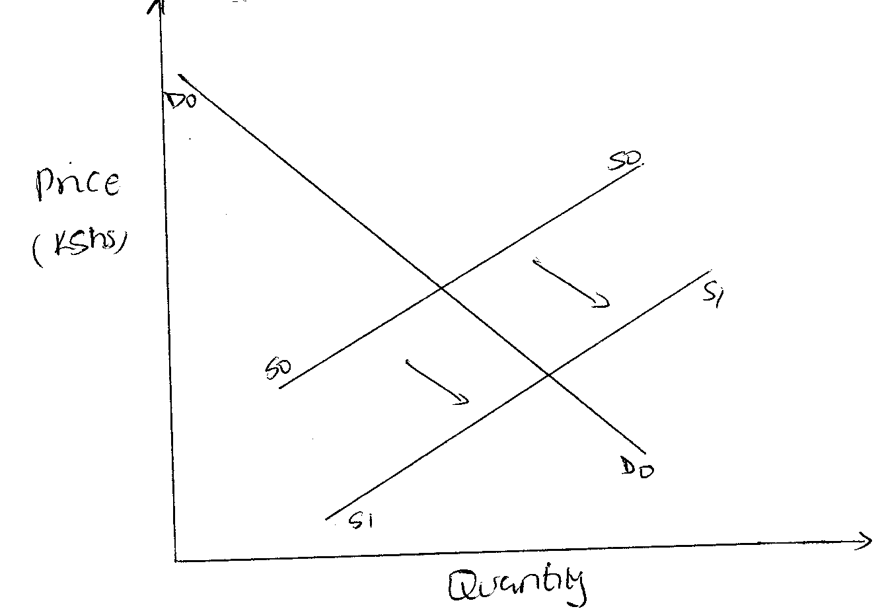

Highlight the factors that may have led to the above behavior. (4 mks)

- ………………………………………………………………………………………….
- …………………………………………………………………………………………..
- …………………………………………………………………………………………..
- …………………………………………………………………………………………..

- Outline four circumstances under which a trader can issue a credit note to a customer.
(4 mks)

- ………………………………………………………………………………………….
- …………………………………………………………………………………………..
- …………………………………………………………………………………………..
- …………………………………………………………………………………………..

- Give the difference between: (4 mks)
- Double and co-insurance
………………………………………………………………………………………………
………………………………………………………………………………………………
………………………………………………………………………………………………
- Premiums and surrender value
………………………………………………………………………………………………
………………………………………………………………………………………………
………………………………………………………………………………………………

- Highlight four duties of commercial attaches in trade promotion. (4 mks)

- ………………………………………………………………………………………….
- …………………………………………………………………………………………..
- …………………………………………………………………………………………..
- …………………………………………………………………………………………..
- Identify the book of original entry in which the following transactions can be recorded.
(4 mks)

Transaction | Book of Original Entry
Paid salaries by cheque
returned goods to a supplier
Sold goods on credit
Bought delivery van on credit

- Outline three leakages in a circular flow of income. (3 mks)

- ………………………………………………………………………………………….
- …………………………………………………………………………………………..
- …………………………………………………………………………………………..

- Outline four advantages of using celebrities in product promotion. (4 mks)

- ………………………………………………………………………………………….
- …………………………………………………………………………………………..
- …………………………………………………………………………………………..
- …………………………………………………………………………………………..
…………………………………………………………………………………………..
………………………………………………………………………………………….
- Kenya is planning to extend her pipeline transport. State four advantages of pipeline transport to the country. (4 mks)

- ………………………………………………………………………………………….
- …………………………………………………………………………………………..
- …………………………………………………………………………………………..
- …………………………………………………………………………………………..

- Outline four emerging issues in office management. (4 mks)

- ………………………………………………………………………………………….
- …………………………………………………………………………………………..
- …………………………………………………………………………………………..
- …………………………………………………………………………………………..

- . (a) The accounts of Joy Light Traders showed the following balances as at 31st December 2012

Land and building 150,000
Motorcars 120,000
Debtors 15,000
Cash 30,000
Creditors 4,000
Capital 31,000

The following transactions took place during the first week of January 2013

January 1 Bought stock of goods for cash Shs. 10,000
" " 2 Paid a creditor by cash Shs. 2,500
" " 3 Sold goods for cash Shs. 5,000
" " 4 Received a cheque from a debtor Shs. 12,000
" " 5 Bought stock of goods by cheque Shs. 8,000
" " 6 a debtor paid in cash Shs. 3,000

Required: Open the relevant Ledger accounts, balance them off and extract a trial balance as at on 6th January 2013 (12mks)

(b) Explain four measures that the government of Kenya should put in place to
alleviate the problems of unemployment (8mks)

