**24. SETTLEMENT**

**This topic entails :-**

1. ***Definition of settlement and urbanization***
2. ***Explaining the factors influencing settlements and settlement patterns***
3. ***Accounting for the distribution and functions of selected towns in Kenya***
4. ***Explaining the growth an functions of selected towns in Kenya***
5. ***Comparing and contrasting selected urban centres in Kenya with those of other parts of the world.***
6. ***Discussing the effects of urbanization***

1. The diagram below shows part of the urban set up. Use it to answer part (a) and (b)

(a) Name the parts labeled **ABC**

(b) Give **three** characteristics of the part labeled **A**

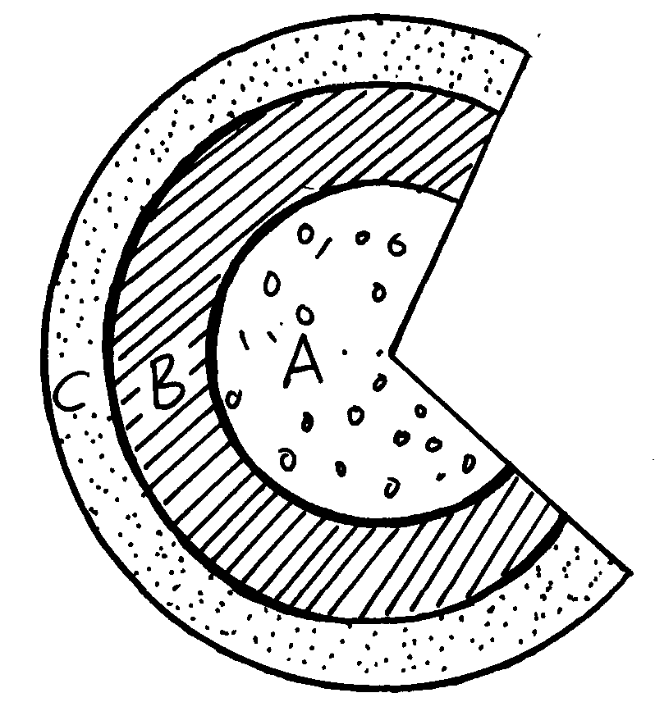

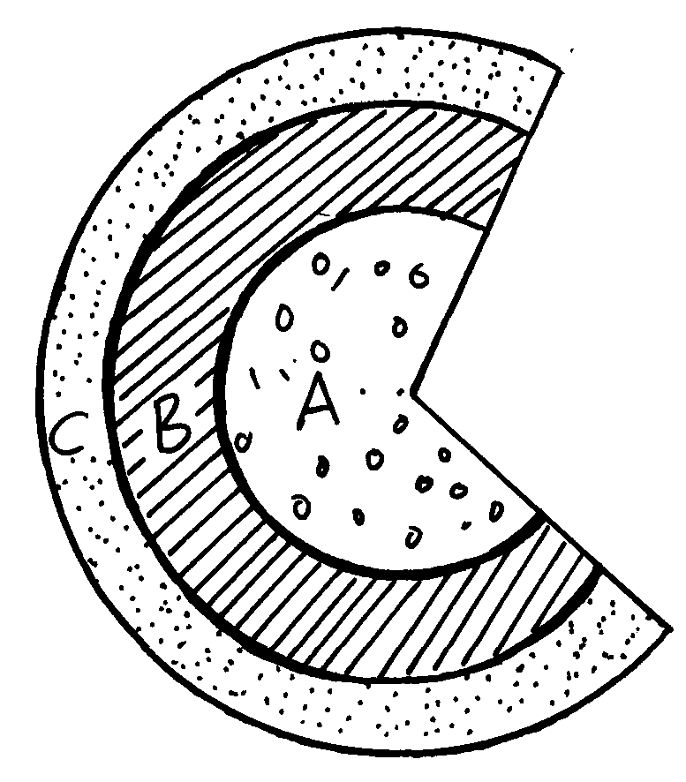

2 a) Name **two** settlement patterns common in rural areas in Kenya

b) The diagram below shows the internal structure of an urban centre. Name the sectors

labeled 1, 2, 3