IDM EVALUATION TEST

SCIENCE STD 7 2020 Time: 1 hour 40 Mins

- Drugs can be misused in the following ways EXCEPT:-
- Taking wrong dosage
- Taking wrong medicine
- Buying medicines without doctor’s prescription
- Taking drugs to prevent diseases
- The following are all sides effects of abusing cocaine EXCEPT:-
- Lack of sleep
- Hallucination
- Loss of appetite
- Liver cirrhosis
- The diagram below shows a blood vessel. Which of the following is LIKELY to be the vessel shown?
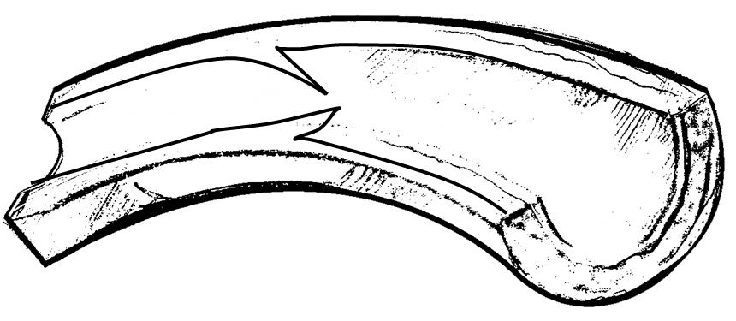

- Venacava
- Aorta
- Pulmonary artery
- Valve
- Children born of mothers who smoke are likely to suffer from one of the following. Which one?
- Lung cancer
- Over weight
- Stigma
- Weak immune system
- Which component of cigarette leads to addiction?
- Ash
- Nicotine
- Carbon dioxide
- Tar
- Nambia drunk a glass of milk for her lunch. In which part of her digestive system did the digestion of milk start?
- Mouth
- Stomach
- Ileum
- Duodenum
- All the following components are carried by the plasma EXCEPT:-
- Urea
- Salts
- Dissolved food materials
- Oxygen

- Which of the following body fluids is NOT a likely medium of transmission of HIV/AIDS?
- Semen B. saliva
- Blood D. urine
- The white bold cells are produced in the part of the body called
- Heart
- Yellow borne marrow
- Kidney
- White bone marrow
- A certain water bone disease has the following signs and symptoms:-
- Violent diarrhea with mucus
- Several abdominal pains
- Dehydration
The disease is LIKELY to be:-
- Cholera
- Typhoid
- Dysentery
- Bilharzia
- The diagram below illustrates the human breathing system. Which part represents the bronchus?
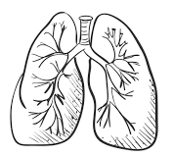

- U B. V C. W D. X
- Bile is manufactured in the ____.
- Intestines
- Stomach
- Live r
- Mouth
- In which part does fertilization take place in plants?
- Anthers
- Stigma
- Pollen tube
- Ovary
- Which of the following is the correct order of development stages of a baby during pregnancy?
- Foetus, embryo, zygote
- Embryo, zygote, foetus
- Zygote, foetus, embryo
- Zygote, embryo, foetus
- The type of roots found near the base of maize stems are used for
- Absorbing water
- Absorbing mineral salts
- Breathing
- Offering extra support
- Which of the following feeds is not common in zero grazing?
- Fodder
- Silage
- Pasture
- Hay
- The diagram below shows a form of soil erosion.
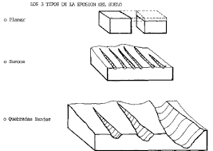

What is the name given to this type of erosion?
- Rill erosion
- Sheet erosion
- Gulley erosion
- Splash erosion

- The MOST appropriate weather instrument to use when measuring the strength of wind is the
- Thermometer
- Raingauge
- Windvane
- Windsock

- The soil that drains water slowest
- Has small air spaces
- Has poor capillarity
- Has rough texture
- Does not make ribbons

- The following are functions of the nose EXCEPT:-
- It helps to warm the air
- It moistens the air
- It filters the air
- It protects the air sacks
- Which one of the following drugs is NOT obtained from the cocoa plant?
- Heroine
- Cocaine
- Hashish
- Mandrax
- Which one of the following is NOT a myth about AIDS?
- AIDS is caused by witchcraft
- AIDS is a curse from gods
- AIDS does not affect fat people
- AIDS is real
- Plants which feed on dead decaying matter are called _______
- Mushrooms
- Saprophytes
- Parasites
- Creepers
- Which one of the following livestock feeds is prepared by the fermentation process?
- Hay B. Pasture
- Fodder D. silage

- Which one of the following drugs is a preventive drug?
- B.C.G B. Panadol
C. Penicillin D. Malaraquin

- Which one of the following is NOT part of a food chain?
- Photosynthesis B. Consumer
C. Producer D. Decomposer

- Which one of the following blood vessel carries blood to the right side of the heart?
- Pulmonary vein
- Aorta
- Venacava
- Pulmonary artery

Use the diagram below to answer questions 28-32

- Which statement below is CORRECT about the blood vessel marked W? It carries _______.
- blood from the lungs
- blood to the lungs
- blood to the body parts
- de-oxygenated blood
- Which chamber pumps blood that is scarlet red in color?
- U B. V
- X D. Y
- The blood vessel marked X is the
- Aorta
- Vena cava
- Pulmonary vein
- Pulmonary artery
- Which of the following statements is NOT correct. The blood vessel marked Y
- Carries deoxygenated blood
- Is the major artery in the circulatory system
- Carries blood to the body organs
- Is the aorta
- The blood vessel marked Z is
- carries blood from the lungs
- is the pulmonary artery
- is the aorta
- carries dull red blood
- Which one of the following is NOT a narcotic drug?
- Tobacco
- Mandrax
- Heroin
- Cocaine
- The diagram below represents a tooth of a human being. Which is the function of the tooth?
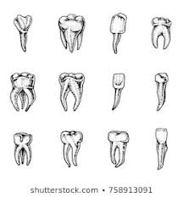

- Grinding
- Chewing
- Crushing
- Biting

- A patient had pale finger nail, shortness, of breath and felt dizzy. The patient as most likely suffering from
- Kwashiorkor
- Marasmus
- Anaemia
- Rickets
- How does heat from a fire reach a person sitting two metres away?
- By convection
- By radiation
- By conduction
- By absorption
- When HIV attacks the body.
Which blood component is mostly affected?
- Red cells
- White cells
- Plasma
- Platycoelous
- The green colored substances that plant use during photosynthesis is called
- Stomata
- Chlorophyll
- Wax
- Pollen grains

- The gas necessary for combustion in the air has a percentage of
- 0.97% B. 21%
C. 0.03% D. 78%

- Through which of the following is the transmission of sound poorest?
- Metal B. wood
C. Air D. water
- Std 5 pupils carried out the experiment below:
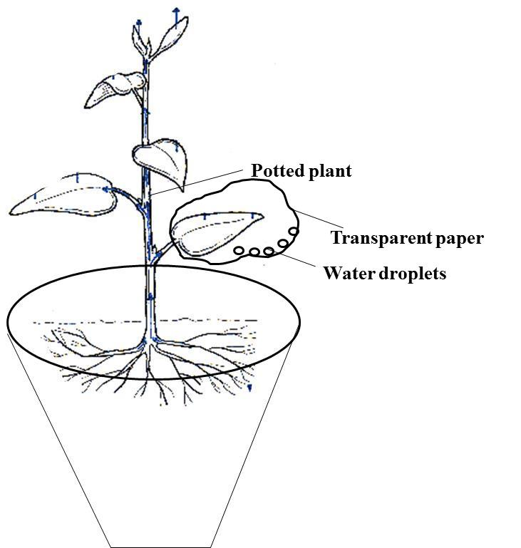

The pupils were investigating?
- Transpiration
- Evaporation
- Respiration
- Absorption

- All the following are TRUE about all mammals EXCEPT:-

- They all give birth
- They suckle their young ones
- Their bodies are covered by fur
- They have constant body temperature

- Which of the following planets is nearer to the earth?
- Mercury
- Saturn
- Neptune
- Uranus

- Which one of the following is the main difference between a fruit and a seed? Fruit have
- Two cotyledons
- Many seeds
- Flesh
- A pair of scars

- Which of the following is NOT an importance of HIV testing?
- To enable one to overcome fear
- To plan for future
- To campaign against the spread
- To transmit to others

- The 3rd polio vaccine is given to infants at the age of
- 6 weeks
- 9 weeks
- 14 weeks
- 10 weeks

- The part of the plant that anchors the plant to the soil also
- Carries out photosynthesis
- Carries out transpiration
- Supports the crown
- Absorbs water and mineral salts

- Which one of these is NOT a function of the micropyle during germination?
- Lets in air into the seed
- Lets in water into the seed
- Allows the radicle to grow out
- Allows the plumule to grow out

- All the following are characteristics of insects pollinated flowers EXCEPT:-
- Scented
- Large feathery stigma
- Sticky pollen grains
- Sticky stigma

- The state in which matter exists depends on:-
- Temperature and pressure
- Freezing and melting
- Size and density
- Temperature and materials

