SUKELLEMO 2022 JUNE AGRICULTURE PAPER 2
M A R K I N G S C H E M E

SECTION A (30 MARKS)

Answer ALL questions in the spaces provided

1. Give three qualities that make the merino breed popular. (1 ½ marks)
- The breed is hardly suited to moderately dry areas.
- Has a good flocking instinct hence easy for a shepherd.
- Produces high quality wool.

2. Name four breeds of rabbits. (2 marks)
- New Zealand white
- Californian white
- Flemish giant
- Chinchilla
- Earlope

3. State three reasons that a farmer would prefer to use an ox-cart instead of a tractor-drawn trailer. (2 marks)

- If a farmer has little capital
- If the land is very steep
- If the farmer has available land for grazing and poor roads

4. State four factors that influence the quality of honey. (2 marks)

- Presence of impurities or foreign materials.
- Source of nectar/food type
- Stage of maturity
- Over smoking reduces quality of honey
- Method of extraction
- Season of the year and flowering

5. Outline four management practices that would ensure maximum harvest in a fish pond. (2 marks)

- Control of stocking rate
- Control of water pollution
- Supply of food for fish
- Aeration of water/flowing water
- Maintaining appropriate depth of water in the pond
- Harvesting at the right maturity stage
- Control of predators

6. State six factors that may determine the quantity of silage eaten by dairy cows.
(3 marks)
- Palatability of the silage
- Physical size of ensiled silage
- Method of preparation of the material
- Animal body weight or size
- Level of milk production
- Physiological state of the cow
- Type of foliage plant
- Other feeds that the cow may have eaten or hunger

7. Name two predisposing factors to foot rot disease in sheep. (1 mark

- Wet ground or muddy soil
- Injuries or hooves
- Overgrown hooves

8. Give two reasons why walls of dairy sheds should be white washed instead of painting with water or oil paints. (1 mark)

- To avoid poisoning from lead
- Discourage insects inhabiting the shed
- Avoiding tainting milk in the shed

9. Give two reasons why tsetsefly control is considered a land reclamation method. (1 mark)
- Human settlement is made possible
- Livestock rearing is made possible

10. (a) What is the intermediate host for liver fluke. (½ mark)
Fresh water snail/mud snail
(b) What is the duration of oestrus cycle in a cow? ( ½ mark)
18 – 22 days
(c) What term is used to refer to the condition during calving in which the hind legs come out first? ( ½ mark)

Breech/rear presentation/mal-presentation

11. Give two causes of soft shells in eggs. (1 mark)

- Deficiency of calcium
- An infection by new castle disease

12. State four reasons for keeping livestock healthy. (2 marks)
- Fast growth and maturity is achieved.
- A long economic and productive life is achieved.
- Maximum production and performance is achieve.
- Good quality products are achieved.
- Spread of diseases is curbed to other animals and human beings
- It is economical to keep healthy animals.

13. Give four qualities of a good acaricide. (2 marks)
- Ability to kill ticks
- Harmless to human beings and livestock
- Be stable for a long duration
- Be effective even after being foiled with dung, mud, hair

14. State four disadvantages of inbreeding in livestock. (2 marks)
- Brings less of hybrid vigour
- Leads to a decline in fertility leading to species extinction
- Reduces performance of livestock
- Leads to a high rate of pre-natal mortality

15. Outline four benefits of steaming-up in livestock. (2 marks)
- Provides nutrients for good foetal growth
- Builds up energy for parturition
- Ensures birth of healthy animals
- Ascertains good health of the mother
- Increases and maintains high milk yield after birth

16. Name four reasons for castrating male calves. (2 marks)
- Makes them docile
- They fatten faster into steers
- Breeding is controlled
- Inbreeding is also controlled
- Breeding diseases like brucellosis and vaginitis are controlled.

17. Outline four uses of solar energy in a farm. (2 marks)
- Used for drying farm produce
- Used for heating water
- Used for distillation of clear drinking water
- Used for cooking with special equipment
- Used for generating electricity

SECTION B (20 MARKS)

Answer ALL questions in this section in the spaces provided

18. The following is a diagram of an artificial incubator. Study it and answer questions that follow.

(a) Identify the following parts shown by letters A and B. (2 marks)
A Thermometer
B Warm water

(b) State three conditions that are necessary for a successful hatching. (3 marks)

- Temperature should be ideal preferably 37.5⁰C – 39.4⁰C to maintain a healthy growth of the embryo.
- Fresh air is ideal in the incubator for embryonic development
- A relative humidity of 60% is ideal in production of healthy chicks during hatching.
- Egg turning regularly is necessary to avoid the germinal disk sticking onto the egg shell that leads to embryonic mortality

19.
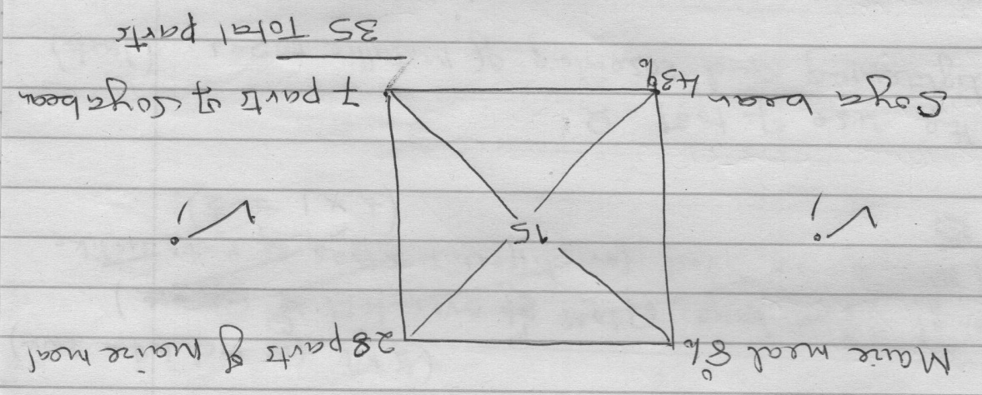

20. The following diagram is a petrol engine of a tractor ignition system, study it and answer the questions that follow.

(a) Identify the following parts F and G. (1 mark)

F Distributor
G Ignition coil

(b) What is the role of part G? (1 mark)
Converts battery voltage from 12 volts to 6000 volts for the spark plugs.

(c) State three maintenance that should be done to the tractor battery. (3 marks)
- Level of electrolyte should be above the plats of topping up with distilled water.
- Corroded terminals should be scrapped clean and smeared grease.
- Battery should be tightly fixed to avoid damage or spillage.
- Battery should be fitted correctly on the tractor.
- Battery should be charged regularly.
- For long storage the contents should be emptied and kept upside down.
- The fan belt for charging the battery should be tightly fixed.

21. Study the following diagram and answer questions below.

(a) Identify the above disease. (1 mark)

Fowl pox

(b) What causes the above disease? (1 mark)

Virus / Avian fox

(c) Give two predisposing factors of the disease. (2 marks)

- Wounds on the body
- Presence of mosquitoes, ticks, lice, and other biting insects.

(d) Give one control measure of the disease. (1 mark)
- Vaccinating all the healthy birds every 6 months
- Killing all the affected birds and disposing the carcasses properly

SECTION C (40 MARKS)
Answer any two questions from this section.
22. (a) Explain eight functions you can carry out in a crush. (8 marks)
- Spraying livestock against external parasites
- Identifying the livestock by branding, ear tagging, ear notching
- Vaccination against notifiable diseases
- Administering prophylactic drugs to livestock in control of diseases
- Treating livestock with other medicants like antihelminths.
- Dehorning livestock to avoid risks of horns.
- Pregnancy, testing in identification of fertility.
- Artificial insemination in avoidance of natural mating.
- Taking body temperature in checking for fever.
- Hoof trimming to avoid foot rot.
- Milking the cows twice a day.

(b) Describe six advantages of rotational grazing. (6 marks)
- Maximum use of the pasture is made by livestock.
- Buildup of pests and diseases is reduced
- Animals faecal material is distributed evenly in all paddocks,
- Pastures are given time to regrow before grazing is done again.
- Excess pastures can be harvested and conserved.
- Fertilizers reseeding and weeding can be done on pastures that are not in use.

(c) Describe six effects of parasites on livestock. (6 marks)
- Suck large volumes of blood causing anaemia in livestock.
- Deprive the host livestock food by extracting nutrients from the alimentary canal of the host animal.
- Injury and damage to tissues and organs mainly the skin and internal organs damaged during migration causing haemorrhage.
- The wounds created on the hides and skins are entry points of disease pathogens and infection.
- Many parasites are vectors of infectious diseases spreading them to other livestock.
- When parasites bite the livestock on their hides and skins they create irritation.
- Obstruction of internal organs mainly the small intestines occurs when internal parasites accumulate causing constipation.

- (a) Describe the characteristics of indigenous cattle that make them more suited to survive in marginal areas . (9mks)

- Have humps that store fat which is broken down to energy and water in times of starvation
- Fairly tolerant to high temperatures due to dewlap and thick hides
- High tolerance to tropical diseases such as trypanosomiasis
- Slow growth rate leading to late maturity
- Low production of both meat and milk due to inheritance of poor characteristics
- Can walk long distances in search of food and water
- Can stay for long distances in search of food and water without seriously affecting their performance and body condition
- Have long calving intervals of more than one year.

(b) Explain five reasons for maintaining farm tools and equipment. (5 marks)
- Increase the durability of tools and equipment to last long.
- To reduce the replacement cost hence save on spending excessively.
- Increase efficiency so that work can be down with comfort without stress.
- Avoid injuries to the user that is done by blunt tools or those with poor handles.
- Avoid damage to the tools that may include breakages to the tools if poorly maintained.

(c) Explain six maintenance commonly done to farm tools and equipment.
(6 marks)
- Cleaning the tools after use.
- Sharpening the cutting tools.
- Tightening the loose handles using bolts and nuts,
- Applying used engine oil on the metal surfaces to prevent rust.
- Repairing and replacing broken parts like the blades.
- Using lubricant for all moving parts of tools and equipment to reduce friction.

24. (a) Describe ten uses of fences on a farm. (10 marks)
- Provide security from thieves, wildlife, trespassers.
- Enable paddocking/rotational grazing/mixed farming
- Control parasites and diseases by keeping away neighbouring animals
- Demarcating the boundaries.
- Live, fences act as windbreakers and shelter belts.
- Provide aesthetic value to the farm
- Increase the farm land value
- Help in soil and water conservation in case of hedges
- Hedges may be a source of fruits and their trimmings a source of fodder, firewood, compost manure.
- Provide privacy
- Isolation of animals for different purposes like treatment, gestation, bull isolation.

(b) Explain five essentials of clean milk production . (10 marks)

A healthy lactating cow.
A healthy and clean milker.
Clean and properly constructed milking parlour.
Clean and disinfected milking equipment.
Proper handling of the milk after milking.
Avoid flavours in milk.-
Milk filtration, cooling and storage.

