Name: …………………………………………………………Class: ………… Adm.No………
School: ………………………………………………………… Date: ……………………
Sign:…………………
121/2
MATHEMATICS
PAPER 2
TIME: 2 ½ HOURS

SUKELLEMO PRE-MOCK E X A M I N A T I O N - JUNE 2022
Kenya Certificate to Secondary Education
MATHEMATICS (PAPER 2)
TIME: 2 ½ HOURS
Instructions
- Write your name, class, admission number, school, date and signature in spaces provided above.
- The paper contains two sections I and II.
- Answer all questions in section I and any five questions from section 11 in the spaces provided below each question.
- Show all the steps in your calculations giving your answers at each stage in the spaces below each question.
- Non-programmable silent electronic calculator and mathematical tables may be used except where stated otherwise.

For Examiner’s Use Only
1 | 2 | 3 | 4 | 5 | 6 | 7 | 8 | 9 | 10 | 11 | 12 | 13 | 14 | 15 | 16 | TOTAL
SECTION A

SECTION B

PERCENTAGE
SCORE
17 | 18 | 19 | 20 | 21 | 22 | 23 | 24 | TOTAL

SECTION I (50 MARKS)
Answer all the questions from this section
- The expression (1 + $\frac{x}{2}$) is taken as an approximation for$\sqrt{1+x}$. Find the percentage error in doing so if x = 0.44. (Give answer correct to 2 d.p) (3 Marks)

- Express the following in surd form and simplify by rationalizing the denominator. 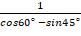 (3 Marks)

- Make q the subject of the formula ( 3 Marks)
P= 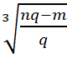

- The data below shows the age of 10 pupils picked at random in a primary school 6, 11, 13, 14, 8, 7, 12, 20, P and 9 if $\sum{{\text{fx}}^{2}}$= 1360. Determine the value of P hence, find the standard Deviation to 3d.p (4 Marks)

- The volume, V of a cylinder varies jointly as its height, (h) and the square of its radius, (r), Calculate the percentage increase in its volume (V), when radius increases by 5% and height, h increases by 10%. (3 Marks)

- Chords AB and CD in the figure below intersect externally at Q. if AB = 5cm BQ = 6cm and DQ = 4cm, calculate the length of chord CD. (2 Marks)
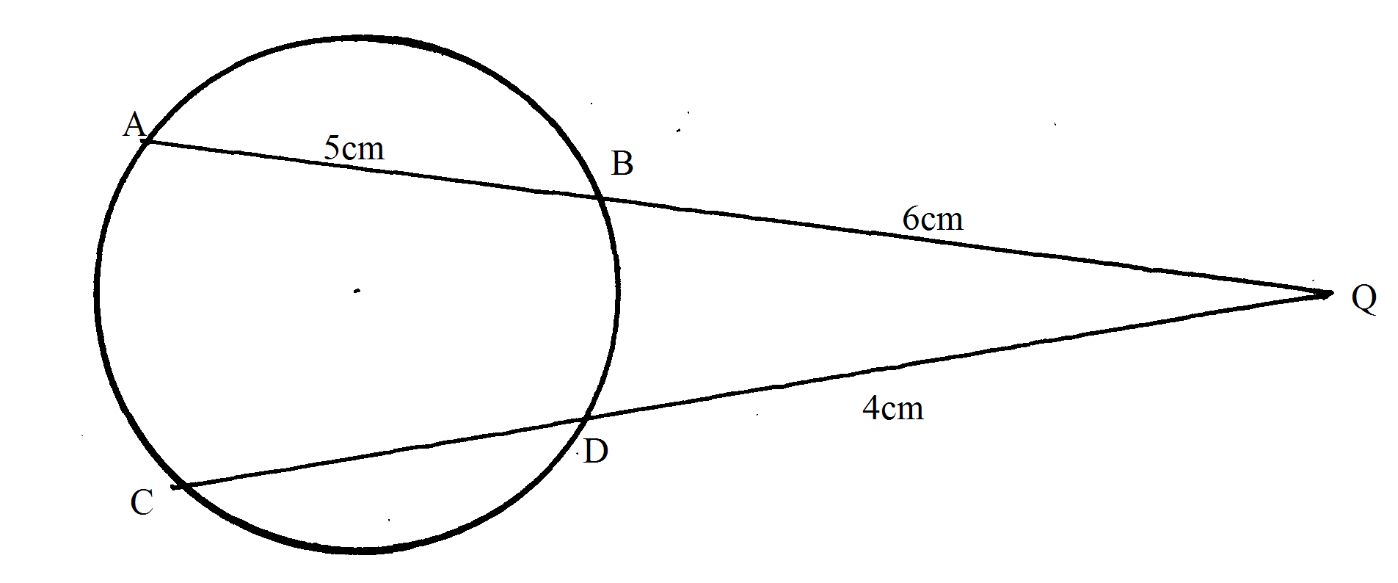
- Jane can do a piece of job in 4 days while Mary can do the same piece of work in 7 days. Mary and Jane did the job together for two days before Jane fell sick. Mary was left to complete the job. How long did it take to do the job? (3 Marks)

- The sketch below represents the graph of y=x²-x-6.Find the area bounded by the curve, x-axis, y-axis and the line x=5. (3 Marks)
X-axis
Y-axis
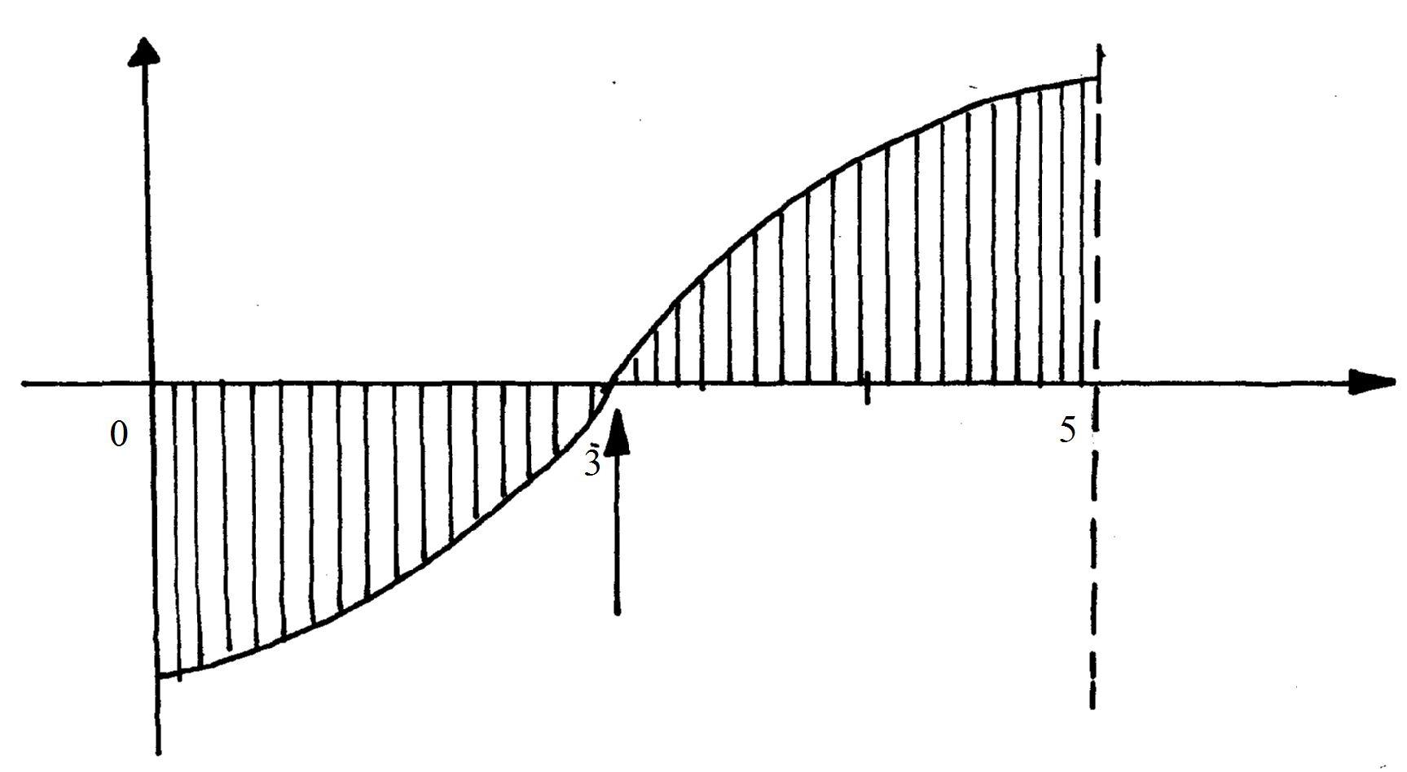

- Use matrix method to determine the co-ordinates of the point of intersection of the two lines. 3x-2y=13, 2y+x+1=0 (3 Marks)

- The figure below shows an arc of a circle through three points A, B and C.
A(2, 5)
C(4,10)
B(3, 8)

Calculate the co-ordinates of the centre of the circle. (4 Marks)

- A bag contains 4 white balls and 5 Red balls of similar shape and size. Two balls are picked at random without replacement. Find the probability that both balls are:
- White (1 Mark)

- Of different colour (2 Marks)

- A point P$\left(2,−3\right)$ undergoes transformation represented by the matrix$\left(\begin{matrix}3 & 0 \\ 0 & 1\end{matrix}\right)$. Find the
Co-ordinate of the image of P. (2 Marks)

- Expand up to the fourth term. (2 Marks)

Hence use the above expansion to evaluate (1.96)6 correct to 4 d.p. (2 Marks)

- Find the value of x in the equation 10sin2x - 7cos x + 2 = 0 for the range 270°≤x ≤360° (3 Marks)

- Find the value of x in (3 Marks)
Log(x-2) + log (x+1) = 1 + log 4

- The sum of two numbers is 9. The sum of the square of the number is 41. Find the numbers (4 Marks)

SECTION II (50 MARKS)
Answer FIVE questions ONLY from this section
- The table below shows the taxation rates for income earned.

Income in ksh pm | Tax rates (%)
1 – 9680 | 10
9681 – 18800 | 15
18801 – 27920 | 20
27921 – 37040 | 25
Excess over 37041 | 30

In that year, Mr. Hamisi paid a net tax of KSh. 5,512 per month. He gets a house allowance
of KShs. 10,000, medical allowance of KShs. 2400 and acting allowance of KShs. 2820 per
month. He was entitled to a monthly personal relief of KShs. 162. He has a life insurance
policy for which he pays a monthly premium of KSh. 1,500 and claims a relief at a rate of
10% of the premium paid per month. The following deductions also made every month.
(i) N.H.I.F. KSh. 320
(ii) Co-operative society shares KSh. 6000
(iii) Union dues KSh. 200
- Calculate Mr. Hamisi’s monthly basic salary in KSh. (7 Marks)

(b) Calculate his net monthly salary. (3 Marks)
18. A jet leaves town P(30°S, 26°W) at 2.00 p.m on Monday and flew due \north to town Q(50°N,26°W).
a) Calculate the distance covered by the jet in Km. ( take ∏=²²/₇ and R=6370) (3 Marks)

b) After 35 min stoppage at town Q the jet flew due East to town R a distance of 2500 nautical miles from town Q.
Find i) the position of town R (3 Marks)

ii) The local time the jet landed at R if its average speed for the whole journey is 1000km/h.
(Take 1nm=1.853km) (4 Marks)

- Use a ruler and a pair of compasses only in all constructions in this question.
(a) Construct the rectangle ABCD such that AB = 7.2cm and BC = 5.6cm. (3 Marks)

- Constructs on the same diagram the locus L₁ of points equidistant from A and B to meet with another locus L₂ of points equidistant from AB and BC at M. Measure the acute angle formed at M by L₁ and L₂. (3 Marks)

- Construct on the same diagram the locus of point K inside the rectangle such that K is less than 3.5cm from point M. Given that point K is nearer to B than A and also nearer to BA than BC, shade the possible region where K lies. Hence calculate the area of this region. Correct to one decimal place. (4 marks)

- (a) The first term of a geometric progression is 36.the sum of the first three terms is 27.
Calculate the common ratio and the value of the second term (4 Marks)

(b)The first term of an AP is 2.the first term of a geometric sequence is also 2 and its common ratio equals the common difference of the arithmetic sequence. The square of the fifth term of arithmetic sequence exceeds the third term of the geometric sequence by 2. Find the common difference and the sum of the first 50 terms of an AP. (6 Marks)

- a) Draw triangle PQR whose vertices are P(1,1) Q(-3,2) and R(0,3) on the grid provided. (1 Mark)
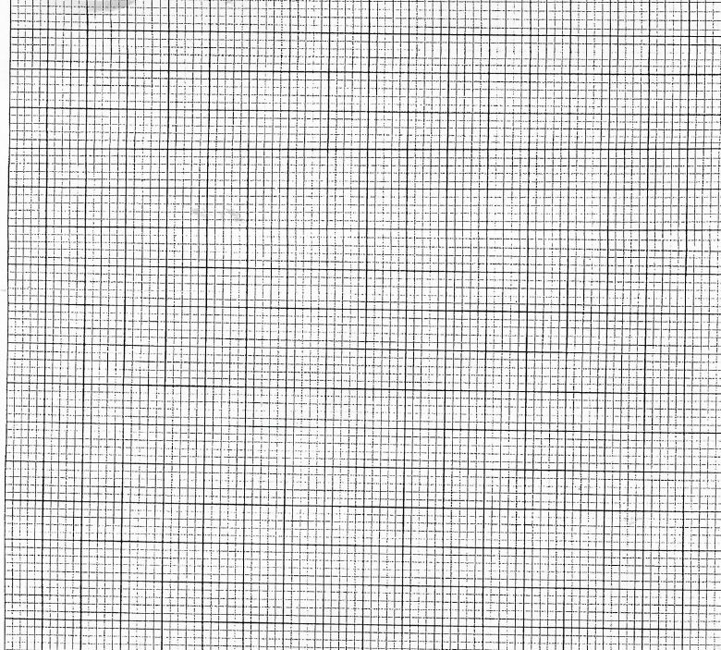
b) Find the coordinates of triangle P¹Q¹R¹ the image of triangle PQR under the transformation whose matrix is 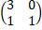. Draw triangle P¹Q¹R¹. (3 Marks)

- P¹Q¹R¹ is then transformed onto P²Q²R² by the transformation with matrix 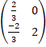 Find the coordinates of P²Q²R² and draw triangle P²Q²R² (3 Marks)

d) Describe fully a single transformation which maps PQR onto P²Q²R². Find the matrix of this transformation (3 Marks)

- In the triangle PQR below, L and M are points on PQ and QR respectively such that PL: LQ=1:3 and QM:MR=1:2, PM and RL intersect at X, given that PQ = b and PR = c,
P
Q
R
M
X
L

- Express the following vectors in terms of b and c
(i) QR (1mark)

(ii) PM (1mark)

(iii) RL (1mark)

- By taking PX = hPM and RX = kRL where h and k are constants find two expressions of PX in terms of h, k, b and c. Hence determine the values of the constant h and k. (6marks)

- Determine the ratio LX: XR (1mark)
23. a) Complete the table below for the function y=2x² + 4x -3 (2 Marks)
x | -4 | -3 | -2 | -1 | 0 | 1 | 2
y |  |  |  |  | -3
b) On the grid provided, draw the graph of the function y=2x² + 4x -3 for -4≤ x ≤ 2 using the scale of 1cm to represent 1 unit on axis and 1cm to represent 2 units on y-axis. (3 Marks)
- Use the graph above to:
- Determine the roots of the equation 2x² + 4x -3=0 (2 Marks)

- Solve the equation 2x² +x -5 =0 (3 Marks)
- The acceleration of a particle, t seconds after passing a fixed point P is given by a = 3t – 3. Given that the velocity of the particle when t = 2 is 5m/s, find;
- Its velocity when t = 4 seconds (3 Marks)

- Its displacement at the time in (a) above (3 Marks)

- The displacement during the third second (4 Marks)

