Name: ………………………………………………..…Adm No: ….…………Class: ………… Candidate’s Sign: ………...............Date: ………………………............................................
OPENER EXAMS
TERM 3 2023
FORM THREE AGRICULTURE

- (a) Define the terms below. (3 marks)
- Weed
………………………………………………………………………………………………………………………………………………………………………………………………………………
- Solifluction
………………………………………………………………………………………………………………………………………………………………………………………………………………
- land fragmentation
………………………………………………………………………………………………………
…………………………………………………………………………………………………………..
(b) State three type of information found in a land title deed. (3 marks)
………………………………………………………………………………………………………….…………………………………………………………………………………………………………..
…………………………………………………………………………………………………………..
- (a) State two disadvantages of tenancy. (2 marks)
…………………………………………………………………………………………………………...……………………………………………………………………………………………………………………………………………………………………………………………………………………
(b) State three signs of kidding in goats’ production. (2 marks)
………………………………………………………………………………………………………….…………………………………………………………………………………………………………..
…………………………………………………………………………………………………………..
- (a) Name two reasons of single housing in calves. (2 marks)
………………………………………………………………………………………………………….…………………………………………………………………………………………………………..
…………………………………………………………………………………………………………..
(b) Name three areas to avoid when collecting soil samples. (3 marks)
………………………………………………………………………………………………………….…………………………………………………………………………………………………………..
…………………………………………………………………………………………………………..

- (a) State two significance of each of the following practices in livestock production: (6 marks)
- De-beaking
………………………………………………………………………………………………………….…………………………………………………………………………………………………………..
…………………………………………………………………………………………………………..
- Docking
………………………………………………………………………………………………………….…………………………………………………………………………………………………………..…………………………………………………………………………………………………………..
- Hoof trimming
………………………………………………………………………………………………………….…………………………………………………………………………………………………………..
…………………………………………………………………………………………………………..
(b) Jomka planted maize in a plot measuring 4m x 6m at a spacing of 75cm x 25cm. Calculate the total plant population in his plot. (2 marks)

- (a) State the importance of soil color in crop production. (1 mark)
………………………………………………………………………………………………………….…………………………………………………………………………………………………………..
…………………………………………………………………………………………………………..
(b) State the significance of leveling nursery bed formation. (1 mark)
………………………………………………………………………………………………………….…………………………………………………………………………………………………………..
…………………………………………………………………………………………………………..

- (a) State four characteristics of plants used in green manure formation. (2 marks)
………………………………………………………………………………………………………….…………………………………………………………………………………………………………..
…………………………………………………………………………………………………………..………………………………………………………………………………………………………….
(b) Name two instances at which opportunity cost is zero. (2 marks)
………………………………………………………………………………………………………….…………………………………………………………………………………………………………..
…………………………………………………………………………………………………………...
- (a) State four characteristics of beef cattle breed. (2 marks)
………………………………………………………………………………………………………….…………………………………………………………………………………………………………..
…………………………………………………………………………………………………………..…………………………………………………………………………………………………………
(b) List two characteristics of ruminant animals. (2 marks)
………………………………………………………………………………………………………….…………………………………………………………………………………………………………..
…………………………………………………………………………………………………………..…………………………………………………………………………………………………………..
- (a) A farmer wanted to prepare feed ration with 20% protein for daily animals. The available feed stuffs were maize 9% proteins and sunflower seed cake 40% proteins if the feed to be prepared was 200kg. Calculate the parts used for each of the above feed stuff using Pearson’s method. (Show your working). (3 marks)

(b) State four advantages of using seeds as planting materials. (2 marks)
………………………………………………………………………………………………………….…………………………………………………………………………………………………………..
…………………………………………………………………………………………………………..…………………………………………………………………………………………………………..
- State two symptoms of phosphorus deficiency in crops. (1 mark)
………………………………………………………………………………………………………….…………………………………………………………………………………………………………..
…………………………………………………………………………………………………………..

- Study the diagrams below and answer the questions that follow in relation to bee keeping.
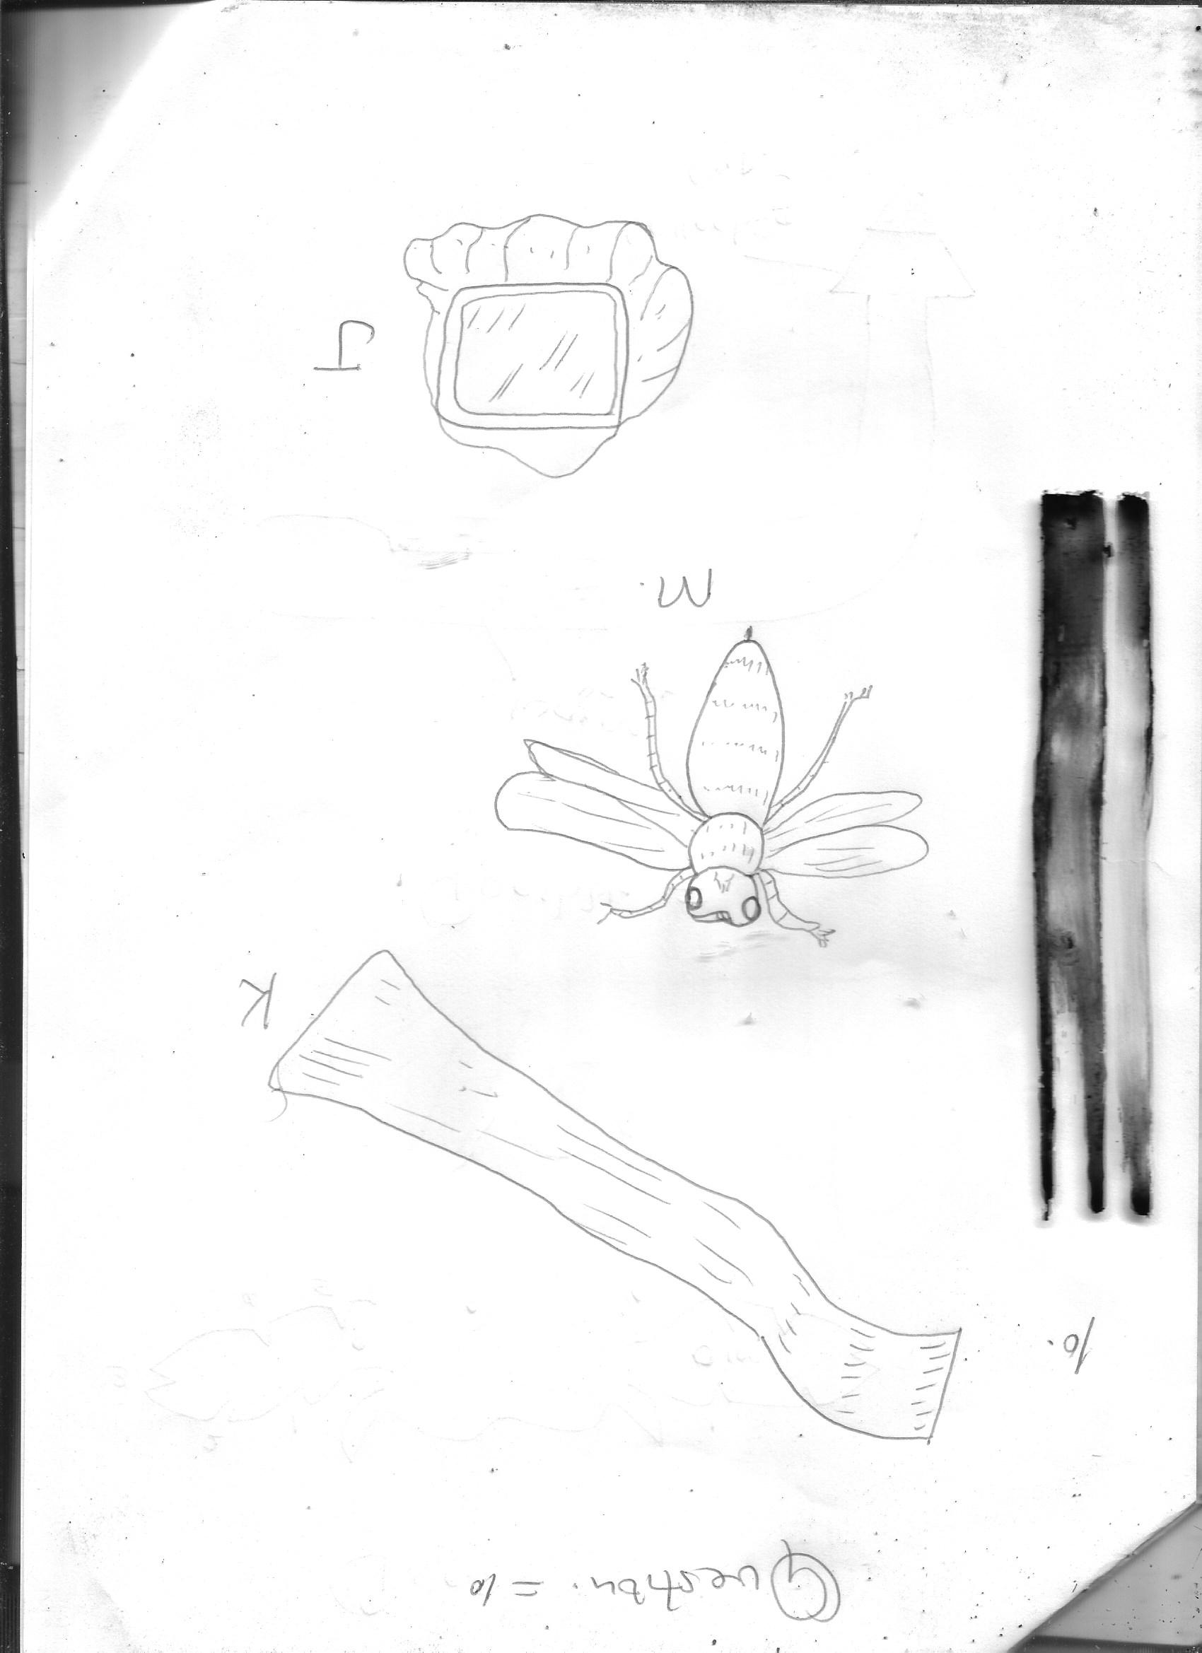
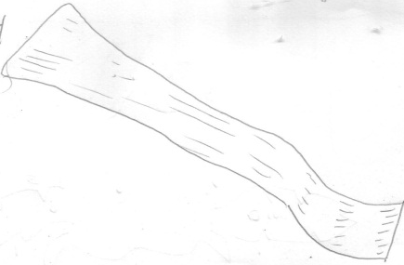

K J

M

- Identify the items labeled K and J as used in bee production. (2 marks)
K …………………………………………………………………………….

J ……………………………………………………………………………..
- State the use of the tool labeled K and J. (2 marks)
K ………………………………………………………………………………………………………….………………………………………………………………………………………………………….
J
……………………………………………………………..…………………………………………..
………………………………………………………………………………………………………….
- Bee labeled M is the smallest in the hive. (1 mark)
- Identify the bee above.
………………………………………………………………………………………………………….…………………………………………………………………………………………………………..
- Name two more bees in the hive. (2 marks)
………………………………………………………………………………………………………….…………………………………………………………………………………………………………..
- State three activities carried out by the bee you named in c (i) above in the hive. (3 marks)
…………………………………………………………………………………………………………..…………………………………………………………………………………………………………..
…………………………………………………………………………………………………………..

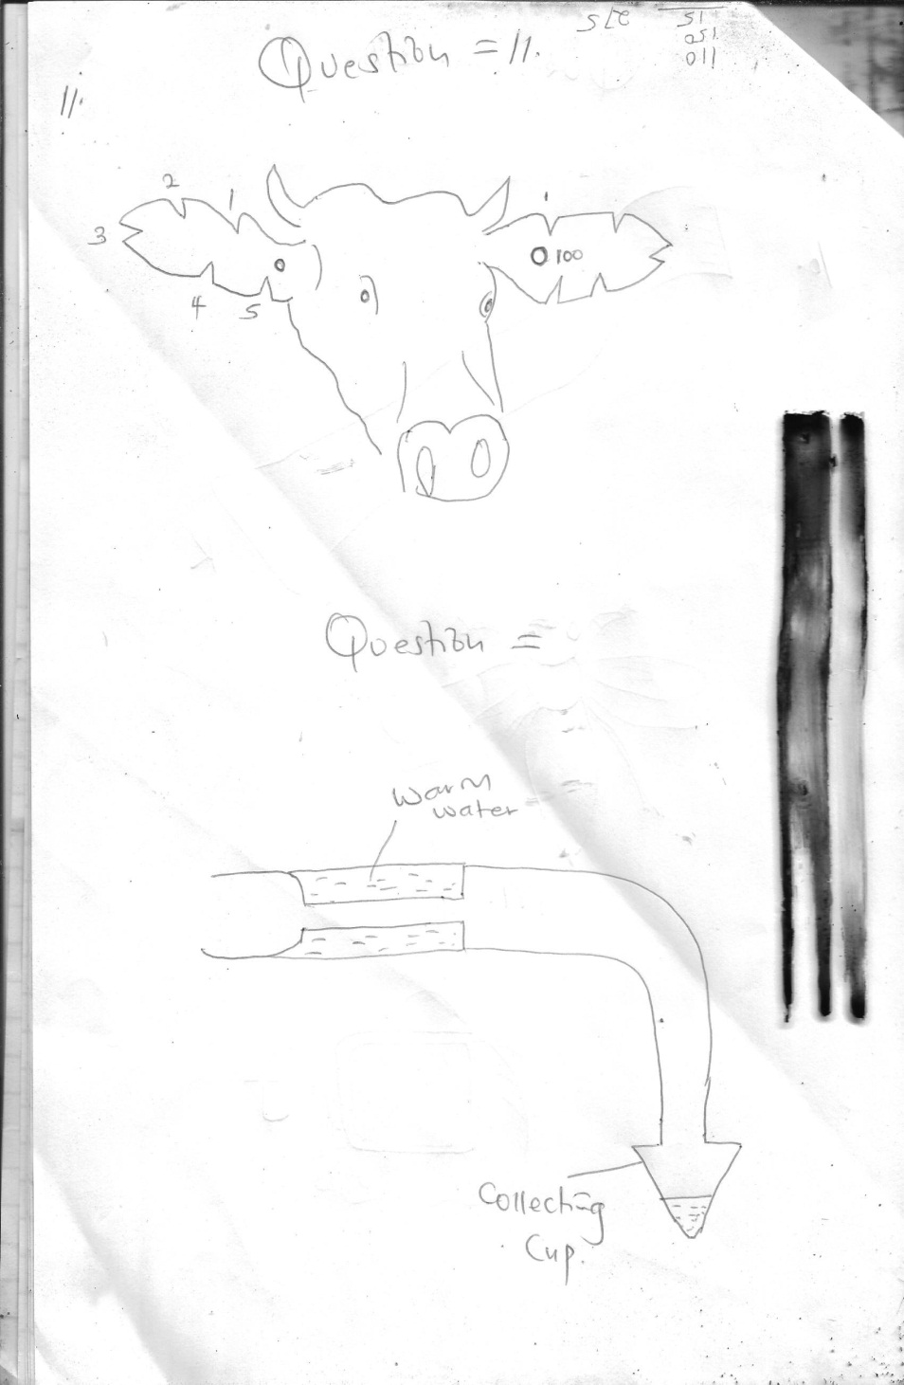
- Study the diagrams below and answer the questions that follow:

- Identify the practice above. (1 mark)
…………………………………………………………………………………………………………..
- State one tool used to carry out the practice. (1 mark)
…………………………………………………………………………………………………………
- Give the identity number of the animal above. (2 marks)

- State two reasons why branding is discouraged when identifying animals. (2 marks)
…………………………………………………………………………………………………………..…………………………………………………………………………………………………………..((e) Using a well labeled diagram, show animal number 70. (2 marks)

(f) Identify the tool shown below and state its use in the farm. (2 marks)
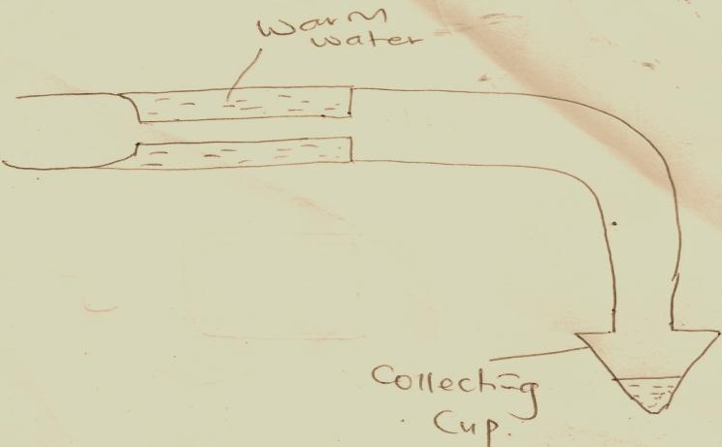

……………………………………………………………………………………………………………………………………………………………………………………………………………………………………………………………………………………………………………………………….
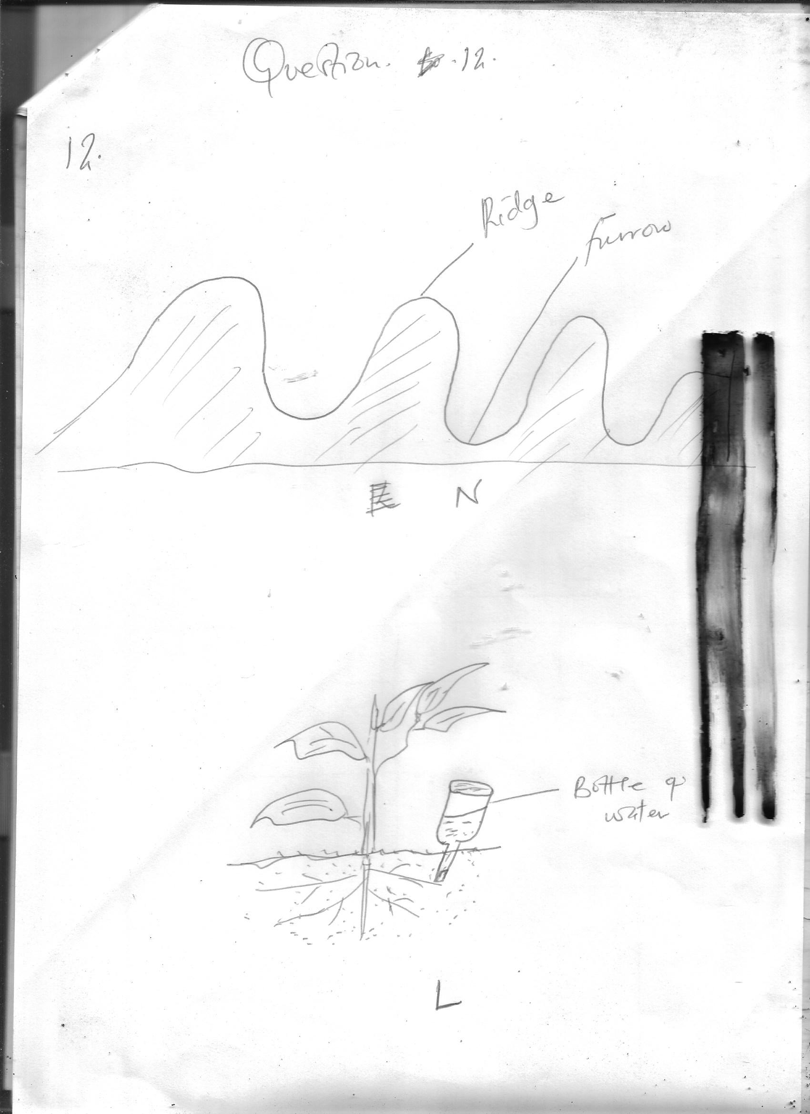
- Study the diagrams below and answer the questions that follow:
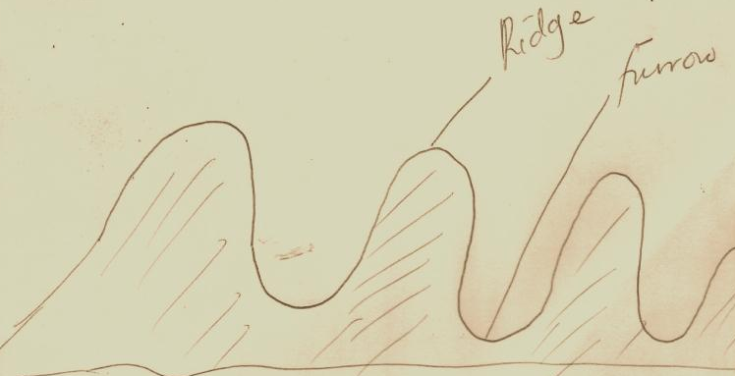

Bottle of
water

L

N
- Identify the farming practice labeled N. (1 mark)
…………………………………………………………………………………………………………..…………………………………………………………………………………………………………..
- State one importance of the practice. (1 mark)
…………………………………………………………………………………………………………..…………………………………………………………………………………………………………..
- State two advantages of irrigation method labeled L over overhead irrigation. (1 mark)
…………………………………………………………………………………………………………..…………………………………………………………………………………………………………....

