Name: ………………………………………………..…Adm No: ….…………Class: ………… Student’s Sign: ………...............Date: …………………............................................

OPENER EXAMS
TERM 3 2023
FORM TWO GEOGRAPHY
- (a)
- Identify two main branches of Geography (2 marks)
- State three ways in which geography is related to agriculture (3 marks)
(b)
- Name two isothermal layers of the atmosphere (2 marks)
- State three characteristics the of troposphere (3 marks)
- (a) Explain the origin of the earth according to passing star theory. (3 marks)
(b) State two characteristics of planet Saturn (2 marks)
- (a) State two conditions necessary for siting a weather station (2 marks)
(b) Describe how a rain gauge is used to measure the amount of rainfall (3 marks)
- (a) Give the metamorphic equivalent of each of the following (3 marks)
- Granite
- Limestone
- Sandstone
(b) State two characteristics of sedimentary rocks. (2 marks)
- (a) Outline five steps that should be followed in order to carry out a successful field study. (5 marks)
(b) State three problems students are likely to encounter during field study (3 marks)
- (a) Identify two methods which may be used to show relief on topographic maps. (2 marks)
(b) Distinguish between direction and bearing (2 marks)
(c) Give two uses of maps (2 marks)

- The figure below represents grid system of a topographic map. Use it to answer the questions that follow.
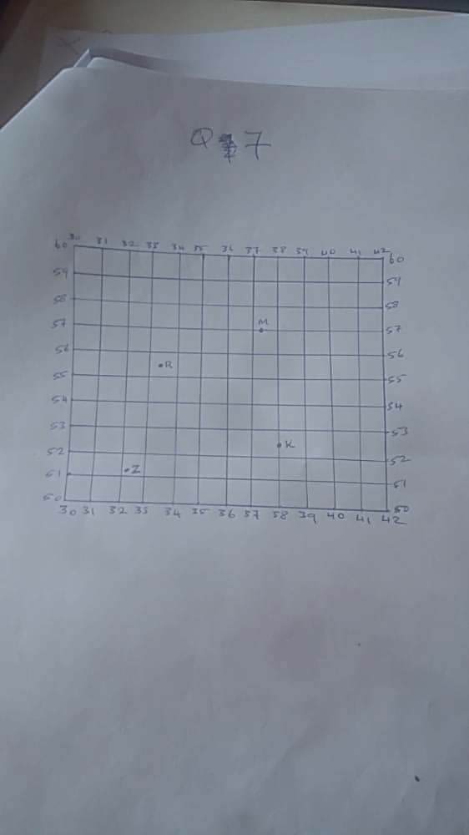
- Give the four- figure grid reference for:
- R (1 mark)
(ii) Z (1 mark)
(b)Give the six- figure grid reference for:
- M (1 mark)
(ii) K (1 mark)
- (a) State two types of earth movement within the earth crust. (2 marks)
(b) State three causes of earth movement (3 marks)
- (a) State two human causes of earthquakes (2 marks)
(b) Identify the scale used to measure:
- The intensity of the earthquake. (1 mark)
(ii) The magnitude of the earthquake (1 mark)
- (a) What is vulcanicity? (2 marks)
(b) List down three resultant features of intrusive vulcanicity. (3 marks)
(c) Explain two negative effect of vulcanicity (4 marks)

