**3. WEATHER AND CLIMATE**

***The topic entails:-***

1. ***Defining weather and stating its elements***
2. ***Explaining conditions necessary for siting a weather station.***
3. ***Use instruments to measure elements of weather***
4. ***Analyse and interpret data on weather conditions***
5. ***Description of the structure and composition of the atmosphere***
6. ***Explain factors influencing weather***
7. ***Carrying out a field study on weather station***
8. ***Distinguish between weather and climate***
9. ***Explain the factors that influence climate***
10. ***Description of the characteristics of the climatic regions of Kenya.***
11. ***Description of characteristics of major climatic regions of the World.***
12. ***Accounting for the causes of aridity and desertification***
13. ***Explaining the effects and possible solutions to aridity and desertification***
14. ***Discussing the causes and impact of climate change on physical and human environment***

1. State **three** causes of desertification.

2. a)i) Differentiate the term aridity and desertification

ii) Differentiate between weather and climate

b) State **two** causes of temperature inversion

c) Explain the occurrence of a land breeze

3. a) Give **three** characteristics of the inter- tropical convergence zone

b) (i) State **three** natural causes of climate change

ii) Explain **four** consequences of climate change on the physical environment

c) Give four reasons why some areas within the equatorial belt do not experience true

equatorial climate

4. (a) Describe the climatic conditions experienced in the Kenya highlands

(b) Explain **four** effects of folding to human activities

5. (a) Distinguish between **weather** and **climate**

(b) State **six** characteristics of equatorial climate

6. (a) Explain how the following factors influence climate:

(i) Ocean currents

(ii) Altitude

(b) Study the map of Africa below and answer the following questions:

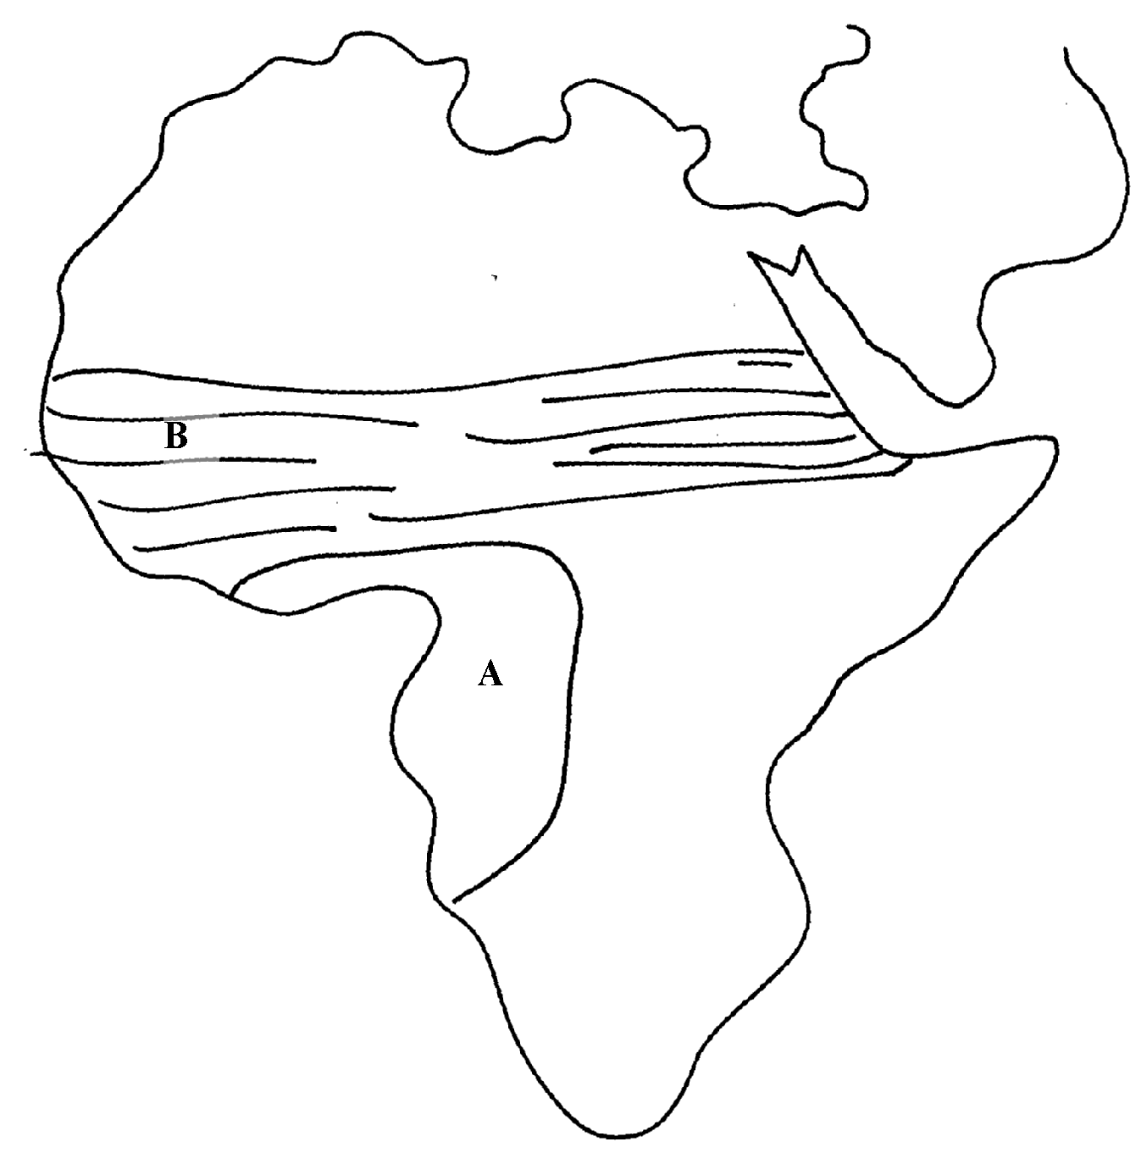

(i) Describe the characteristics of climate marked **A.**

7. (a) State **three** conditions necessary for the formation of dew

(b) State **two** climatic reasons why the government should evict settlers from the Mau

forest complex in the Rift valley of Kenya

8. (a) (i) What is a fog?

(ii) State any **two** conditions necessary for the formation of fog.

(b) Name any **two** isothermic layers of the atmosphere.

9. (a) What is an air mass?

(b) Give **two** climatic characteristics of the Inter-Tropical Convergence Zone (ITCZ)

10. (a) Describe **two** characteristics of a mountain climate

(b) (i) State **two** human causes of climate change

(ii) Explain **three** consequences of climate change

(c) Four classes intend to visit a weather station near your school to study the instruments

for measuring weather element:-

(i) Describe how you would use a rain gauge to measure rainfall

(ii) Name **two** instruments you would find inside a Stevenson screen

11. a) What do you understand by:

i) Micro- climate

ii) Green house effect

b) Name **two** weather recording instruments that are placed in a Stevenson’s screen

12. (a) What is an air mass?

(b) What two conditions favour formation of air mass?

13. (a) What is the Inter-tropical convergence Zone?

(b) Account for any **four** characteristics of tropical rainforests.

14. (a) What is an air mass?

(b)Study the diagram below and name the air masses marked **A, B , C** and **D**

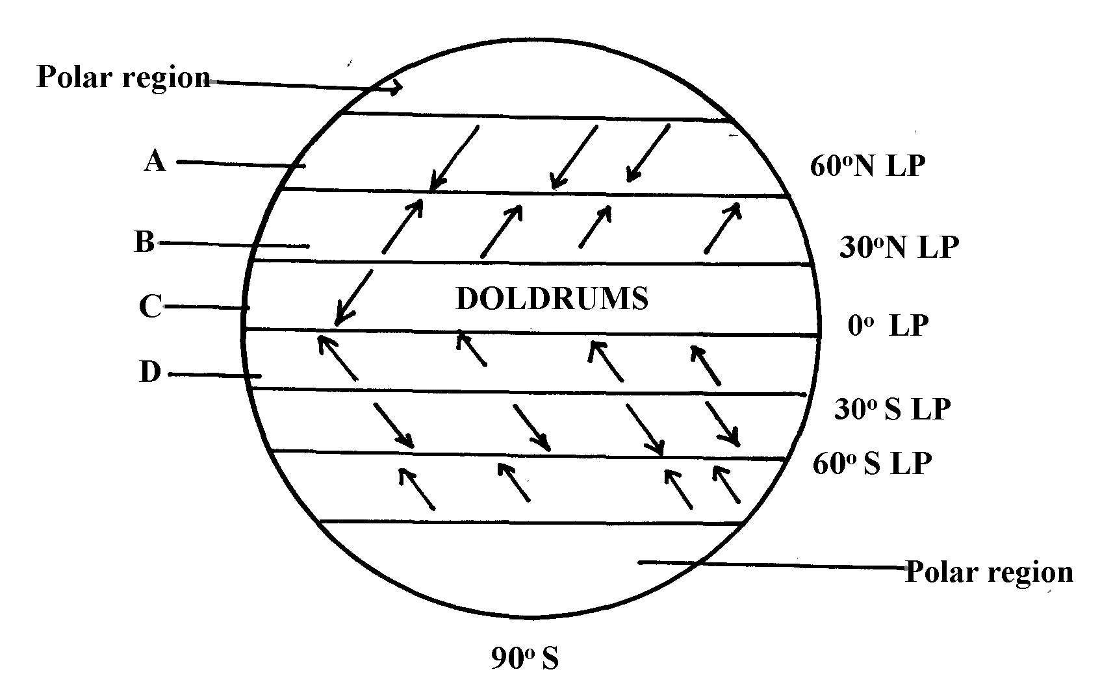

**Key**

LP- Low Pressure

HP- High Pressure

15 (a) (i) What is global warming?

(ii) Give any **four** causes of climate change.

(iii) Name **four** Green house gases

(b)(i) Explain **five** effects of climate change

(ii) Identify with evidence **two** climatic aspects that could have influenced the distribution of vegetation

16. (a Differentiate between:

(i) Aridity and desertification

(b) Give **three** reasons why the recording of weather data at a weather station may be inaccurate

(c) State **two** qualities that makes Stevenson screen suitable for its work

17. The map below shows the climatic regions of Kenya

(a) Use it to answer the question **a** and **b**

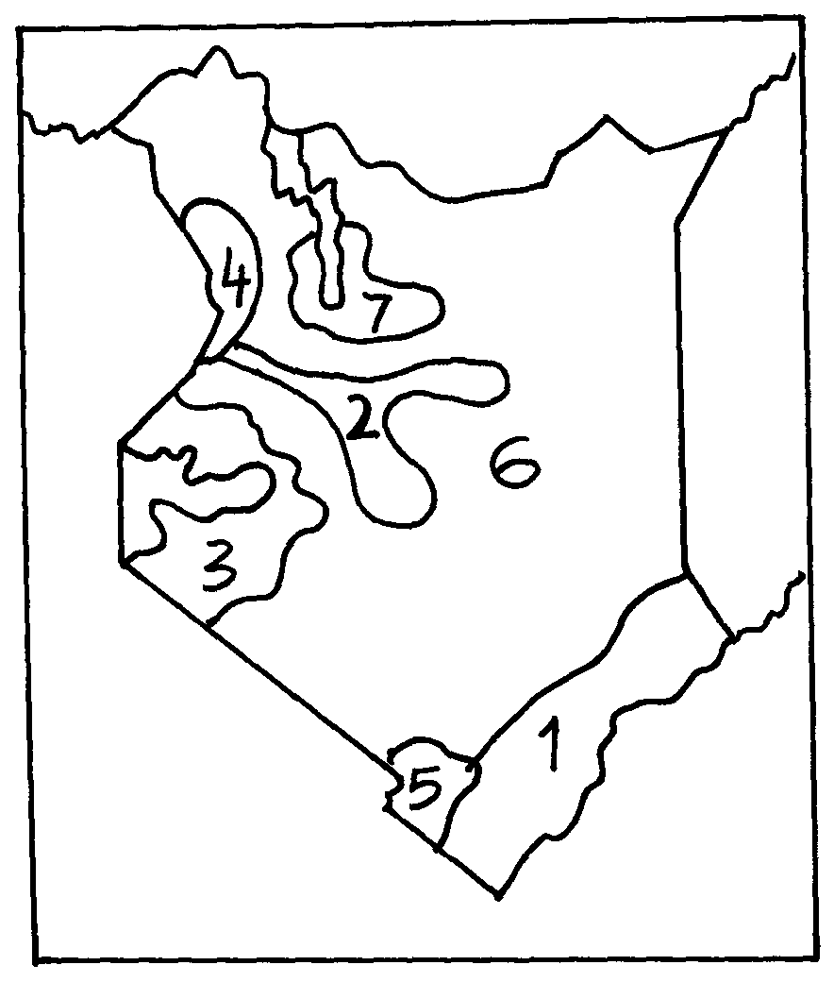

. (a) Name the climatic region name **2** and **3**

(b) State **three** characteristics of climatic region marked 7

18. The map of Africa below shows the different climatic regions of Africa. Use it to answer

question 18.(a).

a )i)Identify the climatic types marked **X** and **Y**

ii) Name any **four** characteristics of the climate marked Z

b) i) Briefly explain the green house effect and the global warming

ii) Explain **three** effects of climatic change on the physical environment

c) Explain how the following factors influence climate

i) Altitude

ii) Continentality

iii) Ocean currents