**WEEDS AND WEED CONTROL**

This topic entails the following:

* Definition of a weed
* Identification of weeds
* Classification o weeds
* Competitive ability of weeds
* Description of weed control methods
* Harmful effects of weeds

The following relevant questions and their answers in this topic will greatly motivate and help the user to comprehend and understand the required concepts and practices:

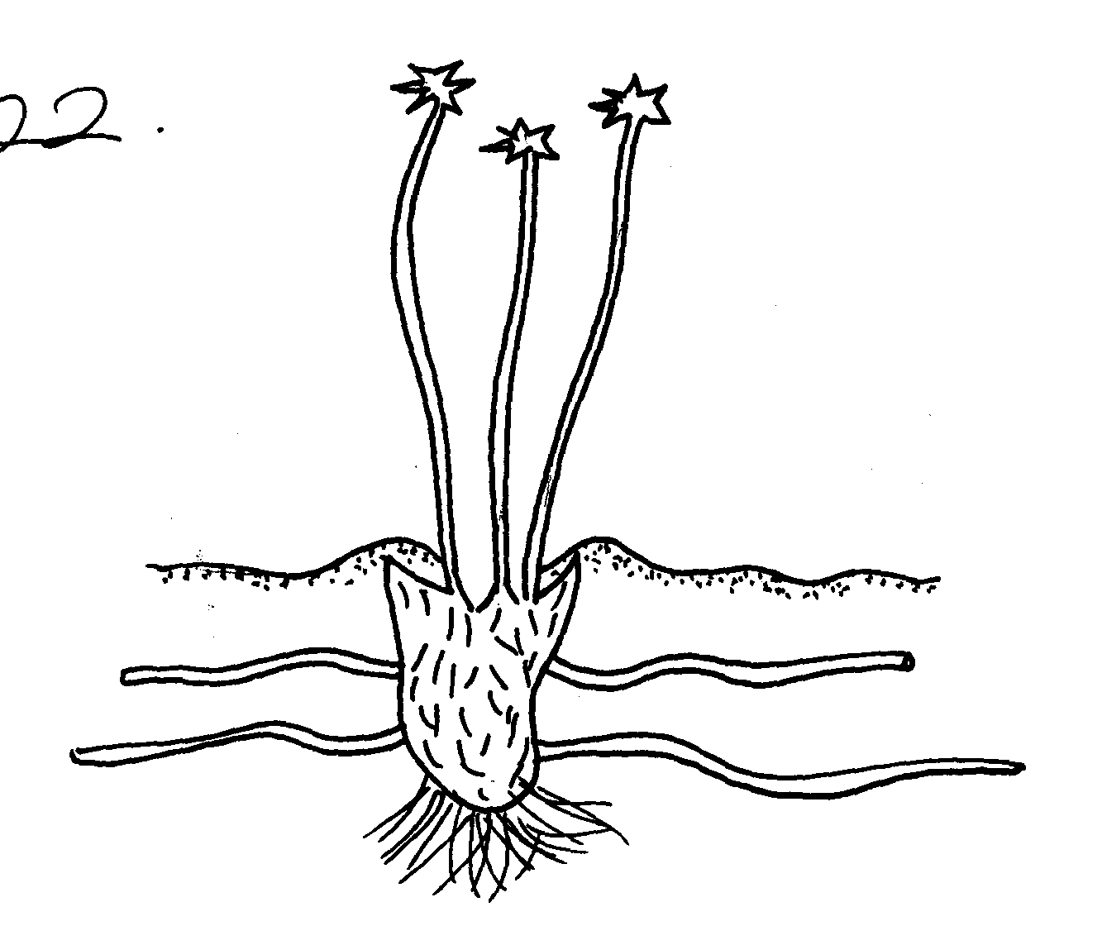1. Study the diagram below and answer the questions that follow:

(a) Identify the weed

(b) Why is it difficult to control the weed?

(c) State the economic importance of the weed shown above

2. The following is an illustration of a common weed of arable land

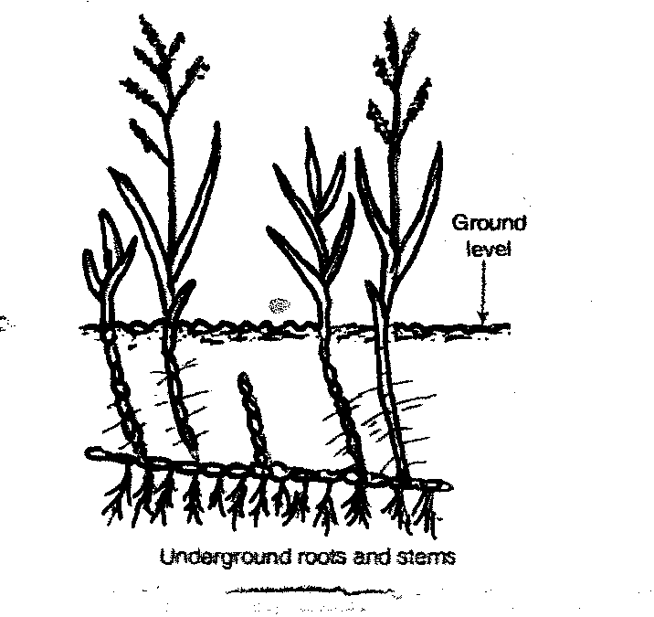

(a) Identify the weed (b) Why is it difficult to control the weed?

(c) State **one** harmful effect of the weed on crop production

(d) Give **two** measures used to control the weed

3. Below is a diagram of some common weeds. Study then and answer the questions that follow:-

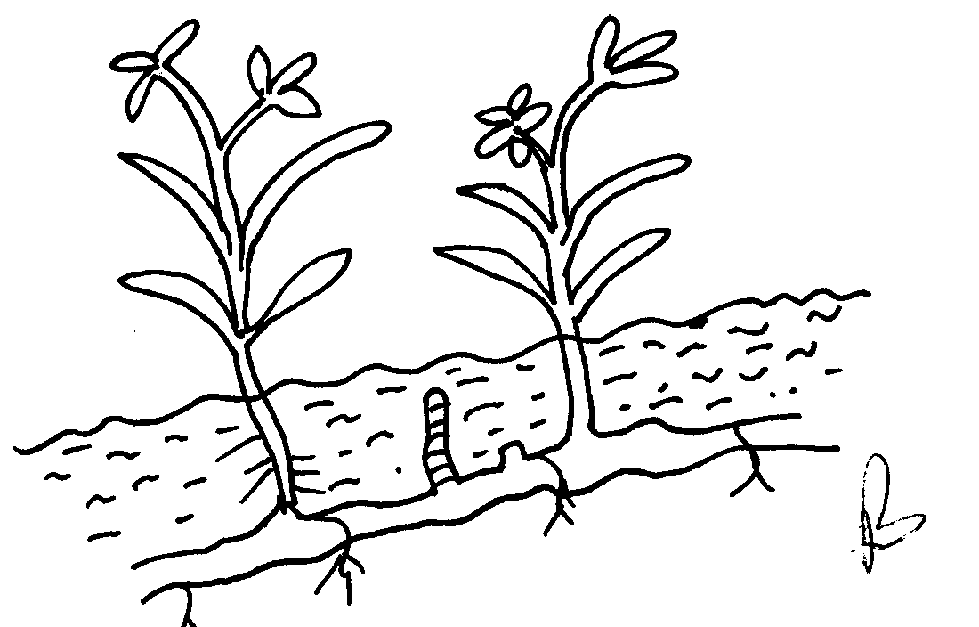

(i) Identify weed **A** and **B**  (ii) State **two** effects of weed **B** on crop production

(iii) Give a reason why weed **B** is difficult to control

(iv) State the effective method of controlling weed **B**

4. Give **four** methods of propagation which make weeds have a high competitive ability

over crops

5. The diagrams below show weeds:-

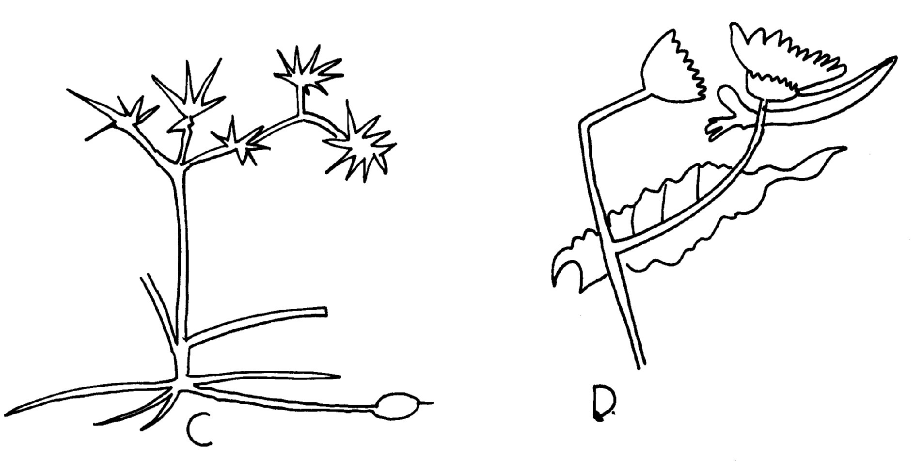

**C**

**D**

Identify the weeds **C** and **D**

(b) State why it is difficult to control weed **C**

(c) State **two** economic importance of weed **D**

6. (a) List any **four** types of weeds known to be poisonous to livestock

(b) At what stage of life cycle is best recommended to control weeds?

7. State **two** disadvantages of using herbicides

8. a) Name **four** herbicides that can be used to control weeds in a field of maize

b) At what stage of growth of maize should the weeds be controlled by use of a post

emergence herbicides

9. (b) Give an account of economic importance of weeds

10. a) mention **two** factors that affect selectivity of herbicides

11. Listing specific examples of weeds describe their harmful effects in agricultural production

**WEEDS AND WEED CONTROL**

1. Oxalis (sorrel)

-(oxalis latifolia)

b)- The weed contain builbs i.e Elaborate & extensive root system that support the plant.

- Because it has rhizomes.

c) State the economic importance of the weed shown.

- Reduces yields of crops.

- Increases cost of production.

- It’s a livestock feed.

- Fixation of nitrogen.

2. (a)Couch grass Digetaria Scalarum ( ½mk)

(b) Why is it difficult to control the weed?

* It has got underground rhizomes which grow deep in the soil ( ½ x 1pt = 1mk)

(c) One harmful effect of the weed on crop production

* Competes with crops for nutrients/soil moisture and space resulting to low yields
* Increases the cost of production when controlling it

(d) Two measures used to control the wed

* Use of appropriate herbicides

- Physical removal of rhizomes

3. i)- A-Double thorn (oxygonium sinuatum)

- B- Coach grass (Digiteria scalarum)

ii) - Lower the quality of produce

* Lower yields
* Compete with intended plants for nutrients and water

iii) Weed B is difficult to control as it has underground rhizomes

iv) Can be effectively controlled by use of chemicals

4. Four methods of propagation which make weeds to have a high competitive ability over crops

* Availability to produce many viable seeds
* Ability to propagate vegetative –with bulbs, rhizomes
* Ability to regenerate woody stems-quickly
* Efficient means of propagation

Ability to remain viable in the soil for a long period of time

5. Weed C – Nutgrass (Cyprus rotundus)

Weed D – Sow thistle (sonchus oleraceous)

6. a) - Thorn apple

* Sodom apple
* Oxalis
* Tick berry ( ½ x4=2 mks)

b) - Before flowering to avoid spread through seeds

- Early stage before spreading underground organs

7.

* Requires skilled labour
* Have long residual effect which interferes with future crops

It is not environmental friendly/ pollutes the environment

8. a)

* MCPA
* 2 - 4 – D
* Bentazon
* Bromoxynil
* Linuron
* Loxyyril
* Atrazine
* Metrubuzin

b) - 10 – 15cm high

- 2 – 4 weeks after emergence

9.

* Complete for nutrients/ light/ space
* ACD as alternate host of insect pests
* Some produce poisonous substances
* Blocks water cords
* Lowers the quality of pasture
* Poisonous to man and livestock
* Parasites of desired crops
* Aquatic weeds affect navigation and water animals
* Increase the cost of production
* Cause irritation to workers
* Some have medicinal value
* Eaten by man and livestock
* Acts as soil cover
* Add organic matter in the soil

- Some are legumes

10. a) two factors that affect selectivity of herbicides

* Stage of plants growth
* Plants morphology and anatomy
* Mode of action
* Environmental factors (2x1=2mks)

11. specific examples of weeds describe their harmful effects in agricultural production

* Compete with crops for nutrients spacing ,light, moisture lowering yield e.g. MacDonald’s eye etc
* Some are parasitic e.g. wihhweed
* Low quality of produce e.g. Mexican marigold lowering quality of milk/pigweed seeds in finger millet
* Poisonous to both man and livestock e.g. Dahira stramonium, Bracken fern
* Allirnate hosts for pests and diseases e.g. mallow weed –for cotton strainer
* Some are allelopallic/hinder germination e.g. Mexican marigold
* Block irrigation channel e.g. salvinia/water hyacinth
* Affect fishing and navigation-salvinia and water hyacinth
* Lower quality of pasture e.g. manyatta grass
* Reduce workers efficiency/irritate e.g. double thorn, shnging nelthe, devil’s horse whip